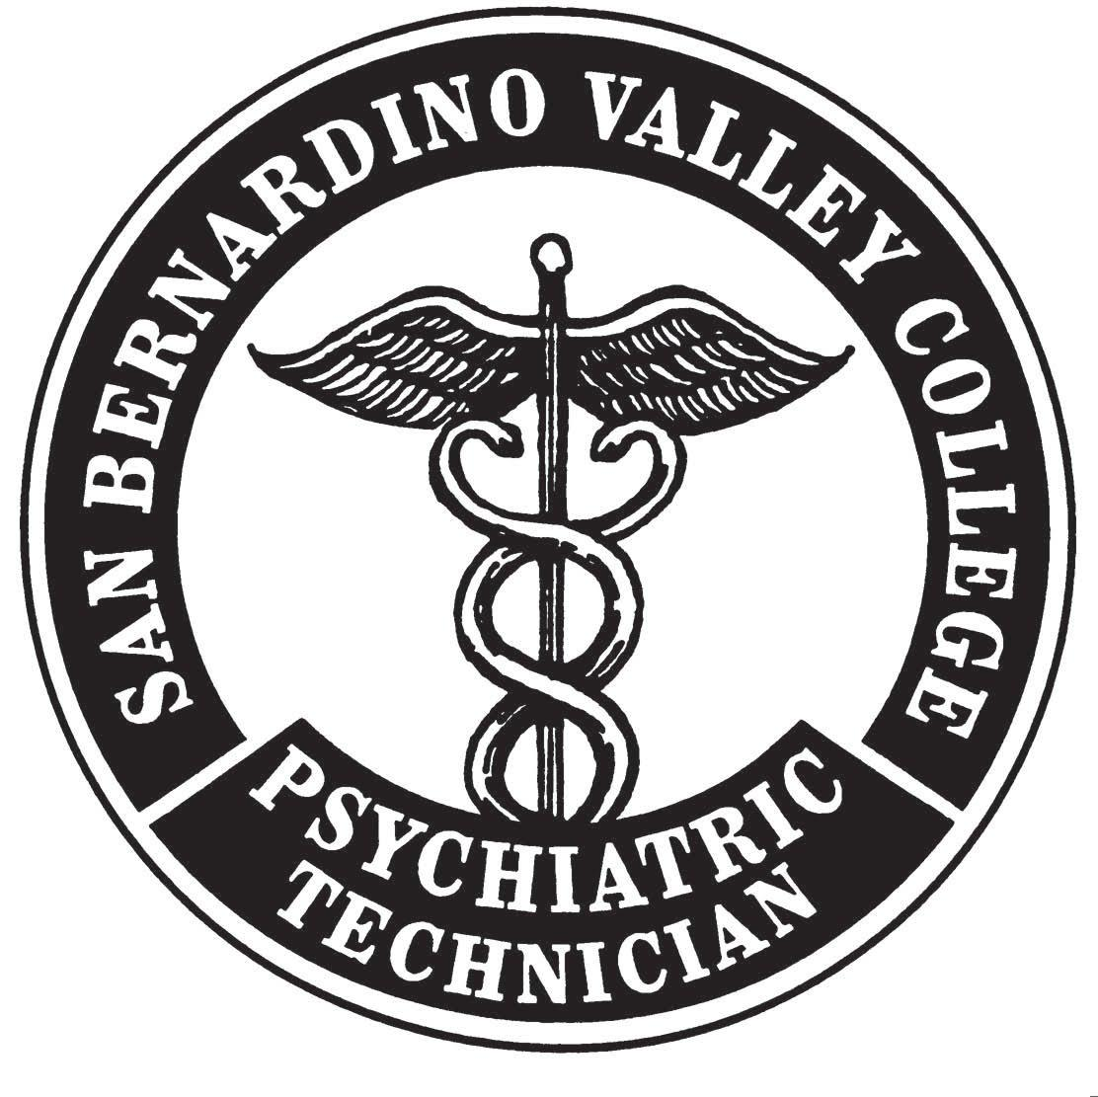
Want To Become a Licensed Psychiatric Technician

Attend an Information Meetings
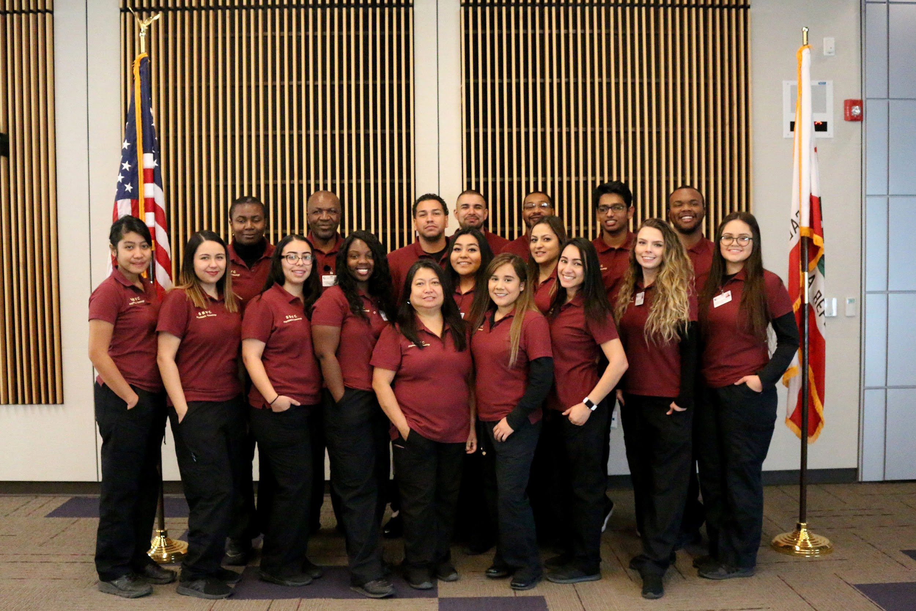

2019
Dates | Date | Day | Time | Room
January | 29 | Tuesday | 4:00-5:30 PM | HLS-143
March | 4 | Monday | 12:30-2:00 PM | HLS- 143
April | 8 | Monday | 4:00-5:30 PM | HLS-142
May | 1 | Wednesday | 11:00-12:30 PM | HLS- 145
May | 3 | Friday | 11:00 – 12:30PM | HLS 143 entative

Psychiatric Technology Program Department
San Bernardino Valley College
(909) 384-8934
http://depts.valleycollege.edu/PsychiatricTech/

