Institutional Self-Evaluation Report

In Support of an Application for
Reaffirmation of Accreditation

Submitted by

San Bernardino Valley College
701 S. Mt. Vernon Ave
San Bernardino, CA 92410

to

Accrediting Commission for Community and Junior Colleges
Western Association of Schools and Colleges

[insert date of submission: Month Year]

Certification

To: Accrediting Commission for Community and Junior Colleges
Western Association of Schools and Colleges

From: Diana Rodriquez, President
San Bernardino Valley College
701 S. Mt. Vernon Ave
San Bernardino, CA 92410

This Institutional Self-Evaluation Report is submitted to the ACCJC for the purpose of assisting in the determination of the institution’s accreditation status.

I certify there was effective participation by the campus community, and I believe the Self-Evaluation Report accurately reflects the nature and substance of this institution.

Signatures:

[Chief Executive Officer of Multi-College District, if applicable] | [Date]
[Chief Executive Officer] | [Date]
[Chairperson, Governing Board] | [Date]
[Name, Title, Representing] | [Date]
[Name, Title, Representing] | [Date]
[Name, Title, Representing] | [Date]
[Name, Title, Representing] | [Date]

NOTE: Suggested total ISER page limit is 250 pages.
Contents
A. Introduction 11
Student Enrollment Data 15
Labor Market Data 21
Demographic Data 22
Socio-economic Data 26
Sites 29
Specialized or Programmatic Accreditation 29
B. Presentation of Student Achievement Data and Institution-set Standards 30
C. Organization of the Self-Evaluation Process 37
D. Organizational Information 38
E. Certification of Continued Compliance with Eligibility Requirements 45
A. Certification of Continued Institutional Compliance with Commission Policies 47
B. Institutional Analysis 53
Standard I: Mission, Academic Quality and Institutional Effectiveness, and Integrity 53
I.A Mission 53
I.A.1 53
I.A.2 54
I.A.3 56
I.A.4 57
Conclusions on Standard I.A. Mission 57
I.B Assuring Academic Quality and Institutional Effectiveness 60
Academic Quality 60
I.B.1 60
I.B.2 61
I.B.3 63
I.B.4 65
Institutional Effectiveness 66
I.B.5 66
I.B.6 69
I.B.7 70
I.B.8 71
I.B.9 72
Conclusions on Standard I.B. Academic Quality and Institutional Effectiveness 74
I.C Institutional Integrity 74
I.C.1 74
I.C.2 76
I.C.3 76
I.C.4 77
I.C.5 78
I.C.6 79
I.C.7 80
I.C.8 80
I.C.9 81
I.C.10 82
I.C.11 83
I.C.12 83
I.C.13 84
I.C.14 85
Conclusions on Standard I.C. Institutional Integrity 85
Standard II: Student Learning Programs and Support Services 86
II.A Instructional Programs 86
II.A.1 86
II.A.2 87
II.A.3 89
II.A.4 90
II.A.5 91
II.A.6 92
II.A.7 93
II.A.8 94
II.A.9 94
II.A.10 95
II.A.11 96
II.A.12 97
II.A.13 98
II.A.14 98
II.A.15 99
II.A.16 99
Conclusions on Standard II.A. Instructional Programs 100
II.B.Library and Learning Support Services 101
II.B.1 101
II.B.2 103
II.B.3 103
II.B.4 104
Conclusions on Standard II.B. Library and Learning Support Services 105
III.C Student Support Services 106
II.C.1 106
II.C.2 107
II.C.3 108
II.C.4 109
II.C.5 111
II.C.6 112
II.C.7 113
II.C.8 114
Conclusions on Standard II.C. Student Support Services 115
Standard III: Resources 116
III.A Human Resources 116
III.A.1 116
III.A.2 117
III.A.3 118
III.A.4 119
III.A.5 120
III.A.7 121
III.A.8 122
III.A.9 123
III.A.10 123
III.A.11 124
III.A.12 125
III.A.13 125
III.A.14 126
III.A.15 127
Conclusions on Standard III.A. Human Resources 128
III.B Physical Resources 128
III.B.1 128
III.B.2 130
III.B.3 131
III.B.4 133
Conclusions on Standard III.B. Physical Resources 134
III.C Technology Resources 134
III.C.1 134
III.C.2 135
III.C.3 136
III.C.4 136
III.C.5 137
Conclusions on Standard III.C. Technology Resources 138
III.D. Financial Resources 138
Conclusions on Standard III.D. Financial Resources 155
III.D.1 Error! Bookmark not defined.
III.D.2 Error! Bookmark not defined.
III.D.3 Error! Bookmark not defined.
III.D.4 Error! Bookmark not defined.
III.D.5 Error! Bookmark not defined.
III.D.6 Error! Bookmark not defined.
III.D.7 Error! Bookmark not defined.
III.D.8 Error! Bookmark not defined.
III.D.9 Error! Bookmark not defined.
III.D.10 Error! Bookmark not defined.
III.D.11 Error! Bookmark not defined.
III.D.12 Error! Bookmark not defined.
III.D.13 Error! Bookmark not defined.
III.D.14 Error! Bookmark not defined.
III.D.15 Error! Bookmark not defined.
III.D.16 Error! Bookmark not defined.
Conclusions on Standard III.D. Financial Resources Error! Bookmark not defined.
Standard IV: Leadership and Governance 156
Decision-Making Roles and Processes 156
IV.A.1 Error! Bookmark not defined.
IV.A.2 Error! Bookmark not defined.
IV.A.3 Error! Bookmark not defined.
IV.A.4 Error! Bookmark not defined.
IV.A.5 Error! Bookmark not defined.
IV.A.6 Error! Bookmark not defined.
IV.A.7 Error! Bookmark not defined.
Conclusions on Standard IV.A. Decision Making Roles and Processes Error! Bookmark not defined.
IV.B Chief Executive Officer 165
IV.B.1 165
IV.B.2 166
IV.B.3 166
IV.B.4 168
IV.B.5 169
IV.B.6 170
Conclusions on Standard IV.B. CEO 171
IV.C Governing Board 171
IV.C.1 171
IV.C.2 173
IV.C.3 173
IV.C.4 173
IV.C.5 174
IV.C.6 175
IV.C.7 175
IV.C.8 176
IV.C.9 176
IV.C.10 177
IV.C.11 178
IV.C.12 178
IV.C.13 179
IV. D Multi-College Districts or Systems 181
IV.D.1 181
IV.D.2 181
IV.D.3 183
IV.D.4 183
IV.D.5 184
IV.D.6 184
IV.D.7 185
Conclusions on Standard IV.D. Multi-College Districts or Systems 186
C. Quality Focus Essay 188

Introduction

History of San Bernardino Valley College

An election to establish the San Bernardino Valley Union Junior College District was held on March 26, 1926. On June 23, 1926, the Board of Trustees met at a site on the east side of Mt. Vernon Avenue equidistant between the downtown areas of San Bernardino and Colton. It was suggested that approximately 30 acres in the northwestern section of the parcel being inspected would provide the ideal location for the new college.
The 1927-1928 SBVC faculty comprised 11 men and six women. Nearly 300 students enrolled for the fall semester of 1927, with the freshmen outnumbering the sophomores nearly six to one. Fifty-four courses were offered, nearly all with a strong academic orientation.
The effects of the Great Depression were felt on campus in the early 1930s but beginning in 1936 SBVC’s financial situation seemed to recover. Additional buildings were added, providing employment for over 500 individuals in the area. The auditorium was accepted by the Board of Trustees in October 1938, and during that same month, the Drama Department presented Shakespeare’s As You Like It as its first production. In other construction projects, State Emergency Relief Administration funds were obtained to construct a Greek Theatre, and Works Progress Administration (WPA) funds were used to build concrete bleachers for the stadium and a new vocational building.
The fall of France in 1940 and the passage and implementation of the Selective Service Act had a sobering effect on the SBVC campus. After the United States’ entry into World War II, the number of male students on the campus decreased drastically. The war impacted the college in other direct ways in both curriculum and campus activities. The vocational building, completed in the fall of 1941, was used to house a number of Off Reservation Training (ORT) courses. Courses in radio equipment repair and battery maintenance were also offered.
Some of the first veterans returned to campus in 1944, and a Veterans’ Club was organized. By the fall of 1945, the faculty men who had been on military leave began to return, and veterans enrolled in SBVC in ever-increasing numbers. A big expansion in enrollment came a year later in 1946 with the addition of many new faculty members and a rapidly growing student body.
Through the 1960s, 1970s, and 1980s changes in curriculum mirrored the changing social and economic conditions. The Civil Rights Movement resulted in a substantial increase of minority students. Occupational courses were in great demand, and courses in psychology and philosophy also became popular.
Faced with increasing enrollment and a cap on state funding, SBVC faculty and administration held a forum in 1991 to discuss “Whom Shall We Serve?” Initiatives to bring new populations to the campus were reduced, while state-mandated tuition was increased, resulting in a sharp decline in enrollment. An earthquake in 1992 severely damaged the book stacks on the main floor of the Library, causing the facility to be closed down for the summer while repairs were made.
During the winter break for the 1995-1996 academic year, trenching began to determine the vulnerability of the campus to future seismic activity. The results of the study revealed that seven of the 15 buildings on campus straddled or were near the San Jacinto earthquake fault and would eventually have to be taken down.
In 1997, SBVC President Sharon Caballero was presented with an immediate challenge. There was a pressing need to identify a funding source to build new facilities to replace seven buildings that straddled the San Jacinto fault line, which traversed campus. A combination of District and College efforts as well as contacts with the Federal Emergency Management Agency (FEMA) resulted in the positive outcome of a state commitment of over $40 million to erect replacement structures.
In 2002, voters passed Measure P, a local bond measure totaling $190 million benefiting SBCCD and its two sister colleges. Steven Ehrlich, a noted architect, was hired to design the new buildings for the Library, Administration/Student Services, Campus Center, Health and Life Sciences, and the Art Building and Gallery at SBVC. These buildings were completed between 2005 and 2006. At the same time several outdated buildings were demolished, and three buildings were retrofitted.
In 2008, SBCCD asked voters again to approve funds to complete work laid out in SBCCD’s Master Plan. Voters approved a $500 million general obligation bond, Measure M, to complete construction projects at SBVC and Crafton Hills College (CHC). In fall 2008, SBVC began another phase of construction with a phasing in of three new buildings on campus and a fourth across Grant Street and the demolition of the old North Hall, the Physical Sciences Building, the Chemistry Building, and the Maintenance and Operations (M&O) Building. Four new buildings opened in 2010: North Hall, Media and Communications, Custodial, and M&O. The new M&O Building was soon converted to the Diesel instructional program, with M&O and Custodial using the same building. In fall 2011, another new three-story building opened, the 56,000-square-foot Physical Sciences Building, the campus’s first Leadership in Energy and Environmental Design (LEED) certified building.
The SBVC campus now features new access points, sweeping walkways, vistas, and an expansive greenbelt area. As visitors, staff, and students traverse the college grounds—from the administration building to the Campus Center—the area now equals the size of the Pasadena Rose Bowl. The revamped Business Building is Silver LEED Certified from the U.S. Green Building Council. A new state of the art Athletic building opened in fall 2016.
In November 2018, voters approved bond measure CC to support new construction and retrofitting of buildings laid out in the 2016 Facilities Master Plan. In addition, SBVC will received $34,000,000.00 from Prop 51 funding to support the construction of a new Career Technology Education (CTE) building. SBVC is the developmental stages for construction of the CTE building and new parking structure
SBVC has found that student success courses, learning communities (such as Valley-Bound Commitment [VBC] for low-income students), College Promise, faculty mentoring, curriculum redesign, guidance, tutoring, recruitment efforts, and celebration programs in STEM have resulted in improved achievement for students. The services provided to students include personal counseling, career counseling, workforce education and job placement, a Veterans Resource Center, programs and services for disabled students, tutoring, academic advising and matriculation, transfer services, vocational rehabilitation, and childcare for students who are parents. There are several tutoring centers on campus specifically dedicated to assisting students in need of academic help.
SBVC presently offers 88 certificate programs, and 57 degree programs (2018-2019 Catalog). SBVC also maintains one of the most diverse and comprehensive vocational programs in its region with 11 programs, from Aeronautics to Water Supply Technology, and has more than 170 distributed education courses. Strong Workforce funding has enhanced offering and resources for CTE programs across campus. New programs include Sterile Processing, Baking, and Pharmacy Technology. Transfer students interested in enrolling in a four-year college or university, SBVC offers 19 AA-T and AA-S transfer degrees that guarantee admission into the four-year CSU and UC systems. SBVC has one fully online degree path and one zero textbook cost degree path.
Despite challenges unique to SBVC, such as a massive construction project, statewide initiatives being implemented throughout the educational system, and uncertainty of the new funding model, SBVC has remained committed to maintaining a culture of continuous improvement and a commitment to provide high-quality education, innovative instruction, and services to a diverse community of learner, and its mission is to prepare students for transfer to four-year universities, to enter the workforce by earning applied degrees and certificates, to foster economic growth and global competitiveness through workforce development, and to improve the quality of life in the Inland Empire and beyond.

Student Enrollment Data

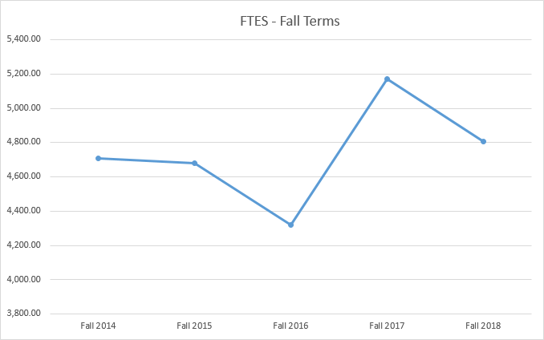Figure 1: FTES – Fall Terms
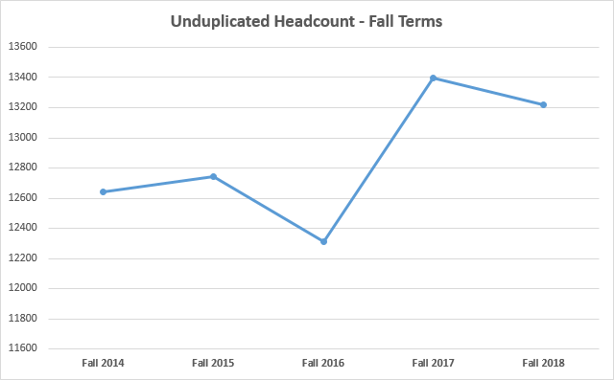
Figure 2: Unduplicated Head Count – Fall Terms
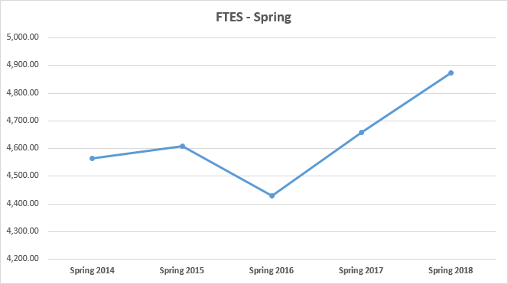Figure 3: FTES – Spring Terms
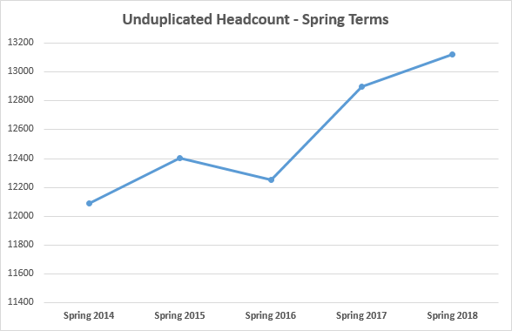Figure 4: Unduplicated Head Counts – Spring Terms
Figures 1-4 show enrollment trends by semester for FTES and Unduplicated Head Count. Fall enrollments rose sharply from 2016 to 2017 but declined slightly in 2018. Spring enrollments also rose sharply in 2016, and have continued to rise the past two years.

Table: First-Time Student Count
Fall Term | First-Time Student Count
2014 | 1,820
2015 | 1,923
2016 | 1,808
2017 | 1,902
2018 | 1,614
Five-Year Average | 1,813

https://datamart.cccco.edu/Students/Enrollment_Status.aspx
The table above includes first-time students of all ages. Approximately 75% of these students come from local feeder high schools within one year of graduation.

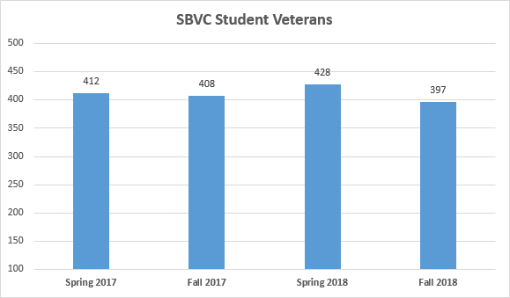Figure : SBVC Student Veterans

Labor Market Data

[insert response]

ACCJC data
Estimates

Demographic Data

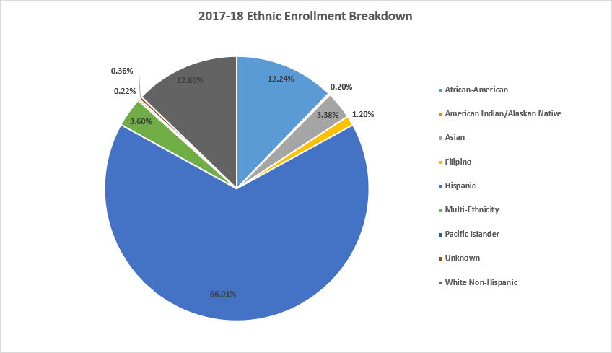Figure ?: 2017-2918 Ethnic Enrollment Breakdown

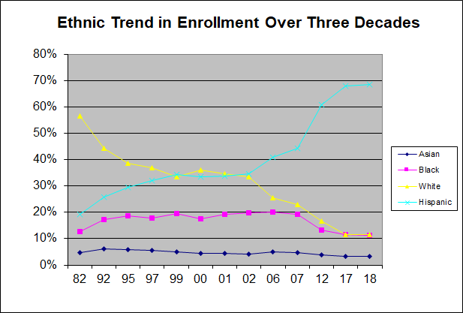
SBVC is a Hispanic Serving Institution with over 66% of students identifying as Hispanic. White Non-Hispanic and African-Americans make up just over 25% of the school population. American Indian/Alaskan Native, Asian, Filipino, Multi-Ethnic, Pacific Islander, and students who did not specify an ethnicity compose the remainder combined make up 9% of the student
Figure ?: Ethnic Trend in Enrollment Over Three Decades
Ethnic enrollment trends over the past three decades show a decline in enrollment of white students with a concurrent increase in the numbers of Hispanic students. Since 2003, the majority of student on campus are Hispanic students. In 2007 the African American student population began to decline, the African American population was stable from 2017 to 2018. The Asian population varies by a few percent each years.
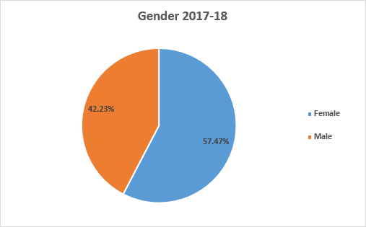
Figure ?: 2017-2018 Gender
SBVC’s student population is predominately female.
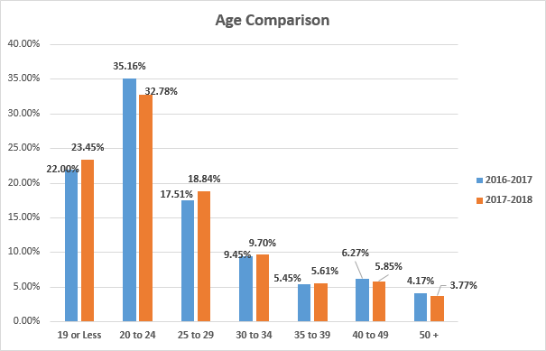Figure ?: Age Comparison
The majority of SBVC’s students range in age from 19-29, with the 20-24 age group, being dominate. 2017-2018 saw an increase in students 19 or less, and students in the 30-34, and 35-39 range.

Socio-economic Data
Table ? shows the demographics for the ZIP codes where approximately 80 percent of the SBVC students live. Many of them are characterized by lower household incomes and higher-than-average poverty rates. These demographics show how essential SBVC is to the community’s well-being.
Table ?: Top 25 ZIP Codes Where SBVC Students Resided in 2018-2019
Top 25 ZIP Codes Where SBVC Students Resided in 2018 – 2019

ZIP code | City | Percent of Students in this ZIP code | Median Household Income | Percent with less than a H.S. Degree | Percent with a Bachelor's Degree or higher | Percent below poverty level with less than a H.S. Degree* | Percent below poverty level with a Bachelor's Degree or higher*
92404 | San Bernardino | 8.9% | $42,051 | 18.59% | 13.85% | 36.2% | 6.5%
92407 | San Bernardino | 8.8% | $56,819 | 17.43% | 16.31% | 32.0% | 7.3%
92324 | Colton | 8.5% | $48,578 | 17.45% | 18.05% | 18.9% | 7.6%
92410 | San Bernardino | 7.7% | $27,383 | 27.56% | 5.71% | 40.7% | 14.0%
92376 | Rialto | 7.2% | $60,732 | 21.85% | 12.07% | 20.6% | 8.9%
92346 | Highland | 7.6% | $59,722 | 15.40% | 26.26% | 32.1% | 4.2%
92405 | San Bernardino | 4.3% | $38,762 | 19.74% | 12.11% | 35.6% | 12.5%
92411 | San Bernardino | 4.2% | $37,266 | 27.07% | 7.59% | 29.5% | 6.6%
92374 | Redlands | 3.0% | $67,606 | 9.88% | 39.24% | 37.3% | 5.0%
92335 | Fontana | 2.9% | $47,226 | 24.73% | 9.77% | 24.4% | 15.0%
92399 | Yucaipa | 2.3% | $58,570 | 8.85% | 29.57% | 29.6% | 4.5%
92336 | Fontana | 2.2% | $87,744 | 11.52% | 29.12% | 16.1% | 1.9%
92354 | Loma Linda | 2.0% | $54,877 | 8.76% | 72.85% | 29.0% | 10.1%
92316 | Bloomington | 2.0% | $53,648 | 25.24% | 12.58% | 22.1% | 5.6%
92373 | Redlands | 1.9% | $65,403 | 5.59% | 64.75% | 24.9% | 5.9%
92408 | San Bernardino | 1.8% | $38,949 | 25.35% | 19.71% | 38.5% | 12.5%
92377 | Rialto | 1.6% | $77,094 | 13.58% | 21.34% | 12.2% | 3.8%
92223 | Beaumont | 1.5% | $63,999 | 9.25% | 31.97% | 19.5% | 4.2%
92313 | Grand Terrace | 1.2% | $65,565 | 9.41% | 38.12% | 24.6% | 1.4%
92337 | Fontana | 1.0% | $76,046 | 14.06% | 19.69% | 8.6% | 2.1%
* Population 25 years and over |  |  |  |  |  |  | factfinder.census.gov

Table: Top Ten Feeder High Schools

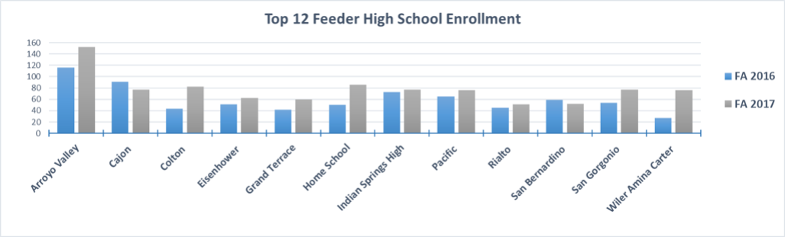Figure ?: Top 12 Feeder High School Enrollments

Figure ?: Top Five Feeder High Schools

Sites

[insert response]

Specialized or Programmatic Accreditation

[insert response]

Presentation of Student Achievement Data and Institution-set Standards

[see Chapter 5.3B and Appendix E of Guide to Institutional Self- Evaluation, Improvement, and Peer Review]

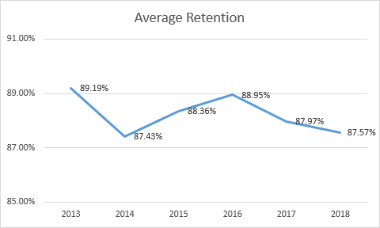
Figure : Average Retention

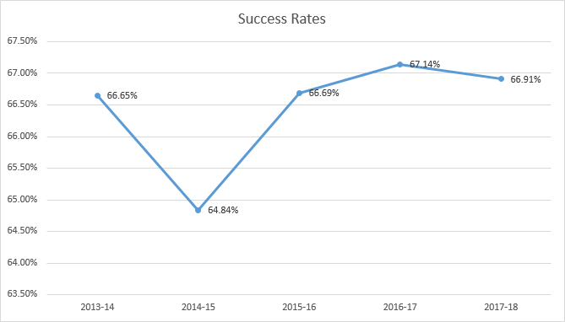Figure: Success Rates

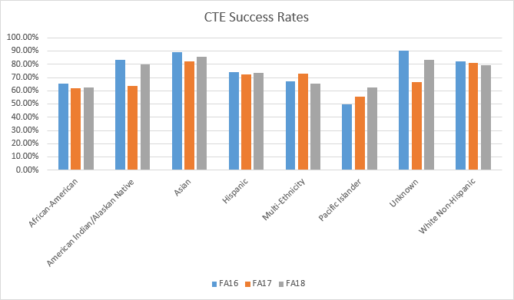Figure: CTE Success Rates
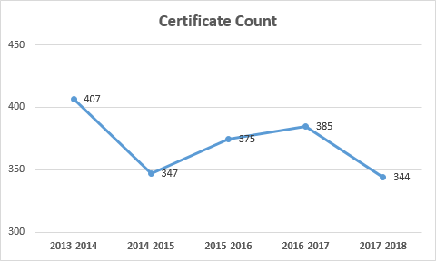
Figure : Certificate Count

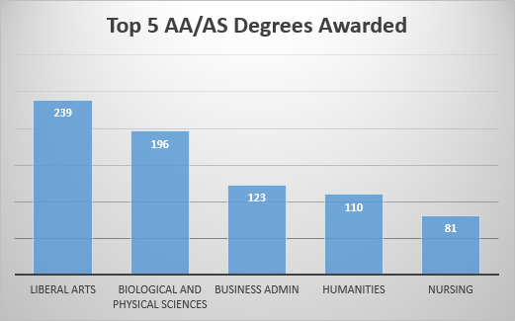
Figure : Top 5 AA/AS Degrees Awarded

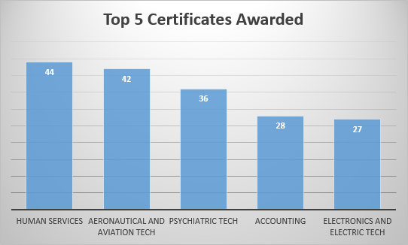Figure : \Top 5 Certificates Awarded

Table: CTE and Completion Success
Ethnicity | CTE | Program Completion
Overall | 50.3% | 36.7%
African-American | 51.9% | 33.0%
Asian | 52.2% | 65.4%
Filipino | 66.7% | 46.7%
Hispanic | 51.3% | 36.0%
Pacific Islander | 75.0% | 37.5%
White | 45.1% | 35.9%

CTE/ Program Completion (2016-17)
https://scorecard.cccco.edu/scorecardrates.aspx?CollegeID=982#home

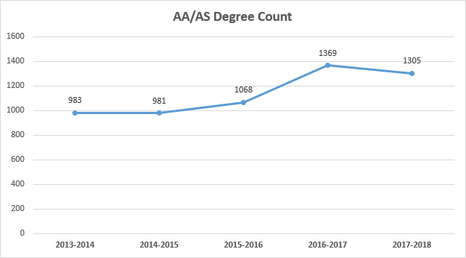Figure : AA/AS Degree Count

Organization of the Self-Evaluation Process

[insert response]

Organizational Information

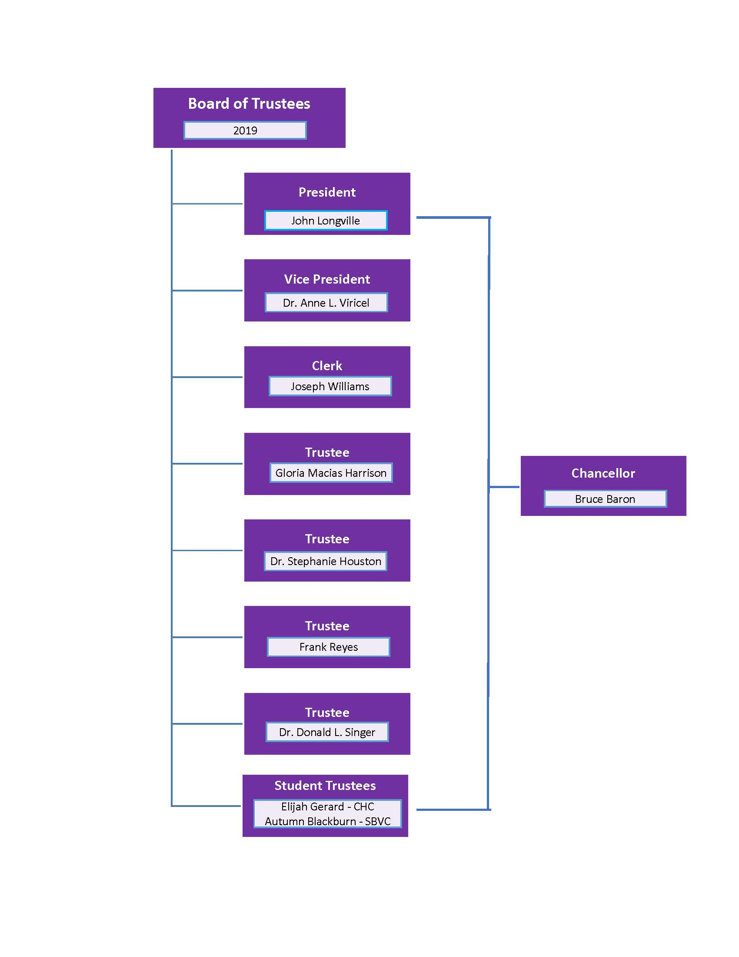
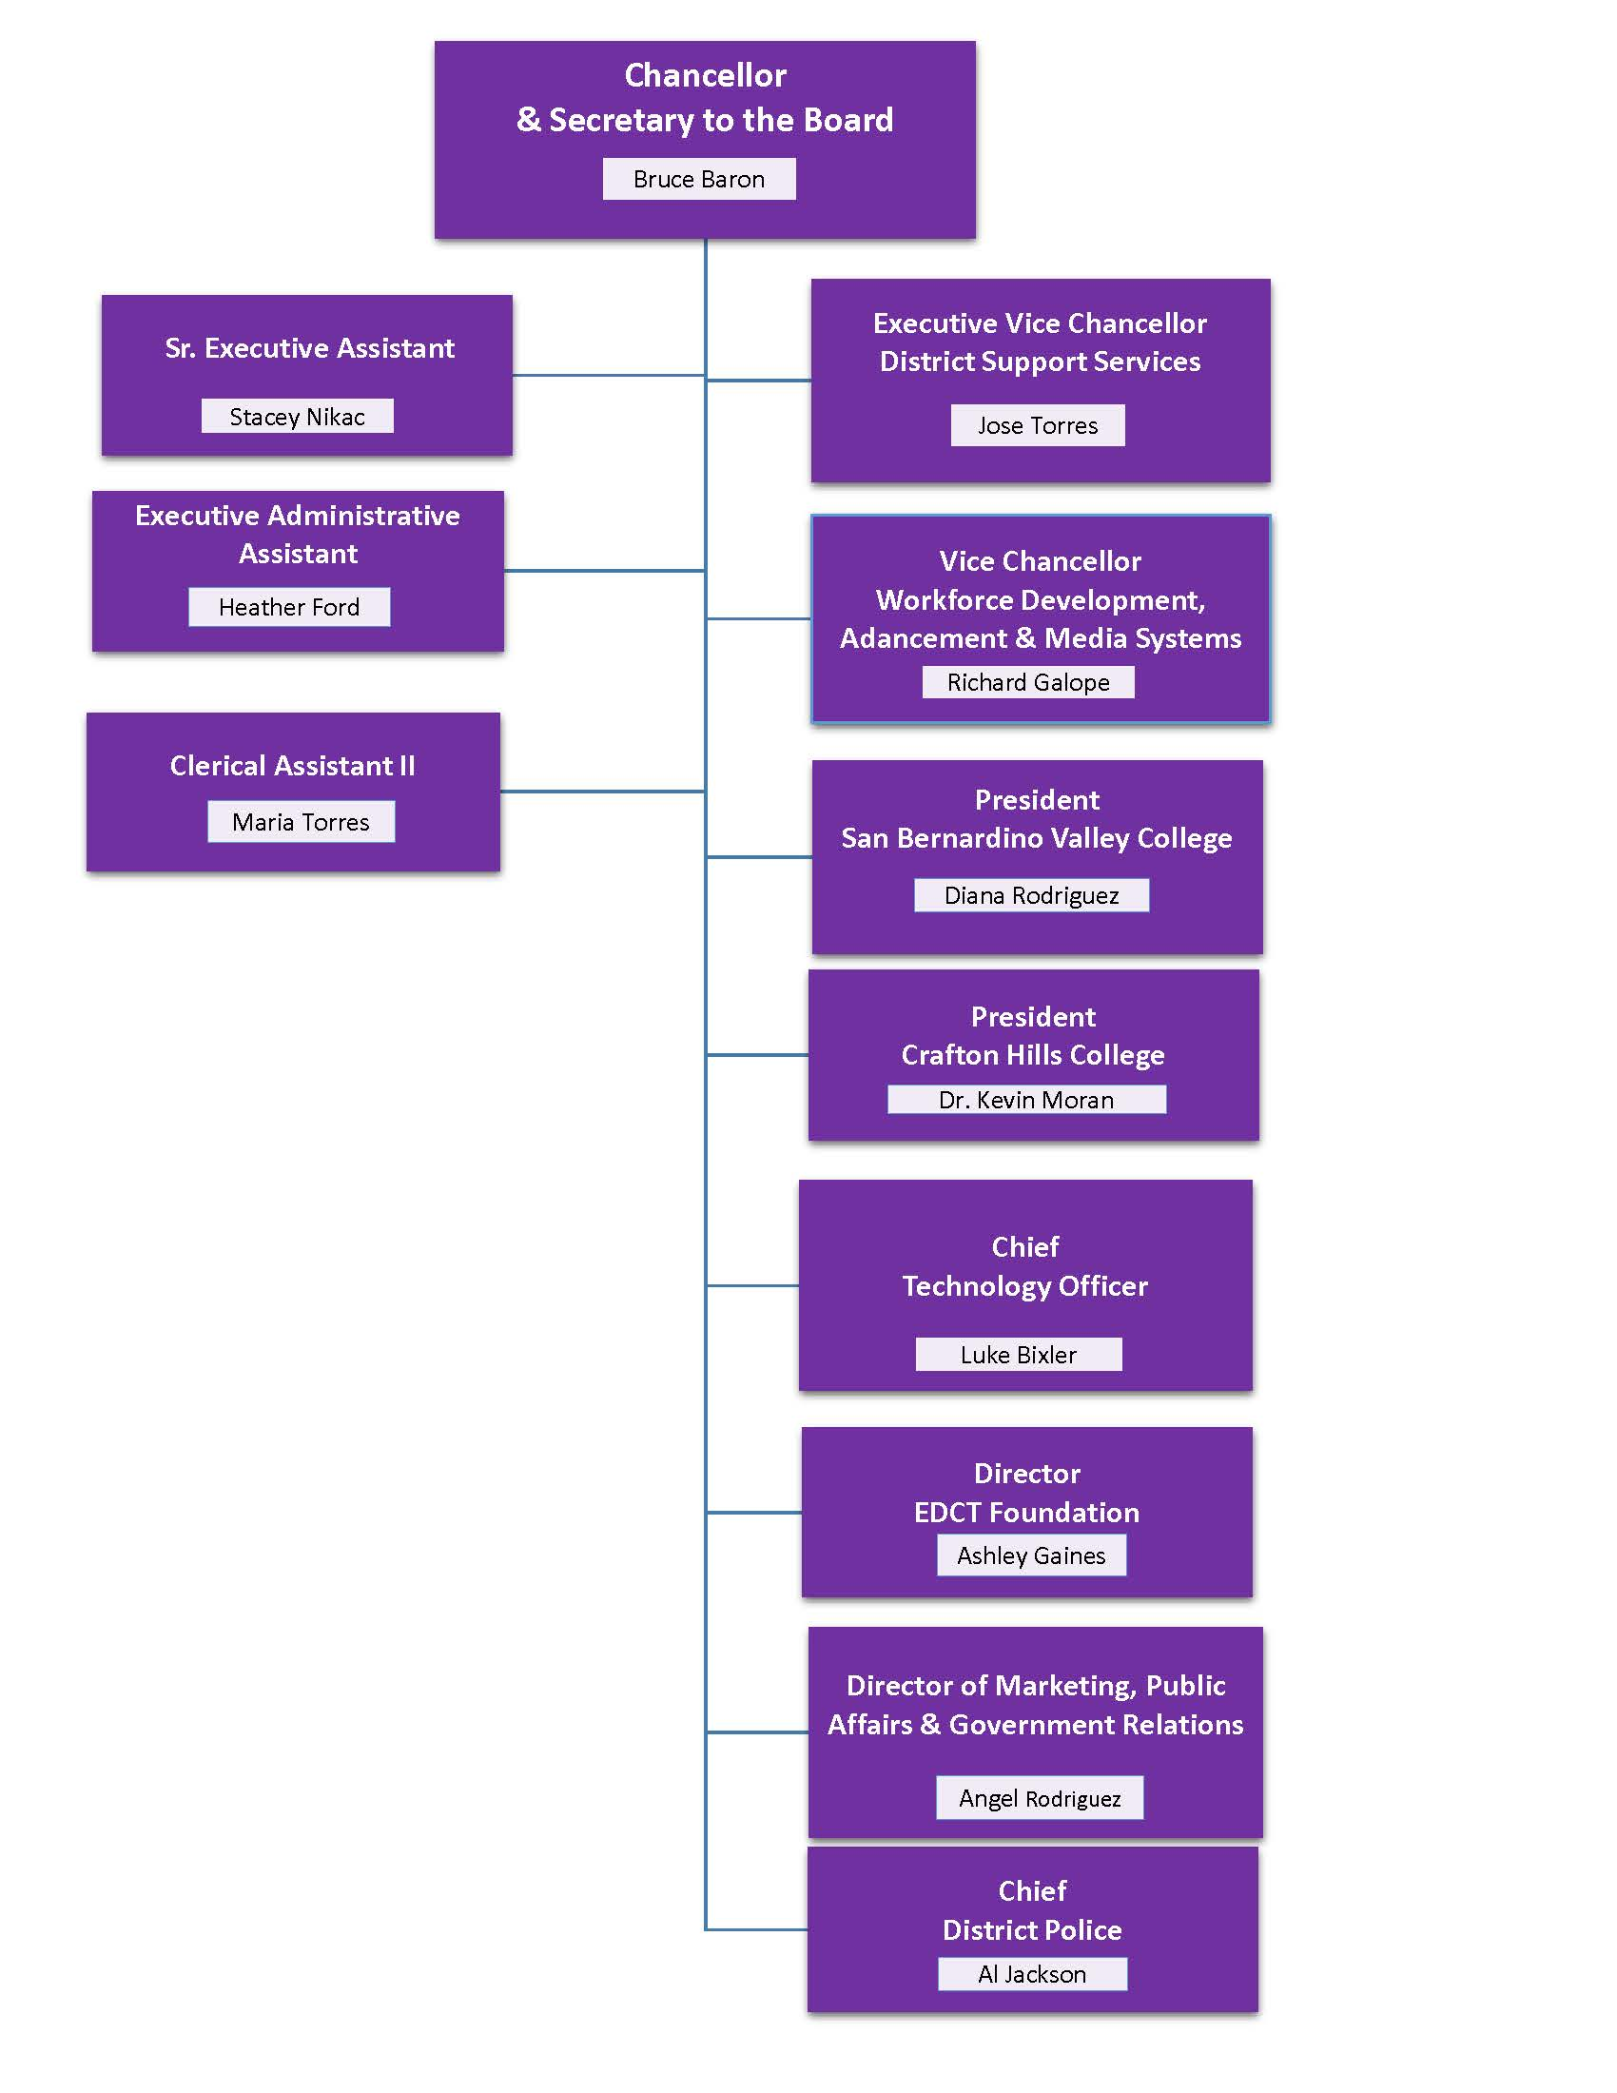
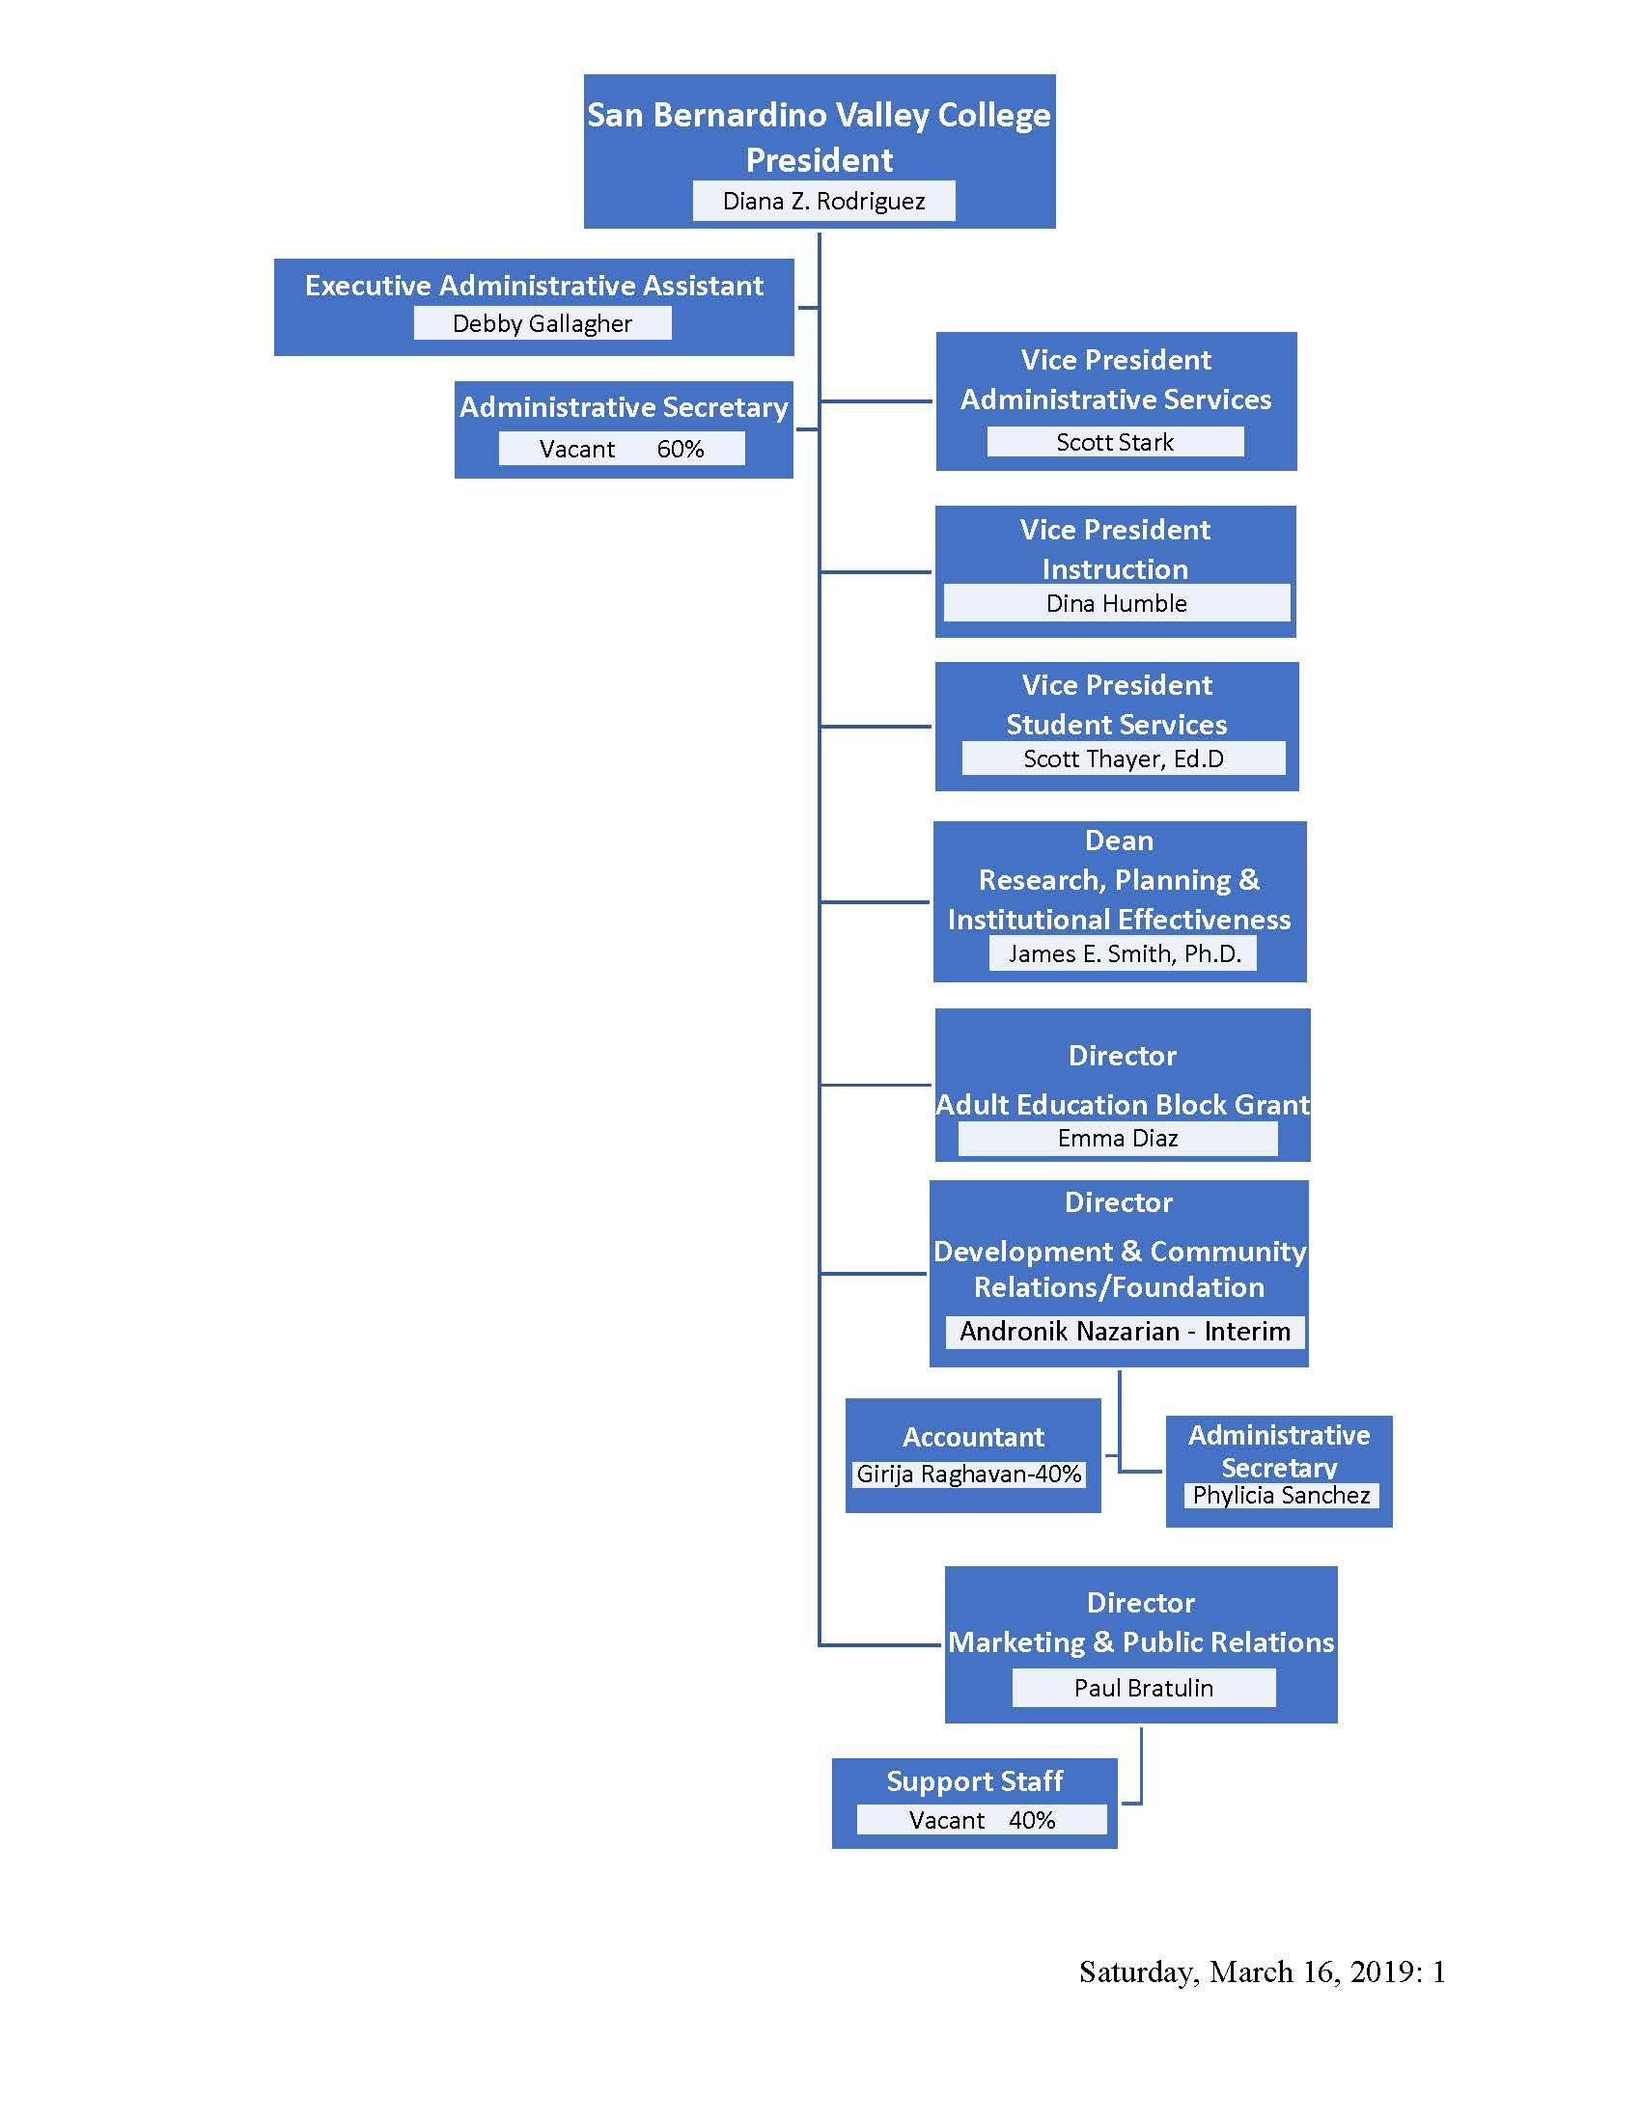
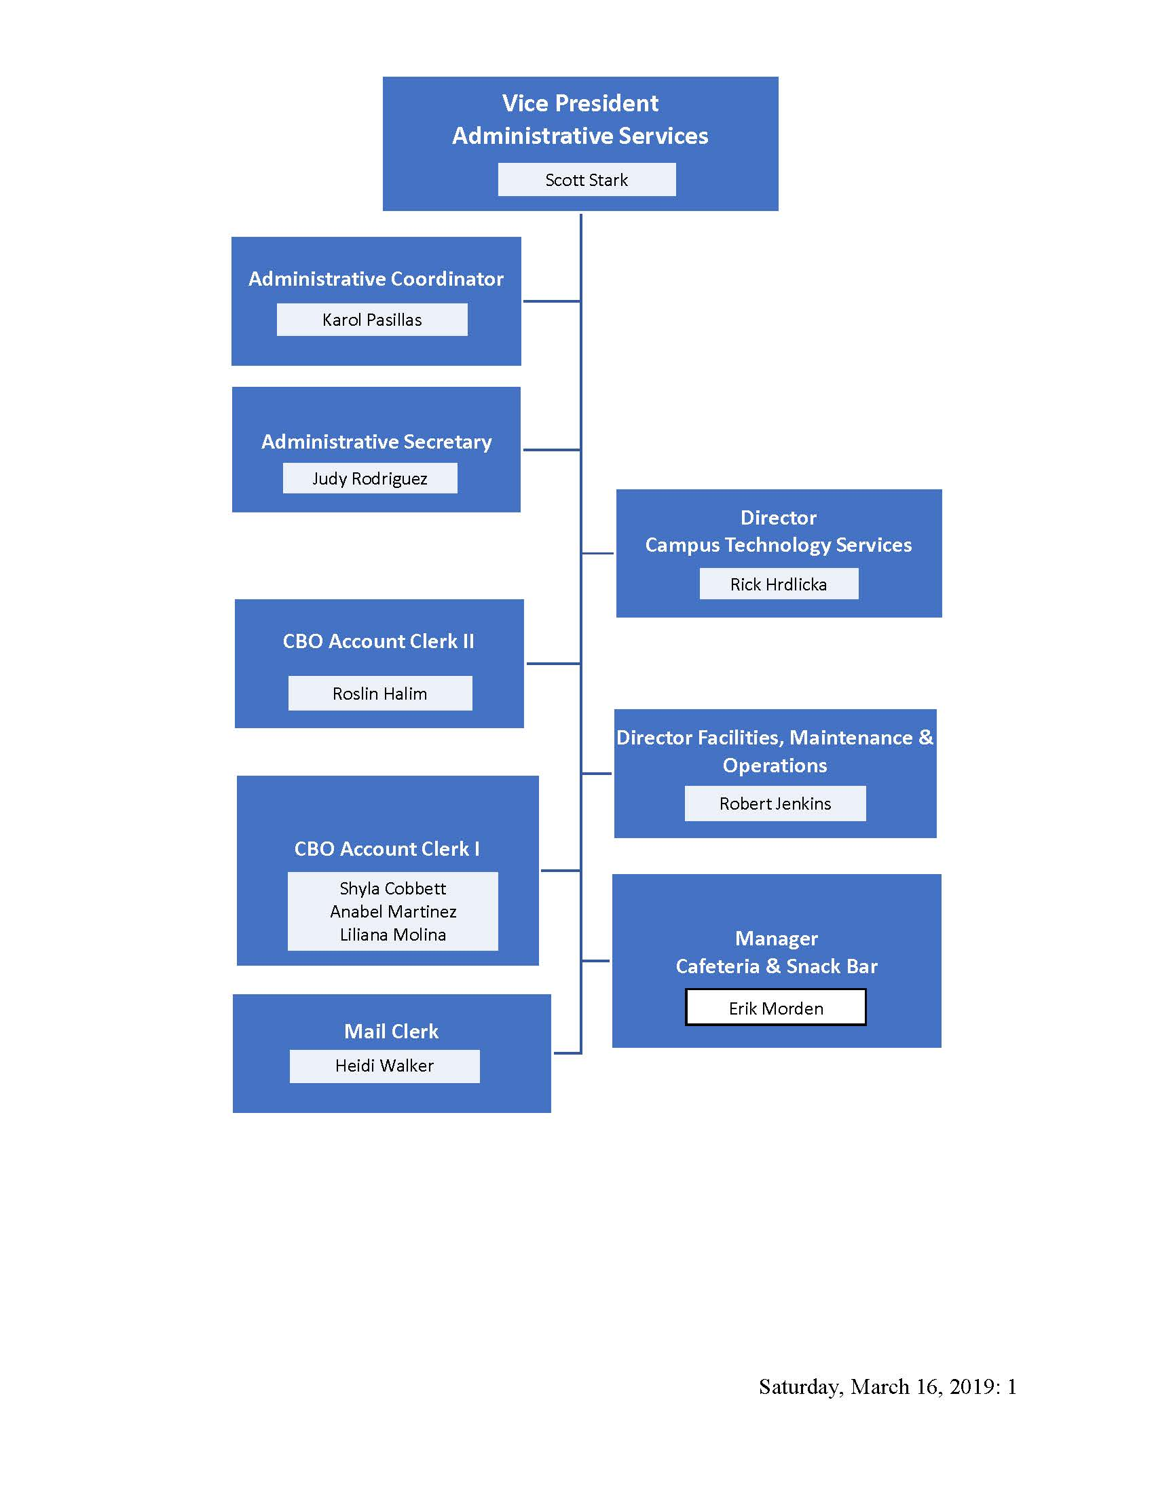
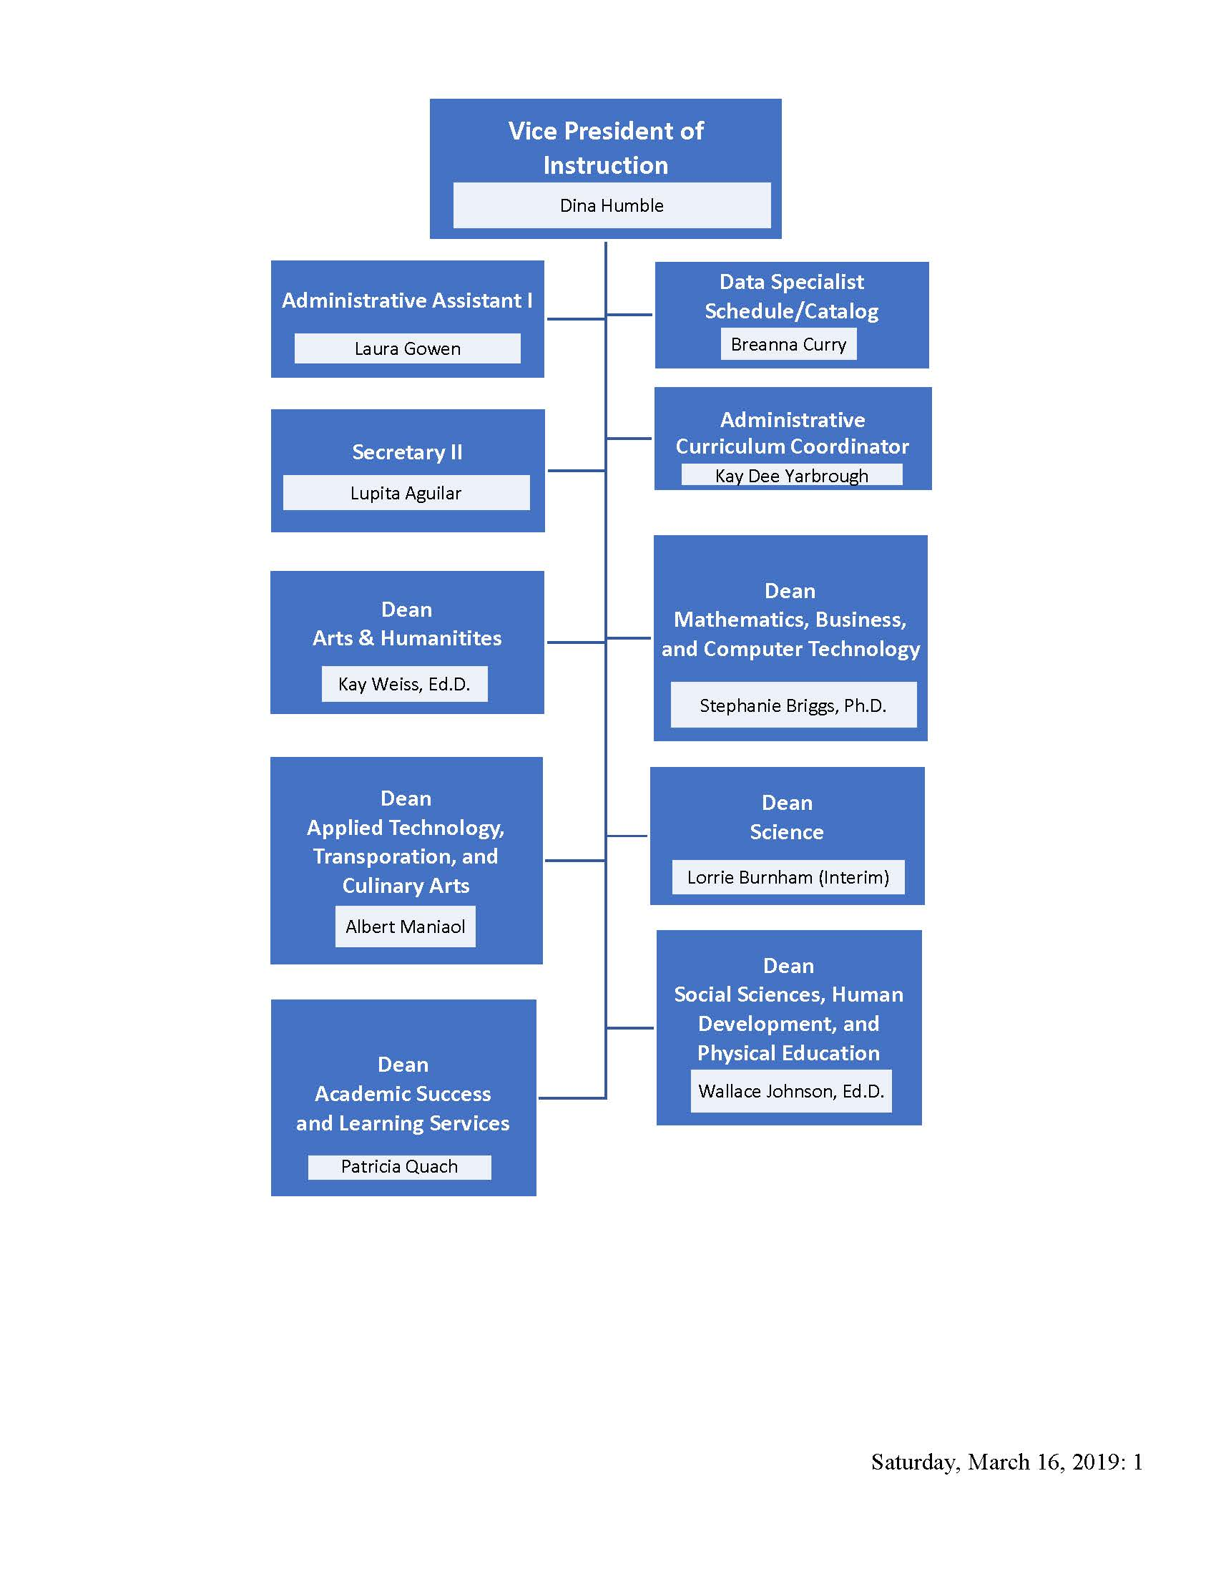
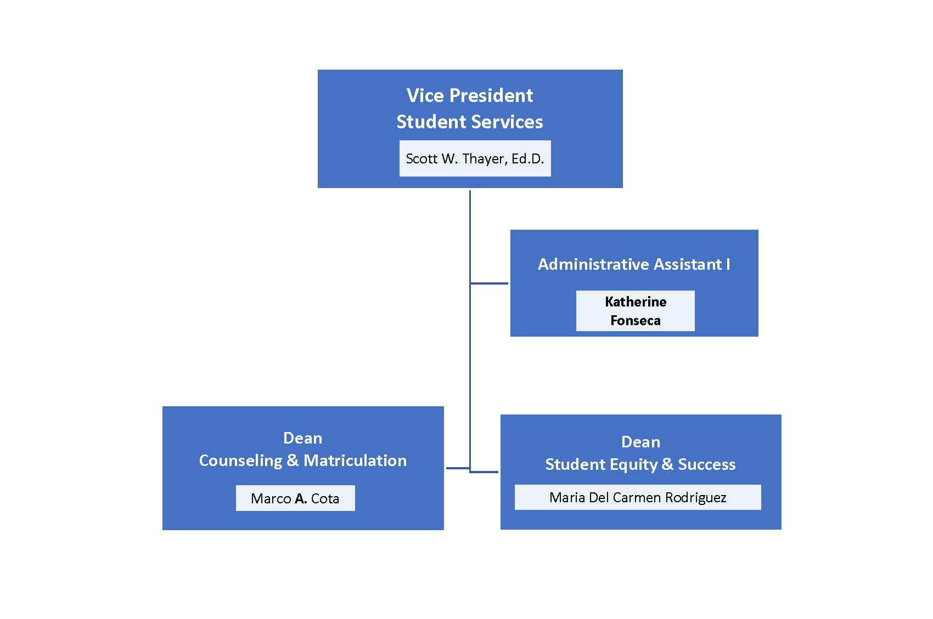

Certification of Continued Compliance with Eligibility Requirements

Eligibility Requirement 1: Authority
San Bernardino Valley College (SBVC) is a public two-year community college operating and awarding degrees and certificates under the authority of the State of California, the Board of Governors (BOG) of the California Community Colleges, and the Board of Trustees of the San Bernardino Community College District (SBCCD).
SBVC is accredited by the Accrediting Commission for Community and Junior Colleges (ACCJC) of the Western Association of Schools and Colleges (WASC). This organization is recognized by the Council on Postsecondary Accreditation and the U.S. Department of Education (USDE).
SBVC also offers programs accredited by the California State Board of Registered Nursing and the National League for Nursing Accrediting Commission.

Eligibility Requirement 2: Operational Status
SBVC is a comprehensive college that meets the educational needs of its community. It offers a wide range of academic and vocational programs leading to degrees, certificates, transfer to four-year colleges and universities, career advancement, job training, lifelong learning, and personal enrichment in support of both its mission and the mission of the California Community College System (CCCS). SBVC has been in continuous operation since 1926.

Eligibility Requirement 3: Degrees
SBVC offers programs leading to 66 Associate of Arts (AA) and Associate of Science (AS) degrees, including 19 Transfer (AS-T and AA-T) degrees and 88 State approved, locally approved and non-credit certificates (effective fall 2018). Most courses satisfy the requirements for either majors or general education (GE).

Eligibility Requirement 4: Chief Executive Officer
Ms. Diana Z. Rodriguez has served as the president of SBVC since her appointment by the Board of Trustees effective July 1, 2016. She does not serve on the Board of Trustees.

Eligibility Requirement 5: Financial Accountability
Annual financial audits are conducted by externally contracted certified public accountants. These audits are reviewed by the Board of Trustees. SBCCD’s business manager provides the financial audit for interested stakeholders.

Certification of Continued Institutional Compliance with Commission Policies

San Bernardino Valley College certifies that it continues to be in compliance with the federal regulations noted below, and Commission Policies on Rights and Responsibilities of the Commission and Member Institutions; Institutional Degrees and Credits; Transfer of Credit; Distance Education and on Correspondence Education; Representation of Accredited Status; Student and Public Complaints Against Institutions; Institution Advertising, Student Recruitment, and Representation of Accredited Status; Contractual Relationships with Non-Regionally Accredited Organizations; and Institutional Compliance with Title IV.

Public Notification of an Evaluation Team Visit and Third Party Comment
Regulation citation: 602.23(b).

[Provide very brief narrative and accompanying links to evidence. If applicable, cite and hyperlink to the standards in your report where more detailed narrative and additional evidence can be found.]

Standards and Performance with Respect to Student Achievement
Regulation citations: 602.16(a)(1)(i); 602.17(f); 602.19 (a-e).

[Provide very brief narrative and accompanying links to evidence. If applicable, cite and hyperlink to the standards in your report where more detailed narrative and additional evidence can be found.]

Credits, Program Length, and Tuition
Regulation citations: 600.2 (definition of credit hour); 602.16(a)(1)(viii); 602.24(e), (f); 668.2;
668.9.
Academic credit is given in semester units based on the Carnegie Unit Value (CUV) system and Title 5 of the California Code of Regulations (CCR) minimum standards. One credit hour of work is equivalent to one hour of lecture or three hours of laboratory per week based on a term of 18 weeks. Information regarding academic credit is published in SBVC’s catalog.
SBVC complies with this policy. The college conforms to the 60-unit semester credit-hour standard. Requirements are on page 33 in the College Catalog. Graduation requirements for the AA degree have the following criteria:
- A student must complete 60 units of degree-applicable work with an overall grade point average (GPA) of C (2.0) or higher in all courses.
- Depending on the major, a student must achieve a grade of C or higher in each course to be counted for the major. Courses completed for a Certificate of Achievement that also fulfill requirements for an AA degree must be completed with a grade of C or higher.
- For associate degrees for transfer, a student must complete a minimum of 18 semester units in the major or area of emphasis.
SBVC ensures that a credit hour meets accepted academic expectations through BP/AP4020 Program and Curriculum Development. The definition of a credit hour is on page 10 of SBVC’s catalog. SBVC has established procedures to ensure that curriculum complies with the definition of “credit hour” or “clock hour,” where applicable. SBVC’s Curriculum Committee ensures that a credit hour meets accepted academic expectations. SBVC complies with the ACCJC’s assessment of clock-to-credit-hour conversion formula.
Transfer Policies
Regulation citations: 602.16(a)(1)(viii); 602.17(a)(3); 602.24(e); 668.43(a)(ii).

[Provide very brief narrative and accompanying links to evidence. If applicable, cite and hyperlink to the standards in your report where more detailed narrative and additional evidence can be found.]

Distance Education and Correspondence Education
Regulation citations: 602.16(a)(1)(iv), (vi); 602.17(g); 668.38.
Distance education (DE) offerings at SBVC do not alter or supplant the mission of the College; those offerings are a way of advancing SBVC’s mission by using technology to increase student access to quality education and services that support a diverse community of learners. One of SBVC’s strategic direction and goals—initiatives that grow out of the mission—is “access”. Thus, there is a clear correspondence between the mission of SBVC, its strategic goals, and the existence of courses approved for DE delivery (0.2).

All courses are the same in content, rigor, and quality, no matter what the mode of delivery as the course outline of record. SBVC requires that all courses proposed for DE delivery be separately reviewed and approved by the Curriculum Committee, a standing committee of the Academic Senate, before being forwarded to the Board of Trustees for final approval.

Student Complaints
Regulation citations: 602.16(a)(1)(ix); 668.43.
The College Catalog provides information on major policies affecting students on pages 30-31 of the 2018-2019 college catalog. This information can also be found on the SBVC website. SBVC affirms its policy to provide fair and equitable treatment to students and employees in an effort to prohibit discrimination on the basis of ethnic group identification, national origin, religion, age, gender, race, color, ancestry, sexual orientation, physical or mental disability, or retaliation.
SBVC is committed to nondiscrimination. The nondiscrimination policy can be found on page 17 of the College Catalog. SBVC’s goal is to provide equal opportunities for all community members in all areas of the College, including admission, student financing, student support facilities and activities, and employment. Federal laws and SBCCD policies strictly prohibit all types of discrimination, including sexual harassment and inequities based on race, color, religion, gender, age, marital status, physical disabilities, mental impairments, or sexual orientation. SBVC is further committed to overcoming gender discrimination and gender stereotyping in vocational education programs. In addition, the lack of English language skills will not be a barrier to admission and participation in vocational education programs. Information regarding SBCCD’s Unlawful Discrimination and Sexual Harassment policies and forms are located on SBCCD’s website, as are SBCCD’s Informal and Formal Complaint Forms that SBVC uses to intake and track student complaints. The complaint forms and related policies are located in the human resources area of SBCCD’s website (4.30).
Students are encouraged to resolve complaints at the appropriate level of the dispute. Any student complaint about a grade, instructor, or course should be first made to the instructor involved. However, should this approach fail or be inappropriate, students may submit a written complaint through the faculty chair or the division dean, or students may use SBCCD’s Informal and Formal Complaint Forms. Once received, the complaint is forwarded to the appropriate College official for review, and the complaint will receive a response as soon as possible. For matters regarding grade appeals, student grievances, discrimination, or sexual harassment, please refer to SBVC’s policies relating to those matters. The student complaint process is currently being updated. For more information on the student complaint process, please refer to the SBCCD BP5530 Student Rights and Grievances.
Sexual harassment of students or employees in the academic and work environments violates both federal and state law and District policy, and it will not be tolerated. It also violates the law and policy to retaliate against any individuals for filing a complaint of sexual harassment or for participation in the investigation or resolution of a formal or informal written or oral complaint of sexual harassment. Unlawful harassment on the basis of sex includes, but is not limited to, classroom conditions, grades, academic standing, scholarships, recommendations, employment opportunities, disciplinary action, or any other aspects of college life within the control of SBCCD.
The policy on sexual harassment can be found on the SBVC website

Institutional Disclosure and Advertising and Recruitment Materials
Regulation citations: 602.16(a)(1))(vii); 668.6.
Evaluation Items:
SBVC complies with this policy through the College Catalog, class schedules, College’s website, and other forms of social media. SBVC uses several forms of institutional advertising to ensure integrity and responsibility in marketing, student recruitment, and representation of the College’s accredited status to prospective and current students. The following list is an overview of how SBVC promotes its educational programs on and off campus:
A. Advertising, Publications, and Promotional Literature
SBVC utilizes the College Catalog and class schedules, which are available in print and electronic formats, to inform the public of its educational programs and services. These publications are clear and updated electronically to ensure that they are factually accurate. The College Catalog and class schedules offer information on SBVC’s education program and display the regulatory and enrollment information.
The catalog is revised and reissued every year. The catalog is available in print and online. Catalog Addendums are published online as necessary.
is available online.

B. Student Recruitment for Admissions
SBVC relies on qualified faculty and staff who are knowledgeable about the College’s admissions policies and procedures for financial aid. The Outreach and Recruitment Office is the primary recruitment unit on campus. The Outreach and Recruitment Office’s objective is to provide prospective and current students with access to SBVC through recruitment and outreach efforts in the local community. The Outreach and Recruitment Office disseminates admissions information, major sheets, and other SBVC information at feeder high schools and community events. Under the direction of the outreach coordinator, trained student ambassadors serve as representatives at college fairs, community events, and high school visits. Together, the outreach coordinator and student ambassadors work to assist current and prospective students with admissions and successfully transitioning into college.
The campus website includes information on gainful employment for degrees and certificates. Gainful employment information includes program costs, licensure rates, and links to the occupational summary on O*.net.
C. Representation of ACCJC Accredited Status
SBVC maintains its accreditation status and informs the public of accreditation activities via the SBVC website. The current accreditation status with the ACCJC is also published in the College Catalog Additionally, the College Catalog includes statements that “SBVC’s Nursing Program is approved by the California Board of Registered Nursing and accredited by the Accreditation Commission for Education in Nursing”.
`
Title IV Compliance
Regulation citations: 602.16(a)(1)(v); 602.16(a)(1)(x); 602.19(b); 668.5; 668.15; 668.16; 668.71 et seq.

[Provide very brief narrative and accompanying links to evidence. If applicable, cite and hyperlink to the standards in your report where more detailed narrative and additional evidence can be found.]

Institutional Analysis

Standard I: Mission, Academic Quality and Institutional Effectiveness, and Integrity

The institution demonstrates strong commitment to a mission that emphasizes student learning and student achievement. Using analysis of quantitative and qualitative data, the institution continuously and systematically evaluates, plans, implements, and improves the quality of its educational programs and services. The institution demonstrates integrity in all policies, actions, and communication. The administration, faculty, staff, and governing board members act honestly, ethically, and fairly in the performance of their duties.

I.A Mission

I.A.1 The mission describes the institution’s broad educational purposes, its intended student population, the types of degrees and other credentials it offers, and its commitment to student learning and student achievement. (ER 6)

Evidence of Meeting the Standard

The mission of SBVC “San Bernardino Valley College maintains a culture of continuous improvement and a commitment to provide high-quality education, innovative instruction, and services to a diverse community of learners. Its mission is to prepare students for transfer to four-year universities, to enter the workforce by earning applied degrees and certificates, to foster economic growth and global competitiveness through workforce development, and to improve the quality of life in the Inland Empire and beyond.”

The mission describes the campuses broad educational purpose which includes providing students the opportunity to earn certificates and degrees, transfer to four-year institutions, job readiness, workforce development, and improve quality of life.

The mission describes the student population as diverse learners in the Inland Empire, as evidence by the student demographics in the introduction,

The mission describes the types of Degrees and Credentials available at the college; certificate, degree, transfer degrees. A full list of degrees and certificates is available on the SBVC Website and in the SBVC Catalog [Pages 41-43 of the 2018-2019 Catalog][.pdf of website]

The mission describes SBVC’s commitment to student learning and achievement as providing a high quality education and services, using innovative instruction and services, and dedication to continuous quality improvement as evidenced in SBVC’s Curriculum, Program Review, and Outcomes processes which are fully described in Standards I.B and II.A.

Analysis and Evaluation

The campus mission statement includes all elements described in Standard I.A.1.

I.A.2 The institution uses data to determine how effectively it is accomplishing its mission, and whether the mission directs institutional priorities in meeting the educational needs of students.

Evidence of Meeting the Standard

The Office of Research Planning and Institutional Effectiveness provides the campus with ample data that demonstrates how successfully the campus is achieving its mission.

“San Bernardino Valley College maintains a culture of continuous improvement and a commitment to provide high-quality education, innovative instruction, and services to a diverse community of learners. Its mission is to prepare students for transfer to four-year universities, to enter the workforce by earning applied degrees and certificates, to foster economic growth and global competitiveness through workforce development, and to improve the quality of life in the Inland Empire and beyond.”

Traditional data on success, retention, completion, transfer, outcomes, and institution set standards informs campus success on its mission to prepare students for transfer, and prepare students for the workforce by earning certificates and degrees. This data is also used in Program Review (see I.B.5) to improve the quality of instruction and services to students at SBVC.

The use of data to create a campus culture of continuous improvement can be observed through Program Review processes, SBVC Strategic Goals and Objectives, and in presentations at campus and community meetings. Campus Climate Survey data bring in the student perspective. Dissemination and analysis of data is ongoing. Campus and community feedback guides innovation and improvement.

SBVC’s student demographic, socio-economic, feeder high school and zip code data clearly demonstrates that the campus serves a diverse community of learners in the Inland Empire, and beyond. Data is used to inform decisions such as offering dual and concurrent enrollment, developing Generation Go a workforce readiness non-credit certificate, and growing an equity minded culture. Data from Research, Planning and Institutional Effectiveness, Strong Workforce and environmental scan, supports program growth and workforce development. Baking, Cyber Security, Sterile Process, Pharmacy Technician and Workforce Readiness are among the new or developing programs that have been established to meet industry needs.

Analysis and Evaluation

The Office of Research Planning and Institutional Effectiveness (RPIE) maintains a website containing comprehensive local, state, and national data that is relevant to the institution and its mission. The Office’s mission, like the campus mission focuses on continuous improvement and achievement.

“The mission of Research, Planning and Institutional Effectiveness is to provide leadership for continuous improvement of academic achievement and institutional excellence by coordinating the college's planning and accreditation processes, offering opportunity and support for the professional development of employees, assisting members of the college community with program evaluation, and providing data to support decision-making.”

RPIE habitually uses data to create reports and inform campus processes, for example;
- EMP One-Sheets support and inform needs assessment
- Campus Climate Reports informs Service Area Outcomes
- State Certification pass rates information student success and workforce readiness
- Strategic Goals and Objectives informs program review
- Success data and research briefs inform quality of instruction and services

Additionally RPIE regularly;
- Creates data based reports and presentations for the Campus, Board of Trustees, and Community Meetings.
- Tracks and reports on the success of cohort groups such as Valley Bound, EOPS, and College Promise.
- Tracks, reports, and shares data for the ACCJC Annual report including Institution Set-Standards

RPIEs systematic data collection, reports and presentations, contain the depth and breadth needed to fully evaluate how effectively the campus is achieving its mission.

I.A.3 The institution’s programs and services are aligned with its mission. The mission guides institutional decision-making, planning, and resource allocation and informs institutional goals for student learning and achievement.

Evidence of Meeting the Standard

The SBVC Planning Model demonstrates the importance of the mission as its base. The SBVC Strategic Goals and Objectives and the SBVC Educational Master Plan (EMP) were formulated using the mission statement as the foundation. The Strategic Goals and Objectives identify six themes that link the mission to planning. These Strategic Goals and Objectives drive and inform the campus program review process. The SBVC Facilities Master Plan (FMP) and the SBVC Technology Strategic Plan also stem from the mission. The latter also aligns with the strategic initiatives and goals.

Program review requires divisions/departments to demonstrate their role in the mission of SBVC. Program review has two phases: needs assessment in the fall and program efficacy in the spring. Each requires evidence of addressing the SBVC mission within program documents. Programs can only participate in needs assessment if their past program efficacy received a rating of “continuation” or “conditional”.

In program efficacy, programs are asked to respond to the statement, “The program has a mission, and it links clearly with the institutional mission.” Responses are evaluated to see if they meet or do not meet the rubric. Both needs assessment and program efficacy are linked to SBVC’s strategic planning in that programs must identify which strategic initiatives they are working to achieve.

Institutional planning uses the documents from program review (See I.B.5) to guide decision making. Program Review recommends and prioritizes growth positions for faculty and classified professionals as well as equipment, technology, facilities and budget needs. Needs Assessment results are used in College Council to distribute one-time funding.

Analysis and Evaluation

The mission of San Bernardino Valley College is to focal point for all planning activities on campus. SBVC Strategic Goals and Objectives support the campus mission. The campus embeds the mission, goals, and initiatives in its planning model, program review process, and major campus documents.

I.A.4 The institution articulates its mission in a widely published statement approved by the governing board. The mission statement is periodically reviewed and updated as necessary. (ER 6)

Evidence of Meeting the Standard

SBVC’s mission statement appears on all major publications including but not limited to the College Catalog, Schedule of Classes, Educational Master Plan, and Campus Website. The mission appears on recruiting materials, campus flyers, and division/department publications. The campus mission is embedded into the campus Program Review and Needs Assessment processes. An email signature generator that includes the mission statement is available to all campus employees.

The campus mission statement was collegially developed and approved by the Board of Trustees on 3/10/16 and is periodically reviewed by major campus committees.

Analysis and Evaluation

The SBVC mission statement is approved by the Board of Trustees and is widely distributed to the campus community. The mission statement is periodically reviewed by campus constituencies.

Conclusions on Standard I.A. Mission

SBVC’s mission statement is broadly disseminated and shows the campus commitment to student learning and achievement. Campus decision making process are tied to the mission of the college. The campus collects and analyzes, data that reflects the values stated in the campus mission. The campus applies knowledge gained from data analysis to improve instruction and support services and create a culture of continuous improvement.

Improvement Plan(s)

[insert response if applicable]

Evidence List

SBVC Mission Statement -Website
SBVC Mission Statement – Catalog
SBVC Degrees & Certificates Offered – Catalog
SBVC Degrees and Certificates Offered – Website (OUT OF DATE!)
Office of Research Planning and Institutional Effectiveness Website (Home Page; Reports Page)(Question: Can ‘support of campus mission’ be added to RPIE mission statement/)
EMP One-Sheets
Strategic Goals and Objectives
Program Review
SBVC Planning Model
Campus Climate Reports
ILOs/SLOs/PLOs
Institution Set-Standards
EMP
Annual Strategic Planning Worksheet
Research Brief – Fall 16
Reports – Student Support Groups
Presentations – Campus and Community Meetings
Generation Go Workforce Readiness Non-Credit
Strong Workforce Data – Baking
Facilities Master Plan
SBVC Technology Strategic Plan
Program Efficacy
Needs Assessment
College Council Minutes – Needs Assessment
Needs Assessment Faculty Prioritization and hiring English when Reading game up position
Representative Sample of College Publications not already in evidence with SBVC Mission
Email Signature Generator Email
Board of Trustee Minutes 3/10/16
Representative Sample of Minutes which include review of mission

I.B Assuring Academic Quality and Institutional Effectiveness

Academic Quality

I.B.1 The institution demonstrates a sustained, substantive and collegial dialog about student outcomes, student equity, academic quality, institutional effectiveness, and continuous improvement of student learning and achievement.

Evidence of Meeting the Standard

San Bernardino Valley College continually engages in substantive dialogue in an atmosphere of mutual respect.

Student outcomes (SLOs/PLOs/ILOs) are discussed at the department, and division level, in the ASLO Committee, Academic Senate, College Council, and at all faculty/campus meetings and through professional development activities.

Dialog on student equity is prevalent throughout the campus. In 2016/2017 SBVC hosted a series of off campus workshops on cultural competency and strategic planning that focused on equity, access, and success and facilitated by Rondine Macadaeg from Elevate Tomorrow.

In August 2019 a team of 9 faculty and one administrators attended the workshop Equity in the Classroom presented by USC Rossiter School of Education, Center for Education. The ‘CUE Team’ as they call themselves, presented information at the Academic Senate Retreat and at the all faculty meeting on opening day. The CUE Team continues to meet and brainstorms ways to facilitate equity awareness.

Preparation of the Basic Skills Plans, SSSP Plans, and Student Equity Plans involve dialog in planning committees, governance committees, District, and Boar of Trustees. Additionally the development of these plans encourages dialog between SBVC and their sister campus Crafton Hills College (CHC).

Dialog around academic quality, institutional effectiveness, and continuous improvement of student learning and achievement takes place at all levels of the campus and the district. For example dialog takes place;
- Through developing major planning documents such as the Educational Master Plan, Strategic Goals and Objectives, and Facilities Master Plan
- When developing grant applications
- Through the use of EMP Sheets
- Through targeted research and analysis such as development an analysis of assessment cut scores, and the success and achievement of cohort groups.
- In governance and planning meetings

Dialog regarding student outcomes, student equity, academic quality, institutional effectiveness, and continuous improvement of student learning and achievement culminates in our Program Review process which is discussed in detail later in this standard.

Further evidence of dialog on student equity, academic quality, institutional effectiveness, and continuous improvement of student learning and achievement includes; trainings from ASCCC on AB705 and Guided Pathways, Dr. Vincent Tinto spoke on student persistence and completion on opening day Fall 2016, Rondine Macadaeg spoke on cultural competency in Fall 2017.
Dr. Wood presented Teaching Men of Color at the all faculty meeting on opening date Fall 2018, Dr. Harris provided follow up training on use of Teaching Men of Color modules in Spring 2019 and in August 2019 a team of 9 faculty and one administrator attended a two day workshop on equity-mindedness in the classroom that was facilitated by the USC Rossier School of Education, Center for Urban Education.

Analysis and Evaluation

SBVC has a robust governance and committee structure as detailed in AP2510 Collegial Consultation which is inclusive all constituency groups with representatives from administration, classified professionals, and faculty included in the committee membership. Student representatives are included on major committees such as College Council, Curriculum, Program Review and ALSO Committee. Community input is sought through Advisory Groups, Focus Groups, and Bi-Annual Community meetings. District and campus leaders have initiated discussion regarding providing students with small stipend to attend campus meetings and search committees to inspirer greater participation. All campus governance and planning meetings are open to the public. The campus communication model shows how dialog and dissemination of information takes place. The SBVC Planning Model further supports that planning and dialog is centered on the campus mission and strategic goals and objectives.

I.B.2 The institution defines and assesses student learning outcomes for all instructional programs and student and learning support services. (ER 11)

Evidence of Meeting the Standard

Learning Outcomes (SLOs/PLOs/ILOs/SAOs) are under the purview of the faculty and processes for the establishment, assessment, and evaluation of outcomes are included in the charge of the ASLO Committee whose membership is comprised of all campus constituencies.

Outcomes for non-administrative areas are written by discipline faculty. In 20XX the establishment of instructional outcomes was moved from an independent process and aligned with the curriculum process. Instructional outcomes are created when a new course or program is established through the campus curriculum process. SLOs are a part of the course outline of record and appear on class syllabi. PLOs are listed in the catalog (?). Changes to SLOs or PLOs are made through the Content Review Process.

In 20XX the ASLO Committee developed the SLO Rubric to provide discipline faculty guidance, which was adopted by the Academic Senate. As part of the curriculum process SLOs and PLOs are review by faculty serving on the ASLO Committee. SLOs and PLOs are evaluated for adherence to the SLO Rubric.

It is the current philosophy of SBVC to practice “3E” assessment; every course, every section, every semester. SLO data is reported in the SLO Cloud. Along with the data, the SLO Cloud can collect assessment methodologies and faculty reflections on instruction and assessment. The SLO Cloud maps course data to PLOs based on mapping sheets completed by discipline experts. The SLO Cloud can create longitudinal reports for courses and programs that display outcome success rates, assessment methodologies, and faculty reflections. SLO Cloud reports can be generated by semester, by academic year, and for a three year period. SLO data can also be exported by campus, division or department and disaggregated by course section number. The SLO Cloud contains data going back to Fall 2013.

SLO assessment data and reports are used for evaluation of SLOs and PLOs. Once an independent paper process that occurred at least once during a three-year period, SLO evaluation was aligned with Program Review’s program efficacy process which occurs every four years. Program efficacy’s focus on SLOs has progressed as the campus culture on outcomes has moved forward, for example:
Year | Program Efficacy Rubric for SLOs
2016-2017 | Program has demonstrated that they have made progress on Student Learning Outcomes (SLOs) and/or Service Area Outcomes (SAOs) based on the plans of the program since their last program efficacy. Evidence of data collection, evaluation, and reflection/feedback, and connection to area services is complete.
2017-2018 | Program has demonstrated that it has fully evaluated within a four-year cycle and is continuously assessing all Service Area Outcomes (SAOs)
2018-2019 | Program has demonstrated that it has fully evaluated within a four-year cycle and is continuously assessing all Service Area Outcomes (SAOs) and/or Student Learning Outcomes (SLOs) and/or Program Level Outcomes (PLOs).
2019-2020

The process for outcomes development, assessment, evaluation, and continuous quality improvement is documented in the Outcomes Handbook. The most recent version of the Outcomes Handbook was developed by the ASLO Committee in 2018/2019 and adopted by the Academic Senate on XX/XX/2019

Analysis and Evaluation

The SBVC Outcomes Assessment Handbook offers guidelines for developing Outcomes at the course, program, and service area level, and describes the processes by which outcomes are defined and assessed.

SBVC defines learning outcomes for all instructional programs and courses during the curriculum process.

Course SLOs are assessed every semester and the data reported in the SLO Cloud. Data collected at the course level is mapped to Certificates and Degree Program Level Outcomes (PLOs).

The SLO Cloud houses longitudinal data and faculty reflections from Fall 2013 forward. The SLO has the capacity to reports for courses and programs by semester, academic year, three-year period or all available data. The report consists of composite data for SLOs/PLOS for the reporting period, assessment methodologies as available, and faculty reflections.

Instructional programs must provide a program analysis and evaluation of SLOs/PLOs as a part of their Program Efficacy cycle. Program Efficacy occurs every four-years, with a mini-review for career technical programs to be completed two-year after their full efficacy. Program Efficacy is fully describe in Standard [ ].

I.B.3 The institution establishes institution-set standards for student achievement, appropriate to its mission, assesses how well it is achieving them in pursuit of continuous improvement, and publishes this information. (ER 11)

Evidence of Meeting the Standard

In February 2014, the Academic Senate finalized the initial group of institution-set standards. They included set-standards for course completion rates, number of degrees awarded, number of certificates awarded, and number of students who transferred to four-year colleges. The standards boundaries for the set-standards were established to be one standard deviation below the mean over a seven-year period. College Council endorsed the institution-set standards on March 12, 2014. The ISS methodology was later used to establish IEPI stretch goals which were calculated at one standard deviation above the 5 year average of each relevant metric. (I will construct a history of the IEPI and ACCJC stretch goals…js)

For Distance Education Courses, the set-standard is the state average for DE courses.

In 2019 the ASLO Committee revised Institution-Set Standard and set the goal at one standard deviation below the three-year mean. The revised Institution Set-Standard include a floor, that which we will not go below, and a stretch goal to encourage campus growth. [Evidence – PPT and BOT Report]. The revised Institution-Set Standard were adopted by the Academic Senate on 4/17/19, and by College Council on 4/24/19 [verify date].

Institution-Set Standards are documented annually in the ACCJC Annual Report. The ACCJC Annual Report is developed by the Dean of RPIE with the support the ASLO Committee, and disseminated to College Council and Academic Senate. The annual Institution Set-Standard data can be viewed on the RPIE website [make it so].

There is one instance where the college fell below the institution-set standard for certificates awarded. This triggered analysis by the RPIE, ASLO Committee and Academic Senate. It was determined and reported to College Council and Academic Senate that the dip below the institution-set standard was an aberration, caused by more students being awarded degrees instead of certificates that year. The campus met the institution-standard the following year and continues to do so [check dates and details/get minutes].

Analysis and Evaluation

The development and establishment of institution-set standards have been collegially in the Academic Senate, College Council, and ASLO committee.

Institution-set standards are embedded in SBVC’s assessment culture. The campus uses the Institution-set standard formula to measure progress on Strategic Goals and Objectives, including but not limited to
2.5 Improve performance on all Student Success Scorecard measures
2.6.5 Increase success rate of transfer level courses
2.6.6 Increase the percentage of students who succeed in CTE courses and programs

(we have discussed including ISS in the Student Equity Report but we have not done it yet)

Institution-set standard, along with stretch goals and timelines are published in the Strategic Plan and Educational Master Plan.

I.B.4 The institution uses assessment data and organizes its institutional processes to support student learning and student achievement.

Evidence of Meeting the Standard

The progression of planning utilizes the campus mission, Strategic Goals and Objectives. program review, EMP, FMP, Institution-set standards, Outcomes, Campus Technology Strategic Plan, Professional Development Plan as well as SBCCD’s imperatives, and California’s Vision for Success to improve institutional effectiveness. Each of these plans and processes make extensive use of data to support student learning and achievement.

Additionally, the dean of RPIE routinely hosts campus and community forums on (flex-day) in- service day meetings to discuss student success and presented at Academic Senate and College Council to capture emerging themes and concerns on campus.

Strategic planning on the SBVC campus has a long history starting in 1999. The first comprehensive plan was a five-year plan spanning the years between 2008-2013. This Strategic Plan was constructed primarily around goals and activities. The next plan was built on the previous plan with goals and objectives to support a revised mission and vision. It included broad-based input from every campus constituency, on-campus and off-campus stakeholders. It covered the period between 2014-2019 and includes more contextual narrative than previous plans. The effort to accommodate all voices expanded the number of objectives beyond our ability to adequately measure. The current Educational Master plan (2017-2021) includes the goals from the previous strategic plan with fewer objectives without measurable outcomes or timelines. The goals and timelines from the previous plan were still in use until 2019. The campus started revising the objectives with measurable outcomes and timelines from the 2014-2019 plan during the 2018-19 school year for use in a new strategic plan (see CC minutes).

Analysis and Evaluation

The College Mission Statement forms the foundation for setting goals, objectives, and planning priorities through its planning documents, grant applications, program review, needs assessment and an abundance of subject specific reports that support student success and achievement are driven by qualitative and quantitative data.

As demonstrated in Standard I.B.1 the institution engages in sustained, substantive, and collegial dialog about student success and achievement.

Institutional Effectiveness

I.B.5 The institution assesses accomplishment of its mission through program review and evaluation of goals and objectives, student learning outcomes, and student achievement. Quantitative and qualitative data are disaggregated for analysis by program type and mode of delivery.

Evidence of Meeting the Standard

The institution assesses the accomplishment of its mission through program review (Educational Master Planning Sheets) (E2.5.1—EMP sheet examples) which include planning statements that evaluate goals and objectives in light of the student access and performance data, in the sheets. Access and performance data include, student demographics, course retention, course success, and an assessment of student learning outcomes (SLOs). The Office of Research, Planning and Institutional Effectiveness is engages in conversations with the Program Review and ASLO Committees about how best to include SLO/SAO assessment data in the EMP data/planning sheets. Over the years the sheets have undergone a number of changes. In 2010 student services programs were included. In 2017 SLOs and SAOs were included in the datasheets. Each program receives an updated data sheet annually. The EMP data/planning sheet is used as an evaluation tool by the Program Review Committee into program efficacy and needs assessment.

- Efficacy Rotation Chart
- Efficacy Reporting (Institutional Program Review Report—2018-19)
Will be posted in May 2019
- Program Review Minutes (Voting on Team Review of Programs—2018-19)
Minutes will be posted after the April 5, April 19, and May 3, 2019 meetings.
- Efficacy Reporting (Institutional Program Review Report—2017-18, pp. 21-505)
- Program Review Minutes (Voting on Team Review of Programs—2017-18)
March 30, 2018
April 20, 2018
May 4, 2018
- Efficacy Reporting (Institutional Program Review Report—2016-17, pp. 19-684)
- Program Review Minutes (Voting on Team Review of Programs—2016-17)
April 7, 2017
April 21, 2017
April 28, 2017
- Moved SLO/PLO/SAO evaluation to Program Review Efficacy Cycle (March 3, 2017 meeting minutes)
- Needs Assessment Requests (2018-19) Will be posted on the website spring 2019
- Needs Assessment Requests (2017-18)
- Needs Assessment Requests (2016-17) Will be posted on the website spring 2019
- Program Review Minutes (Voting on Needs Assessment Documents—2018-19)
November 2, 2018 Minutes
November 16, 2018 Minutes
- Program Review Minutes (Voting on Needs Assessment Documents—2017-18)
November 3, 2017 Minutes
November 17, 2017 Minutes
- Program Review Minutes (Voting on Needs Assessment Documents—2016-17)
November 18, 2016 Minutes
December 2, 2016 Minutes
- Needs Assessment Reporting to the Campus (2018-19) Will be posted in the Institutional Program Review Report in May 2019
- Needs Assessment Reporting to the Campus (2017-18—Institutional Program Review Report—pp. 5-9)
- Needs Assessment Reporting to the Campus (2016-17 Institutional Program Review Report—pp. 8-10)

Analysis and Evaluation

The Program Review Process is transparent, and all documents (efficacy reports, needs assessment requests, committee minutes, etc.) are posted on the college’s Program Review website.

The Faculty and Administrative Co-Chairs of the Program Review Committee are members of College Council where they take part in planning, issue management, and communication for college governance issues. The Faculty Co-Chair is a member of the Academic Senate and regularly informs that constituency of Program Review processes and outcomes.

The Program Review Committee is charged with evaluating the effectiveness of programs and services. The current efficacy cycle for full review is every four years. However, in order to comply with Title 5 regulations, CTE programs are required to review their programs every two years. Committee membership requires area representation and is comprised of at least three Vice Presidents or their designees, as appointed by the President, 10% faculty representation by Division, at least three classified staff members as appointed by Classified Senate/CSEA, and one student.

Efficacy evaluation is framed by the college’s strategic initiatives and incorporates the programs’ EMP data and dialogue that is updated and submitted to the Office of Institutional Research each fall. Full-efficacy reviews require areas to address the following through both data analysis and anecdotal evidence:

- Increase Access (programs address service to demographic makeup of the college and pattern of services)
- Promote Student Success (programs provide data/analysis demonstrating achievement of instructional or service success and analysis of SLOs/SAOs/PLOs)
- Improve Communication, Culture & Climate (program demonstrates and analyzes communication efforts with college and community and demonstrates and analyzes its impact on culture and climate)
- Maintain Leadership and Promote Professional Development (program demonstrates currency in professional development activities)
- Effective Evaluation & Accountability (program provides mission/statement of purpose that is linked to the college’s and provides data analysis of productivity, evidence of program’s relevance/currency—specifically curriculum for instructional programs and incorporates program weaknesses and challenges into planning)
- Facilities (program evaluates sustainability of physical environment for its program).

Program efficacy requires departments/programs to submit their EMPs as part of the review process. Departments/programs evaluate their effectiveness through analysis of FTES, duplicated enrollment, FETF, WSCH, student success and retention, % of online enrollment, degrees awarded, and certificates awarded. Department/program planning is linked to data analysis, anticipated challenges and opportunities, SAO/SLO/PLO assessment, and previous progress on department/program goals.

During the 2017-18 academic year, the Academic Senate voted to align SLO/PLO/SAO reporting processes with Program Efficacy in order to eliminate duplication of reporting. At that time departments reported on their SLO/PLO/SAO progress, assessments, and findings on a three-year cycle. Beginning in fall 2017, this cycle was aligned with the four-year Program Review cycle, and departments submit evidence to the Program Review Committee, via the Efficacy process, that each course and program has completed a summary evaluation at least once during the four-year review cycle.

The Program Review Committee conducts an annual campus-wide needs assessment each fall. Programs’ requests for budget, equipment, faculty or classified staff are evaluated and ranked to inform college decision-making. Request for technology or facilities are forwarded to committees charged with evaluating those requests. The results of the Needs Assessment Program Review Rankings are sent via email to the entire campus. Results are also posted on the Program Review website. Needs assessment is tied to department/program efficacy; departments/programs are required to address how the content of their latest Program Efficacy Report and current EMP data support their requests.

I.B.6 The institution disaggregates and analyzes learning outcomes and achievement for subpopulations of students. When the institution identifies performance gaps, it implements strategies, which may include allocation or reallocation of human, fiscal and other resources, to mitigate those gaps and evaluates the efficacy of those strategies.

Evidence of Meeting the Standard

- EMP Information Sheets
- Student Success and Retention Reports disaggregated
- Community meetings discussion above
- Program Review – analysis of service population and tie between Needs Assessment and allocation of resources
- Grants
- HSI
- STEM
- Tutoring/SI – reallocation as per AB705?? Dirkson to 100%
- Cohorts
- ValleyBound
- Dual/Concurrent
- RPIE reports – showing success of cohort groups
- CC/sILOs?? –
- Equity Reports
- LBGT
- Veteran

Outcomes
Analysis of section level learning outcomes data can be used to identify performance gaps within a department or campus as a whole. The SLO Cloud will export raw data for courses that can be sorted at section level. Section level data allows for disaggregation in a number of ways, such as, mode of delivery, cohort or linked courses, short-term vs. long-term, accelerated course vs. traditional courses, and “0” level course vs. “100” level courses vs. “200” level courses. Faculty can evaluate disaggregated strictly using quantitative data and/or incorporate faculty reflections it identify challenges, successes, and improve the quality of teaching and learning.

Analysis and Evaluation

Every three years the campus prepares a formal Student Equity Report. This report includes data disaggregated by all student demographics including race, gender, age, foster youth, LGBGT, and veteran status (E2.5.6—most recent Student Equity Report). The report identifies groups that are disproportionately impacted on key performance metrics and specifies which support programs will address the gaps.

Outcomes;

Disaggregation, which has previously only taken place at the campus level, is becoming part campus culture at the department level. Analysis of disaggregated SLO data began to appear in program efficacy documents in 2017. The 2019-2020 program efficacy includes disaggregation of SLO data it its evaluation rubrics. [Lib Tech 2017, Kinesiology 2019, Architecture 2019, Food Services 2019]

I.B.7 The institution regularly evaluates its policies and practices across all areas of the institution, including instructional programs, student and learning support services, resource management, and governance processes to assure their effectiveness in supporting academic quality and accomplishment of mission.

Evidence of Meeting the Standard

AP2410 Board Policies & Administrative Procedures
AP2510 Collegial Consultation
DA
Academic Senate
Program Review
Curriculum
College Council
Student Services Council
Opening Day meetings
Committee Evaluations

Analysis and Evaluation

The Office of Research, Planning and Institutional Effectiveness (RPIE) makes regular reports that analyze student-success scorecard data. Reports are made to the Academic Senate, College Council, and the Board of Trustees. Strengths and weaknesses are discussed with respect to the disaggregated data. Student Equity Reports are prepared every three years (E2.5,6)
RPIE makes presentations at community meetings addresses enrollment and success rates.
RPIE webpage (E2.5.5) Each year the campus holds a campus and community meeting where score-card and student equity data is presented along with plans for partnerships, instructional programs, and student success programs.(E2.7.1) RPIE has standing agenda items on the College Council agenda for strategic planning and Educational Master planning where data is discussed in terms of planning priorities (see CC minutes).

I.B.8 The institution broadly communicates the results of all of its assessment and evaluation activities so that the institution has a shared understanding of its strengths and weaknesses and sets appropriate priorities.

Evidence of Meeting the Standard

All members of the campuses community have an opportunity to participate in planning. (see the records of the planning cycle for the Educational Master Plan E.2.8.1)

All members of the campus community have an opportunity to participate in Strategic planning and mission review.

See planning discussions around grant development E2.8.3 Grant planning.

Advisory committees in CTE programs meet regularly to evaluate program practices and recommend ways to improve E2.8.4

Campus Climate surveys are conducted every year. They are distributed in two phases: (1) students and faculty during Spring semester; (2) classified professionals and managers during summer months. We recently discovered gaps in survey results from previous years resulting from replacing computer hardware without completely backing up hard-drives. For the last 8 years the campus used SNAP survey software for Campus Climate Surveys. In 2018 our District switched to Qualtics, a service that provides more efficient backup storage of data E2.8.4 Examples of CC surveys. The results of these annual surveys are presented to the College Council and posted on the RPIE website (link to webpage).

Analysis and Evaluation

On the first day of every semester, the president and executive team visit each division meeting to hear feedback about campus policies and practices.

I.B.9 The institution engages in continuous, broad based, systematic evaluation and planning. The institution integrates program review, planning, and resource allocation into a comprehensive process that leads to accomplishment of its mission and improvement of institutional effectiveness and academic quality. Institutional planning addresses short- and long-range needs for educational programs and services and for human, physical, technology, and financial resources. (ER 19)

Evidence of Meeting the Standard

Institutional planning and evaluation is cyclical and recurs at established intervals. For instance the Strategic Plan and Objectives, EMP, FMP, and Campus Technology Plan are on a 5 year cycle and include short and long range planning objectives. Such plans are fluid and can be updated as necessary, but undergo a thorough evaluation and review that begins during the last year of the plan’s cycle.

Curriculum – Content review for courses and programs take place every 7 years, with the exception of CTE programs who undergo content review every 2 years.
Program Review Needs Assessment is conducted annually and program efficacy is conducted every 4 years with the exception of CTE who alternate between a full program efficacy and a mini-efficacy report every 2nd year.

SLOs are aligned with both Content Review and Program Review processes.

In 2019-2020 ASLO Committee established a review cycle for many of the key documents on campus including the mission, ethics policies, …..

The campus standing committee structure is evaluated every two years to ensure that committees are relevant to the campus mission and have the appropriate campus membership. Often starting in the Academic Senate, committee deletions, committee additions, or changes to a committee mission or membership are collegially discussed and an updated campus committee structure is forwarded to College Council for further discussion and adoption. These changes can be established out of cycle should the need arise. For example ad-hoc Guided Pathways Committee…..

Analysis and Evaluation

Program Review is central to campus planning. With the campus mission at its core, program efficacy acts as a touchstone for all departments on campus. Through program efficacy departments verify that their curriculum is up to date and the catalog is accurate, evaluate student success, retention, and outcomes, conduct analysis on equity and access, and engage in short-term and long-range planning. The Program Review committee follows a department’s progress on planning goals annually through EMP Sheets, and from efficacy report to efficacy report. Program’s program efficacy status, analysis of data student performance data, and progress on planning goals is a factor in the Needs Assessment process which is directly tied to allocation of campus resources.

As with all committees on campus Program Review completes a Committee Self-Evaluation Survey every year and uses the data to improve internal processes and communication. The Program Review committee evaluates and improves its processes annually.

Conclusions on Standard I.B. Academic Quality and Institutional Effectiveness

The Program Review Committee evaluates the student achievement data and planning statements for all instructional, student services, and administrative services programs. The planning sections of the EMP sheets are expected to highlight what to expand that lead to activities that lead to successful outcomes and to make changes to activities that lead to declines in success. The committee evaluates the data and planning statements and makes recommendations (E2.5.2—recommendation sheet example). Quantitative and qualitative data are disaggregated and discussed by the committee (E2.5.3 Program Review meeting minutes). The committee also organizes training sessions for program representatives to make them aware of ‘best practices’ for using data for planning that leads to a cycle of continuous improvement. Training sessions focus on the unique approaches used by particular divisions—instructional, student services, and administrative services. Evaluations/recommendations are tailored to the division and program type and instructional mode of delivery.

Improvement Plan(s)

Student Placement (AB705) – Evaluate and Refine
Create a review rotation for accreditation for such items a mission; strategic

Evidence List

[insert list]

I.C Institutional Integrity

I.C.1 The institution assures the clarity, accuracy, and integrity of information provided to students and prospective students, personnel, and all persons or organizations related to its mission statement, learning outcomes, educational programs, and student support services. The institution gives accurate information to students and the public about its accreditation status with all of its accreditors. (ER 20)

Evidence of Meeting the Standard

Analysis and Evaluation

SBVC upholds and protects the integrity of its practices through its mission statement and institutional strategic initiatives, commitment to diversity, policies and procedures, and compliance with the California Education Code and other relevant regulatory requirements. SBVC regularly reviews its institutional plans and educational policies to ensure that they are current and accurate.
SBVC completes and submits all required reports to the Accreditation Commission, California Community Colleges Chancellor’s Office (CCCCO), state and federal governments, and any other body requiring information about the College. SBVC ensures that information related to its mission, strategic initiatives, educational programs, admissions requirements, student services, tuition and other fees, financial aid programs, and policies related to transcripts, transfer of credit, and refunds of tuition and fees is accurate and readily available to the public. The College Catalog, schedule of classes, and website are the main sources of information with regard to SBVC’s educational programs and institutional policies. SBVC’s accreditation status is published in the catalog.
SBVC has policies to ensure academic honesty, integrity in hiring, and prevention of conflict of interest violations. The College Catalog, schedule of classes, and related policies and procedures address how violations of integrity are addressed. Due process protections for employees are also addressed in collective bargaining agreements.

SBVC utilizes established policies and procedures to receive and address complaints, which may be submitted confidentially and anonymously, regarding questionable accounting practices; operational activities that are in violation of applicable laws, rules, and regulations; or questionable activities that may indicate potential fraud, waste, and/or abuse. SBVC regularly reviews its policies and procedures through its collegial consultation process to ensure they are equitably and consistently administered. SBVC welcomes accreditation site visit teams and provides assistance and support to peer evaluators so that they may perform their duties.

I.C.2 The institution provides a print or online catalog for students and prospective students with precise, accurate, and current information on all facts, requirements, policies, and procedures listed in the “Catalog Requirements”. (ER 20)

Evidence of Meeting the Standard

Courses are included in GE requirements based on the philosophy of GE as articulated in a statement on page 33 of the 2013-2014 College Catalog (3.72). These courses are in alignment with the CSU system and IGETC requirements for GE. The statement also delineates CCs derived from this rationale for GE.

SBVC maintains its accreditation status and informs the public of accreditation activities via the SBVC website. The current accreditation status with the ACCJC is also published in the 2013-2014 College Catalog (page 5). Additionally, the College Catalog includes statements that “SBVC’s Nursing Program is approved by the California Board of Registered Nursing and accredited by the Accreditation Commission for Education in Nursing” (p. 5).
Program Review process verifies accuracy of catalog

Analysis and Evaluation

The SBVC catalog is updated annually, and is available in print and on SBVC’s website for easy access. Deans and faculty chairs are required to ensure consistency between the information appearing in print and online. Students are encouraged to meet with their counselors on a regular basis to facilitate understanding of requirements and to be updated on recent information not yet reflected in print media.

I.C.3 The institution uses documented assessment of student learning and evaluation of student achievement to communicate matters of academic quality to appropriate constituencies, including current and prospective students and the public. (ER 19)

Evidence of Meeting the Standard

SBVC reports student achievement data to current and perspective students, campus, district and community in a variety of ways. RPIE prepares student achievement reports and presents the information to campus constituencies, at community meetings, and reports to the Board of Trustee. Additionally, the RPIE website posts these reports for public viewing. RPIE website also includes data on student success and graduation rates by department.

The SLO Cloud generates reports outcomes success by class, certificate, or degree. Note: SLO reports are not currently available without login.

Analysis and Evaluation

SBVC documents, evaluates and disseminates information on student learning and achievement to campus and district constituencies, current and prospective students, and the public. Student learning and achievement reports and data are available for viewing on the RPIE website and presented and discussed at campus, district and community meetings.

I.C.4 The institution describes its certificates and degrees in terms of their purpose, content, course requirements, and expected learning outcomes.

Evidence of Meeting the Standard

Part II of the SBVC Catalog provides comprehensive information on general requirements for certificates degree, transfer and transfer. The catalog further details discipline specific requirements for certificates and degrees, including a description of the discipline, discipline degree or certificate requirements, and Program Learning Outcomes.

Comprehensive and discipline specific information on general requirements for certificates degree, transfer and transfer is distributed by the Counseling office and published in department brochures.

This information is also available on the campus website.

SBVC is currently working toward Guided Pathways implementation whereby each path is clearly articulated for students. When completed, Guided Pathways will be available in the College Catalog and campus website.

Analysis and Evaluation

SBVC provides descriptions of certificates and degrees in terms of their purpose, content, course requirements, and expected learning outcomes is a variety of publications and modalities.

I.C.5 The institution regularly reviews institutional policies, procedures, and publications to assure integrity in all representations of its mission, programs, and services.

Evidence of Meeting the Standard

The review cycle for Board Policies (BPs) and Administrative Procedures (APs) is governed by AP2410 Board Policies & Administrative Procedures and administered through District Assembly, an advisory committee with representation across constituencies from SBVC, CHC, and the District. AP2410 Board Policies & Administrative Procedures ensures that BPs and APs are reviewed by the appropriate departments and constituency groups at both campuses and the district before being forwarded to the Board of Trustees for approval.

Internal policies and procedures such as Program Review, Curriculum, Outcomes processes and Student Equity practices are reviewed and updated by campus governance groups and through the campus committee structure. For instance, the Curriculum and Program Review committees operate under the authority of the Academic Senate. Both committees perform a self-evaluation of both their committee and their processes on and report to the Academic Senate on an ongoing basis. Changes to processes, committee charge, or membership are brought to the Academic Senate for consideration and approval.

Publication of the College Catalog includes multiple checkpoints to verify accuracy prior to publications including the Office of Instruction, Office of Student Services, Deans, and Department Chairs. Verification of catalog information is also included as part of the Program Review process.

Campus publications are fact-checked by departments, Marketing, and Print Shop prior to publication [Need verification and evidence, print shop verifies, what does Paul do?].

How is website information maintained and verified?

Analysis and Evaluation

SBVC regularly reviews institutional policies, procedures, and publications to assure integrity in all representations of its mission, programs, and services. The campus has checks and balances through AP2410 Board Policies & Administrative Procedures and local practices to ensure that policies, procedure, and publications accurate and up to date.

I.C.6 The institution accurately informs current and prospective students regarding the total cost of education, including tuition, fees, and other required expenses, including textbooks, and other instructional materials.

Evidence of Meeting the Standard

SBVC informs all students, current and prospective, of campus tuition and fees via the printed and online College Catalog, and the Admissions and Records website. Information on tuition and fees is also available in the Counseling office. The exact cost of textbooks by course and section are available on the SBVC Bookstore website.

SBVC submit comprehensive data to the IPEDS National Center for Education that is used to inform estimates on the cost rent and transportation in the City of San Bernardino. The IPEDS summary paper informs students of these costs of living as well as costs for tuition, fees, and an estimated annual cost for textbooks.

A link to the IPEDS National Center for Education summary paper for San Bernardino Valley College is available on the RPIE website. SBVC website also maintains Gainful Employment information by discipline. The sites include the estimated cost of tuition, fees, and instructional materials.

https://doclib.sbccd.org/Files/SBVC/Research/Gainful%20Employment/2016-17/Psychiatric%20Technology/51.1502-Gedt.html

https://www.valleycollege.edu/admissions-financial-aid/admissions-records/admissions/enroll_fees.php

Analysis and Evaluation

San Bernardino Valley College accurately informs current and prospective students the total cost of education, including tuition, fees, and other required expenses, including textbooks, and other instructional materials using a variety of resources and modalities.

I.C.7 In order to assure institutional and academic integrity, the institution uses and publishes governing board policies on academic freedom and responsibility. These policies make clear the institution’s commitment to the free pursuit and dissemination of knowledge, and its support for an atmosphere in which intellectual freedom exists for all constituencies, including faculty and students. (ER 13)

Evidence of Meeting the Standard

Academic Freedom is ensured by BP/AP4030 Academic Freedom. BP/AP 4030 is regularly reviewed as per AP2410 Board Policies & Administrative Procedures, and can be brought forward for review at any time.

SBVC reiterates its commitment to Academic Freedom in the SBVC print and online catalogs. Additionally, the California Teachers’ Association (CTA) contract with the SBCCD addresses academic freedom (Article 6). SBVC provides faculty and students with the freedom to explore all knowledge appropriate to their discipline. The Faculty Ethic Statement also upholds faculty and student rights to Academic Freedom

https://www.valleycollege.edu/about-sbvc/campus-committees/academic-senate/faculty_ethics.php

Analysis and Evaluation

SBVC policies, procedures and ethics statements make clear the institution’s commitment to the free pursuit and dissemination of knowledge. SBVC support for an environment of intellectual freedom for all constituencies

I.C.8 The institution establishes and publishes clear policies and procedures that promote honesty, responsibility and academic integrity. These policies apply to all constituencies and include specifics relative to each, including student behavior, academic honesty and the consequences for dishonesty.

Evidence of Meeting the Standard

Under the SBVC Catalog heading of Student Rights and Responsibilities, these policies, which include student behavior and conduct on campus and in the classroom, plagiarism, cheating, fabrication, and disciplinary action are listed under the SBVC Catalog heading of Student Rights and Responsibilities and are also available on the SBVC Website, the Student Handbook, and the Online Student Handbook.

Student Conduct is governed by BP/AP 5500 Standards of Student Conduct and AP 5520 Student Discipline. AP 3430 Prohibition of Harassment, and AP 3435 Discrimination and Harassment Procedures may also be applied to student conduct should a student’s action meet the criteria for discrimination or harassment.

https://www.valleycollege.edu/online-classes/handbook-students-online/academic-honesty-online.php

Analysis and Evaluation

SBVC maintains and publishes their policies on academic honesty, intellectual integrity, and student conduct for all students regardless of the modality in which a course is delivered. Ninety-three percent of students who responded to the 2017-2018 Student Campus Climate Survey agreed or strongly agreed that faculty are clear about the rules regarding academic honesty.

I.C.9 Faculty distinguish between personal conviction and professionally accepted views in a discipline. They present data and information fairly and objectively.

Evidence of Meeting the Standard

BP4030 Academic Freedom details the obligations of academic employees in regard to academic freedom: “Academic freedom shall be guaranteed to all academic employees.” Faculty and students are responsible for “distinguishing between established fact and theories and one’s own opinion” (2018-2019 College Catalog, p. 18). This policy is found on the SBCCD website (4030) and excerpted in the College Catalog for the public to view

The Faculty Ethics Statement addresses academic freedom, asserting, “Respect the stated regulations of San Bernardino Community College District, (provided the regulations do not contravene academic freedom), maintaining our right to criticize and seek revision to improve the regulations of the college.” The Faculty Ethics Statement encourages faculty to distinguish between personal convictions and professional views, stating that faculty should “show due respect for the opinions and diversity of others through the exchange of constructive criticism and ideas of their colleagues.”

Faculty have a responsibility to students to

  - encourage intellectual curiosity and the pursuit of learning,
  - demonstrate respect for students as individuals, and
  - respect individual perspectives and contexts.

The Academic Senate reviewed and discussed the Faculty Ethics Statement on 2017/2018 It was noted that the ethics statement expresses faculty ideals and SBVC’s good intentions but is not designed as an enforcement tool. The preface of the Faculty Ethics Statement was amended to be inclusive of AP3430.

Student feedback is sought on during faculty evaluation process includes a student survey. One of the questions on this survey asks whether an instructor presents information in a fair and unbiased manner. Therefore, student feedback is sought regarding the instructors’ appropriate application of academic freedom.

Analysis and Evaluation

SBVC supports academic freedom and respects the rights of both faculty and students as regards academic freedom. Based on SBVC’s 2012 self-study survey, 81 percent of students were satisfied with and believed the College supports academic freedom, and 86 percent of faculty reported their belief that faculty are fair and objective in their presentation of course material.

Over 87% of students who responded to the 2017-2018 Student Campus Climate Survey agreed or strongly agreed that SBVC, which is inclusive of classroom instruction, is free of racial and gender bias.

I.C.10 Institutions that require conformity to specific codes of conduct of staff, faculty, administrators, or students, or that seek to instill specific beliefs or world views, give clear prior notice of such policies, including statements in the catalog and/or appropriate faculty and student handbooks.

Evidence of Meeting the Standard

[insert response]

Analysis and Evaluation

[insert response]

I.C.11 Institutions operating in foreign locations operate in conformity with the Standards and applicable Commission policies for all students. Institutions must have authorization from the Commission to operate in a foreign location.

Evidence of Meeting the Standard

N/A

Analysis and Evaluation

[insert response]

I.C.12 The institution agrees to comply with Eligibility Requirements, Accreditation Standards, Commission policies, guidelines, and requirements for public disclosure, institutional reporting, team visits, and prior approval of substantive changes. When directed to act by the Commission, the institution responds to meet requirements within a time period set by the Commission. It discloses information required by the Commission to carry out its accrediting responsibilities. (ER 21)

Evidence of Meeting the Standard

A link to San Bernardino Valley College’s accreditation website appears in the footer of every web page, allowing interested parties to immediately access SBVC’s accreditation status. The main accreditation page includes contact information for ACCJC, recent accreditation reports, ACCJC action letters, and ACCJC reaffirmation letters. In addition, the college is accredited by the Accreditation Commission for Education in Nursing (ACEN) and is recognized by the California State Board of Registered Nursing and links to those entities are on the main accreditation page. From the main accreditation page, interested parties can link out information on the ASLO Committee, past accreditation reports, accreditation evidence, and other resources.

As a result of the 2014 accreditation visit, SBVC was able to address the recommendations provided by ACCJC. A follow-up report was provided to the Commission during (2016), and a midterm report was filed in (2017). The SBVC follow up report and mid-term report examined College Recommendation 1, specifically addressing the development, assessment, and evaluation of Program Learning Outcomes, and District Recommendations 1-3 that addressed issues in Human Resources, Budget and Finance, and Board of Trustee’s adherence to and review of policies and procedures.

Note: Upload Accreditation Certificate to main page and be sure all Annual Reports are uploaded

Analysis and Evaluation

SBVC is in full compliance with past Accreditation Commission recommendations as evidenced by the Follow Up Report (2016) and the Midterm Report, (2017) and submission of the ACCJC Annual Reports. SBVC has been responsive to ACCJC’s recommendations and has been proactive in many areas to sustain and improve the quality of its services.

I.C.13 The institution advocates and demonstrates honesty and integrity in its relationships with external agencies, including compliance with regulations and statutes. It describes itself in consistent terms to all of its accrediting agencies and communicates any changes in its accredited status to the Commission, students, and the public. (ER 21)

Evidence of Meeting the Standard

SBVC has numerous relationships with outside agencies, including nonprofits, such as the Boys and Girls Club, as well as with school districts. For example, SBVC offers dual enrollment classes at San Bernardino Unified School District (SBUSD), Colton Unified School District, and Rialto Unified School District. In 2019, SBCCD entered into CCAP/dual enrollment agreements with Lifelong Learning Administration Corporation (Learn4Life) ⎢ Provisional Accelerated Learning (PAL) & Charter Academy and Alta Vista Public Charter Schools

One of the SBUSD partnerships is MCHS, one of the most successful programs of its kind in the state, providing high school students the opportunity to complete their diplomas and associate degree concurrently (SBUSD_MCHS). MCHS received a designation as a “Distinguished School” in the California School Recognition Program (CDE_2007). MCHS has also had 100 percent pass rates on the CAHSEE test over the past six years.

Vocational programs have benefited from the many advisory programs with business and industry. Students from the applied technology programs are well trained; the technology faculty and administrators at SBVC have been very active to recruit and address job opportunities after students are trained.

SBVC has expanded partnerships with area school districts and employers with Generation Go, a non-credit workforce readiness program. Students participating in Generation Go receive 54 hours of instruction in soft skills for employment and earn a Job Readiness Skills certificate. Student serve a paid internship SBVC’s partner employers in the community which provides them with work experience.

Analysis and Evaluation

SBVC demonstrates honesty and integrity in its relationships with external agencies. SBVC is in compliance with regulations and statutes. The growth of partnerships with area schools and employers speaks to SBVC reputation in the community.

I.C.14 The institution ensures that its commitments to high quality education, student achievement and student learning are paramount to other objectives such as generating financial returns for investors, contributing to a related or parent organization, or supporting external interests.

Evidence of Meeting the Standard

San Bernardino Valley College is a non-profit school, without external interests, that is state funded. As stated in the campus mission SBVC’s goal is to ‘provide quality education’. The campus measures its performance, not by how much revenue it generates, but by how many students attain their educational goals, and the quality of services offered by the campus.

Analysis and Evaluation

SBVC has a commitment to high quality education. SBVCs goals are based student achievement, student learning, quality of support services, access and equity. SBVC measures and evaluates campus goals through the SBVC Strategic and Goals, Scorecard, and Vision for Success Goals.

Conclusions on Standard I.C. Institutional Integrity

[insert response]

Improvement Plan(s)

ASLO Question: Is/Can student success data by department be added to Gainful Employment information EMP Sheet on the ‘homepage’ for every department

Evidence List

[insert list]

Standard II: Student Learning Programs and Support Services
The institution offers instructional programs, library and learning support services, and student support services aligned with its mission. The institution’s programs are conducted at levels of quality and rigor appropriate for higher education. The institution assesses its educational quality through methods accepted in higher education, makes the results of its assessments available to the public, and uses the results to improve educational quality and institutional effectiveness. The institution defines and incorporates into all of its degree programs a substantial component of general education designed to ensure breadth of knowledge and to promote intellectual inquiry. The provisions of this standard are broadly applicable to all instructional programs and student and learning support services offered in the name of the institution.

II.A Instructional Programs

II.A.1 All instructional programs, regardless of location or means of delivery, including distance education and correspondence education, are offered in fields of study consistent with the institution’s mission, are appropriate to higher education, and culminate in student attainment of identified student learning outcomes, and achievement of degrees, certificates, employment, or transfer to other higher education programs. (ER 9 and ER 11)

Evidence of Meeting the Standard

EMP, Strong Work Force, 2016 Environmental Scan,

The Curriculum Committee, as part of the curriculum review and approval process, reviews all degree and certificate programs to ensure they comply with higher education standards and regulations. Appropriate learning outcomes are established for courses, certificates and degrees. The Curriculum process reviews courses and programs for alignment with the mission. Through the curriculum process SBVC assures courses and programs meet the articulation requirements for transfer to four-year universities.

Departments, through the Program Review process, must demonstrate how they align with the mission of SBVC. Program Review also conducts a robust analysis of student learning outcomes and student achievement data.

As evidenced by the Education Master Plan, 2016 Environment Scan, and Strong Workforce alignment, CTE programs address regional workforce needs, employment opportunities, and the College mission. CTE programs have employer advisory boards to ensure program and curriculum alignment with workforce needs. CTE programs participate in curricular and program review on a biennial basis. The Inland Empire Regional Consortium reviews CTE degrees and certificates as required by the CCCCO.

ADD DE STUFF

Analysis and Evaluation

All instructional programs at SBVC are consistent with the campus mission, EMP, community data in the environmental scan, and Strong Workforce. San Bernardino Valley College ensures that approved courses and programs are appropriate to higher education by complying with the requirements of the CCCCO and by meeting Title 5 regulations regardless of location or means of delivery.

Learning outcomes are established and evaluated through the curriculum and program review processes. Faculty incorporate outcomes into instruction and report on student attainment of outcomes every semester.

II.A.2 (Applicable to institutions with comprehensive reviews scheduled through Fall 2019.) Faculty, including full time, part time, and adjunct faculty, ensure that the content and methods of instruction meet generally accepted academic and professional standards and expectations. Faculty and others responsible act to continuously improve instructional courses, programs and directly related services through systematic evaluation to assure currency, improve teaching and learning strategies, and promote student success.

(Applicable to institutions with comprehensive reviews scheduled after Fall 2019. ) Faculty, including full time, part time, and adjunct faculty, regularly engage in ensuring that the content and methods of instruction meet generally accepted academic and professional standards and expectations. In exercising collective ownership over the design and improvement of the learning experience, faculty conduct systematic and inclusive program review, using student achievement data, in order to continuously improve instructional courses and programs, thereby ensuring program currency, improving teaching and learning strategies, and promoting student success.

Evidence of Meeting the Standard

The Curriculum Committee, whose membership includes 10% of faculty from each campus division, ensures that all SBVC courses and programs are compliant with accepted academic and professional standards. As stated in the Curriculum Handbook, the course outline of record must include methods of instruction, learning objectives, learning outcomes, appropriate assignments, and sample texts. Courses offered through DE must undergo further scrutiny. Approval and review processes for degrees and certificates identify learning outcomes and ensure that programs meet the needs of students and the community.

CTE Courses are reviewed every two years and Academic courses and programs are reviewed every six years. Faculty can access the Content Review report which gives the dates the courses were last approved so that they know when they need to update the content of their courses. The Content Review report is available on the Curricunet Website:

Educational quality of student learning programs and support services is evaluated on a four-year cycle through the Program Review Efficacy Process. Efficacy evaluation is framed by the college’s strategic initiatives and incorporates the programs’ EMP data and dialogue that is updated and submitted to the Office of Institutional Research each fall. Program Review teams evaluate efficacy documents and provide feedback to the departments/programs for consideration in planning and improving quality.

For program efficacy reporting, programs/departments are required to include a mission/purpose statement and address the way that mission/purpose links to the institution’s mission.

The program efficacy reporting requires programs/departments to demonstrate currency in professional development activities and ways faculty and staff engage in professional growth.

The program review efficacy reporting process requires departments/ programs to provide evidence of program’s relevance/currency—specifically curriculum for instructional programs. SLO/PLO/SAO progress is reported via the efficacy process on a four-year cycle and requires a summary evaluation at least once during those four years.

The program review efficacy reporting process requires departments/programs to provide evidence that the pattern of service or instruction meets student needs.

Analysis and Evaluation

Curriculum is a faculty-driven process and all courses are reviewed for quality and rigor. The Curriculum Committee meets every week, alternating between Technical Review and Full Committee meetings. Faculty initiate the process for either a new course or program; the course or program is launched in Curricunet and reviewed by colleagues prior to coming to the committee.

To be approved for DE, faculty must complete an analysis through the approval process which includes methods of instruction, delivery methods, explanation of the need, evaluation methods, sample assignments, and contact types and frequency. The handbook highlights the approval process on pages: 12-13 (under the course proposals section). Once the faculty member has completed the analysis, it is then approved by the DE committee, then the Technical Review, and then the Full Committee.

The Program Review Process is transparent, and all efficacy reports and committee minutes are posted on the college’s Program Review website.

In order to comply with Title 5 regulations, CTE programs are required to review their programs every two years in order to ensure that they meet industry standards.

II.A.3 The institution identifies and regularly assesses learning outcomes for courses, programs, certificates and degrees using established institutional procedures. The institution has officially approved and current course outlines that include student learning outcomes. In every class section students receive a course syllabus that includes learning outcomes from the institution’s officially approved course outline.

Evidence of Meeting the Standard

Learning outcomes are identified for courses, programs, certificates and degrees using the procedures outlined in the Outcomes Handbook. SLOs are on CORs. In 2018-2019 the Curriculum and ASLO committees recently added an outcomes approval process through Curricunet, so members of the SLO committee can review outcomes to be sure they meet the SLO Rubric and make recommendations as needed. Approved CORs can be accessed from the main Curricunet page.

Course syllabi include learning outcomes from the COR. As per the Outcomes Handbook, faculty assess student achievement on outcomes and record the data in the SLOCloud. Learning outcomes are evaluated at least once every four years as part of the program review processes. The SLOCloud generates reports at the course and program level that are analyzed and evaluated for continuous quality improvement.

Analysis and Evaluation

SBVC identifies, assesses, and evaluates learning outcomes through the curriculum and program review processes. Faculty assess outcomes and report assessment data in the SLOCloud every semester.

II.A.4 If the institution offers pre-collegiate level curriculum, it distinguishes that curriculum from college level curriculum and directly supports students in learning the knowledge and skills necessary to advance to and succeed in college level curriculum.

Evidence of Meeting the Standard

In the curriculum approval process, pre-collegiate curriculum is distinguished from college-level curriculum by the course numbering system. The numbering systems (IIA4.1) designate 001 - 099 as pre-collegiate courses, 100-299 as collegiate level courses, and 600-699 as non-credit courses.

The office of Research, Planning, and Institutional Effectiveness (RPIE) conducts job analyses and other surveys and engages in data analysis. Students participate in a comprehensive matriculation process, which includes assessment and advisement. These are instrumental in identifying the varied educational needs of students and the community. This information is essential to making informed decisions regarding the need for pre-collegiate course offerings. The Basic Skills committee uses this data to foster instructional support across campus. [sample of projects supported by Basic Skills, includes overnight textbooks, Reading lab software, tutoring support] As detailed in Standards II.B and II.C, appropriate instructional support services are offered across campus, including tutoring, supplemental instruction, computer labs, writing lab, and reading lab.

English, mathematics, and reading departments have revised their curriculum to meet the goal established in AB 705. Students wishing to complete college level English and math with one year may select English and math pathways that offer accelerated basic skills, collegiate level courses with supplemental instruction, and/or non-credit support classes.

Analysis and Evaluation

The institution is in the process of implementing AB 705 with the offering of supplementary courses such as English 086 and 087 to facilitate students’ success in English 101. We are in compliance with AB 705 and have adopted the co-requisite model, which is widely employed by other colleges in the state. All indications are these courses are making a difference in student retention and success. However, we are in the early stages of implementation and are in the process of establishing baseline data for evaluation of effectiveness of the model.

II.A.5 The institution’s degrees and programs follow practices common to American higher education, including appropriate length, breadth, depth, rigor, course sequencing, time to completion, and synthesis of learning. The institution ensures that minimum degree requirements are 60 semester credits or equivalent at the associate level, and 120 credits or equivalent at the baccalaureate level. (ER 12)

Evidence of Meeting the Standard

The college conforms to the 60-unit semester credit-hour standard. Requirements are on page 33 in the College Catalog. Graduation requirements for the AA degree have the following criteria:

- A student must complete 60 units of degree-applicable work with an overall grade point average (GPA) of C (2.0) or higher in all courses.
- Depending on the major, a student must achieve a grade of C or higher in each course to be counted for the major. Courses completed for a Certificate of Achievement that also fulfill requirements for an AA degree must be completed with a grade of C or higher.
- For associate degrees for transfer, a student must complete a minimum of 18 semester units in the major or area of emphasis.

SBVC ensures that a credit hour meets accepted academic expectations through BP/AP4020 Program, Curriculum, and Course Development. The definition of a credit hour is on page 10 of SBVC’s catalog. SBVC has established procedures to ensure that curriculum complies with the definition of “credit hour” or “clock hour,” where applicable. SBVC’s Curriculum Committee ensures that a credit hour meets accepted academic expectations. SBVC complies with the ACCJC’s assessment of clock-to-credit-hour conversion formula.

Analysis and Evaluation

SBVC has practices in place to ensure compliance with ER 12.

II.A.6 The institution schedules courses in a manner that allows students to complete certificate and degree programs within a period of time consistent with established expectations in higher education. (ER 9)

Evidence of Meeting the Standard

The establishment of course sequences for degrees and certificates is a part of all program proposals and program modifications that go through the Curriculum Committee. Department Chairs, Division Deans, and the VPI ensures that the schedule and sequencing of courses allow students to complete a degree within 2 years, and a certificate within one year. Higher credit degrees, such as Chemistry, or degrees with prerequisites such as Nursing may take longer. The Program Review process includes a section on Access. One aspect of this section requires department faculty to analyze and evaluate their course scheduling to ensure it meets the needs of the student population.

Analysis and Evaluation

[insert response] Department chairs have access to enrollment data and use this data in the scheduling of classes. [need to include where and how they have access to this information] Data including fill rates, persistence, retention, wait lists, and trends over time contribute to data-driven decision-making when scheduling courses.

[more]

II.A.7 The institution effectively uses delivery modes, teaching methodologies and learning support services that reflect the diverse and changing needs of its students, in support of equity in success for all students.

Evidence of Meeting the Standard

Student development courses have been created to facilitate the success of first-year college students. SBVC programs are targeted to enhance the educational experiences of specific student populations. For example, the success rates of African American and Latino students have been enhanced by the Tumaini Program and Puente Project, respectively. College Promise and First Year Experience, two outstanding programs, assist incoming high school students with tuition, textbooks, scheduling, and have built-in instructional support services. In order the facilitate AB 705, faculty are implementing new instructional strategies by embedding SI into courses or linking credit courses with non-credit support courses. Students with identified disabilities have the support of a strong DSP&S office. Both the EOP&S and STAR programs support first- generation students with academic and financial assistance. The Honors Program challenges those students who favor more academic rigor.

To meet the needs of diverse students, SBVC has employed various delivery modes. Campus classes are scheduled during the day, evenings, and on weekends. Courses are offered in a DE format, including ITV, which involves streaming video and is employed in various courses to assist students in the Big Bear area who may have difficulty attending classes on the SBVC campus. SBVC offers a fully online AA-T.

SBVC faculty have adopted new teaching methodologies by implementing the use of Open Education Resources and Zero Cost Textbook cost. Students can locate these courses can in the schedule and on the campus website https://www.valleycollege.edu/open-education-resources/students/zero-cost-textbook-classes.php. OER and ZTC courses are offered online and on campus.

Analysis and Evaluation

To facilitate achievement of its mission to provide quality instruction to a diverse community of learners, SBVC encourages the use of a variety of student-centered delivery modes, methodologies, and teaching strategies.

II.A.8 The institution validates the effectiveness of department-wide course and/or program examinations, where used, including direct assessment of prior learning. The institution ensures that processes are in place to reduce test bias and enhance reliability.

Evidence of Meeting the Standard

Several departments use departmental course and/or program examinations or components of examinations or projects in determining achievement of SLOs. For example, Chemistry utilizes the American Chemical Society Annualized Exam in partial assessment of its programmatic outcomes in Chemistry 150 and 151 and Chemistry 212 and 213. The chemistry exam is normed on a national level by the American Chemical Society.

Analysis and Evaluation

Discipline faculty work to align assessments with SLOs. Departments that utilize departmental exams review the exams and the results on a regular basis, looking for trends in achievement in addition to evidence of any disproportionate impact.

II.A.9 The institution awards course credit, degrees and certificates based on student attainment of learning outcomes. Units of credit awarded are consistent with institutional policies that reflect generally accepted norms or equivalencies in higher education. If the institution offers courses based on clock hours, it follows Federal standards for clock-to-credit-hour conversions. (ER 10)

Evidence of Meeting the Standard

All faculty are required to teach to the COR, which includes stated learning outcomes as approved by the Curriculum Committee. Each unit of credit is based on Title 5 state requirements and accepted practices in higher education.

The policies for awarding academic credit for DE programs and traditional programs are the same. Academic credit is not a function of delivery mode. Further, the SLOs for a course remain the same, regardless of delivery mode. Any review of curriculum proceeds through the Curriculum Committee. However, a separate approval process for DE courses is required. Each course is reviewed every six years as a part of the content review process. At that time, all parts of the unified COR, including the DE approval, are reviewed and adjusted as necessary.

Clarification of the academic credit for DE classes was added to the Handbook for Online Students (3.52) in the fall of 2012. Furthermore, the College Catalog and the schedule of classes were amended in the summer of 2013 to include clarification for students.

Self-Evaluation

The institution meets the standard. Credit is awarded based on performance measures, which include course objectives and SLOs. SBVC adheres to Title 5 Section 55002 of the CCR, which specifies the relationship of hours of lecture, laboratory, and study.

II.A.10 The institution makes available to its students clearly stated transfer-of-credit policies in order to facilitate the mobility of students without penalty. In accepting transfer credits to fulfill degree requirements, the institution certifies that the expected learning outcomes for transferred courses are comparable to the learning outcomes of its own courses. Where patterns of student enrollment between institutions are identified, the institution develops articulation agreements as appropriate to its mission. (ER 10)

The official clearinghouse of articulation for the CCCS, the UC system, and the CSU system is the Articulation System Stimulating Inter-institutional Student Transfer (ASSIST). This agency is cited in the College Catalog, class schedule, and other publications related to transfer. The SBVC website includes a page with information for students regarding transfer and articulation.

SBVC has developed articulation agreements with numerous universities, including those showing low transfer rates for SBVC students, to encourage transfer to these institutions. These agreements are updated annually. SBVC’s articulation officer oversees all the articulation agreements for all programs, including those that offer classes in the DE delivery mode. The articulation agreements are evaluated when the content review process has an impact on a program and when new courses or programs are offered. For example, new courses were developed for computer science, and these courses were articulated with partner institutions to ensure they aligned with student transfer requirements.

Course equivalency is determined at the departmental level, and the Admissions and Records Office evaluates transcripts from other institutions for equivalence to SBVC courses for eligibility in fulfilling graduation requirements.

There are no instances where prior work experience is used as credit for a specific course offered in a DE mode.

Self-Evaluation

As of June 2020, all ten of the UC campuses articulate with SBVC, and 17 campuses of the 23 in the CSU system have articulation agreements with SBVC https://www.valleycollege.edu/student-services/counseling/transfer-course-list/. Nineteen private universities also articulate with SBVC https://www.valleycollege.edu/student-services/counseling/transfer-course-list/transfer-course-agreements-with-independent-universities.php. Articulation agreements are constantly renewed and updated, as the articulation officer consults with faculty on course revisions and new course development to meet transfer needs of students. SLOs are submitted through the curriculum process for courses, certificates, and degrees, and are available at the Office of Instruction website where they are promptly updated when departments make adjustments.

SBVC will maintain its current articulation agreements with UC, CSU, and private universities, and expand when needed to include new partners.

II.A.11 The institution includes in all of its programs, student learning outcomes, appropriate to the program level, in communication competency, information competency, quantitative competency, analytic inquiry skills, ethical reasoning, the ability to engage diverse perspectives, and other program-specific learning outcomes.

Evidence of Meeting the Standard

NOTE: Alignment of SLOs to ILOs what is expected to happen prior to accreditation!

All SBVC programs have PLOs established through the curriculum process and include competencies in communication, quantitative reasoning, information and inquiry, ethics and diversity as appropriate to the program. SBVC’s ILOs include communication competency, information competency, quantitative competency, analytic inquiry skills, ethical reasoning, and the ability to engage diverse perspectives.

SBVC ILOs are categorized as follows:
- Communication Skills
- Quantitative Skills
- Critical Thinking Skills
- Discipline Specific Skills
- Personal, Social, and Professional Responsibilities

SBVC alignment and assessment of learning outcomes are rooted in SLOs, course level learning outcomes. SLOs are aligned to PLOs, and SLOs are aligned to ILOs.

The rationale for rooting alignment and assessment of learning outcomes at the course level stems from our diverse student population. Student goals vary. Students will take courses to improve their reading and writing skills, to improve their math skills, for employment advancement, and for pleasure without choosing to obtain a certificate or degree. CTE students on a certificate or degree pathway ‘job out’, because they are hired in the industry, without obtaining a certificate or degree. Students transfer to other universities without obtaining a certificate or degree, and of course, students do complete certificates and degrees. What do all these students with diverse learning goals have in common? They take classes. Thus, rooting learning outcomes assessment at the course level and aligning SLOs with PLOs and ILOs, provides ample data for assessment and evaluation.

Analysis and Evaluation

SBVC has PLOs for all programs and ILOs for the institution that align with communication competency, information competency, quantitative competency, analytic inquiry skills, ethical reasoning, the ability to engage diverse perspectives, and other program-specific learning outcomes. SBVC uses course level alignment and assessment to capture the widest range of data on learning outcomes for use in assessment and evaluation.

II.A.12 The institution requires of all of its degree programs a component of general education based on a carefully considered philosophy for both associate and baccalaureate degrees that is clearly stated in its catalog. The institution, relying on faculty expertise, determines the appropriateness of each course for inclusion in the general education curriculum, based upon student learning outcomes and competencies appropriate to the degree level. The learning outcomes include a student’s preparation for and acceptance of responsible participation in civil society, skills for lifelong learning and application of learning, and a broad comprehension of the development of knowledge, practice, and interpretive approaches in the arts and humanities, the sciences, mathematics, and social sciences. (ER 12)

Evidence of Meeting the Standard

SBVC 2018-2019 Catalog: page 33-39

Analysis and Evaluation

The general education patterns (SBVC, CSU, and IGETC) are updated annually to reflect new, modified and deleted SBVC curriculum.

II.A.13 All degree programs include focused study in at least one area of inquiry or in an established interdisciplinary core. The identification of specialized courses in an area of inquiry or interdisciplinary core is based upon student learning outcomes and competencies, and include mastery, at the appropriate degree level, of key theories and practices within the field of study.

Evidence of Meeting the Standard

The Curriculum Committee evaluates all degree programs to ensure adequate depth and breadth in accordance with Title 5 standards. Within the minimum of 60 units required for a degree, a minimum of 18 semester units are required in the major or area of emphasis as determined by the SBCCD. Additionally, students may also complete general education requirements and additional graduation requirements or electives, if necessary, to bring the total units to a minimum of 60 semester units.

The College Catalog describes the PLOs for each program and SLOs for the degree required core courses are available on the course outline of record.

http://www.curricunet.com/SBVC/

Analysis and Evaluation

Degrees offered at SBVC meet the minimum requirement of 60 semester units, with a minmum18 of those semester units from core discipline courses. PLOs and SLOs for the degree required core courses include mastery, at the appropriate degree level, of key theories and practices within the field of study.

II.A.14 Graduates completing career-technical certificates and degrees demonstrate technical and professional competencies that meet employment standards and other applicable standards and preparation for external licensure and certification.

Evidence of Meeting the Standard

The Curriculum Committee evaluates all CTE certificate and degree programs to ensure adequate depth and breadth in accordance with Title 5 standards. CTE programs consult with advisory committees and network with area employers to ensure that graduating students have the skills and competencies for employment in the field. Core courses within a discipline prepare students for external licensure and certification as well as any TSA’s for Perkins.

Analysis and Evaluation

SBVC CTE programs have active advisory committees that ensure curriculum and outcomes are relative to the field and prepare students for external licensure. CTE programs and courses undergo curriculum content review every two years and program to ensure relevancy and currency.

II.A.15 When programs are eliminated or program requirements are significantly changed, the institution makes appropriate arrangements so that enrolled students may complete their education in a timely manner with a minimum of disruption.

Evidence of Meeting the Standard

SBVC’s Program Discontinuance Policy was developed in 2007 and approved by the Academic Senate. Under the Program Discontinuance Policy, programs can be discontinued or placed on hiatus while significant curricular changes are being made. The Program Discontinuance Policy requires that existing students in the program have a pathway to completion.

Note: Discontinuance Policy should be reviewed.

Analysis and Evaluation

On the rare occasions when Program Discontinuance Policy has resulted in discontinuance of hiatus students are provided a pathway to completion. The Paralegal Program was discontinued in (20XX), and arrangements were made for students to complete their paralegal degree or certificate at Riverside Community College. Machine Trades was placed on hiatus from 20XX-20XX to update curriculum and equipment. (how was this handled??)

II.A.16 The institution regularly evaluates and improves the quality and currency of all instructional programs offered in the name of the institution, including collegiate, pre-collegiate, career-technical, and continuing and community education courses and programs, regardless of delivery mode or location. The institution systematically strives to improve programs and courses to enhance learning outcomes and achievement for students.

Evidence of Meeting the Standard

As evidenced and discussed in Standard II.A.2 the quality of educational programs is evaluated through the Program Review Efficacy Process. All departments are required to complete Program Efficacy every 4 years. In fulfillment of Title 5 CTE complete a mini-review 2 years after their full Program Efficacy.

Analysis and Evaluation

Program Efficacy is a robust analysis and evaluation of how the program meets the mission of the college and ensures access for all students by demonstrating that the pattern of service or instruction meets student needs. Programs analyze and evaluate learning outcomes, and student success and retention data. Program Efficacy speaks to currency of curriculum, and engages in short and long term planning goals that reflect trends in the discipline.

Conclusions on Standard II.A. Instructional Programs

SBVC offers exemplary curriculum, certificates, and degrees that meet Title 5 and other eligibility requirements.

SBVC has comprehensive curriculum, program review and outcomes processes. These processes are interwoven which provides checks and balances that ensure program quality and currency.

Students taking classes for personal or education growth, students earning a certificate or degree, and students seeking to transfer can be assured of a quality education.

Improvement Plan(s)

Evaluate AB 705 data and use data for improvement.

Evidence List

http://www.curricunet.com/SBVC/admin/reports/content_review.cfm

This is a link from the handbook which explains the process:

https://doclib.sbccd.org/Files/SBVC/Instruction/Curriculum%20BOARD%20DOCS.MINUTES.ARCHIVE/Handbook/3.%20Chapter%20Three%20-%20Approval%20Process.pdf

Here are minutes from Tech Review:

https://doclib.sbccd.org/Files/SBVC/Instruction/Curriculum%20BOARD%20DOCS.MINUTES.ARCHIVE/Committee_Minutes/Tech_Review_Minutes/2018/1.%20Spring/4-9-18.pdf

Here are minutes from the Full Committee Review:

https://doclib.sbccd.org/Files/SBVC/Instruction/Curriculum%20BOARD%20DOCS.MINUTES.ARCHIVE/Committee_Minutes/Full_Committee_Minutes/2018/2.%20Fall/10-8-18.pdf

https://doclib.sbccd.org/Files/SBVC/Instruction/Curriculum%20BOARD%20DOCS.MINUTES.ARCHIVE/Committee_Minutes/Full_Committee_Minutes/2018/2.%20Fall/11-26-18.pdf

All courses approved for DE must be approved by the DE committee through Curricunet.

https://doclib.sbccd.org/Files/SBVC/Instruction/Curriculum%20BOARD%20DOCS.MINUTES.ARCHIVE/Handbook/3.%20Chapter%20Three%20-%20Approval%20Process.pdf

https://doclib.sbccd.org/Files/SBVC/Instruction/Curriculum%20BOARD%20DOCS.MINUTES.ARCHIVE/Handbook/5.%20Chapter%20Five%20-%20Course%20Proposals.pdf

II.B.Library and Learning Support Services

II.B.1 The institution supports student learning and achievement by providing library, and other learning support services to students and to personnel responsible for student learning and support. These services are sufficient in quantity, currency, depth, and variety to support educational programs, regardless of location or means of delivery, including distance education and correspondence education. Learning support services include, but are not limited to, library collections, tutoring, learning centers, computer laboratories, learning technology, and ongoing instruction for users of library and other learning support services. (ER 17)

Evidence of Meeting the Standard

Link to different areas of the campus website that describe library, learning support, and computer services.

Library collection analysis – get from Ginny

Library database descriptions and number of materials available.

Scans from catalog and/or schedule of classes that detail learning support services.

Analysis and Evaluation

Library and Learning Support Services are available to students regardless of location or means of delivery. SBVC Library has a print and online collection that supports the depth and breadth of the campus curriculum. Ebooks and research materials are available on or off campus to all students via the SBVC Library’s online databases. Reference services are available in person, by phone, or online using ‘Ask A Librarian’.

Reference librarians provide generalized and course specific bibliographic instruction in the Library’s online classroom, and provides online tutorials on research. Library 110 Information Literacy is offered every semester

Computer labs are available in Library Computer Lab, Associated Student Center Lab, Success Center, Veteran’s Center, and Business Building. ZTC grant provides chrome books for ZTC students check out.

The Writing Center has tutors available for face-to-face writing conferences with individual students and the Writing Center offers online tutoring for students in 100 level classes and above. The Student Success Center is open for scheduled and drop in tutoring sessions. The Student Success Center specializes in STEM programs, Humanities and Social Sciences. Academic Support is also provided through Supplemental Instruction (SI). Usage of SI on campus is increasing with the implementation of AB 705. The ZTC/OER grant is providing access to NetTutor for all of SBVC’s online classes and allows online students access to tutoring services. The Tutoring and Academic Support Website provides links to additional online resources available to all students.

- Reading Lab (?)

II.B.2 Relying on appropriate expertise of faculty, including librarians, and other learning support services professionals, the institution selects and maintains educational equipment and materials to support student learning and enhance the achievement of the mission.

Evidence of Meeting the Standard

The SBVC Library’s Collection development policy outlines the library’s mission to support campus curriculum. Librarians use a wide variety of collection development resources including, Library Journal, Booklist, School Library Journal, Books in Print, to select materials for the campus. There is a library materials faculty request form available online for faculty to recommend specific titles. Students may also request titles. Librarian professional development and continuing education.

The campus Technology Committee uses campus processes and works with other campus committees, district committees, professional development and grant development to select and maintain educational equipment that support student learning The 2018-2021 Technology Plan outlines the mission, vision and goals of the campus.

Departments may also request educational equipment and technology to support student learning through the campus Program Review Needs Assessment process.

- Technology Upgrade Rotation (Rick H.)
- Software licenses
- Student email/Outlook365/Canvas/wifi
- Technology Plan

Analysis and Evaluation

SBVC Library maintains a print and online collection with the depth and breadth to support the campus curriculum. The reading level for library materials purchased ranges from 6th grade through college level to accommodate the reading levels or our student population.

Educational Equipment and Technology for learning support services are selected by technology and discipline experts through the Technology Committee, Online Resources Committee, and Program Review processes.

II.B.3 The institution evaluates library and other learning support services to assure their adequacy in meeting identified student needs. Evaluation of these services includes evidence that they contribute to the attainment of student learning outcomes. The institution uses the results of these evaluations as the basis for improvement.

Evidence of Meeting the Standard

The Library and all learning support services programs at San Bernardino Valley College participate in the campus Program Review processes. Program Efficacy, which occurs every four years, is a comprehensive reflection on how departments meet the mission and strategic goals of the college. Programs report on the depth and breadth of services offered, student population served, progress and attainment of learning outcomes, and student success. During Program Efficacy, departments engage in short and long range planning and improvement. Program may participate in the annual Program Review Needs Assessment process to make requests for additional faculty, classified professional, facilities, equipment, or technology to improve campus services to students.

- Program Review documents for all relevant areas
- SLO/SAO reports for all areas (Patti Q, Dirkson)
- Library Use and Student Success report (Ron H.)
- Student Surveys
- NEED – several examples of how PR/SLO/SAO have led to improvements

Analysis and Evaluation

SBVC meets the standard. Library and most learning support services undergo Program Review and SLO/SAO assessment and evaluation. Newer areas (workforce readiness, noncredit), established SLOs/SAOs and were added to the PR process in SP 19.

II.B.4 When the institution relies on or collaborates with other institutions or other sources for library and other learning support services for its instructional programs, it documents that formal agreements exist and that such resources and services are adequate for the institution’s intended purposes, are easily accessible and utilized. The institution takes responsibility for and assures the security, maintenance, and reliability of services provided either directly or through contractual arrangement. The institution regularly evaluates these services to ensure their effectiveness. (ER 17)

Evidence of Meeting the Standard

- Library agreements for CCL Library Consortium
- CHC/SBVC Library cooperation
- Library Security
- Campus Security
- Technology Support/Help Desk
- Custodial & Maintenance
- CHECK with Patti Q., Dirkson L., and Caleb L. for anything beyond campus services

Analysis and Evaluation

SBVC Library collaborates with institutions and consortiums as appropriate to support library services and the library collection. Formal agreements are maintained in the Library Director’s office. Security is provided to all learning support services through SBCCD Police. All learning support service areas are equipped with fire alarms, panic buttons (double check), and telephones hook up to the campus emergency alert services. All learning support services participate in semi-annual disaster drills. The Library has 3M security gates and uses tattle tape to secure the print collection. Computers in all campus labs are protected with security cables. Technology that circulates can be track through GPS (check) and can be disabled remotely

Conclusions on Standard II.B. Library and Learning Support Services

[insert response]

Improvement Plan(s)

AB 705

Evidence List

- Library agreements for CCL Library Consortium
- CHC/SBVC Library cooperation
- Library Security
- Campus Security
- Technology Support/Help Desk
- Custodial & Maintenance
- Collection Development Plan
- Collection Statistics
- Library Orientation Statistics
- Relevant website screenshots
- Database statistics
- Canvas screenshots
- Remote Access passwords

III.C Student Support Services

II.C.1 The institution regularly evaluates the quality of student support services and demonstrates that these services, regardless of location or means of delivery, including distance education and correspondence education, support student learning, and enhance accomplishment of the mission of the institution. (ER 15)

Evidence of Meeting the Standard

Student support services departments fully participate in programs review processes including annual EMP, annual needs assessment, and program efficacy every 4 years. The efficacy process requires student support services to; provide evidence that the pattern of service, in person or online, meets student needs, assessment and evaluation of SAOs, and addresses the how the department meets the institution’s mission. Educational quality of student support services is evaluated on a four-year cycle through the Program Review Efficacy Process. Efficacy evaluation is framed by the college’s strategic initiatives and incorporates the programs’ EMP data. EMP dialogue and data is updated and submitted to the Office of Institutional Research each fall. Program Review member teams evaluate efficacy documents and provide feedback to the departments/programs for consideration in planning and improving quality.

Student support services receive evaluative feedback from Campus Climate Surveys, post services feedback satisfaction surveys, and service data. Service data is disaggregated by ethnicity, gender, location and time of day,

Analysis and Evaluation

Procedures are in place at SBVC to evaluate the quality of programs, services and ensure support of the College mission in Student Services regardless of modality.

In addition to program review and Campus Climate Surveys, the quality of student services is overseen by the Student Services Support Plan (SSSP) Committee, which oversees the development SSSP plan, reviews plan data, and creates the SSSP report, and Enrollment Management and Student Equity committee, who has as part of its charge the “…reviewing [of] internal and external assessment trend data as it applies to enrollment planning, researching and reviewing successful models of recruitment and retention programs..”

The College periodically contract with 25th Hour Communication to assess the ease and accuracy of campus services using ‘secret shopper’ model.

II.C.2 The institution identifies and assesses learning support outcomes for its student population and provides appropriate student support services and programs to achieve those outcomes. The institution uses assessment data to continuously improve student support programs and services.

Evidence of Meeting the Standard

Student Services departments analyze qualitative and quantitative data to evaluate services, evaluate SAOs, and inform planning. Collection of SAO data is ongoing, and a full analysis of evaluation of SAOs must take place at least once during the department’s four year program efficacy cycle. SAOs are used to continuously improve services to students. For example in Admission and Records (A&R) 2018 program efficacy examination of data for the SAO “Students will become more self-sufficient with learning how to use the Admissions and Records online systems such as: Webadvisor, online transcripts and the SBVC email account.” allowed the department identify that only 47% of students surveyed understood how to order online transcripts. In response, A&R, has improved their communication and outreach to current and former students by creating an A&R Facebook page, and Instagram page. In addition, A&R identified that surveyed are not at a point in their education that requires transcripts and is reaching out to students who are concluding their educational journey at SBVC by providing information on requesting online transcripts at graduation fairs.

Analysis and Evaluation

SBVC defines SAOs for its student population. SAO assessment data is collected, analyzed and evaluated. The results of SAO assessment and evaluation is used to improve student support programs and services.

II.C.3 The institution assures equitable access to all of its students by providing appropriate, comprehensive, and reliable services to students regardless of service location or delivery method. (ER 15)

Evidence of Meeting the Standard

The College provides on campus and remote students equitable access to student services.
On the SBVC campus, A&R, financial aid, individual counseling sessions and online advising are available during day and evening hours and on Super Saturdays.

Counseling, admissions, and financial aid service to the mountain communities, Big Bear and Rim of the World, is provided on-site before registration starts and during Super Saturdays.

All students can access student services information in the College catalog, on the webpages, and can call campus departments for assistance. Online counseling and Telecounseling via Skype is available. Financial Aid has implemented Qless software to improve in person wait times, and Chatbot software to facilitate targeted online help at the student’s point of need. Financial Aid TV, which consists of sixty second video help modules, is available on the campus website. Students can also access FAQs or call the published help lines for further assistance with online systems such as CCCApply, and FAFSA application that are not administered by the campus.

Online orientation and additional workshops designed to explain the policy of the college regarding academic performance, explore strategies to improve GPA, and modify behaviors for academic success are available in English and Spanish. (Counseling Efficy 2016).

There are services for students that are best utilized in person. Comprehensive information on services offered and contact information these departments, for instance DSPS, Student Health, and the Food & Clothing Panty, are available in the College catalog and the College website.

Analysis and Evaluation

The efficacy and accuracy of student support services, regardless of modality, is evaluated through the program review process. The Enrollment Management and Student Equity Committee provides another check point for consistent and accurate enrollment and student services information as does the periodic reports on access to accurate information from 25th Hour Communication.

II.C.4 Co-curricular programs and athletics programs are suited to the institution’s mission and contribute to the social and cultural dimensions of the educational experience of its students. If the institution offers co-curricular or athletic programs, they are conducted with sound educational policy and standards of integrity. The institution has responsibility for the control of these programs, including their finances.

Evidence of Meeting the Standard

The mission of the Office of Student Life is one of equity and inclusiveness for SBVC’s diverse community of learner. Student clubs must identify a faculty advisor, register with the Office of Student Life, and be recognized by Associated Student Government. Clubs identify that their focus such as, achieving success, personal or academic growth, diversity beyond the classroom, and inclusiveness, support the campus mission. Each club develops a constitution that states their intended purpose and how the club will enrich the campus community.

Student club budgets are developed according to AP 6200 Budget Preparation. Clubs submit their budget to the Office of Student Life. The Office of Student Life prepares the overall budget for the department and sends it to the Division, who in turn sends the budget to President’s Cabinet for final review. Once budgets are approved and funds available, student clubs expenses go through multiple layers of budget approvals before funds a distributed.

Oversite is provided in a number of ways. The Office of Student Life participates in the Program Review Process. Faculty club advisors are charged with overseeing club programs and funding, ensuring the club effectiveness, and recruitment and retention of club members. AP 7400: Travel delineates procedure for student travel to conferences. The Office of Student Life ensures compliance with Title V and Title IX.

Analysis and Evaluation

SBVC has a robust programs and services that contribute to the social and cultural dimensions of the student’s educational experiences. These programs include Student Life, Student Government, Student Health Services, Service Learning, The Pantry, and Athletics.

The Office of Student Life assumes a leadership role in creating a campus environment that integrates the rich diversity of our campus with learning experiences and those experiences outside of the classroom that complement the academic curriculum. Student participation in the design and implementation of campus-wide programs provides opportunities for the development and enhancement of leadership, interpersonal skills, and personal growth. The office provides structured activities, programs, services, resources, and facilities to accomplish this mission.

The Inter-Club Council. The Inter-Club Council (ICC) is composed of one club representative from each of the chartered clubs on campus and serves as the forum by which clubs communicate and work collaboratively with one another to strengthen and support campus events and activities. The club rush event is regularly sponsored by the ICC. ICC has a designated time for networking via an established college hour for meetings and events. Clubs are student focused and intended to provide students with a holistic environment on campus, one that encourages academics and addresses the personal development of students and their interests.

Student government. The AS offers students the opportunity to share in college governance, interact with professionals, participate in social and cultural activities, and create and administer their own programs and support systems that reflect diversity and instill self-reliance, ethical leadership, and responsible action. Student leaders have membership in campus collegial consultation committees per California Education Code 70902(b)(7).

Programs such as VBC, College Promise, and Alpha Gamma Sigma have service-learning components. College Promise requires fifteen hours of community service for program participation. HACU Club is developing local community partnerships with a focus on aiding the homeless in the community. Alpha Gamma Sigma sponsors activities such as electronic waste recycling, among other events. Although service learning has been slow to develop at SBVC, the Office of Student Life will be using the Presence, a campus wide engagement software, to track student involvement on campus, identify trends in student behavior, and increase student outreach and engagement in service-learning opportunities.

The Valley 360 Resource Center, affectionately known as The Pantry, provides meals, clothing, and baby items for hundreds of San Bernardino Valley College students who will need them most, allowing them to focus more time on their studies and on completing their degree or certificate that will lead them to employment in the high-paying career of their dreams. Associated Student Government advocated for space on campus for the Panty, and for a new space in the Library Building when the Pantry. The Panty is open two days a week.

Student Health Services has a wide array of services for physical and mental health and health information resources, including the availability of an online magazine for wellness tips. Student Health Services received a grant that has enabled them to develop a series of programs and workshops directed to improving mental health.

Athletics and sporting events. The Athletics Program hosts numerous sporting events that showcase SBVC’s student athletes, thereby promoting home team spirit, sportsmanship, and a sense of belonging beyond physical education courses. A dedicated counselor from the Counseling Department provides counseling services for the athletes’ well-rounded development. Athletic Success Center (The Huddle) provides sports-minded students easy access to extra help in math and English, priority registration, and financial resources.

II.C.5 The institution provides counseling and/or academic advising programs to support student development and success and prepares faculty and other personnel responsible for the advising function. Counseling and advising programs orient students to ensure they understand the requirements related to their programs of study and receive timely, useful, and accurate information about relevant academic requirements, including graduation and transfer policies.

Evidence of Meeting the Standard

Student services offers face-to-face and online orientations for all students. Student services hosts single and multi-day campus orientation for incoming high school students, and their parents, and cohort groups such as FYE, Valley Bound, and College Promise. The College also uses the campus webpage, social media sites, campus advertising and email to inform students on graduation and commencement requirements.

Student services faculty share information about academic advising resources in a variety of ways, including but not limited to announcements during all faculty meeting, working with the Academic Senate to evaluate and approve the adoption of software, emails, and flex and in-service day workshops.

Analysis and Evaluation

II.C.6 The institution has adopted and adheres to admission policies consistent with its mission that specify the qualifications of students appropriate for its programs. The institution defines and advises students on clear pathways to complete degrees, certificate and transfer goals. (ER 16)

Evidence of Meeting the Standard

AP 5010 Admission sets forth policies for students are consistent with the College’s mission to serve a diverse community of learners. AP 5010, the college catalog, College website, and promotional materials, stipulate the criteria for international students, student residency, and for student participation in dual/concurrent enrollment programs. Programs with internal requirements for admission, such as nursing, or external requirements for licensure such as aeronautics, are clearly stated in program requirements and literature.

Counseling, Transfer Center, and discipline offices, advises students how best to attain their educational goals. The College catalog, and the campus website includes general education requirements for graduation and transfer, and the discipline courses required. Discipline specific planning sheets and program catalogs are available in print in Counseling and departmental offices. The campus utilizes Starfish software to create educational plans that lays out the course requirement and sequencing for students to achieve their educational goals.

The campus is engaged in developing a Guided Pathways model to guide students using meta-measure pathways that allows students to complete graduation/transfer requirements in and shorter period of time and with minimal accumulation of units. The First Year Experience, Valley Bound, forerunners for pathways on campus, have laid the foundation for two year College Promise program and the ZTC degree pathway.

Analysis and Evaluation

In accordance with the College mission, SBVC has consistent policies that govern student admission. These policies that are widely available to perspective and current students.

While SBVC developed student “pathways” such as FYE and Valley Bound before the Guided Pathways initiative formally defined and scripted Guided Pathways as a navigational model for student completion.

College adoption of the Guided Pathways framework may appear sluggish to from a campus wide perspective. The Guided Pathways team of four faculty with administrative suport, mindful of campus culture, has sought to become well informed prior to implementing Guided Pathways, educate campus through targeted training, and institutionalize the Guided Pathways framework on campus in incremental steps. Guided Pathways is gaining momentum, as illustrated by the Media Academy “meta-major” which spans telecommunications, broadcasting, digital archiving, journalism, information literacy, videography, theater and music productions, and soundtrack production which has been development with the cooperation of diverse disciplines across campus including, RTVF, English, Music, Theater, Communication Arts and Library Technology. The Guided Pathways Team needs to work further with department chairs and within divisions to streamline and standardize GE courses, and identify new curriculum to be developed.

II.C.7 The institution regularly evaluates admissions and placement instruments and practices to validate their effectiveness while minimizing biases.

Evidence of Meeting the Standard

Prior to the adoptions of AB705, SBVC utilized Accuplacer for assessment in mathematics, reading, ESL and English. Student seeking to enroll in English 101 also completed an essay that was evaluated by the English faculty. Evaluation of Accuplacer and adjustment of cut of scores was conducted by department faculty based on student success data and feedback from faculty and counselors. Counseling also receives a monthly assessment report that informs assessment decisions.

With the implementation of AB 705 a new self-guided placement instrument, developed in collaboration with department faculty and the SSSP committee. The self-guided placement is based on a student’s self-report GPA in high school courses. The self-guided assessment recommend appropriate math, ESL, English and reading courses, but students are free to select and enroll in college or remedial level courses based on their educational goals and/or skill sets.

Guided self-placement was implemented in summer 2019. Validation of the self-assessment instruments will follow the established pattern used for Accuplacer. The Office of Research, Planning, and Instructional Effectiveness will gather success data over several semester, which will be combined with Starfish data, and monthly assessment reports and be evaluated by departmental faculty who will consider adjustments to course recommendations using self-reported GPA as the ‘cut score’. However, and adjustments would only inform students on course recommendations, not require or limit students to registration in the courses recommended.

Analysis and Evaluation

SBVC is compliant with AB705. Guided self-placement was collegially developed by faculty, SSSP Committee, and informed with data gathered from the RPIE office, and analysis of self-assessment instruments at other California Community Colleges. Development of guided self-placement was transparent, with regular report outs to Academic Senate, College Council and the Board of Trustees. New curriculum has been developed to provide credit or non-credit companion and support courses. SBVC has increase instructional support services including tutoring, supplemental instruction, and self-pace computer instruction to provide additional support for students. Analysis of guided self-placement will take place when sufficient data has been gathered for a thorough evaluation.

II.C.8 The institution maintains student records permanently, securely, and confidentially, with provision for secure backup of all files, regardless of the form in which those files are maintained. The institution publishes and follows established policies for release of student records.

Evidence of Meeting the Standard
The Admissions and Records Office is responsible for maintaining student records. Student records are electronically archived electronically and password protected. The SBCCD has a policy for the release of student records, which is compliant with FERPA (BP/AP5040). The policy is posted for student access on the SBCCD website.

The Financial Aid Office is governed by both federal and state regulations with regard to the maintenance of student records. Federal regulations governing financial aid require that student financial aid records are kept for three years after the date of the last Fiscal Operations Report and Application to Participate (FISAP), which is filed each September 30th following the end of the academic year. The Financial Aid Office complies with this regulation. State regulations governing state financial aid require that student financial aid records are kept for three years from the last day of the period in which the grants were intended. The SBVC Financial Aid Office complies with this regulation. Financial aid records are now scanned into SBVC’s Imagenow System, and only the Financial Aid staff have access to these records. The SBVC Financial Aid Office follows FERPA regulations with respect to releasing student records. The policy is posted for student access on the SBCCD website (4.66).

Analysis and Evaluation

Student admission records, transcripts, and financial aid records are maintained in accordance with state and federal guidelines. Student records are secured and only released in accordance with board policies and administrative procedures.

Conclusions on Standard II.C. Student Support Services

[insert response]

Improvement Plan(s)

[insert response if applicable]

Evidence List (to be organized and numbered later)

Relevant pages of the College Catalog
Relevant Websites
Sample handouts and brochures
General Counseling
Transfer Center
SSSP Plan and Report
Enrollment Management Plan
Program Efficacy for Admission and Records & Counseling
Program Efficacy instruction and documents for Student Services departments
https://www.valleycollege.edu/current-students/commencement/index.php
https://doclib.sbccd.org/Files/SBVC/Counseling/Graduation_Requirements/Graduation%20Requirements%202019-2020.pdf

https://www.valleycollege.edu/admissions-financial-aid/admissions-records/records/graduation.php

Starfish
Educational Planning Documents
AP
Nursing/Psych Tech admission requirements
College Promise
Imagenow Login Screen

Standard III: Resources
The institution effectively uses its human, physical, technology, and financial resources to achieve its mission and to improve academic quality and institutional effectiveness.
Accredited colleges in multi-college systems may be organized so that responsibility for resources, allocation of resources, and planning rests with the district/system. In such cases, the district/system is responsible for meeting the Standards, and an evaluation of its performance is reflected in the accredited status of the institution(s).

III.A Human Resources

III.A.1 The institution assures the integrity and quality of its programs and services by employing administrators, faculty and staff who are qualified by appropriate education, training, and experience to provide and support these programs and services. Criteria, qualifications, and procedures for selection of personnel are clearly and publicly stated and address the needs of the institution in serving its student population. Job descriptions are directly related to institutional mission and goals and accurately reflect position duties, responsibilities, and authority.

Evidence of Meeting the Standard

Administrative Procedures, including AP7120 Recruitment and Hiring, AP7210 Academic Employees, AP7230 Classified Employees, AP 7240 Confidential Employees, AP7250 Educational Administrators, AP7260 Classified Supervisors and Managers, job descriptions and job postings are publically available on the SBCCD Website. The AP’s, job descriptions and job postings clearly delineate the minimum qualifications for employment and procedures for hiring personnel.

HR works with an internal hiring policy document to assure the consistency of hiring practices. HR is creating an external hiring policy manual for end users, this will further assure the consistency and transparency of hiring practices. HR is developing and vetting a Hiring Committee Handbook through the Collegial Consultation process.

Analysis and Evaluation

SBVC uses the most recent edition of the Minimum Qualifications for Faculty and Administrator’s in California Community Colleges Handbook to assure that faculty and administrators hold the appropriate credentials.

CSEA negotiates the job description for classified professionals including the education, training and experience required for each position.

The Online Program Committee leads campus discussions and makes recommendations to the Academic Senate regarding faculty qualifications and training for Distance Education Courses.

Minimum qualifications and desired qualifications for job postings are based on the job description determined by the hiring manager in consultation with department members, administration, the hiring committee, and HR as appropriate.

All campus positions have a role in fulfilling the campus mission to provide quality education and services to a diverse community of learners.

III.A.2 Faculty qualifications include knowledge of the subject matter and requisite skills for the service to be performed. Factors of qualification include appropriate degrees, professional experience, discipline expertise, level of assignment, teaching skills, scholarly activities, and potential to contribute to the mission of the institution. Faculty job descriptions include development and review of curriculum as well as assessment of learning. (ER 14)

Evidence of Meeting the Standard

The recent edition of the Minimum Qualifications for Faculty and Administrator’s in California Community Colleges Handbook is used to determine the appropriate degrees required for each discipline.

AP7210 Academic Employees details the hiring procedures including development of the job posting and desired qualifications and experience. For instructional faculty candidates, a teaching demonstration is required on a topic determined by the hiring committee. Non-instructional faculty candidates may be asked to give a teaching demonstration, participate in role playing, or give a presentation as determined by the hiring committee.

Interview questions at first level and second level interviews are crafted by the hiring committee and included questions directed towards the candidate’s contributions to the campus mission and service to the campus community outside the classroom.

Job postings for instructional faculty positions include curriculum development, program review, and participation in campus committees. Candidates may submit copies of transcripts during the application process, but must submit original transcripts before hiring.

Human Resources maintains internal documentation of all hiring procedures for HR employees. HR is developing an external document of hiring procedures to guide hiring managers through the process and a Hiring Committee Handbook

The quality of faculty hired by SBVC is ensured through the faculty evaluation process and the tenure review process.

Analysis and Evaluation

SBVC has well-defined processes that are detailed in Administrative Procedure to ensure faculty hired meet minimum qualifications, and for the development of desirable qualifications and experience. Human Resources has internal documentation of hiring processes to ensure consistency in hiring and in developing external documentation for managers and screening committees.

III.A.3 Administrators and other employees responsible for educational programs and services possess qualifications necessary to perform duties required to sustain institutional effectiveness and academic quality.

Evidence of Meeting the Standard

The recent edition of the Minimum Qualifications for Faculty and Administrator’s in California Community Colleges Handbook is used to determine the appropriate degrees and qualifications for administrators. AP7259 Educational Administrators and AP7260 Classified Supervisors and Managers detail the hiring procedure including development of the job posting, desired qualifications, experience, and committee composition. Candidates may submit copies of transcripts during the application process, and must submit original transcripts before hiring.

Analysis and Evaluation

HR and SBVC hiring manages ensure that candidates hired possess the qualifications necessary for the position, and that candidates will continue to support institutional effectiveness, academic quality, and support student success.

III.A.4 Required degrees held by faculty, administrators and other employees are from institutions accredited by recognized U.S. accrediting agencies. Degrees from non-
U.S. institutions are recognized only if equivalence has been established.

Evidence of Meeting the Standard

Administrators, full-time and part-time faculty must meet minimum qualifications defined by the state in the “Minimum Qualifications for Faculty and Administrators in California Community Colleges,” provided by the CCCCO and in collaboration with the state Academic Senate.

AP7210 Academic Employees ensures that faculty are involved in the selection of new faculty. The administrative procedure specifically states that the majority of a faculty selection committee shall be composed of faculty. Interviews may include a teaching demonstration, role play, a writing sample, or skills demonstration, as appropriate. The demonstrations are typically 10-15 minutes in length. An evaluation form is used by the hiring committee to assess the responses by the candidate.

All faculty are hired under the same faculty hiring process SBCCD AP7210. Faculty who teach online classes are held to the same standards as faculty who teach traditional face-to-face classes. Prior to teaching a DE section, a faculty member documents the various ways in which he or she is prepared for the delivery mode. Record of such successful preparation for online teaching is a part of the comprehensive quality control process for online classes.

SBVC’s Academic Senate determines equivalency or eminence according to AP 7211 Faculty Service Areas, Minimum Qualifications, and Equivalencies. Applicants who believe that they possess qualifications equivalent to the minimum qualifications for a position and wish to request that a determination of equivalency be made in a specific discipline must complete a District Request for Equivalency form and provide supporting documentation as appropriate. Applicants for both full-time and part-time positions are notified of the opportunity to apply for an equivalency at the time of application. Equivalency is district-wide. For example, faculty granted equivalency at SBVC also receive equivalency at CHC. Previously, the Academic Senates at each campus have operated equivalency process independently. In 2018-2019, the Academic Senates worked together to craft AP 7211 Equivalency which establish a joint equivalency committee.

All candidates in the pool for adjunct positions are subject to initial screening by HR staff for sensitivity to diversity and to ensure that they meet the same minimum academic and professional standards established by the statewide Academic Senate and approved by the Board of Governors of the CCCs. Applicants for adjunct positions are subject to the same equivalency processes as candidates for full-time positions. Potential part-time faculty may be interviewed by a single department chair or a departmental committee. Recommendations arising from these interviews are used by managers to make hiring decisions. It is recommended that applicants for adjunct positions be required to demonstrate teaching, counseling, librarianship, or other job-related skills to exhibit their ability to work effectively with SBVC’s student population.

Analysis and Evaluation

SBVC has processes in place to determine equivalency. Equivalency was conducted under the old policy in AP 7210 while the details, forms, and processes implementation of AP 7211 were being put in place. Since the processes are relativity new, there have not been a sufficient number of equivalencies completed to evaluate the new joint committee equivalency process. SBVC and CHC’s Academic Senates will evaluate the process and make recommendations for changes in spring 2020.

III.A.5 The institution assures the effectiveness of its human resources by evaluating all personnel systematically and at stated intervals. The institution establishes written criteria for evaluating all personnel, including performance of assigned duties and participation in institutional responsibilities and other activities appropriate to their expertise. Evaluation processes seek to assess effectiveness of personnel and encourage improvement. Actions taken following evaluations are formal, timely, and documented.

Evidence of Meeting the Standard

Policies and procedures for performance evaluations of faculty and classified professional are contractual items negotiated with local CTA and CSEA. Policies and procedures for the evaluation of administrators and classified managers is delineated in AP7259 Educational Administrators and AP7260 Classified Supervisors and Managers. APs and contracts establish timelines, responsible parties, evaluation instruments, and who serves on an evaluation team. APs and contracts further define the steps to be taken if an evaluation indicates deficiencies which include professional development opportunities support from CTA, CSEA, Academic Senate or mentor, as appropriate.

Although the content of evaluation forms vary by employee classification, all personnel have the opportunity to speak to their interpersonal communication skills, their participation the campus community and the campus mission, and dedication to student success.

The cycle and tracking of employee evaluations is performed by HR. Employee positions are stored in ADP. Information in ADP is used to generate a spreadsheet which incorporates timelines that HR uses to track positions through the evaluation process. HR verified that evaluations for all personnel are up to date.

Analysis and Evaluation

Evaluation of personnel is conducted in a timely manner. Evaluations are relevant to the duties performed, and evaluations provide opportunities for personal and professional growth.

  - The evaluation of faculty, academic administrators, and other personnel directly responsible for student learning includes, as a component of that evaluation, consideration of how these employees use the results of the assessment of learning outcomes to improve teaching and learning. (Effective January 2018, Standard III.A.6 is no longer applicable. The Commission acted to delete the Standard during its January 2018 Board of Directors meeting.)

[Skip Standard III.A.6. Continue responses with Standard III.A.7)

III.A.7 The institution maintains a sufficient number of qualified faculty, which includes full time faculty and may include part time and adjunct faculty, to assure the fulfillment of faculty responsibilities essential to the quality of educational programs and services to achieve institutional mission and purposes. (ER 14)

Evidence of Meeting the Standard

SBVC employs high-caliber full and part time faculty to provide instruction, student and instructional support services. Although the District as a whole is meeting the FON, the 75/25 FT faculty ratio at SBVC has been below 50% since 2012-2013 (Tableau Data). The College has XX departments with no full-time faculty, and XX departments with 1 full-time faculty.

Departmental data for FTEF is provided for analysis in the program review process in both the annual EMP and during the four-year program efficacy cycle. FTEF data, along with WSCH/FTEF, student success and retention data, and departmental planning is considered during the annual needs assessment process when departments are able to request growth positions for faculty. All faculty growth positions are ranked by the Program Review committee. These rankings serve as advisory to the College president when growth funding is available, or when faculty resignation or retirement create an opportunity to reallocate funding to another department. The Faculty Replacement Rubric, developed by the Academic Senate, is used to determine if a vacancy should be refilled.
It is campus practice, particularly with instructional faculty, that categorically funded positions go through the program review process.

Analysis and Evaluation

Through the program review process the campus assesses the need for additional faculty and ranks faculty growth requests according to greatest institutional need. Lack of ongoing funding has limited growth over the past decade. Still, the faculty prioritization list is used when funding becomes available. In 2017-2018 there were 31 requests for faculty growth positions. Four positions were funded through Strong Workforce, one position funded when a department voluntarily release a position, and one growth position.

III.A.8 An institution with part time and adjunct faculty has employment policies and practices which provide for their orientation, oversight, evaluation, and professional development. The institution provides opportunities for integration of part time and adjunct faculty into the life of the institution.

Evidence of Meeting the Standard

Employment procedures for adjunct faculty are defined in AP 7210. The CTA contract governs the evaluation and seniority ranking of adjunct faculty. Adjunct orientation is done every fall and spring and consists of an all adjunct meeting, breakout sessions for professional development, and department meetings. Adjunct faculty are welcome at all division and department meetings as well as professional development activities. The Academic Senate defines a process for the election of adjunct senators, and campus meetings are open to everyone.

Analysis and Evaluation

Policies and procedures are in place for hiring and evaluation of adjunct faculty. Adjunct faculty has full access to professional development activities, including adjunct orientation which takes place just prior to fall and spring semesters. Adjunct faculty are compensated for professional development in accordance with the CTA agreement. Adjunct faculty can participate in the collegial consultation process through the Academic Senate and there is an adjunct member serving on the CTA board.

III.A.9 The institution has a sufficient number of staff with appropriate qualifications to support the effective educational, technological, physical, and administrative operations of the institution. (ER 8)

Evidence of Meeting the Standard

All classified growth positions are ranked by the Program Review committee. These rankings serve as advisory to the College president when growth funding is available, or when faculty resignation or retirement create an opportunity to reallocate funding to another department.

Analysis and Evaluation

Through the program review process, the campus effectively assesses the need for additional classified and ranks classified growth requests according to greatest institutional need. Lack of ongoing funding has limited growth over the past decade.

III.A.10 The institution maintains a sufficient number of administrators with appropriate preparation and expertise to provide continuity and effective administrative leadership and services that support the institution’s mission and purposes. (ER 8)

Evidence of Meeting the Standard

Administrative positions are not a part of the campus program review process. New administrative positions are generally discussed in President’s cabinet, then moved forward to Chancellor’s cabinet. Administrative growth positions are often affiliated with grants or categorical funding in those instances, such as the SSSP plan, which come to the Academic Senate for support and/or approval. Job descriptions are collegially developed and approved by the Board of Trustees.

Analysis and Evaluation

The process for administrative growth positions needs to be collegially reviewed in light of Prioritized Board Directives for the 2019-20 General Fund. Approved by the Board of Trustees on February 21, 2019 the Prioritized Board Directives for the 2019-20 General Fund Budget states that “Funding for any new positions must be approved through the process of program review or any other prioritization process as established at the colleges and district offices.” It would benefit the campus to have an approved prioritization process for administrative position that are supported by general funds.

III.A.11 The institution establishes, publishes, and adheres to written personnel policies and procedures that are available for information and review. Such policies and procedures are fair and equitably and consistently administered.

Evidence of Meeting the Standard

The Board Policies and Administrative Procedures, CTA Contract and CSEA Contract are available for information and review on the District website. HR, CTA and CSEA email announcements and presentations guide employees to BPs, APs, and contracts as appropriate. HR includes information about union contracts and HR policy and procedure at new employee trainings. HR provides training on policy interpretation for new HR employees.

Employee complaints made directly, or indirectly through the SBCCD Community Suggestion box are addressed and resolved. BPs/APs that govern HR are reviewed, at minimum, at least every 10 years on the BP/AP review cycle. Changes to BPs & APs out of cycle may be brought forward to District Assembly, a district collegial consultation committee with representatives from both campuses, the district, and all constituency groups, at any time during the regular academic year. Review of and changes to BPs and APs is a collegial process that goes out to both campuses and receives final approval to the Board of Trustees

Self-Evaluation

Although, there is no single handbook that gathers all policies, procedures, and contract in a single reference, policies, procedures, and contracts are established and available. HR is developing FAQs by topic that will refer employees to the appropriate BP, AP, or contract. HR shares information on employee benefits, internal employment opportunities, and training opportunities via email.

District administration and the Office of Human Resources are aware that HR would benefit from better alignment of HR resources, standardization of practices and improved communication and transparency. District administration and the Office of Human Resources is working to improve HR services. The Office of Human Resources has undergone two reorganizations in recent years to remove positions that are obsolete and create positions relevant to current practice and legal compliance. HR is developing a number of internal and external handbook to inform employees of hiring practices, Title IX, and evaluation processes.

III.A.12 Through its policies and practices, the institution creates and maintains appropriate programs, practices, and services that support its diverse personnel. The institution regularly assesses its record in employment equity and diversityconsistent with its mission.

Evidence of Meeting the Standard

III.A.13 The institution upholds a written code of professional ethics for all of its personnel, including consequences for violation.

Evidence of Meeting the Standard
UPDATE WITH NEW AP AND Title 9 – Senate updated ethics policy

In addition to the SBVC mission statement, the campus has identified values that express its basic beliefs. These tenets are widely published in venues such as the annual College Catalog and apply to all employees at SBVC.

Faculty. The ethics statement for the faculty of SBVC was revised by the Academic Senate in September 2017 and occupies a prominent position on the Academic Senate website.

Classified staff. There is no ethics statement applicable to all classified staff of SBVC; however, participants in the Classified Senate have adopted and adhere to an ethics statement that was incorporated into the constitution of that group in 2004. In conducting the business of the Senate, participants are to adhere to democratic principles, uphold the majority vote of the Senate, and work to develop an inclusive collegial consultation process.

Administrative/management employees. Administrative and managerial employees developed a management ethics statement approved by the management roundtable in 2005. The statement, based in part on the ethics statement published on the website of the Association of California Community College Administrators, emphasizes the attributes of trustworthiness, respect, fairness, concern, and citizenship. The ethics statement for managers was reviewed in 2012.

Board of Trustees. The ethical behavior expected of a member of the Board of Trustees of the SBCCD is specifically addressed by BP2715 Code of Ethics – Standards of Practice. The Orientation and Development for Community College Trustees and the Trustee Handbook used for trustee orientation also include information on Board ethics.

Analysis and Evaluation

Each employee category has discussed the issue of ethical behavior to some extent. Members of the Board of Trustees, managers, and faculty have written ethics statements. The ethics statement for faculty is featured prominently on the website of the SBVC Academic Senate. The ethics statement for classified staff does not address ethical behavior in general and applies only to participants in their role as representatives in the Classified Senate; the statement is featured prominently on the website for the Classified Senate. The management ethics statement is not published.

Adherence to ethical principles is reinforced by a variety of policies and procedures intended to discourage unethical behavior. Such policies include BP3410 Nondiscrimination, BP2260 Conflict of Interest, BP3430 Prohibition of Harassment, and BP7310 Nepotism. Additionally, SBVC supplies an instrument for anonymous reporting of ethical infractions. The compliance hotline webpage states that SBVC “is committed to providing an ethical place to work and go to school.” Reports of suspected unethical behavior can be made anonymously by web or telephone.

III.A.14 The institution plans for and provides all personnel with appropriate opportunities for continued professional development, consistent with the institutional mission and based on evolving pedagogy, technology, and learning needs. The institution systematically evaluates professional development programs and uses the results of these evaluations as the basis for improvement.

Evidence of Meeting the Standard

The Professional Development Committee, chaired by the Professional Development Coordinator, oversees professional development opportunities at the College. Professional development is open to all campus constituencies. Professional development workshops take place on Flex Days, In-Services Days, Classified Connection Week, Adjunct Orientation, and throughout the semester. Professional development topics range from computer and software instruction, to instructional pedagogy, to training on campus processes, to yoga. The Professional Development Coordinator creates, coordinates or assists in the planning of Opening Day, institutes, and retreats.

Professional Development committee funds conference attendance and steers the campus sabbatical process.

Analysis and Evaluation

SBVC has a diverse and robust professional development program. Under the leadership of the Professional Development Coordinator, the Professional Development Committee creates amazing programing on a limited budget.

Professional Development surveys campus employees to evaluate services and develop new topics. Additionally, constituencies will directly contact professional development when a need is identified on campus. Professional development is a component of any grant application submitted by the college.

III.A.15 The institution makes provision for the security and confidentiality of personnel records. Each employee has access to his/her personnel records in accordance with law.

Evidence of Meeting the Standard

The safety and confidentiality of personnel records are governed by AP 7145 Personnel Files and AP 3100 Retention and Destruction of Records. Employees may make an appointment to view their personnel file. The appointment is supervised by HR to ensure that nothing is added or removed from an employee file.

Active personnel files are kept in a secure location at the district offices, with a limited number of confidential employees having access to the files.

Note to self: Ask Kristina where it is documented that supervisors can view files

Analysis and Evaluation

HR maintains the security and confidentiality of personnel files. When personnel files are only disclosed to the employee, steps are taken to ensure that materials are not added or removed from personnel file during viewing.

Conclusions on Standard III.A. Human Resources

[insert response]

Improvement Plan(s)

[insert response if applicable]

Evidence List

Sample Job Postings
Sample Job Descriptions
APs
Sample Screening Tools

III.B Physical Resources

III.B.1 The institution assures safe and sufficient physical resources at all locations where it offers courses, programs, and learning support services. They are constructed and maintained to assure access, safety, security, and a healthful learning and working environment.

Evidence of Meeting the Standard

SBVC has a comprehensive Facilities Master Plan that is includes a thorough facilities analysis, space utilization inventory, campus needs, and recommendations for renovation, replacement, and addition of facilities. The FMP is linked to campus strategic planning objectives.

Facilities inventory, safety, and security checks are conducted on an ongoing basis. Once facilities are put into operation, safety criteria as assigned by the Occupational Safety and Health Administration (OSHA), National Fire Protection Agency (NFPA), California Environmental Protection Agency (CEPA), Department of Toxic Substance Control (DTSC), Department of Pesticide Regulation (DPR), Certified Unified Program Agency (CUPA), as well as numerous other regulatory agencies are maintained through board policies and administrative procedures. All new building were constructed to California Building Code, and were reviewed and inspected by the DSA. All new building were constructed to California Building Code, and were reviewed and inspected by the DSA. Further all administrative services departments, for example M&O, Custodial, Food Services, participate in program review, and undergo a thorough analysis that includes departmental goals & challenges, short and long ranges planning, and needs assessment. The Facilities and Safety Committee (FSC) is actively involved in ensuring that the campus is a safe, clean, and conformable environment that is conducive to student learning.

The campus community can report their concerns about the security, safety or maintenance needs in a variety of ways. Members of the campus community with security concerns can contact campus police who are available 24/7 [night/weekend calls go through CSUSB and are relayed here for campus police?], or city police. Student Health Services, or local EMT services are available for medical emergencies. Concerns about the safety of campus facilities can be reported directly to the Administrative Services office. Such concerns are also reported to the Facilities and Safety Committee or emerge through the program review process. There is an anonymous SBCCD Community Suggestion Box that can be utilized to report safety and maintenance concerns. Maintenance and safety issues can be reported to a department or division office and a work order will be placed in the system to address the concerns.

Safety locks have been installed on all classroom doors and in most departments and offices. Doors can be immediately locked from the inside without a key. SBVC is increasing use of security cameras in public spaceds.

When work orders are placed the supervisor or assigned technician contacts the customer directly within 48 hours of receiving the work order, clarifies the issue, provides an estimated timeline for accomplishment, provides ongoing status updates if the job is prolonged, and checks with the customer when the job is complete to determine satisfaction and agreement prior to the job being closed out. The supervisor also contacts customers on a random spot check to ensure satisfaction of service.

Contractual agreements between SBVC and host institutions, such as Big Bear High School, Middle College High School, William McKinley Elementary, Redlands USD, Amazon and Stater Bros., ensure that host facilities are maintained according to state and federal standards. All students have access to campus services, for instance, online counseling, online tutoring, electronic library resources, chat reference, and online writing lab. Counseling and assessment are provided on regularly schedule at Big Bear High School.

Self-Evaluation

The College provides clean, safe, comfortable, and well maintained educational environment. The campus community can report security and safety concerns directly to administration, Student Heath, local authorities, and local emergency medical services. FSC and program review process complement physical inspections by external agencies. The FMP and program review evaluate the sufficiency of physical resources.

III.B.2 The institution plans, acquires or builds, maintains, and upgrades or replaces its physical resources, including facilities, equipment, land, and other assets, in a manner that assures effective utilization and the continuing quality necessary to support its programs and services and achieve its mission.

Evidence of Meeting the Standard

All administrative services departments participate in the program review process. Administrative services departments update their EMP sheets annually and may take part in the annual needs assessment process. Administrative services departments undergo a thorough program efficacy once every four years.

The Program Review Committee actively gathers needs assessment requests related to facilities, and forwards this list to the FSC annually for prioritization and potential funding and implementation. The criteria used by FSC for prioritization of facilities requests are (1) urgent safety; (2) urgent facilities deterioration, urgent program impact, or lessor safety; (3) lessor facilities deterioration or program impact; and (d) program or facilities improvement. In a similar fashion, program review gathers equipment needs which are prioritized by the program review committee. A new process to fund urgent and emerging needs was started in 2014 and provides a procedure for constituencies to present requests for facilities modifications to the College Council for funding.

The Budget Committee and the College Council, using the program review needs assessment prioritization list, often release one time funds with the president’s approval, for the replacement of equipment and facilities upgrades. The developmental budget process now includes a line item for ongoing and routine replacement of instructional and operational equipment.

The campus has undergone major reconstruction and renovation over the past 15 years. The current FMP, collegial developed in 2016 and is aligned with the College’s mission and EM. The FMP drives current and future major facilities growth and renovation projects. SBVC and CHC facilities needs have been prioritized by District Assembly. Accordingly, replacement CTE building and proposed parking structure will be the first construction projects funded by Measure CC, the successful bond measure SBCCD sponsored in 2018

Utilization of College facilities are scheduled each semester with highest priority given to the instructional programs. This scheduling is accomplished in the office of the VPI. This schedule is then loaded into the facility scheduling software, and Administrative Services schedules all other facilities use via the facilities use application process for both in-house and community use applications. Community applications are processed pursuant to BP6700 Civic Center and Other Facilities Use and the California Civic Center Act. The SBVC campus is relaunching a pilot program with Resource 25 facility scheduling software capable of increasing efficiency of facility use and scheduling.

Self-Evaluation

The campus has processes, and procedures with clear ties to the College mission and planning goals to gather, prioritize, and initiate major and minor facilities enhancement, renovation, or construction.

More efficient use of campus facilities accomplished with less staff time is a goal that may be facilitated with the redeployment of Resource 25 facilities scheduling software. Many classes, especially on weekends when use of the entire campus is not required, can be consolidated into a single or several buildings, thereby saving significant utility costs and custodial resources.

III.B.3 To assure the feasibility and effectiveness of physical resources in supporting institutional programs and services, the institution plans and evaluates its facilities and equipment on a regular basis, taking utilization and other relevant data into account.

The campus underwent an extensive evaluation of current and future space utilization during the development of the FMP which included assessing the condition of facilities and equipment. The majority of building were judged to be in good condition. The FMP uses FTES growth estimates to calculate future needs for instructional and instructional support spaces.

User groups connected to the new buildings have had considerable voice in making sure the new classrooms and/or labs are conducive to student learning. With wide participation on committees and dialogue, groups generally reach consensus on key issues. Due to the escalation of costs since the reconstruction of the greater part of the campus, needs often outstrip resources, which results in difficult decisions and accordingly SBVC has become vigilant regarding recommended materials and products based on performance, life-cycle costs, energy use, and minimizing inventory.

SBVC developed standards for materials and building systems in 2012. There was a joint effort of the SBCCD Facilities Department, the Measure M program management firm and SBVC’s Administrative Services and M&O resulting in standardized installations, less inventory required for multiple types of equipment, and increased consistency of equipment and systems across the campus. This effort resulted in College-approved standards that were published and incorporated into projects that were in design, including the now completed state of the art gymnasium. “Total cost of ownership” is addressed through comprehensive lifecycle cost studies for buildings in design including the forthcoming CTE replacement building and new parking structure. The establishment of standards for materials and building systems allows maintenance staff to be knowledgeable on a limited variety of equipment and systems thus increasing the efficiency of the long-term maintenance and repair of campus facilities.

Campus facilities and equipment are systematically inspected through internal and external processes [need list/schedule from Scott]. Maintenance, custodial, and grounds continuously observe and routinely address maintenance needs within their area of responsibility.

Efficient use of instructional space is an area of facilities management is a current priority. Resource 25 software is used to evaluate the use of SBVC facilities, providing reports of underutilized spaces, highest use spaces, and recommendations for class consolidation to mitigate utility and operational costs. Use of Resource 25 to create classroom assignments for spring 2018 highlighted the strengths and challenges of using software, instead of people, to assign classroom space. While traditional lecture classrooms were used to great efficiency, specialized classrooms or classes needing specialized space were often inappropriately used or assigned. Uses of Resource 25 has been postponed to in order to achieve for better integration of the schedule with the system and more accurate coding of classrooms and classes. A success relaunch of the Resource 25 facilities scheduling software is anticipated.

Analysis and Evaluation

The College regularly assesses the use of facilities and has plans in place to both increase space utilization and meet future needs. The FMP which has clear ties to the College mission and planning goals guides major construction and renovation projects. All administrative services areas, including those responsible for maintenance of facilities, undergo program efficacy to evaluate the effectiveness of the department and assess the need for new equipment or personnel. Personnel and equipment prioritization are used by College Council, and the campus president to guide hiring of growth positions and new equipment. Additionally, program review gathers facilities requests which are prioritized by FSC and used initiates renovations and facilities enhancement.

III.B.4 Long-range capital plans support institutional improvement goals and reflect projections of the total cost of ownership of new facilities and equipment.

Evidence of Meeting the Standard

SBVC and SBCCD engages in long ranging facilities and budget planning. The 2017 Comprehensive Master Plan is living document intended to guide educational planning over the next five years, and facilities planning for fifteen years. Multi-year budget forecast are routinely developed by the DBC and disseminated to the campus for planning purposes. The campus uses these projections to develop multi-year forecasts at the department level [verify]. The campus budget includes a line item for long-term care and replacement of equipment. The planning process for facilities renovation and construction include total cost of ownership.

San Bernardino Valley College and SBCCD participate in the California Community Colleges Facility Condition Assessment Program, which assesses existing buildings to help districts plan for maintenance and repair work. The Facilities Condition Index (FCI) is the ratio of the cost of all needed repairs to the replacement cost of the facility, expressed as a percentage. The FCI value is used to anticipate and budget for long-term maintenance of facilities.

In 2012 SBVC initiated a building and facility systems commissioning process. While DSA field inspectors reviewed the installations for compliance with plans and specifications, the campus sought to view the full cycle operation for new systems. The commissioning process calls for an engineering firm to run the various systems through the full operational spectrum to ensure it is operating as intended, observing such factors as energy use, reliability of correct operation, noise and vibration, automatic operation and control programming, performance of mechanisms, safety, and many other factors. Heating ventilation and air conditioning systems are a prime target for this commissioning. The intended result is proactive and early identification of system problems is brought on by errors in design by the design architect or engineer or contractor fabrication and installation problems. SBVC can then enforce correction of these errors prior to final payment to the professional design team or contractor

Analysis and Evaluation

SBVC does plan and evaluate the use of its physical resources for effectiveness, and has long-range plans to meet improvement goals that consider total cost of ownership.

Conclusions on Standard III.B. Physical Resources

SBVC upholds and utilizes planning and program review processes which are strongly tied to the campus mission, educational goals, and strategic planning initiatives. Long range planning documents such as the CMP, EMP, and FMP, are informed by program review.

Improvement Plan(s)

[insert response if applicable]

Evidence List

[insert list]

III.C Technology Resources

III.C.1 Technology services, professional support, facilities, hardware, and software are appropriate and adequate to support the institution’s management and operational functions, academic programs, teaching and learning, and support services.

Evidence of Meeting the Standard

Campus Technology Services (CTS), in cooperation with District Technology and Education Support Services (TESS) has on-site responsibility for ensure that available hardware and software are adequate to support the entire campus employee and student population. CTS has nine employees to support the campus, and TESS has twenty employees who oversee district wide support systems and software.
The Technology Committee, co-chaired by the Director of CTS is responsible for the development of the Campus Technology Plan. CTS maintains a five-year computer rotation plan that also includes an inventory of the over 1,400 computers distributed throughout 67 labs across campus. CTS maintains a separate rotation list for campus personnel. All faculty on campus are issued a Windows or Macintosh personal computer or laptop. The Technology Plan is inclusive of DE/CE needs. Additionally, the Online Program Committee maintains an Online Learning Plan.

Technology needs are primarily identified through the Program Review process. The annual needs assessment process allows all departments on campus to submit technology requests. Needs assessment requests are tied to the campus mission, campus strategic initiatives, EMP Sheets, and program efficacy. Technology requests are forwarded to the Technology Committee who create a priority ranking based on campus wide need. The prioritization list is forwarded to the president, who, in consultation with College Council and the Budget Committee funds technology requests using one-time monies.

Network hosting, data security and recovery are provided by Ellucian. The disaster recovery plan in reviewed annually as part of the audit processes. Technology Services maintains a network blue print for internal use.

Analysis and Evaluation

The College, through Campus Technology Services, TESS, and the Technology Committee has sufficient employees for technology support and resources for the campus.

III.C.2 The institution continuously plans for, updates and replaces technology to ensure its technological infrastructure, quality and capacity are adequate to support its mission, operations, programs, and services.

Evidence of Meeting the Standard

The Campus Technology Plan 2018-2022 and the District Strategic Technology Plan are the primary planning tools that guide technology planning, updates, and replacement. CTS maintains a 5-year technology replacement list detailing the location, number of computers, and year to be replaced. Additionally, departments may request additional technology using the campus program review process.

Campus climate surveys are inclusive of technology allowing the campus to gather employee and student satisfaction with campus technology resources. Survey results and comments are publicly available on the campus or district website. The District Climate Survey addresses the effectiveness of TESS. Survey results are discussed in College Council, District Assembly, CTS, Technology Committee, Online Learning Committee, and the TESS Executive Committee.

Analysis and Evaluation

Campus and district planning documents ensure that the campus community is working with reliable up-to-date technology. Program review needs assessment process prioritizes technology requests from departments and divisions. CTS and TESS are evaluated through their participation in program review processes and evaluation of survey results.

III.C.3 The institution assures that technology resources at all locations where it offers courses, programs, and services are implemented and maintained to assure reliable access, safety, and security.

Evidence of Meeting the Standard

CTS services at the SBVC campus and assures the reliability, safety, and security of campus technology resources. Goal 1 of the Campus Technology Strategic Plan is to “Provide exemplary technology resources and support while maintaining fiscal and environmental responsibility.” And Goal 6 “Identify and meet accessibility standards set by Section 508 “speaks to the College’s dedication to providing accessible services. The five-year computer rotation designates the locations on campus where computers are housed. In instances where the College is providing instruction at a remote site or location the contractual agreement such as a CCAP agreement with that site whereby the site will provide appropriate facilities for instruction and instructional support. Ellucian, who specializes in technology support for higher education, handles backup and recovery services for the district,

Analysis and Evaluation

SBVC provides dependable, safe, and secure access to technology for the campus community. SBVC implements and maintains technology resources at all campus locations.

III.C.4 The institution provides appropriate instruction and support for faculty, staff, students, and administrators, in the effective use of technology and technology systems related to its programs, services, and institutional operations.

Evidence of Meeting the Standard
Professional and Organizational Development offers a wide variety of resources for instructional support to classified professionals, administration and faculty. There are a variety of self-paced online tutorials including
- @ One
- OER Professional Development Resources
- Lynda.com
- DE Professional Development Workshops

Professional and Organizational Development hosts a multitude of training sessions on software in use on campus including, but not limited to, Microsoft Office products, Canvas, Oracle, ADP, and the SLO Cloud.

Professional and Organizational Development has also arranged scheduled for one-on-one sessions with TESS personnel to answer specific questions from faculty who utilize technology in face-to-face and online instruction.

Analysis and Evaluation

Professional and Organizational Development provides exemplary technology training to the campus community. Training is available in group and individual formats. Professional and Organization Development uses surveys and feedback forms to evaluate and enhance the services offered by the department.

III.C.5 The institution has policies and procedures that guide the appropriate use of technology in the teaching and learning processes.

Evidence of Meeting the Standard

AP 6535 Use of District Equipment, AP7371 Personal Use of Public Resources, and AP3720 Computer and Network Use guide the appropriate use of technology in the teaching and learning process. These APs are referenced in the 2019-2020 Faculty Online Handbook and will be included in the 2020-2021 Faculty Handbook. Administrative policies are available on the district website.

Online Learning Plan?
HR paperwork for new hire?
Logins/Use policy at computer labs

Analysis and Evaluation

While SBVC has policies and procedures that guide the appropriate use of technology in the teaching and learning process the campus could benefit from increasing distribution of those policies and procedures to the campus community.

Conclusions on Standard III.C. Technology Resources

[insert response]

Improvement Plan(s)

[insert response if applicable]

Evidence List

[insert list]

III.D. Financial Resources

  - Financial resources are sufficient to support and sustain student learning programs and services and improve institutional effectiveness. The distribution of resources supports the development, maintenance, allocation and reallocation, and enhancement of programs and services. The institution plans and manages its financial affairs with integrity and in a manner that ensures financial stability. (ER 18)

Evidence of Meeting the Standard

Prior to the introduction of the CCCCO’s Student Centered Funding Model SBCCD used a collegially developed Resource Allocation Model. Under this RAM funding was allocated to each college based on the percentage of FTES generated by each college. These percentages generally hover near 70% SBVC and 30% CHC, for instance RAM allocation for 2017-2018 was 69.91 SBVC and 30.03 CHC, thus the informal phrase used to reference the RAM is the “70/30 split”.

The RAM is used to divvy up revenue that comes to the District, both general and categorical funds. For example, the RAM was used to allocate Strong Workforce funds between the two campuses.

The RAM, budget, and multi-year budget forecasts are developed and vetted through the District Budget Committee (DBC) in accordance with AP 6200 Budget Development. DBC is a collegial consultation committee comprised of administrators, faculty, and classified professionals representing SBVC, CHC, and SBCCD. DBC vets drafts of the RAM, budget, and multi-year budget forecast through the campuses for feedback prior to being forwarded to the Board of Trustees for approval.

SBVC has fiscal policies and procedures to ensure sound financial practices and financial stability. BP/AP6200, Budget Preparation; BP/AP6250, Budget Management; BP/AP6300,
Fiscal Management; BP/AP6320, Investments; BP/AP6330, Purchasing; BP/AP6340, Contracts; and BP/AP6400, Audits, are maintained and employed by SBCCD Fiscal Services and tested for compliance annually by the outside auditor. There have been no audit exceptions in the past two consecutive fiscal years.

SBVC has a fund balance and relies on the fund balance minimize the negative impact of the state budget cuts to the College. The fund balance is also used for growth. SBVC Budget Committee and College Council in accordance with SBVC procedure have released some of the fund balance for the one-time purchase of emerging and urgent needs as well as program review priorities.

Analysis and Evaluation

SBVC and SBCCD budgets are developed in accordance with Title 5, California Community Colleges Budget and Accounting Manual (BAM), best practices of the Government Finance Office Association (GFOA) and fiscal policies set forth by the board

  - The institution’s mission and goals are the foundation for financial planning, and financial planning is integrated with and supports all institutional planning. The institution has policies and procedures to ensure sound financial practices and financial stability. Appropriate financial information is disseminated throughout the institution in a timely manner.

Evidence of Meeting the Standard

The integration of the campus program review with the College mission and strategic goals forms the foundation for financial and instructional planning

SBVC Budget Committee meets once a month. The mission, charge, and membership for the budget committee was collegially developed and adopted by the Academic Senate on XX/XX/20XX and College Council on XX/XX/20XX. SBVC Budget Committee serves in an advisory capacity to College Council. A primary function of the Budget Committee is to recommend an amount from the campuses general fund balance to be released for one- time funding of items on the program review needs assessment prioritization lists.

Analysis and Evaluation

The Budget Committee serves in all three areas of the College Council's primary functions including: planning, issue management, and communication. Specifically, the Budget Committee develops annual budget assumptions, recommends reserve and contingency funds, identifies discretionary monies, and reviews and develops strategies for funding campus priorities. The Budget Committee reviews and makes recommendations for resolution of emerging budget issues and creates processes for better budget development and management. Throughout the year, the Budget Committee articulates and clarifies the budge development and management process for the campus community, including training, promoting budget awareness, and maintaining the transparency for budget decisions.

  - The institution clearly defines and follows its guidelines and processes for financial planning and budget development, with all constituencies having appropriate opportunities to participate in the development of institutional plans and budgets.

Evidence of Meeting the Standard

The SBVC Planning model is uses the mission statement as the foundation for the model followed by the Strategic Plan. The SBVC Planning Model traces decision making from the Strategic Plan to both needs assessment and program efficacy in program review. A flowchart is used for planning purposes to illustrate how requests are funneled from program review to the President for review and potential funding.

The Budget Committee reviews the college fund balance, budget, as well as revenue and expenditure forecasts, and makes recommendations for fund source and amounts. With available funds identified by the Budget Committee, one-time and ongoing funding for faculty, staffing, budget augmentation and equipment are reviewed in College Council, and funding recommendations are forwarded to the president for approval.

Each spring the college follows a prescribed procedure for budget development. Budget worksheets are provided to each responsibility manager to allocate rollover funds based on area discussions and collaboration to address program needs. Board policies and administrative procedures as well as the San Bernardino County Office of Education provide clear guidelines for processing of contracts, purchase requisitions, vendors, and so forth.

The state financial-planning guidelines, processes, and accounting are available on the chancellor’s website. The institution follows the CCCCO BAM procedures for all transactions and recordings.

SBVC and SBCCD follow established board policies and administrative procedures on financial planning, budget development, and financial management. These procedures (6000 series) are published and available on the SBCCD website.

The processes are also made known and published in the annual budget book, including the budget calendar, budget process, budget assumptions, and influencing factors, such as revenue projections and inflation, regulatory and economic. This information is presented in open meetings of the board and is also available on the SBCCD website. Other processes are developed within SBVC committees, published and disseminated through college forums, presentations, and via committee members reporting to their constituencies.

Analysis and Evaluation

The institution meets the standard. The 2019-2020 budget year began an increased effort by DBC and SBVC Budget Committee to communicate budget information and improve budgetary shared decision making. SBVC Budget Committee is a collegial consultation committee and operating in accordance with its charge.
.

Encouragement and new emphasis are being placed on members to report out the information gained in these meetings with their constituencies and to solicit feedback.

Fiscal Responsibility and Stability

  - Institutional planning reflects a realistic assessment of financial resource availability, development of financial resources, partnerships, and expenditure requirements.

Evidence of Meeting the Standard

The SBVC community in general, as well as institutional planners, receive regular updates and information regarding college financial health and planning. The president provides budget updates and information at each semester opening day address, and at other opportunities throughout the year, including open college forums. The budget forecast, including budget assumptions, is also presented at open meetings of the board.

The DBC reviews timely revenue forecasts and budget information each month and uses this information to make realistic and meaningful budget recommendations to the chancellor. While this occurs throughout the year, there is focused effort during the budget development cycle to establish budget assumptions and goals, including FTES targets for the year. DBC practices multi-year forecasting based on the current RAM.

The SBVC Budget Committee is updated monthly by the vice-president of administrative services VPAS and other members of the DBC. College Council is provided a monthly update of fund balance prior to hearing requests for funding and making recommendations of funding these requests from the fund balance. These committees have representation from all constituent groups, and the budget/financial information is disseminated further by these individuals.

The budget as well as monthly expenditure reports are presented at open meetings of the board and posted on the SBCCD website.

The budget development worksheets are sent to the departments and divisions along with a budget memo that includes instructions and parameters that have been set by the DBC, the Chancellor’s Office, as well as the SBVC Budget Committee and VPAS. These instructions and parameters take into consideration realistic financial resource information combined with SBCCD and SBVC goals for the year.

Analysis and Evaluation

Institutional planning does reflect a realistic assessment of financial resource availability, development of financial resources, partnerships, and expenditure requirements. The SBCCD and SBVC endeavor to ensure this, as evidenced by the development of a RAM to reflect the new Student Centered Funding Model in 2019.

  - To assure the financial integrity of the institution and responsible use of its financial resources, the internal control structure has appropriate control mechanisms and widely disseminates dependable and timely information for sound financial decision making. The institution regularly evaluates its financial management practices and uses the results to improve internal control systems.

Evidence of Meeting the Standard

SBCCD has several measures in place to maintain the financial integrity of the SBVC. Both county and district software systems are in place to prevent the over expenditure and encumbrance above the approved budget in the account series. Monthly negative balance reports are distributed to departments, programs, and divisions to help correct over expenditures within line-item budgets. Oracle does not allow a purchase requisition to be converted into a purchase order without the proper fund balance available to fund the request.

All changes to the budget, as in transfers between accounts, and budget adjustments, follow a designated approval process that ultimately includes review and recording by the Campus Business Office (CBO), and finally approval by Fiscal Services and the Board of Trustees. These changes are all open for review and scrutiny at the board meeting and are available on the SBCCD website. The institutional budget is an accurate reflection of institutional spending.

SBCCD contracts for annual independent audits. SBCCD has an internal auditor who reviews any transactions for irregularities and provides his findings and recommendations for corrective action.

SBCCD annual independent audits reflect the appropriate allocation and use of financial resources in compliance with established governmental rules, regulations, policies, and established accounting practices. SBVC has an external auditor contracted by SBCCD Fiscal Services. Audits are conducted annually. Findings are provided to SBVC and appropriate action is taken to correct the finding immediately. Measures are implemented to ensure proper conformance to rules, regulations, policies, and approved governmental practices.

The audit findings are reported at the public meeting of the board. While these findings are posted on the SBCCD website, beginning in 2013-2014, the audit findings are reported to the Budget Committee and College Council for posting and dissemination to constituencies.

Analysis and Evaluation

Budgeting and monitoring expenditures is a shared process with SBCCD. The College’s financial management practices are continually monitored by Fiscal Services and the internal auditor to maintain compliance. Internal processes are reviewed ongoing, and changes are made to resolve issues that arise.

The internal control processes are highly scrutinized at multiple levels within the control structure of SBVC and SBCCD Fiscal Services, including ongoing oversight by the District internal auditor to ensure regulatory compliance and best practices. Any discrepancy or issues that get through the campus control and CBO, are brought to SBVC’s attention and resolved in collaboration with Fiscal Services and the internal auditor. An external auditor reviews internal controls, management practices, and financial documents annually and reports to the Board. SBCCD responds in a timely manner to any audit exceptions or recommendations

  - Financial documents, including the budget, have a high degree of credibility and accuracy, and reflect appropriate allocation and use of financial resources to support student learning programs and services.

Evidence of Meeting the Standard

[insert response]

Analysis and Evaluation

[insert response]

  - Institutional responses to external audit findings are comprehensive, timely, and communicated appropriately.

Evidence of Meeting the Standard

As per AP 6400 Financial Audits an external audit is conducted annually and reported to the board at an open meeting. The audit findings are posted on the SBCCD website, are communicated at the DBC, and communicated to the SBVC Budget Committee.

The external audit is conducted in the fall of each year and submitted to the CCCCO by December 31. Management responds immediately to the audit findings with corrections and implemented the correction plan prior to preparation of the final audit report.

Analysis and Evaluation

[insert response]

  - The institution’s financial and internal control systems are evaluated and assessed for validity and effectiveness, and the results of this assessment are used for improvement.

Evidence of Meeting the Standard

SBVC’s internal control systems are audited annually by the SBCCD external auditor. No exceptions have been noted in two consecutive years. The audit findings are reported to the
board each year and posted on the SBCCD website. Any findings are immediately met with an acceptable solution that is implemented and reviewed at the next audit.

Financial management processes are reviewed after each audit to identify any areas where improvement can be implemented. The audits include financial statements and discuss the financial management of SBVC in the area being audited. The reports make recommendations about internal controls that could strengthen and improve SBVC’s financial processes and accountability. SBCCD support services also provide direction on improving the effectiveness of fiscal planning, implementation, and operation.

Additionally, the SBCCD offices and management of SBVC are members of various statewide committees and professional organizations and attend meetings to obtain information about areas of operation that may need to be addressed at the institutional level.

The SBCCD implemented Oracle, a financial program that gives managers easier access to financial data in 2018. This was in response to SBVC’s request for a financial management tool that would provide a higher level of fiscal oversight.

Analysis and Evaluation

Despite several years of evaluation, preplanning and training the transition to Oracle in 2018-2019 was cumbersome at best, causing undue stress on all personnel, delayed vendor payments, and delayed reimbursements. District Support Services responded by hiring temporary personnel to input outstanding invoices and [check for accuracy and more responses]. District Support Services, CTA, and Professional Development teamed up to delineate appropriate levels of responsibility and Oracle training. SBVC and SBCCD will continue to press forward for increased oversight and fiscal management capability.

  - The institution has sufficient cash flow and reserves to maintain stability, support strategies for appropriate risk management, and, when necessary, implement contingency plans to meet financial emergencies and unforeseen occurrences.

Evidence of Meeting the Standard
SBVC has fiscal policies and procedures to ensure sound financial practices and financial stability. BP/AP6200, Budget Preparation; BP/AP6250, Budget Management; BP/AP6300,

Fiscal Management; BP/AP6320, Investments; BP/AP6330, Purchasing; BP/AP6340, Contracts; and BP/AP6400, Audits, are maintained and employed by SBCCD Fiscal Services and tested for compliance annually by the outside auditor.

District Assembly is reviewing and modifying these board policies and administrative procedures Chapter 6 for improvement, update, and consistency with governmental budgeting and accounting standards and CCCCO guidelines.

SBVC maintains a fiscal reserve and fund balance which are available in the event of a fiscal emergency. The SBVC fiscal reserve equals its fund balance. As the CCCS appears to begin a period of growth again, the SBVC Budget Committee and College Council in accordance with SBVC procedure have released some of the fund balance for the one-time purchase of emerging and urgent needs as well as program review priorities.

SBCCD and SBVC are covered by the SWACC, which is a joint powers authority (JPA). It was formed for the purpose of providing the services and other items necessary and appropriate for the establishment, operation, and maintenance of a joint program for liability and property damage claims against public agencies. In addition, it also provides a forum for discussion, study, development, and implementation of recommendations of mutual interest with other joint programs. The third-party administrator for SWACC is Keenan and Associates. The board of this co-op has determined that the amount of coverage for SBCCD is sufficient to meet the needs of each college.

The large financial emergencies and unforeseen occurrences are addressed by the SBCCD reserve. SBCCD has various risk-management programs covering property and liability impacts, workers compensation programs, and so forth, that provide coverage for any catastrophic event(s) impacting SBVC. SBCCD has several processes in place to provide appropriate risk-management strategies, including mandated cash reserves, additional reserve
balances, and spreading the risk by membership in SWACC. Membership costs for participating districts in the SWACC are determined on actuarial studies. Sufficient funds exist to cover significant incidents.

SWACC administers the SAFER program for excess property and liability insurance coverage. SAFER has numerous layers of excess protection for SBCCD. The SBCCD deductible for liability is $50,000, and $5,000 for property. The current premium for this coverage is $456,000 annually evaluated and is assessed from the colleges prior to their allocation [update]. Risk management is also improved through the efforts of the newly created office of Environmental Health and Safety, which provides training, safety and emergency plans, and hazard management.

SBCCD depends on the state apportionment for funding its budgets. Delays (deferrals) in the distribution of funds may require SBCCD to engage in annual short-term borrowing from the county treasury in the form of an interest-free tax revenue anticipation note (TRANS) or similar instrument. The board may approve inter-fund transfers/ borrowing if cash-flow issues arise.

Analysis and Evaluation

SBCCD and SBVC have sufficient financial reserves and strategies to maintain financial stability. SBVC maintains a fiscal reserve and fund balance. The College President practices conservative and prudent risk management and cost control measures to mitigate SBVC’s reliance on the same.

  - The institution practices effective oversight of finances, including management of financial aid, grants, externally funded programs, contractual relationships, auxiliary organizations or foundations, and institutional investments and assets.

Evidence of Meeting the Standard

SBCCD manages all institutional investments, real estate, and capital assets. Foundations are organized as nonprofit organizations (separate 501c3), and constitute entities separate from the institution, with Foundation boards. The SBVC Foundation conducts business in alignment with its established bylaws. Changes to these bylaws through the years are in keeping with the mission of SBVC and the organization. The Foundation is staffed by full-time employees. Officers of the SBVC Foundation Board include a president, vice president, secretary, and treasurer. The SBVC president serves as the secretary and the SBCCD director of Fiscal Services serves as the treasurer. The treasurer provides direct financial support to the Foundation working with the staff, auditors, and investment firms on all financial matters.

The SBCCD, CBO, and the appropriate department (Financial Aid, EOP&S, and CalWORKS) oversee and process payments on accounts. Because of the need for so many signatures through the approval path, an ongoing review of the request occurs through each level of approval. If spending is out of the category or beyond the budget for the area, the process is interrupted and corrected.

External funding agencies (federal, state, county, local) require SBVC to provide backup documentation for all payments. Federal regulations require that a certain number of students go through a verification process. An annual report, FISAP is provided to the federal government each September, and reports all the grants, loans, and work-study awards and payments. Financial Aid must also report, but it does so into a different system—the Common Origination and Disbursement system (COE) of the USDE. An audit is performed by the external auditors each July to ensure compliance. Training is provided by the California Student Aid Commission and the USDE, along with conferences, workshops, and webinars to help staff keep apprised of program requirement.

EOP&S provides bus passes, gas cards, parking permits, book vouchers, and book loans. They also provide school supplies to help students. This is funded by categorical funds. Students in the program are required to (a) have a BOG waiver (A/B), (b) be on full-time status, (c) be a first-generation college student, and (d) be in good standing. A program plan is submitted to the state of how funds will be spent. The department submits midyear and year-end reports to the state. These cover all financial transactions in the program. The audits of this department are performed by the external auditor.

SBVC supports special programs and reports to their respective external agencies, for example,

- The STAR program provides supplemental grant aid awards to students who receive Pell grants. Students provide documentation, which is reviewed by staff against

- Datatel records. The federal government requires an annual progress report. Audits are performed at the district level. When payments are made, the information is approved at the department level, and submitted to Financial Aid and to the District for further processing.

- CalWORKS provides funding to people receiving welfare to help them obtain an education leading to self-sufficiency. This categorical funding is provided by the state. The student provides documentation of eligibility, verified by staff against the county welfare system. CalWORKS provides book vouchers, childcare, and transportation (bus pass and parking permits). The CCCCO performs an annual audit of the budget to ensure conformance to the program plan and state guidelines. This audit is also reviewed by the District’s internal and external auditors and staff. Students are audited for attendance, class load, job verification (and performance) in order to receive continued CalWORKS services.

The individual grant managers provide immediate management of the grants, SBVC’s director of grant development provides the next level of oversight, followed by SBCCD Fiscal Services.

Annual audit reports are provided to the funding agencies. Electronic reports are also entered into the external funding agencies’ electronic programs. These reports and data are audited both by the external agency as well as by external and internal auditors. The external agencies provide audit and compliance reports that ensure the institutional compliance with program and accounting regulations. There were no material findings in the last audit report presented to the Board by SBCCD’s external auditor [fact check].

Analysis and Evaluation

SBVC practices effective oversight of finances. The annual external audit, and continued procurement and ongoing maintenance of grants and entitlement funding from external agencies, including federal government programs are testament to this.

Liabilities

  - The level of financial resources provides a reasonable expectation of both short- term and long-term financial solvency. When making short-range financial plans, the institution considers its long-range financial priorities to assure financial stability. The institution clearly identifies, plans, and allocates resources for payment of liabilities and future obligations.

Evidence of Meeting the Standard

SBVC considers long-range plans, including revenue, growth, expenditure, and fund balance forecasts when making short-term financial plans to ensure the fiscal stability of SBVC.

The College Council considers the budget forecast when making decisions to fund one-time needs and ongoing commitments. For example, the Budget Committee reviewed the budget forecast and “what-if” scenarios prior to making a recommendation to the College Council to spend $1 million from the general fund balance for the fiscal year 2014 one-time needs requests of program review and to not recommend any ongoing commitments for the upcoming fiscal year. Likewise, the College Council was apprised of short- and long-term financial information prior to approving and recommending the expenditure to the president (9.31, 9.32).

Each year the SBCCD adopts a budget, which includes a list of outstanding obligations. Funds are set aside to cover the SBCCD’s long-term liabilities and obligations, including debt service payments, insurance, and health benefits for both current staff and retirees. All liabilities and future obligations are reviewed by the external auditor for compliance with governmental accounting standards. When purchases or contracts are issued, they create the immediate liability. The purchase order or contract cannot be issued or encumbered unless cash funds are available to cover the liability. The fund is encumbered for the contract amount. When the purchase is complete, the payment is released.

The SBCCD maintains a 10% fund balance to help provide a safety net for future obligations.

Analysis and Evaluation

SBVC does consider long-range financial priorities when establishing short-term financial plans to ensure both SBCCD and SBVC financial stability. The SBVC administration, in collaboration with SBCCD Fiscal Services and the chancellor, runs numerous “what if” scenarios by changing key variables that show how current budget decisions will play out in the long term relative to financial stability, fund balance, and ability to achieve institutional goals.

Long-range planning for facilities has primarily been accomplished through the FMP as required by the bond Measures P, M, and CC. Most buildings have been online for some time now, and the remaining will enter service by the end of 2016. Accordingly, cost-loaded long-range maintenance and repair/replacement plans will need more attention, sophistication, and granularity in detail have been incorporated into the SBVC financial plan. Additionally, educational and operational equipment replacement are included in long-range financial planning, even if it must be deferred in the year of replacement.

  - The institution plans for and allocates appropriate resources for the payment of liabilities and future obligations, including Other Post-Employment Benefits (OPEB), compensated absences, and other employee related obligations. The actuarial plan to determine Other Post-Employment Benefits (OPEB) is current and prepared as required by appropriate accounting standards.

Evidence of Meeting the Standard

SBCCD has assessed the colleges for these past liabilities and continues to assess for SBVC’s past and future OPEB liability per the College’s ARC in accordance with GASB Statement 45. The assessment is part of the RAM, and the annual amount is assessed prior to the college allocation

Analysis and Evaluation

SBVC both plans for and allocates sufficient resources to cover short- and long-term liability for OPEB and other employee-related obligations.

  - On an annual basis, the institution assesses and allocates resources for the repayment of any locally incurred debt instruments that can affect the financial condition of the institution.

Evidence of Meeting the Standard

SBVC annually assesses and allocates resources for the repayment of locally incurred debt. Debt is managed by SBCCD. Locally incurred debt includes the following:

1. TRAN short-term borrowing from the county treasury for cash-flow difficulty brought about by state payment deferrals,
2. SERP, and
3. OPEB (GASB Statement 45 requirements).

SBCCD continues to assess for SBVC’s past and future OPEB liability per the ARC in accordance with GASB Statement 45. The ARC is $XXX,XXX, and the SBCCD deposit into the OPEB reserve/trust in fiscal year 20XX-20XX was $XXX,XXX. This represented 1.15 percent of the $65,124,168 [update] unrestricted expenditure and is not an adverse impact on the SBCCD or SBVC financial stability

Analysis and Evaluation

[insert response]

  - All financial resources, including short- and long-term debt instruments (such as bonds and Certificates of Participation), auxiliary activities, fund-raising efforts, and grants, are used with integrity in a manner consistent with the intended purpose of the funding source.

Evidence of Meeting the Standard

Series A of the Measure CC authorization will be sold in the amount of $XXX million [update]. The Citizen’s Oversight Committee, responsible for oversight of bond expenditures to ensure compliance with bond language and Prop 39 requirements, has reported annually to the board and community that all expenditures are in compliance and funds are used appropriately

There is an annual assessment to the SBVC for debt repayment obligations. SBCCD and SBVC employ prudent debt management practices. Resources are allocated as per the SBCCD allocation model, which assesses the SBVC for these liabilities prior to the allocation of resources to ensure financial stability. Processes are established to ensure that the integrity of purchase requests match the intended allocation.

Student clubs have their expenses approved by club membership and by student leadership and SBVC staff to ensure that expenditures are consistent with the mission and the goals of the institution. Expenditures support student access to the institution and success in completion of educational requirements.

Both internal and external audits of the CBO, which handles the financial transactions of clubs and organizations, are performed annually. Managers or advisors are notified by the supervisor of CBO each year as to the status and funds of each club.

Grants, such as MESA, furnish an annual performance review (APR) to the federal government to remain in compliance with the objectives of the grant. All grants received by the institution are managed by an assigned grant manager and reviewed by the SBVC director of grants, for fiscal and performance accountability. Grant and other special fund expenditure requests are also reviewed by SBCCD Fiscal Services prior to approval of the expense.

Most fundraising activities are conducted or processed through the SBVC Foundation. The activities are approved by its foundation board working closely with the SBVC administration to ensure that activities are appropriate and in keeping with the missions of both the foundation and SBVC. The executive board includes the president of the college (secretary) and the director of Fiscal Services.

Analysis and Evaluation

External audits conform to governmental accounting standards; the audits demonstrate the financial integrity of the institution.

  - The institution monitors and manages student loan default rates, revenue streams, and assets to ensure compliance with federal requirements, including Title IV of the Higher Education Act, and comes into compliance when the federal government identifies deficiencies.

Evidence of Meeting the Standard

SBVC participates in state and federal financial aid programs, and monitors student loan default rates. The College participates in the state Cal Grant and BOG waiver, in addition to federal grant programs including the Pell grant, Federal Work-Study program, and the Supplemental Educational Opportunity Grant (SEOG).

SBVC participates in private Sallie Mae student loans by providing information to the prospective lenders regarding the student’s attendance and course load, and “total cost of attendance,” certifying the maximum loan amount for the student. SBVC does not monitor the default rate of these loans, as they are private loans and the applicants must have a credit check and/or co-signor cosigner for the loan. The funds, however, are dispersed to the students through the institutional Financial Aid Office and CBO for security and accountability.

SBVC administered the now sunset federal FFEL program. SBCCD had a combined default rate of 24.77 percent in 2010, and 21.3 percent in 2009. SBVC’s default rate for this program was 24 percent for the last cohort year 2009-2010, just below the federal guideline of 25 percent.

SBVC currently administers the federal Perkins loan program. While the College Financial Aid Office processes the applications, the program is administered by Fiscal Services and managed by Affiliated Computer Services Inc. (ACS), a contracted loan servicing company. ACS services the loans, monitors defaults, and sends defaults to collections and to the CCCCO’s Tax Offset Program, which garnishes state tax returns, for potential collection.

Funds have not been added to the program in recent years, so the fund balance available for loans has been diminishing. Federal guidelines for maximum default in a three-year aggregate is 50 percent. The SBVC default rate for this loan program follows: 2017, XX percent; 2016, XX percent; 2015, XX percent.

Analysis and Evaluation

The loan program is being administered pursuant to federal requirements, and the default rates are being monitored and individual cases reported for potential capture of some of the lost funds. The current balance available in this diminishing fund is approximately $XX,000 [update]. The defaults have no effect on the stability of college finances.

Contractual Agreements

  - Contractual agreements with external entities are consistent with the mission and goals of the institution, governed by institutional policies, and contain appropriate provisions to maintain the integrity of the institution and the quality of its programs, services, and operations.

Evidence of Meeting the Standard

SBVC has agreements that are processed through the SBCCD Fiscal Services Business Office and submitted to the board for approval. These agreements allow SBVC to provide services to students and to help with the institutional mission and goals. BP/AP6340 governs this process.

Each manager who initiates a contract is responsible for the oversight and performance of the contract. Termination clauses in the agreements can be invoked when a contract is not meeting the scope and standards of the agreement. The office of the vice chancellor of fiscal services provides oversight in the contracting process with the campus. Guidelines and timelines are established and distributed yearly to SBVC.

Architectural, program-management, and construction-management contracts/ services are contracted by SBCCD and managed by SBCCD’s Facilities and Planning Department in coordination with SBVC. These services provide institutional support with ongoing maintenance, new-construction, and reconstruction projects. These projects are outlined in the FMP and the five-year Scheduled Maintenance Plan. Any material changes in the plan, such as projects added to the Measure M bond project list, are in collaboration with SBVC. The Measure CC program management procedures, developed in collaboration with SBVC, and updated in 2019, govern internal controls for contracting, invoicing, payments, contract changes/amendments, and so forth. All internal contracting procedures are governed by and fit within the legal parameters of the California Public Contract Code. Bond-related contract issues are resolved in coordination and consult with SBCCD bond and/or construction attorneys. The bond program controls and processes, including financial, are included in the program implementation plan, reviewed and updated annually.

SBVC uses vendors to provide outside services by contract, such as maintenance agreements with companies that help maintain the plant operations of the institution. There are also contracts for services that enhance campus operations and/or classroom environments: security (e.g., Brinks Security), maintenance of copy machines and mailing machines, and hazardous waste removal.

In the Athletics Department, there are numerous annual contracts, which include transportation, game management, and equipment repairs. SBVC also contracts with local K-12 institutions, which provide services to high school students who are dual-enrolled in both their high school and SBVC. There is also an agreement with the SBCS, allowing students in the academy classes to receive credits and certification of program completion. [Add CCAP, College Promise, Generation GO?]

Analysis and Evaluation

There are numerous (nonpublic works) contracts, both annual and one-time, to support the college educational programs and operations. Contracts are all effectively governed by California Public Contract Code, and BP/AP6340. SBCCD Business Services provides oversight to all College and District contracts to ensure legal compliance and has a process to submit contracts for review. The President’s Cabinet and Chancellor’s Cabinet also review all contracts to ensure and maintain the integrity of the institution prior to Board of Trustees’ review and approval

Conclusions on Standard III.D. Financial Resources

[insert response]

Improvement Plan(s)

[insert response if applicable]

Evidence List

Standard IV: Leadership and Governance
The institution recognizes and uses the contributions of leadership throughout the organization for promoting student success, sustaining academic quality, integrity, fiscal stability, and continuous improvement of the institution. Governance roles are defined in policy and are designed to facilitate decisions that support student learning programs and services and improve institutional effectiveness, while acknowledging the designated responsibilities of the governing board and the chief executive officer. Through established governance structures, processes, and practices, the governing board, administrators, faculty, staff, and students work together for the good of the institution. In multi-college districts or systems, the roles within the district/system are clearly delineated. The multi-college district or system has policies for allocation of resources to adequately support and sustain the colleges.

Decision-Making Roles and Processes

IV.A.1 Institutional leaders create and encourage innovation leading to institutional excellence. They support administrators, faculty, staff, and students, no matter what their official titles, in taking initiative for improving the practices, programs, and services in which they are involved. When ideas for improvement have policy or significant institution-wide implications, systematic participative processes are used to assure effective planning and implementation.
Evidence of Meeting the Standard
AP2510 Collegial Consultation describes the campus committee structure. The committee structure is designed to promote new ideas for the improvement of campus plans, processes, and programs. Campus communication is designed in a manner that allows anyone on campus to put forward their ideas for consideration. The campus communication flowchart captures this aspect of the process. Campus plans are communicated to the campus through committee minutes, newsletters, and public forums before they are implemented.
The president informally encourage campus participation in planning by the president by visiting all division meetings with the executive team at the beginning of each semester to provide all faculty members with an opportunity to provide input about campus practices and policies and each month the President and executive team hold open-hours for faculty and staff to drop in without appointments to discuss campus issues.
SBVC holds campus meetings where members of the community are invited to participate in strategic planning. These meetings involve providing attendees with data on student performance, updates on programs, updates on facilities, etc. Evidence: (1) flyers announcing Campus & Community events. (2) PowerPoint presentations from the events, (3) Agendas from the Campus & Community events. All CTE programs have Advisory groups to provide broad-based input for planning from campus and community stakeholders. Evidence: Advisory group minutes
Each year, Campus Climate Surveys are distributed to campus constituency groups. Results from the Leadership and Governance section of the faculty, classified professional, and manager surveys indicate that the majority of employees agree that they have a substantial voice on campus, are encouraged to be innovative, and have opportunities to serve on committees.
One example of how ideas move through the campus and become reality is the Valley 360 Resource Center which was brought forward by ASG to College Council in August 2017 and after consultation with constituencies, community outreach and partnerships the Valley 360 Resource Center became reality in November 2016.
Another example is how the campus supports new practices is the Basic Skills Committee role in providing grants to faculty to initiate innovative programs to support student success in the area of basic skills.
Analysis and Evaluation
The current SBVC campus leadership has established a culture of open communication where innovation is encouraged. Participative processes are integrated into strategic planning and program development through formal and informal structures.
Institutional structures have been constructed to encourage input and participation for all campus constituencies and community stakeholders. Committee meetings (and the published minutes), campus workshops, campus & community forums, together with informal opportunities to provide feedback to the campus executives are all evidence of an open, inclusive, and transparent decision-process.
IV.A.2 The institution establishes and implements policy and procedures authorizing administrator, faculty, and staff participation in decision-making processes. The policy makes provisions for student participation and consideration of student views in those matters in which students have a direct and reasonable interest. Policy specifies the manner in which individuals bring forward ideas and work together on appropriate policy, planning, and special-purpose committees.
Evidence of Meeting the Standard
AP2510 Collegial Consultation outlines administrative, classified, faculty, and student roles in decision making processes. Committee memberships includes managers, faculty, classified and student representation on major collegial consultation committees including District Assembly, College Council, Accreditation and SLO Committee, Curriculum, Enrollment Management, Facilities and Safety, SSSP, and Program Review. Managers are assigned to committees by the leadership team. Faculty are assigned by the Academic Senate. Classified professional are assigned to committees by CSEA and Classified Senate. Student representatives are assigned by ASG.
The charges for the Curriculum and Program Review clearly state that the committees operate under the authority of the Academic Senate.
Analysis and Evaluation
Administrative procedures provide the opportunity for all staff to influence the development of policy and the development of programs. Additionally all campus meetings are open and attendance of non-committee members is encouraged. When ad-hoc or special planning committees are convened every effort is made to include all constituencies as per SBVC’s governance philosophy stated in AP2510 Collegial Consultation. For instance, process of developing the SBVC Strategic Plan was an inclusive process that involved meetings and workshops with all campus constituencies first in separate settings, faculty groups, with staff meetings, student meetings, Later, all members of the campus community were invited to participate meetings all were present.
The Governance Philosophy expressed in AP2510 states that
San Bernardino Valley College is committed to the idea of Collegial Consultation as assured in BP/AP2510. We acknowledge the rights and responsibilities accorded to all parties within the District to participate effectively in District consultation and support the establishment of procedures whereby faculty, staff, and students are ensured of appropriate consultation on matters affecting them.
We believe that groups of individuals working together to pool their knowledge, experience, and perspectives are an integral part of the decision making process at SBVC, and that the development of policies and procedures for college governance benefits greatly by involving those with appropriate expertise and those who will be most affected by those policies and procedures.
And ensures that students and classified professionals are involved in collegial consultation.

IV.A.3 Administrators and faculty, through policy and procedures, have a substantive and clearly defined role in institutional governance and exercise a substantial voice in institutional policies, planning, and budget that relate to their areas of responsibility and expertise.
Evidence of Meeting the Standard
Administrators and faculty have substantive and clearly defined roles in campus and district policies, planning, and budget.
In accordance with BP/AP2410 Board Policies & Administrative District Assembly is where changes to Board Policies and Administrative Procedures begin and end. Administrators and faculty are represented on DA and appropriate constituencies have feedback into BPs and APs.
Local planning committees such, College Council, SSSP, and Enrollment Management and District planning committees, DA, DIEC, include administrators and faculty as active voting members.
Campus and District Program Review Committees have administrative and faculty membership that participate in the needs assessment ranking process. Campus Budget Committee and District Budget Committee also have strong administrative and faculty membership.
Analysis and Evaluation
Administrators and faculty participate fully in areas of institutional policies, planning, and budget.
IV.A.4 Faculty and academic administrators, through policy and procedures, and through well-defined structures, have responsibility for recommendations about curriculum and student learning programs and services.
Evidence of Meeting the Standard
AP2510 Collegial Consultation and BP4202 Program, Curriculum, and Course Development state that the Curriculum Committee operates under the prevue of the Academic Senate and in accordance with the Senate approved Curriculum Handbook. The Curriculum Handbook outlines the appropriate involvement of the faculty, the Academic Senate, and administrators in making recommendations in the areas of curriculum and academic standards. The AP2510 Collegial Consultation and the Curriculum Handbook dictate the composition of the Curriculum Committee which faculty as assigned by the Academic Senate, the VPI, managers, students, articulation officer, and classified professionals, including the articulation officer
Curriculum Committee Charge: Under BP2510, the Academic Senate has a responsibility to make recommendation with respect to Academic and Professional matters. Curriculum is an academic matter and, therefore, the curriculum committee is authorized by the Academic Senate to make recommendation about the curriculum of the college, including:
- approval of new courses,
- deletion of existing course,
- proposed changes in course,
- periodic review of course outlines,
- approval of proposed programs,
- deletion of programs,
- review of degree and certificate requirements,
- approval of prerequisites and corequisites,
- and assessment of curriculum as needed.
In addition to course review, approvals, and modifications, the committee has a focus on Title 5 compliance, Distance Education (DE) modality approval, and statewide mandates. All curricular changes are approved by the Board of Trustees.
SLOs are included on the COR. SLOs are evaluated using the SLO Rubric developed by the ALSO Committee and approved by the Academic Senate.
Analysis and Evaluation
Faculty have authority over the curriculum process. Faculty members are involve in every phase of the curriculum development process from conceptualizing courses, designing the courses, evaluating the course content, and approving the course outline of record. When changes are made to the content of a course or programs, before substantive change documentation is submitted, the changes are discussed in the departments meeting and/or in the Online Program Committee before being submitted to the curriculum committee for review.

IV.A.5 Through its system of board and institutional governance, the institution ensures the appropriate consideration of relevant perspectives; decision-making aligned with expertise and responsibility; and timely action on institutional plans, policies, curricular change, and other key considerations.
Evidence of Meeting the Standard
AP2510 Collegial Consultation describes the district and campus and governance structure.
Classified Senate webpage post their Code of Ethics, Bylaws, committee membership, and Constitution. Article 3 of the Classified Senate Constitution discusses the role and purpose of classified professionals in collegial consultation.
Similarly, ASG’s webpage includes a section on shared governance and ASG’s constitution outlines expectations of student offers in shared governance.
The Academic Senate website includes faculty roles in governance and collegial consultation under Title 5 of the California Code of Regulations, Section 53200 Definitions commonly known as the 10+1. The Academic Senate By-Laws and Constitution outline the purpose and role of the Academic Senate in the campus governance structure. The SBCCDTA Contract ensures faculty participation on campus committees. Faculty committee assignments are made by the Academic Senate.
Management job descriptions include a description a manger’s role in campus/district leadership.
Analysis and Evaluation

IV.A.6 The processes for decision-making and the resulting decisions are documented and widely communicated across the institution.
Evidence of Meeting the Standard
Policy and planning decisions are communicated on the several campus websites including the President’s webpage, the ORPIE webpage, the President’s News Letter. In addition, the campus has formal communications channels for communicating policy changes, including announcements and presentations on Opening Day and Flex Days. Decision making processes include discussion and feedback from campus collegial consultation committees who are charged with sharing information with their constituencies.
Analysis and Evaluation
Decision making processes are publically available. Processes are in place to distribute information regarding policy and planning decisions. Committee members could be more diligent about reporting out to constituency groups, and committees could be more diligent about posting minutes.
IV.A.7 Leadership roles and the institution’s governance and decision-making policies, procedures, and processes are regularly evaluated to assure their integrity and effectiveness. The institution widely communicates the results of these evaluations and uses them as the basis for improvement.
Evidence of Meeting the Standard
AP2510 Collegial Consultation is regularly reviewed as part of the BP/AP Review process. The BP/AP review process run through District Assembly allows the opportunity for all constituencies to participate in evaluation and revision of AP2510 Collegial Consultation.
The Campus Committee Structure is reviewed by Academic Senate biennially for relevancy and effectiveness. Committees can be formally and permanently added to the campus committee structure at any time should the need arise. The Guided Pathways committee began as an ad-hoc committee of the Academic Senate. Over time the committee recognized a need to be permanent committee and developed a formal change and membership which was presented to and approved by the Academic Senate in SP19.
Analysis and Evaluation

Conclusions on Standard IV.A. Decision Making Roles and Processes

The college committee structure offers an effective method of two-way communication between campus leadership and campus constituencies. Faculty, staff, and students are appointed by Academic Senate, Classified Senate, and student government. Committee meetings are open to all who want to attend. Committee chairs or their designees also attend College Council meetings.
College Council serves as the primary structure for broad-based input from all college constituencies. Co-Chaired by the campus president and the academic senate president College Council meets bi-monthly; the membership includes committee chairs from all campus collegial consultation committees and the entire executive team.
The Program Review Committee, under the authority of the Academic Senate, regularly assesses the efficacy and needs of campus programs.
Campus Climate Surveys provide all members of the campus community with a voice to evaluate policies and procedures and decision-making process.
Performance evaluations for manager provide stakeholders on campus and in the community with an opportunity to evaluate specific managers.
Improvement Plan(s)
Evidence List
- Evidence—Communication Flowchart; Classified Senate; CSEA Bargaining Agreement, CTA Bargaining Agreement, Academic Senate Minutes; Advisory Committee minutes.
- [ Evidence: President’s webpage
- ORP webpage
- President’s Newsletter
- College Council
- Curriculum Committee Website
- Evidence: Communication flowchart
- Technology plan
- Enrollment Management Plan
- Educational Master Plan presentations]
- Evidence: Curriculum Committee minutes
- Evidence: SLO refinement process (minutes from ASLO committee)
- Evidence: Committee membership list
- Evidence: Committee Evaluation Survey
- Evidence: Strong Workforce planning documents
- [Program viability procedures
- Evidence: Curriculum Handbook
- Evidence: Curriculum Committee website
- Evidence: Curriculum Committee minutes
- Evidence: District Assembly Constitution
- Evidence: Online program learning Plan
- Evidence: Online committee minutes
- Evidence: Strong Workforce planning documents
- Evidence: Committee Evaluation Survey
- Evidence: Associated Student Government Constitution
- Evidence: Strategic Plan Presentations (announcement flyers and presentations)
- Evidence: Educational Master Plan presentations
- Evidence: Student Equity Plan
- Evidence: Student Success Committee Minutes (formally known as the Matriculation Committee)
- Evidence: Professional Development Plan
- Evidence: Budget planning process (minutes for the SBVC Budget Committee) & (minutes from District Assembly)

IV.B Chief Executive Officer

IV.B.1 The institutional chief executive officer (CEO) has primary responsibility for the quality of the institution. The CEO provides effective leadership in planning, organizing, budgeting, selecting and developing personnel, and assessing institutional effectiveness.

Evidence of Meeting the Standard

The College President serves as the chief administrative officer. BP2430 Delegation of Authority to the Chancellor states that “The Chancellor may delegate any powers and duties entrusted to him/ or her by the Board (including the administration of colleges and centers), but will be specifically responsible to the Board for the execution of such delegated powers and duties.” The college president’s job description further identifies the college president as the chief administrative officer.

The president ensures that campus planning documents such as the EMP are aligned with the college mission. The president, in collaboration with vice president of instruction, vice president of student services, vice president of administrative services, and dean of institutional research, planning and institutional effectiveness, has created an evidence- based campus culture with a focus on equity and student success. Ms. Rodriguez is an advocate for equity and student success, and is the driving force behind Generation Go!, and the College Promise programs on campus.

Analysis and Evaluation

Under President Rodriquez’s guidance the campus has strengthened ties between campus data, strategic goals, and educational planning to increase student access and success. For instance, during her first semester on campus the president was tasked with taking over the development of the comprehensive master plan for the campus. While ensuring collegiality, President Rodriguez successfully realigned the existing draft with the campus mission, and strategic initiatives. The CMP includes realistic goals for student success that were developed using campus and community data. President Rodriguez practices transparency in all that she does, short- and long- range institutional planning is shared with campus constituencies and the surrounding community.

IV.B.2 The CEO plans, oversees, and evaluates an administrative structure organized and staffed to reflect the institution’s purposes, size, and complexity. The CEO delegates authority to administrators and others consistent with their responsibilities, as appropriate.

Evidence of Meeting the Standard

The college president’s job description includes a lengthy list of the qualification, duties, and responsibilities, including the delegation of authority. Accordingly, Ms. Rodriguez delegates authority to the VPs, Deans and others to act within the scope of their position and job description. The SBVC Organization Chart illustrates the formal administration structure on campus. AP2510 Collegial Consultation Collegial speaks to the campus’s governance philosophy and collegial consultation processes.

President Rodriguez works with President’s Cabinet and Chancellor’s cabinet, and takes input from campus constituencies and collegial consultation committee, to evaluate the administrative structure at SBCCD. During her tenure as college president, Ms. Rodriguez has stabilized upper administration and worked with the SSSP Committee, SSSP Plan, and Academic Senate to grow and stabilize the administrative structure on campus, particularly in the area Student Services. Recently, Ms. Rodriquez has worked with the VPI and appropriate Deans to centralize the tutoring and instructional support services thereby increasing access for all students.

Analysis and Evaluation

As per BP2430 Delegation of Authority to the Chancellor BP2510 Collegial Consultation , and the job description for the college president, President Rodriguez delegates’ authority to campus administrators, supervisors, and faculty as is appropriate and consistent with their responsibilities. President Rodriguez is patient and intentional, seeking to hire administrators, faculty and staff who embody the campus mission.

IV.B.3 Through established policies and procedures, the CEO guides institutional improvement of the teaching and learning environment by:
- establishing a collegial process that sets values, goals, and priorities;
- ensuring the college sets institutional performance standards for student achievement;
- ensuring that evaluation and planning rely on high quality research and analysis of external and internal conditions;
- ensuring that educational planning is integrated with resource planning and allocation to support student achievement and learning;
- ensuring that the allocation of resources supports and improves learning and achievement; and
- establishing procedures to evaluate overall institutional planning and implementation efforts to achieve the mission of the institution.

Evidence of Meeting the Standard

President Rodriquez has maintained the collegial consultation process described in AP2510 Collegial Consultation and the College Governance Handbook. Collegial consultations committees include Accreditation and Student Learning Outcomes, Facilities and Safety, Technology, Budget, Professional Development, and Enrollment Management. The Matriculation/SSSP, Curriculum, and Program Review Committees are collegial consultation committees that operate under the authority of the Academic Senate. The chairs of collegial consultation committees along with CSEA, CTA, and Student Government have a seat on College Council.

The College Council has three primary functions: planning, issue management, and communication. The college planning function includes the college Educational Master Plan (EMP), thereby developing the college’s Education Strategic Plan. The EMP includes
the Program Review annual needs prioritization, Technology Plan, Five Year Construction & Facilities Plan, Enrollment Management Plan, Basic Skills Plan, and Professional Development Plan. College Council reviews each of the plans and analyzes each for budget impact and provides recommendations to the President. [note: reads awkwardly, but direct quote from 2510[

The issues management function takes place as campus issues are presented to the College Council and referred to the appropriate committee for review, consideration, and recommendation to the President.

The communication function is served by the College Council as the central communication venue for college governance issues including budget, in that all constituent groups are represented and are responsible for reporting and disseminating of information to their appointing body

The Strategic Planning Model illustrates that the mission and strategical goals are the foundation for campus planning, The Strategic Planning Model further illustrates how collegial consultation committees are campus processes are interdependent on each other, and that planning is a shared responsibility.

The campus collegial consultation process is used to evaluate and strategize planning instruments, initiatives, student success, for instance Scorecard data, Vision for Success data,
EMP, program review prioritization, ILOs, and College Promise.

A recent illustration of established procedures to evaluate overall institutional planning with the campus mission and goals is the work done in College Council on the campus strategic direction and goals spreadsheet that highlights progress alignment with campus offices/committees/processes, accreditation standards, state initiatives, and student funding model. The spreadsheet illustrates how the campus works to achieve its goals, how campus goals are tied to the boarder goals of state, and how the campus work aligns with accreditation. The spreadsheet is visual illustration used by the President and College Council to measure progress, distribute resources, and eliminate duplication of effort.

Analysis and Evaluation

Lead by President Rodriguez, College Counsel is the embodiment of how the collegial processes described in AP2510 Collegial Consultation, and the Strategic Planning Model are inclusive of the campus community, and sets the goals and priorities for the campus. Anchored by an exemplary program review process and grounded by an evidence based culture the president allocates available campus resources to the best benefit of students.

The success of the campus mission, and strategic direction and goals is quantitatively and qualitatively evaluated using traditional student success matrix, increased access to student and instructional support services, progress on strategic goals, campus climate surveys, campus event feedback, committee self-evaluations, and anecdotal evidence such as social media posts.

Campus Climate
Committee Self-Assessments

IV.B.4 The CEO has the primary leadership role for accreditation, ensuring that the institution meets or exceeds Eligibility Requirements, Accreditation Standards, and Commission policies at all times. Faculty, staff, and administrative leaders of the institution also have responsibility for assuring compliance with accreditation requirements.

Evidence of Meeting the Standard

President Rodriguez guides the campus accreditation process. She meets weekly with the ALO to ensure that the campus meets Eligibility Requirements, Accreditation Standards and Commission policies, and meets bi-weekly with the faculty lead of the ALSO Committee to ensure that local processes for accreditation are being followed. Ms. Rodriguez is knowledgeable of programmatic accreditations on campus and assures that programs have the necessary support for their accreditation

President Rodriguez works directly with the ALO in the development and timely of the ACCJC Annual Reports and, maintains currency on accreditation by attending meetings, conferences, and workshops that disseminate information and updates on Eligibility Requirements, Accreditation Standards and Commission policies, for example; Region 9 meetings, ACCJC Team Training, CCLC Annual Conference, Wheelhouse Fellowship Academic, ACCT meetings, and serving ACCJC visiting teams.

Analysis and Evaluation

The College President is fully engaged in campus accreditation processes. She consults regularly with the ALO and faculty lead, both of whom have a seat on College Council. President Rodriguez informs the campus community about regional and programmatic accreditation through campus presentations and reports.

IV.B.5 The CEO assures the implementation of statutes, regulations, and governing board policies and assures that institutional practices are consistent with institutional mission and policies, including effective control of budget and expenditures.

Evidence of Meeting the Standard

The District Assembly is responsible for reviewing and implementing governing board policies. The president, an ex-officio member of District Assembly, routinely evaluates the alignment of institutional practices to board policies through discussions in the College Council and the President’s Cabinet, and works in conjunction with the vice presidents of SBVC to monitor the implementation of the statutes. Through the involvement of the different constituency groups, any and all changes in SBVC practices and policies are immediately reflective upon adoption. Additionally, the SBCCD and SBVC governance structures allow for governing board policies to be reviewed at all levels to ensure alignment of institutional practices, policies, and the mission.

The flowchart for changes to board policies or administrative procedures from AP2410 Board Policies & Procedures shows how addition of new or revising of existing board policies and administrative procedures moves from the District Assembly to the appropriate constituent groups. BPs/APs are reviewed on a 10 year cycle, however new or revised BPs/APs may be brought to District Assembly at any time. Further, the campus governance chart from AP2510 Collegial Consultation shows how the District Assembly interacts with the College Council and other collegial consultation groups.
The president reviews budget summaries on a regular basis and is the ultimate decision maker for SBVC’s expenditures. The president holds the responsibility centers accountable for their budgets, with appropriate expenditures to support their respective areas. While the president is well informed on making these decisions, information is also provided through established processes on the SBVC campus. The Budget Committee identifies unexpended funds and tracks the campus fund balance. The Budget Committee recommends to College Council what portion of the fund balance should be spent to fund one-time needs. College Council make a recommendation to the president regarding the allocation of funds based on the program review prioritizations lists.

Analysis and Evaluation

The College President regularly participates in the campus and district meetings that drive the development of policies, procedures, and budget. She actively advocates for enhancement of SBVC funding and actively opposes redistribution of funds away from the campus. The president works to establish a working budget that meets the needs of the campus and allows for one time funding and growth to enhance teaching and learning.

IV.B.6 The CEO works and communicates effectively with the communities served by the institution.

Evidence of Meeting the Standard

The college president regularly communicates with the campus community. All campus meetings are an opportunity of celebrates campus successes, and a spring board for sharing campus goals. President Rodriguez, with the VPs, outreaches to the campus by hosting a monthly open office hour. The college president regularly attends, and reports out, at collegial consultation meetings at the campus and the district including, College Council, Academic Senate, Chancellor’s Cabinet and District Budget Committee. She participates in the annual Campus/Community Meeting, a public workshop to gather input on the college’s strategic direction.

The college president is active in the community and has implemented outreach programs such as FoodIE, Fest, Winterfest, and SBVC Day of Service. She serves on a number of local and national boards including Arrowhead United Way, RJ Academies, Making Hope Happen Foundation, Capella University National Board, International Board of the Hispanic Association College and Universities. Additionally, Ms. Rodriguez is active at the State level. Ms. Rodriguez has addressed members of the State Assembly, on several occasions on such topics as Generation Go!, and the condition of campus facilities.

Analysis and Evaluation

President Rodriguez actively engages and communicates with the campus community.

Conclusions on Standard IV.B. CEO

[insert response]

Improvement Plan(s)

[insert response if applicable]

Evidence List

[insert list]

IV.C Governing Board

IV.C.1 The institution has a governing board that has authority over and responsibility for policies to assure the academic quality, integrity, and effectiveness of the student learning programs and services and the financial stability of the institution. (ER 7)

Evidence of Meeting the Standard

The role of the Board of Trustees is to ensure the mission of the SBCCD, which is “to promote the discovery and application of knowledge, the acquisition of skills, and the development of intellect and character in a manner that prepares students to contribute effectively and ethically as citizens of a rapidly changing and increasingly technological world,” is achieved.

The board is composed of seven trustees elected from the local communities and two student trustees elected by their respective campuses, according to the SBCCD BP2060. Each student trustee is entitled to vote in an advisory capacity according to the SBCCD BP2070. Trustees serve a four-year term, while the nonvoting student trustees serve a one-year term.

BP2000 describes the general guiding principles of the Board of Trustees; their duties and responsibilities are listed. This policy identifies the board’s responsibility to “establish policies for, and approve, current and long-range educational plans and programs, and promote orderly growth and development of the colleges within the District.” BP2000, Section A, 1 & 7, outline the board’s responsibility for hiring and evaluating the chancellor. BP2000, Section C, addresses establishing and maintaining academic standards, assuring the quality, integrity, and effectiveness of student learning programs, and BP2000, Section B, details the board’s responsibility to ensure the financial stability of SBVC. Further administrative procedures detail how the board carries out its responsibilities.

Chapter 4: Academic Affairs series of board policies states that “the colleges of the district shall offer comprehensive instructional programs in the areas of general education, transfer education, vocational education, learning skills education, community services, and joint programs with business, industry, labor, government, and other accredited educational institutions.” In addition, BP4100 Graduation Requirements for Degrees and Certificates addresses degrees and certificate requirements; BP4220 addresses the standards for scholarship; BP4100 addresses the graduation requirements for degrees and certificates offered, while the Chapter 5: Student Services of board policies covers a variety of student services-related items, such as, but not limited to, admissions, tuition, fees, refunds, student records, enrollment priorities, and course adds and drops.

Board Budget Committee

Analysis and Evaluation

Board policies are in place to inform and guide trustees on their role and responsibilities to ensure academic quality, support student learning, provide for the financial stability of the district. Additionally, the Board of Trustees use the following documents to ensure that new and returning trustees fully understand their role and responsibilities.
- Orientation and Development for Community College Trustees
- Trustee Handbook (revised 4/24/17)
- Trusteeship
- Board Chair Handbook

Trustees participate in state and national conferences [list] that enhance their knowledge of the role of the Board and state informed about educational trends, initiatives and laws.

IV.C.2 The governing board acts as a collective entity. Once the board reaches a decision, all board members act in support of the decision.

Evidence of Meeting the Standard

The 2017 Trustee Handbook and AP 2200 Board Duties and Responsibilities instructs Trustees to act as a whole once a decision is made.

Analysis and Evaluation

The 2017 Trustee Handbook instructs Trustees to act as a whole once a decision is made.

IV.C.3 The governing board adheres to a clearly defined policy for selecting and evaluating the CEO of the college and/or the district/system.

Evidence of Meeting the Standard

BP/AP2431 Chancellor Selection and BP/AP7250 Educational Administrators define the process for selecting the chancellor and college presidents. BP/AP 2435Evaluation of the Chancellor outlines the process for the evaluation of the chancellor.

Analysis and Evaluation

BP/AP2435 Evaluation of the Chancellor includes a survey that is sent out to the district community via email. These surveys are sent out in a timely manner. The chancellor’s evaluation is a standing closed session item on the Board of Trustees business meeting.

IV.C.4 The governing board is an independent, policy-making body that reflects the public interest in the institution’s educational quality. It advocates for and defends the institution and protects it from undue influence or political pressure. (ER 7)

Evidence of Meeting the Standard

The 2017 Trustee Handbook instructs trustees on the roles and responsibilities of a board member and instructs to board to serve as an advocate for district.

AP2200 Board Duties and Responsibilities further discusses that the Board support the colleges in the pursuit of their missions and goes on the state that the Board is to represent the general public for whom they hold the colleges in trust. They are responsible for balancing and integrating the wide variety of interests and needs into policies that benefit the common good and the future of their region.

The 2017 Trustee Handbook, AP2200 Board Duties and Responsibilities, AP2710 Conflict of Interest, and BP2715 Code of Ethics – Standards of Practice prohibit trustees from unethical behavior.

Board members are elected in seven different regions and represent the diverse community served by SBCCD.

Analysis and Evaluation

Trustees receive initial and on-going training on the roles and responsibilities of a board member.

IV.C.5 The governing board establishes policies consistent with the college/district/system mission to ensure the quality, integrity, and improvement of student learning programs and services and the resources necessary to support them. The governing board has ultimate responsibility for educational quality, legal matters, and financial integrity and stability.

Evidence of Meeting the Standard

The establishment and revision of Board Policies and Administrative Procedures is governed by BP and AP2410 Board Policies & Administrative Procedures.

The 2017 Trustee Handbook and AP 2200 Board Duties and Responsibilities instructs the Board to act with integrity and work in the best interest of the colleges and student success and gives the board ultimate responsibility for educational quality, legal matters, and integrity. To this end the Board has establishes institutional values that are reviewed and updated annually.

The Board holds an annual board meeting (AP2300 Annual Organization Meeting) for the election of Board officers. Additionally, the Board has a mid-year retreat in January and a two-day retreat in June during which board members reflect on the years accomplishments and learn about effective trustee practices. The board works on plan to further the goals stated in the SBCCD Strategic Plan and sets the Board Institutional Values, Board Planning Imperatives, and Chancellor’s Goals.

Analysis and Evaluation

[insert response]

IV.C.6 The institution or the governing board publishes the board bylaws and policies specifying the board’s size, duties, responsibilities, structure, and operating procedures.

Evidence of Meeting the Standard

Chapter two of Policies and Procedure that pertain to the Board of Trustees are publicly available. These policies and procedures outline the number of trustees, and structure of the board. The duties and responsibilities of the Board can be found in policies and procedures, and the Trustee Handbook.

Analysis and Evaluation

The Board of Trustees publishes the board bylaws and policies

IV.C.7 The governing board acts in a manner consistent with its policies and bylaws. The board regularly assesses its policies and bylaws for their effectiveness in fulfilling the college/district/system mission and revises them as necessary.

Evidence of Meeting the Standard

BP/AP2410 Board Policies & Administrative defines the ten-year timeline for BP/AP review and establishes points of accountability for the review process. BP/AP review starts and concludes in District Assembly. PolicyStat is used to track the BP/AP review cycle. PolicyStat track changes to BPs/APs, and includes notes and rationale for BP/AP changes. District Assembly members are able to see changes online. District Assembly members are responsible for ensuring input by subject area experts and preventing conflicts with other District BPs/APs. The BP/AP review cycle was reviewed at District Assembly in spring 19.

In matters relating to board policies in Chapter 2 (not including BP/AP2410 Board Policies & Administrative & BP/AP2510 Collegial Consultation, which will go through the full review process), the Board will submit board policies and policy changes to the District Assembly (DA) for review and feedback only, prior to placing on board agenda.

New Trustees receive training on BPs and APs in Chapter 2. Board members attend local, state, and national training to stay current on-board policies and discuss policies at their planning retreats. The full text of all BPs and APs being reviewed, revised, or added are published in the Board Book for first and second read.

Analysis and Evaluation

It is the goal of the Board to act ethically and work within district policies, procedures and bylaws to further the goals of the campuses and district. Although the processes in BP/AP2410 Board Policies & Administrative are not swift, the Board respects the process which allows for collegial consultation across both campuses and the district.

IV.C.8 To ensure the institution is accomplishing its goals for student success, the governing board regularly reviews key indicators of student learning and achievement and institutional plans for improving academic quality.

Evidence of Meeting the Standard
At the request of the Board of Trustees the District Office of Research, Planning, and Institutional Effectiveness created a Key Performance Indicators (KPI) dashboard that is available online. The KPI Dashboard allows trustees see district wide progress the four KPI goals, student success, enrollment and access, partnerships of strategic importance, and district operational systems, at a glance. Trustees receive an update on KPIs during the board study sessions.

There are Board study sessions are partially or entirely devoted to discussions on student learning and achievement, and institutional plans for improving academic quality. Recent Board student sessions have included; 5/23/19: Quarterly Non-Credit and Basic Skills Updates
& Student Equity/SSSP Update, 5/30/19: SBVC & CHC Program Review and Educational Master Plan Update, and 8/1/19: Transfer & Graduation Rates.

Analysis and Evaluation

[insert response]

IV.C.9 The governing board has an ongoing training program for board development, including new member orientation. It has a mechanism for providing for continuity of board membership and staggered terms of office.

Evidence of Meeting the Standard

Trustees receive Community College League of California (CCLC) Trustee Training.
The Trustee Handbook is designed to complement, augment, and expand upon the CCLC Trustee Training. The Trustee Handbook contains topics in which all trustee members should be trained to be effective at the local level. The handbook defines the role and responsibilities of Chancellor and Board President in board member training, and includes a sign-off sheet to verify the training of board members in each topic area. The Trustee Handbook was last reviewed in 2017.

Analysis and Evaluation

Trustees receive ongoing professional development at retreats, conferences, and study sessions. The Board members participated in Trustee Training and CCLC Annual Conference. The 7/25/19 study session included training on Robert’s Rules of Order, Brown Act, and conflict of interest. Trustees, seeking to improve their ability to work well with each other, and SBCCD personnel, had a facilitated worship around the DISC personality assessment.

IV.C.10 Board policies and/or bylaws clearly establish a process for board evaluation. The evaluation assesses the board’s effectiveness in promoting and sustaining academic quality and institutional effectiveness. The governing board regularly evaluates its practices and performance, including full participation in board training, and makes public the results. The results are used to improve board performance, academic quality, and institutional effectiveness.

Evidence of Meeting the Standard

The board is committed to assessing its own performance as a board in order to identify its strengths and areas in which it may improve its functioning. To this end, the board has established the following processes for evaluation:

• The board and the chancellor shall establish goals and objectives to be accomplished each fiscal year.
• A report will be completed by the chancellor on the accomplishments of the board goals and objectives at the end of the fiscal year and will be submitted at the board retreat.
• During the annual planning session each board member will complete the self- evaluation instrument according to BP2745 Board Self-Evaluation and submit it to the chancellor.
• The chancellor shall synthesize the annual report and the self-evaluation and information will be shared with the board.
• The board shall meet in open session to complete a final review and assessment of the

Analysis and Evaluation

[insert response]

IV.C.11 The governing board upholds a code of ethics and conflict of interest policy, and individual board members adhere to the code. The board has a clearly defined policy for dealing with behavior that violates its code and implements it when necessary. A majority of the board members have no employment, family, ownership, or other personal financial interest in the institution. Board member interests are disclosed and do not interfere with the impartiality of governing body members or outweigh the greater duty to secure and ensure the academic and fiscal integrity of the institution. (ER 7)

Evidence of Meeting the Standard

BP2715 Code of Ethics, last reviewed in 2017, presents the code of ethics which includes thirteen responsibilities of a board member. The oath for a board member is as follows:

As a member of the San Bernardino Community College District Board of Trustees, I will perform my duties in accordance with my oath of office. I am committed to serve the individual needs of the citizens of the District. My primary responsibility is to provide learning opportunities to each student regardless of sex, race, color, religion, ancestry, age, marital status, national origin, or handicap.

Analysis and Evaluation

The institution meets the standard. The 13 responsibilities include performing board duties effectively and credibly, working with fellow board members cooperatively, voting fairly and without bias, representing all community members, welcoming the active involvement of students, employees, and citizens of SBCCD, and striving to provide the most effective college board service possible.

IV.C.12 The governing board delegates full responsibility and authority to the CEO to implement and administer board policies without board interference and holds the CEO accountable for the operation of the district/system or college, respectively.

Evidence of Meeting the Standard

BP2431 Selection of the Chancellor specifies that the Board of Trustees is responsibility for the selection and evaluation of the chancellor. The job description for the chancellor details the responsibility and authority granted to this individual to administer board policies. As stated in

BP2430 Delegation to the Chancellor states that the board clearly delegates to the chancellor the executive responsibility for administering the policies adopted by the board and executing all decisions of the board requiring administrative action, including but not limited to, the administration of colleges and centers, recommending appropriate actions needed to be taken when no written board policy is available, as well as the acceptance of written resignations and conferring with the District legal counsel for matters of SBCCD. The chancellor is expected to perform the duties contained in the chancellor job description and fulfill other responsibilities as may be determined in annual goal-setting or evaluation sessions. The board holds the chancellor accountable for the operations of the two colleges and the SBCCD office.

Analysis and Evaluation

The board has selected, evaluated, and clearly delegated authority to the chancellor.

IV.C.13 The governing board is informed about the Eligibility Requirements, the Accreditation Standards, Commission policies, accreditation processes, and the college’s accredited status, and supports through policy the college’s efforts to improve and excel. The board participates in evaluation of governing board roles and functions in the accreditation process.

Evidence of Meeting the Standard
BP/AP3200 Accreditation, sets the requirements for preparation for reaffirmation of accreditation. AP3200 includes the following requirements regarding preparation of the self- evaluation and participation of the Board of Trustees.

- The development of a self-study report and any other materials necessary to support accreditation or reaffirmation of accreditation shall begin no less than two years before the accreditation visit.
- The college president shall appoint an ALO, who will be responsible for coordinating all necessary activities in preparation for the visit by the visiting team and subsequent reports and visits. Each college shall have an Accreditation Steering Committee with members from faculty, management, the classified staff, and students.
- The self-study report shall be made available to the faculty, classified staff, managers, and student leaders for review and comment before it is sent to the Board of Trustees for approval.

- The self-study and any subsequent reports required by the ACCJC shall be approved by the SBCCD Board of Trustees before they are submitted to the ACCJC.

Analysis and Evaluation

The board is informed on results of past accreditation visits and annual reports. The ALO presents all reports to the board first before sending them to the Accrediting Commission. The board typically addresses accreditation at one of its study sessions and/or planning each year.

AP2510 Collegial Consultation establishes the ASLO Committee and a collegial consultation committee. The charge of the ASLO Committee states that the committee “prepares the self-study, prepares for the accreditation team site visit, follow up on implementation of accreditation recommendations, performs assessments as needed, and prepares any follow-up reports or documentation.” SBVC has been focusing on accreditation since 2017 and preparing for the self-evaluation for over two year. The ASLO Committee meets bimonthly, or as necessary, to support the writing of the self-study document and any other reports as required. The ALSO meeting minutes since 2006 can be found at the ASLO website. The ASLO Committee members have attended conferences in regards to accreditation. Reports to ACCJC are distributed to collegial consultation groups for feedback and approval. The ASLO Committee began making presentations, facilitating workshops, and working with constituencies regarding the 2020 self-evaluation study in fall 2018.

Analysis and Evaluation

[insert response]

Conclusions on Standard IV.C. Governing Board

[insert response]

Improvement Plan(s)

[insert response if applicable]

Evidence List

[insert list]

IV. D Multi-College Districts or Systems

IV.D.1 In multi-college districts or systems, the district/system CEO provides leadership in setting and communicating expectations of educational excellence and integrity throughout the district/system and assures support for the effective operation of the colleges. Working with the colleges, the district/system CEO establishes clearly defined roles, authority and responsibility between the colleges and the district/system.

Evidence of Meeting the Standard

[insert link to functional map here]

Analysis and Evaluation

[insert response]

IV.D.2 The district/system CEO clearly delineates, documents, and communicates the operational responsibilities and functions of the district/system from those of the colleges and consistently adheres to this delineation in practice. The district/system CEO ensures that the colleges receive effective and adequate district/system provided services to support the colleges in achieving their missions. Where a district/system has responsibility for resources, allocation of resources, and planning, it is evaluated against the Standards, and its performance is reflected in the accredited status of the institution.

Evidence of Meeting the Standard

The District Support Services Plan details how SBCCD supports the college mission and functions by providing fiscal, business, human resources, payroll, purchasing, warehousing and printing services. TESS provides the infrastructure for technology districtwide and administers educational learning systems for DE.

District Assembly was created to provide a venue for communication between SBCCD and the colleges to review District policy and assign appropriate committees to resolve issues. Members are elected for all constituencies and locations. The Constitution can be found outlining the purpose, membership, election procedures, and duties of officers, meeting norms and the composition of the executive council.

DA, TESS, District Marketing and Outreach Committee, DIEC, DPR, and DBC, develop, monitor, and update various activities based on data but also solicit campus input with appropriate distribution of college members in each group. Information or potential action items are brought back to the campus community with the intent of improving the services of the colleges.

The Chancellor’s Cabinet is comprised of the vice chancellors (vice chancellor of fiscal and business services, vice chancellor of human resources, and associate vice chancellor of technology and education support services) and campus presidents. They meet twice a month and they have cabinet retreats quarterly and act as a primary conduit for exchanging information and ideas between the districts and campuses.

SBVC campus climate surveys include evaluation of employees’ satisfaction with District services. SBCCD also surveys the campus to see if SBVC is effectively meeting employee needs.

The ACCJC functional map further delineates areas of primary, secondary, and joint responsibility between the campuses and district. The functional map was collegial developed and mutually agreed upon.

SBCCD’s distribution of resources is dependent upon the source of funds. For the most part, the largest source of revenue that comes to SBCCD is in the form of general apportionment from the CCCCO. Previously, the most significant factor in determining the amount of general apportionment is the generation of FTES. SBCCD calculates the FTES generated by each campus and general apportionment is based on FTES. Generally, FTES fall around 70 percent to SBVC and 30 percent to CHC. SBCCD does receive other sources of revenue from local, state, and federal sources that either is allocated 100 percent to one particular campus (e.g., grants), or based on FTES (e.g., safety money and block grants).

With the adoption of the CCCCO’s Student Centered Funding Formula, the DBC actively sought an equitable alternative to FTES for division of general apportionment. In 2019-2020 the DBC agree on a new RAM………[update as talks progress]

Analysis and Evaluation

[insert response]

IV.D.3 The district/system has a policy for allocation and reallocation of resources that are adequate to support the effective operations and sustainability of the colleges and district/system. The district/system CEO ensures effective control of expenditures.

Evidence of Meeting the Standard

[insert response]

Analysis and Evaluation

[insert response]

IV.D.4 The CEO of the district or system delegates full responsibility and authority to the CEOs of the colleges to implement and administer delegated district/system policies without interference and holds college CEO’s accountable for the operation of the colleges.

Evidence of Meeting the Standard
The SBVC president’s job description clearly delineates the president’s responsibility for the campus to plan, organize, coordinate, direct, and administer all departments, programs, activities, budgets, and personnel of the College. The president works under the general direction of the chancellor who holds the president accountable for his/her performance through the evaluation procedure described in AP7250 Educational Administrators. The SBVC president serves as a member of District Assembly and Chancellor’s Cabinet, which provide a mechanism for communication between SBCCD, the chancellor, and SBVC.

Analysis and Evaluation

The president’s responsibilities to the campus are detailed in the president’s job description. AP7250 Educational Administrators is the mechanism used to hold the president responsible for his/her actions. The president’s evaluation has taken place in a timely manner. The evaluation was inclusive of the required committee membership, and the campus received evaluation surveys.

IV.D.5 District/system planning and evaluation are integrated with college planning and evaluation to improve student learning and achievement and institutional effectiveness.

Evidence of Meeting the Standard

[insert response]

Analysis and Evaluation

[insert response]

IV.D.6 Communication between colleges and districts/systems ensures effective operations of the colleges and should be timely, accurate, and complete in order for the colleges to make decisions effectively.

Evidence of Meeting the Standard

The chancellor and SBCCD use several mechanisms for communicating with the colleges. SBCCD provides annual reports pertaining to finance, personnel, and demographics. Districtwide committees such as Chancellor’s Cabinet and District Assembly facilitate the sharing of information, which is brought back to SBVC and shared out to constituency groups.

Communication also takes place through the collegial consultation process via the Academic, Classified, and Student Senates at SBVC. The chancellor addresses the Academic Senate every semester and the Executive Vice-Chancellor of Finance addresses the Academic Senate at least once a year. District Administrators are invited to campus meetings as issues arise. The chancellor sends out by e-mail to all SBCCD staff, a monthly letter discussing local and statewide decisions and issues facing SBCCD and the colleges, and the Highlights of the Board Meeting newsletter. The SBCCD website provides a variety of information about SBCCD, the Board of Trustees, board agenda, and board meeting minutes and recordings for public access. The SBVC President sends out via email the President’s Report to the Board of Trustees every month.

DBC had discussion on 8/22/19 on improving communication with the campuses. The discussion resulted in two e-mail announcements per academic semester which includes links to District committee website, agendas and minutes. Further the email lists meeting dates for each committee and encourages interested parties to attend.

Analysis and Evaluation

District Assembly membership includes all campus constituencies. District Assembly members are expected to report out on the constituent groups. In the communication model used by SBCCD, effectiveness of the communication relies heavily on the assumption that consistent and timely sharing of information between entities occurs and that that information will be shared vertically with SBVC staff who are responsible for the day-to-day operation of the colleges.

The district is aware, through climate surveys and committee self-evaluation surveys, that although pathways of communication between the district and campus exist, that those pathways aren’t always implemented or followed. District committee members are being encouraged to report to their constituencies on a regular basis. The new email announcement of meetings provides another point communication.

IV.D.7 The district/system CEO regularly evaluates district/system and college role delineations, governance and decision-making processes to assure their integrity and effectiveness in assisting the colleges in meeting educational goals for student achievement and learning. The district/system widely communicates the results of these evaluations and uses them as the basis for improvement.

Evidence of Meeting the Standard

The District RPIE Office regularly evaluates district services using the District Climate Survey. More than a satisfaction survey of district departments, the District Climate survey includes insightful questions on Inclusiveness and District Shared Governance that elicits honest responses used to formulate theses and initiate improvements. Survey results are publicly posted on the District RPIE website, and distributed and discussed at District Assembly and District collegial consultation committees.

The District Committee on Institutional Effectiveness is charged align SBVC’s goals and strategic initiatives to the Board’s Imperative while balancing the district-level strategies with measurable outcomes.
- Support the colleges' Institutional Effectiveness processes
- Support the accreditation processes at the colleges and ensure that the related accreditation district entities (HR, Business Services, TESS, etc.) are meeting accreditation requirements
- Draft and finalize District Scorecard with support from colleges
- Provide an update on annual Student Success Scorecard
- Monitor progress of IEPI objectives
- Involve community evaluation and best practices to make data informed decisions
- Develop mechanisms to assess progress on major district plans and make recommendations to District Assembly
- Develop mechanisms to assess effectiveness of District Support Services
The District initialed a new Program Review process in 2017 that better mirrors the campus processes. District Program Review requires district services to undergo a detailed and evaluative self-analysis of their services every four years.

District needs assessment and prioritization is now conducted during the summer months in order to better sequence with the campus program review processes. District program review feels that the district needs assessment will be better informed if the process takes place after CHC and SBVC needs have been identified.

Analysis and Evaluation

The District Office of RPIE, District Committee on Institutional Effectiveness, and District Program Review are evaluating their roles and charges and evolving into more effective entities to assess how the district is assisting the colleges in meeting educational goals for student achievement and learning.

Conclusions on Standard IV.D. Multi-College Districts or Systems

[insert response]

Improvement Plan(s)

[insert response if applicable]

Evidence List

[insert list]

C. Quality Focus Essay

Introduction of Projects

[insert response]

Anticipated Impact on Student Learning and Achievement

[insert response]

Outcome Measures

[insert response]

Action Plan(s)

[insert plan for each project]

Activity | Responsible Party | Resources | Timeline

The Commission acted to modify the Standard during its January 2018 Board of Directors meeting.

