ACADEMIC SENATE
Website Publishing & Document Upload
Training Guide

Step-by-step instructions for uploading agendas, minutes, and presentations to the Academic Senate website using Modern Campus CMS.

Table of Contents

1. System Access & Prerequisites ......................................................................................................... 3
2. Logging In (Single Sign-On / SSO) ………………………………………………………………….......... 4
3. Navigating to the Meeting Management Area ……………………………………………………………. 6
4. Creating a New Meeting .................................................................................................................... 7
5. Uploading Documents to a Meeting ................................................................................................. 10
6. Publishing the Page ......................................................................................................................... 14
7. Running a Spelling & Link Check ..................................................................................................... 16
8. Fixing an Invalid File Name .............................................................................................................. 18
9. Uploading Documents After Meeting Created …………………………………………………………... 22
10. Quick-Reference: File Naming Rules .............................................................................................. 26

1. System Access & Prerequisites

Before you can publish or update content on the Academic Senate website, you must be granted access to the content management system (Modern Campus CMS). Follow the process below to obtain access.

1 | Contact IT to request access.  You cannot self-register. Access must be requested through the IT department.

2 | Obtain authorization from the Academic Senate President.  IT will require confirmation from the Academic Senate President before granting access. The President is responsible for both adding and removing access to specific webpages for staff members.

3 | Schedule a training session before making any live changes.  This guide is a reference tool. Hands-on training with a current website editor is strongly recommended before you work on the live site.

📅 TIP | Contact the Academic Senate office to schedule your training session. Making changes without training can affect the live website and all public visitors.

2. Logging In (Single Sign-On)

The website uses Single Sign-On (SSO). You will log in using the same institutional username and password you use for other campus systems — you do not need a separate password.
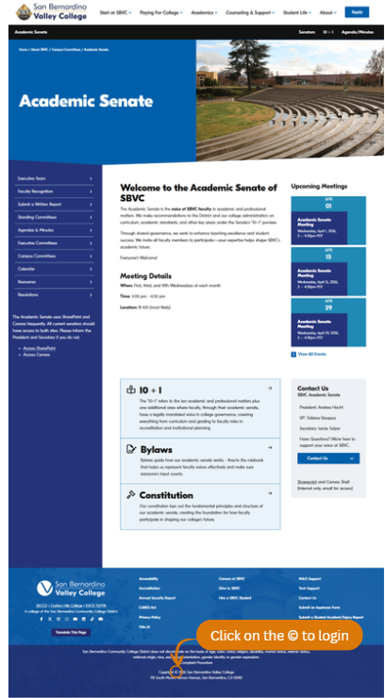
1 | Go to any Academic Senate webpage in your browser.  Navigate to the Academic Senate section of the SBVC website.

2 | Scroll to the very bottom of the page.  Look for the copyright symbol (©) in the footer. This is the hidden entry point for editors.

3 | Click the copyright symbol (©) in the footer.  This small symbol in the bottom footer opens the login portal. It is not advertised on the page — you must scroll down to find it.

The © symbol is located in the footer at the bottom of the page. Click it to open the CMS login portal.

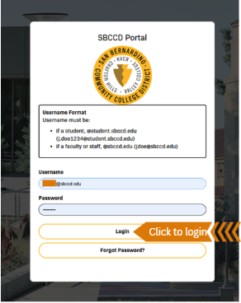
4 | Log in using your SSO (Single Sign-On) credentials.  The SBCCD Portal login screen will appear. Enter your institutional email and password, then click Login.

NOTE | After a successful login, the system takes you directly to the CMS backend view of whichever page was open in your browser. From there you can navigate anywhere you have permission to edit.

5 | You are now in the CMS backend.  The page will change to show the Modern Campus CMS interface with editing controls at the top.

6 | Click 'Back to Pages' to navigate to the page list.  This takes you to the main navigation area where you can locate the Agendas and Minutes folder.
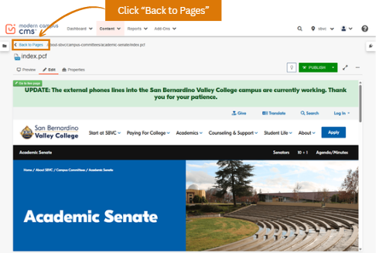
The CMS backend view. You can see editing controls at the top of the page including Back to Pages, Edit, Properties, and Publish.

3. Navigating to the Meeting Management Area

After logging in and clicking 'Back to Pages,' you will see the full list of pages and folders for the Academic Senate section. You need to navigate to the Agendas and Minutes folder to create or update meetings.

1 | Click on the 'agendas-minutes' folder in the page list.  The page list shows all files and folders. Find the folder named 'agendas-minutes'. This opens the folder containing all meeting records organized by year. Click the 'agendas-minutes' folder (circled in orange) to open the meeting directory.

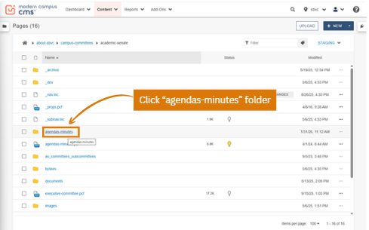
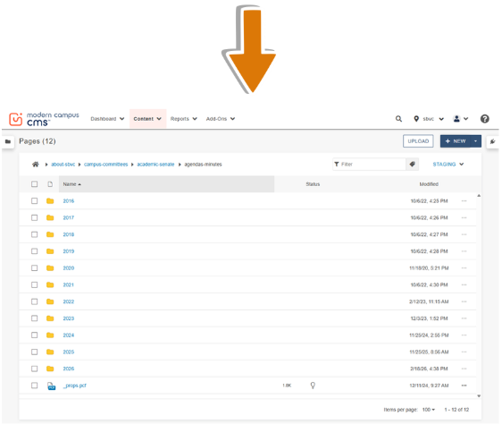

4. Creating a New Meeting

Follow these steps to create a brand-new meeting entry. You will need the meeting date, time, room, and any special notes before you begin.

1 | Inside the 'agendas-minutes' folder, click '+NEW' in the top toolbar.  The +NEW button is located at the top right of the page list. Click it to create new content.

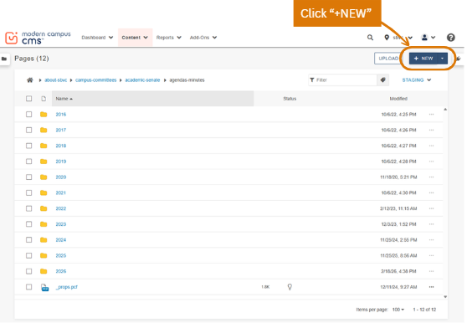

2 | Select 'New Committee Meeting' from the dialog.  A dialog box will appear with content type options. Click the 'New Committee Meeting' icon.

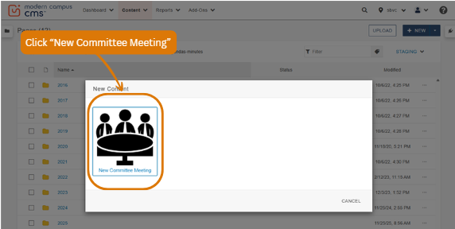
3 | Fill in the meeting information form.  A form will appear with fields for the meeting title, year, month, and day. Fill in all required fields accurately.

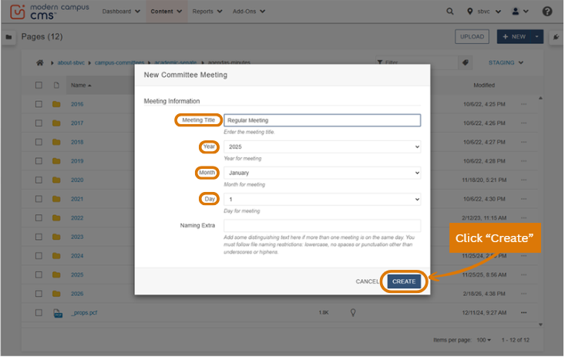
The New Committee Meeting form. Fill in the Meeting Title (e.g., 'Regular Meeting'), Year, Month, and Day. The Naming Extra field is optional — use it only if two meetings fall on the same day.

4 | Click 'CREATE' to create the meeting.  After clicking Create, the system will build the meeting files. Wait for the confirmation notification at the bottom of the screen before continuing.

✅ WHAT HAPPENS NEXT | After clicking CREATE, the system will display a notification: 'Your new content is being created. Please stand by.' Wait for this to complete before navigating away.

5 | You will be taken to the MultiEdit Content form.  This is the main meeting editing page where you will enter the meeting details and upload documents. Complete all relevant fields.

The MultiEdit Content form. Fill in the Meeting Title, Meeting Date/Time (use the calendar icon), Meeting Location (building and room), and check 'Special meeting?' if applicable. The Agenda and Minutes fields will be filled when you upload documents.

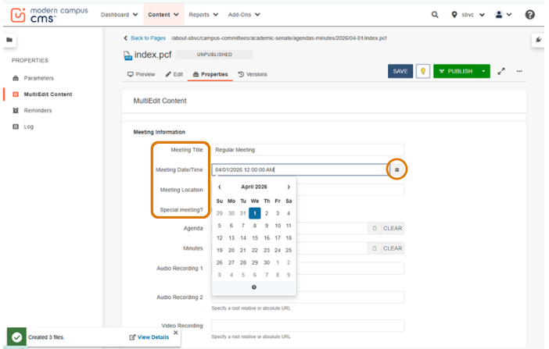
Click the calendar icon next to Meeting Date/Time to select the correct date using the date picker.

5. Uploading Documents to a Meeting

Once the meeting record is created and the basic information is filled in, you can upload the associated documents: agenda, minutes, and any presentation files.

📋 FILE NAMING RULES — READ BEFORE UPLOADING | Files must follow these rules or the upload will be rejected: ✓ Lowercase letters only ✓ Numbers are allowed ✓ Underscores ( _ ) are allowed as separators ✗ No uppercase letters ✗ No spaces ✗ No special characters (hyphens, !, @, #, etc.) CORRECT: march_4_2026_agenda.pdf INCORRECT: March 4 2026 Agenda.pdf

5a. Uploading the Agenda and Minutes

1 | On the Index or MultiEdit Content page, click the folder/file icon next to the 'Agenda' field.  This opens the 'Choose a File' file manager dialog.

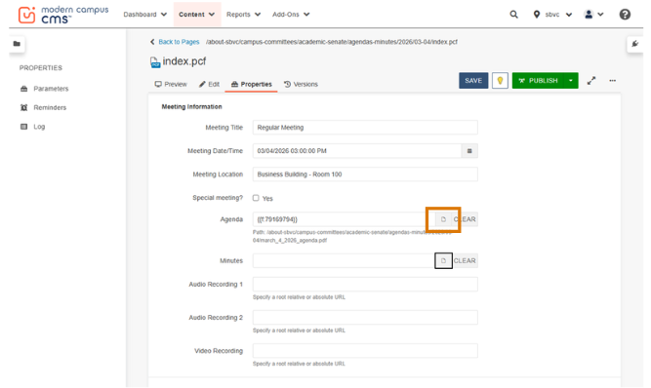

The MultiEdit Content form with an agenda already attached (top). Below, the 'Choose a File' dialog opens when you click the folder icon. Click UPLOAD to begin adding files.

2 | In the 'Choose a File' dialog, click the 'UPLOAD' button.  The upload interface will expand to show a drag-and-drop area and an +ADD button.

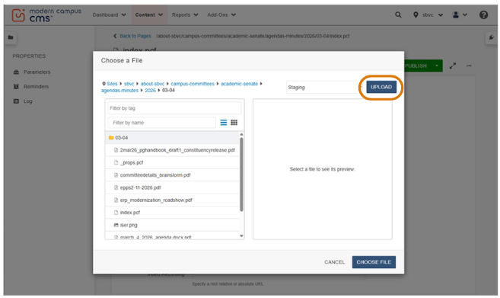

3 | Add your file using one of two methods:

Option A – Drag & Drop  Open File Explorer on your computer, locate the document, and drag it into the dashed upload area in the dialog.  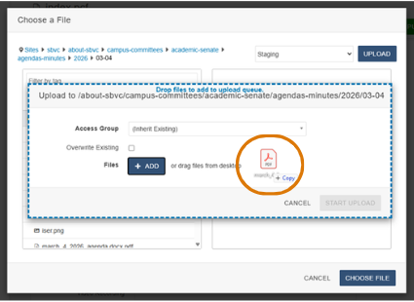 | Option B – Click +ADD  Click the '+ADD' button to open a file browser. Navigate to your file, select it, and click Open.  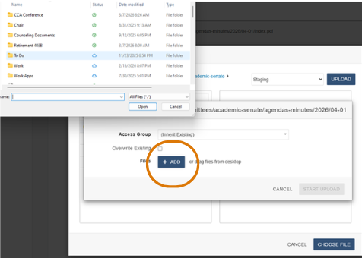

The upload dialog shows both methods: drag-and-drop (outlined in a dotted blue line) and the +ADD button (outlined in orange) and shows the Windows file browser that opens when you click +ADD.

4 | Click 'START UPLOAD.'  The file will upload. A progress indicator will appear. Do not navigate away until the upload is complete.

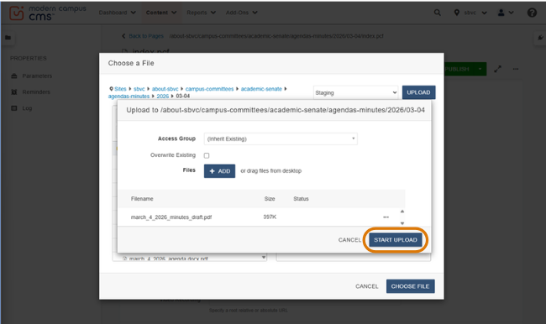

After adding the file, it appears in the queue. Verify the file name follows the naming rules (lowercase, underscores, periods, no spaces). Then click 'START UPLOAD' (circled in orange).

5 | Select the uploaded file and click 'CHOOSE FILE.'  After the upload completes, the file will appear highlighted in the file browser. Click on it to select it, then click 'CHOOSE FILE' to attach it to the meeting record.

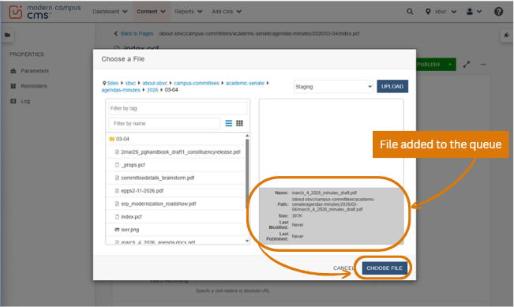
The file (highlighted in orange) appears in the file list after uploading. Click the file to see its details (if needed), then click 'CHOOSE FILE' (highlighted in orange) to attach it to the Agenda or Minutes field.
6 | The system returns you to the meeting page with the file linked.  The agenda or minutes path will now appear in the field. Repeat the same process for the Minutes field.

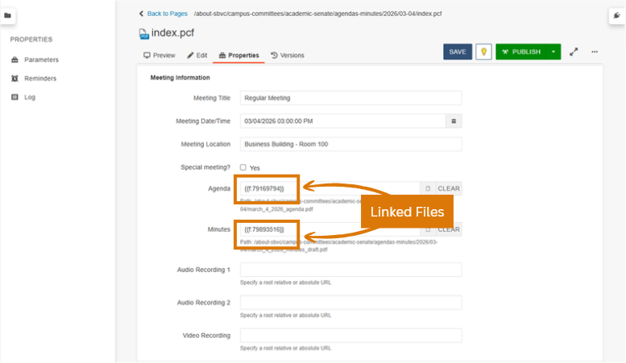
The MultiEdit Content form after uploading. The Agenda and Minutes fields now show the file paths, confirming both files have been successfully attached.

5b. Uploading Presentation Files

After the agenda and minutes are uploaded, scroll down to find the Presentations section. Upload each presentation file using the same process described above, starting by clicking the folder/file icon next to the 'Presentation File' field. This opens the 'Choose a File' file manager dialog, and you will repeat the process.

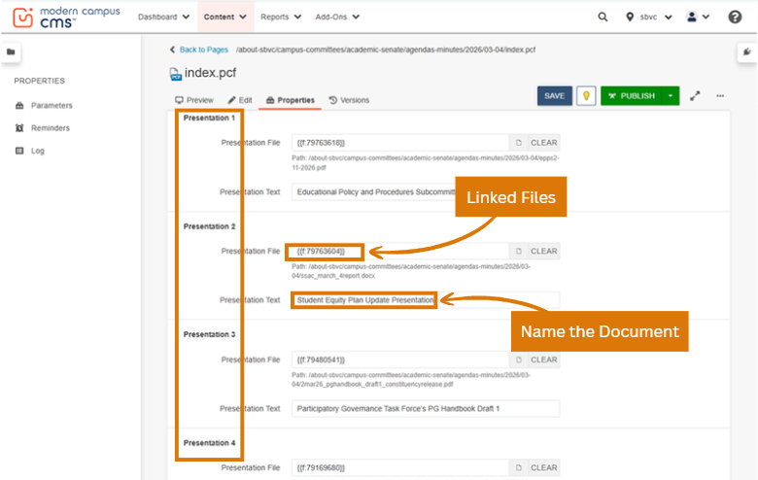
The Presentations section showing multiple presentation slots (Presentation 1, 2, 3, etc.). For each presentation, upload the file and enter a descriptive title in the 'Presentation Text' field.

6. Publishing the Page

Once all documents are uploaded and the meeting information is complete, you must publish the page to make it visible to the public. Publishing requires three steps, do not skip any.

1 | Click 'PUBLISH' in the top toolbar of the meeting page.  The Publish button is located in the top right of the editing page. Clicking it will open a 'Save and Publish' dialog.

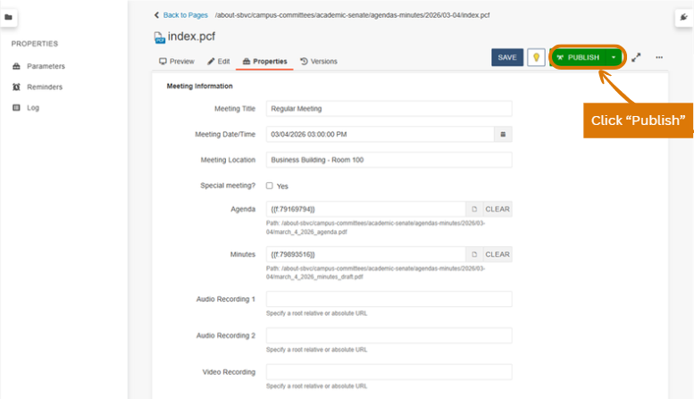

2 | Click 'SAVE' in the dialog that appears.  The system asks whether to save current changes before publishing. Always click Save to ensure your most recent work is published. Click SAVE in the 'Save and Publish' dialog.

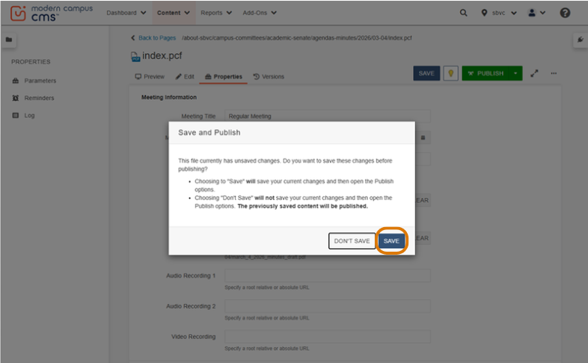
3 | Click 'PUBLISH' on the final confirmation screen.  The 'Publish – index.pcf' dialog will appear showing a Final Check tab. Click the green PUBLISH button to push the page live in the final publish confirmation dialog.

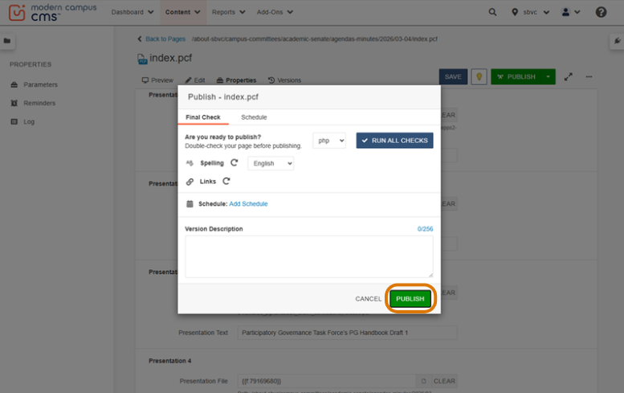

Note: If there are spelling errors, it is best practice to fix them before publishing. You can still publish, but errors will be visible on the live page.
⚠ IMPORTANT | The page is NOT live until all three steps are completed: (1) Click Publish, (2) Click Save, (3) Click Publish again. Stopping partway through leaves the page in draft/unpublished mode.

4 | Verify the published meeting page.  After publishing, the system shows a preview of the live page with all the documents listed. Review it to confirm everything is correct.
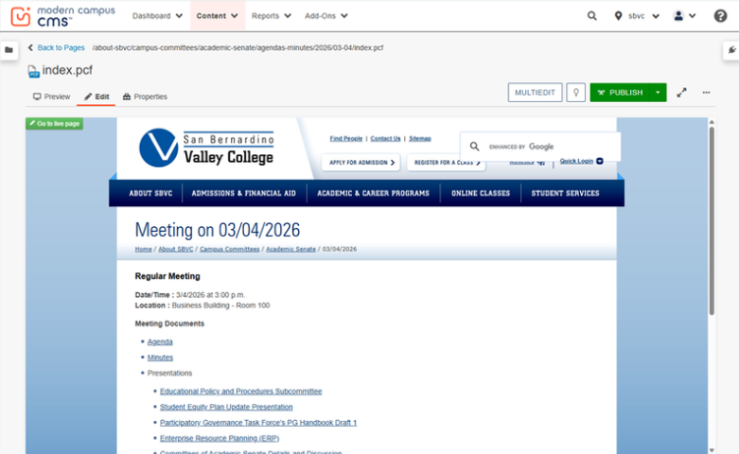
The published meeting page as it appears to the public. It shows the meeting date, date/time, location, and links to all uploaded documents (Agenda, Minutes, and Presentations). It is recommended to check the Academic Senate website under “Agendas and Minutes” as that is what the public will see.

7. Running a Spelling & Link Check

The CMS includes a built-in spelling checker and link validator. Running these checks before publishing helps catch errors before they are visible to the public.

1 | On the Publish confirmation screen, locate the Spelling and Links rows.  These are visible in the 'Final Check' tab of the Publish dialog.

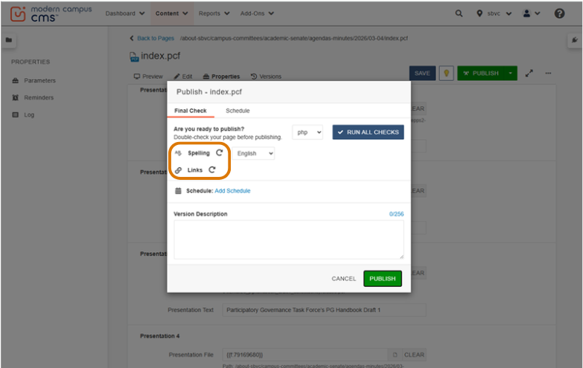

2 | Click the circular arrow icon (↺) next to 'Spelling' or 'Links' to run the check.  Each check runs independently. Click the icon to trigger the check for that category.

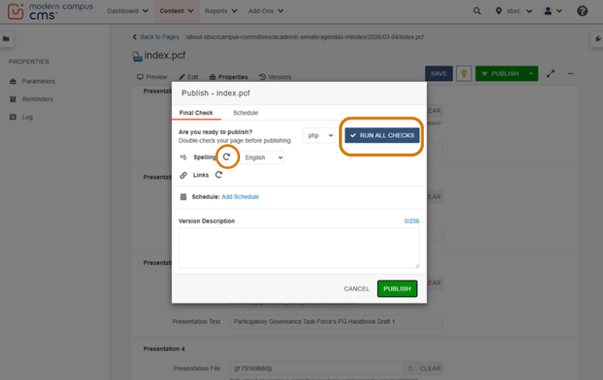

The Publish / Final Check dialog. Click 'RUN ALL CHECKS' (blue box) to run everything at once, or click the individual circular arrow icons next to Spelling and Links to run each check separately.
3 | Review any errors that are returned.  If errors are found, the system will display a count (e.g., 'Spelling: 2 errors'). Click on the errors to see what needs to be corrected.

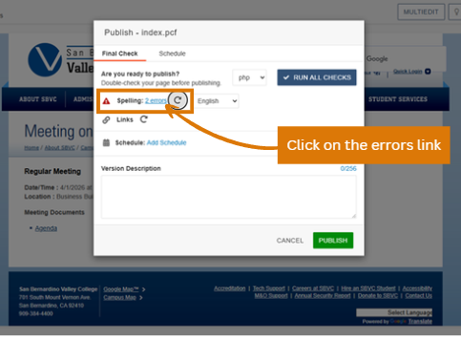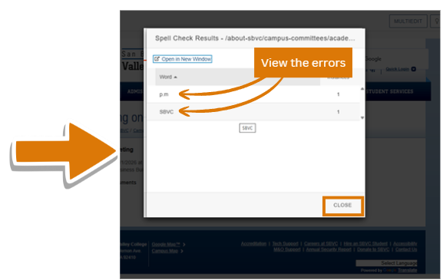

The Spell Check Results dialog listing words the system flagged. Review each flagged word, some may be proper nouns or abbreviations that can be ignored. Click CLOSE when done reviewing.

⚠ NOTE | The spelling and link checker identifies errors but does NOT fix them automatically. You must close all dialogs, return to the page editor, correct the issues manually, re-run the check, and then publish.

4 | Fix all errors manually, then publish.  Close the checker, edit the page content as needed, return through MULTIEDIT, and click Publish again.

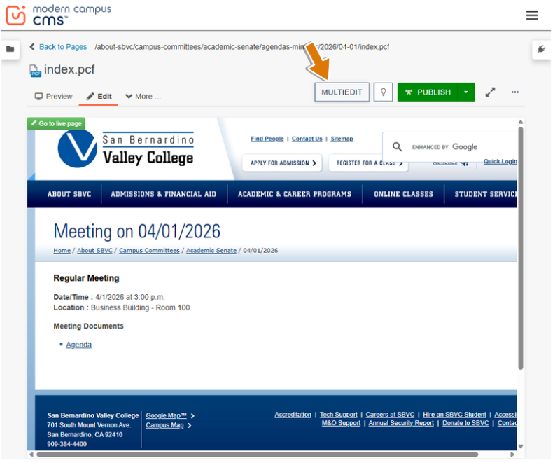

8. Fixing an Invalid File Name

If a file name does not follow the CMS naming rules, the system will reject it and display a red error message in the upload dialog. You must rename the file before the upload can proceed.

📋 FILE NAME RULES REMINDER | ✓ Lowercase letters only ✓ Numbers allowed ✓ Underscores allowed  ✓ Periods allowed  ✗ No uppercase letters ✗ No spaces ✗ No special characters (hyphens, !, @, #, etc.)  CORRECT: march_4_2026_minutes_draft.pdf  INCORRECT: March_4_2026 Minutes Draft.pdf

1 | Watch for the red error message in the upload queue.  If the file name is invalid, the system displays a red warning below the file name in the upload dialog.

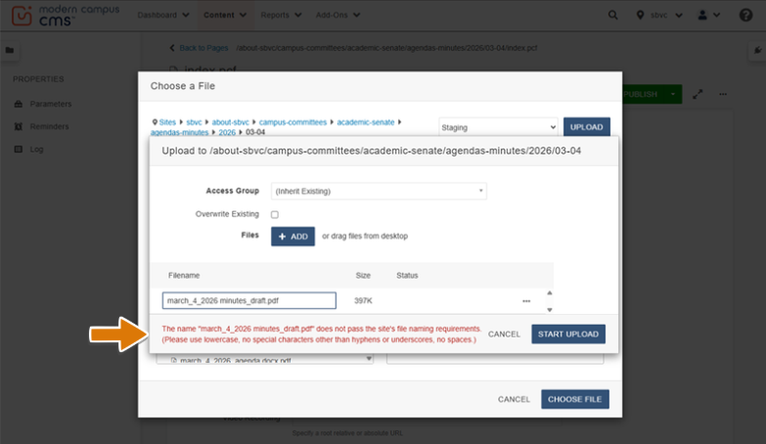
The upload dialog showing a red error message: 'The name does not pass the site's file naming requirements.' This appears when the file name contains uppercase letters, spaces, or special characters.

2 | Click the three-dot menu (…) next to the file name.  A small context menu will appear with options for that file.

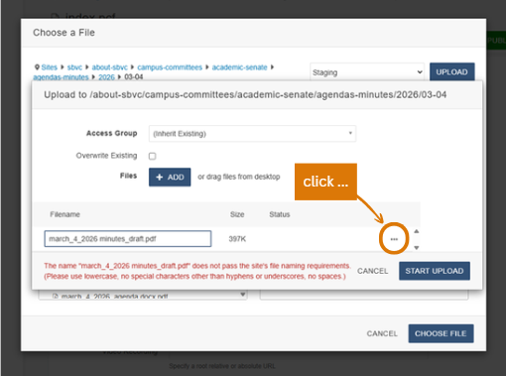
Click the three-dot (…) icon on the right side of the file row (circled in orange) to open the options menu, then click 'RENAME'.

3 | Click 'RENAME' from the menu. ⋮  The file name field becomes editable.

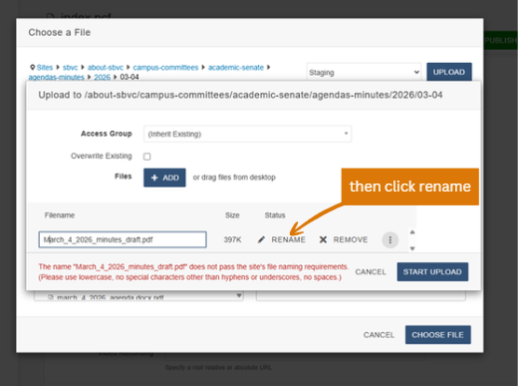
4 | Type the corrected file name.  Replace the name with a valid version: all lowercase, no spaces (use underscores instead), no special characters.

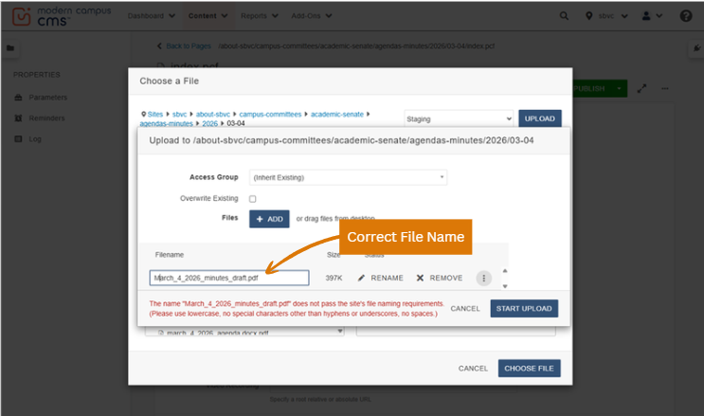
The rename field is now editable. Type the corrected file name following the rules above. Example: change 'March_4_2026_minutes_draft.pdf' to 'march_4_2026_minutes_draft.pdf'.

5 | Click anywhere on the row to confirm. Verify the red error is gone.  If the name is now valid, the red error message will disappear. If it is still showing, review the name again and look for any remaining uppercase letters, spaces, or invalid characters.

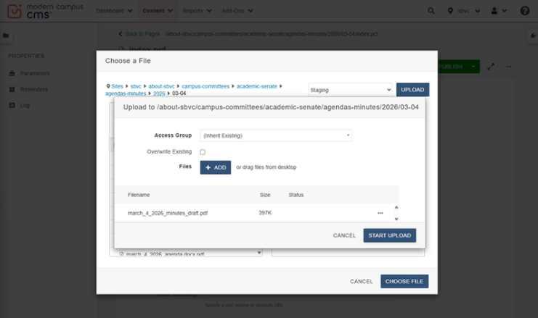
After renaming, the file row shows no red error message, and the START UPLOAD button becomes active.

6 | Click 'START UPLOAD' to upload the renamed file.

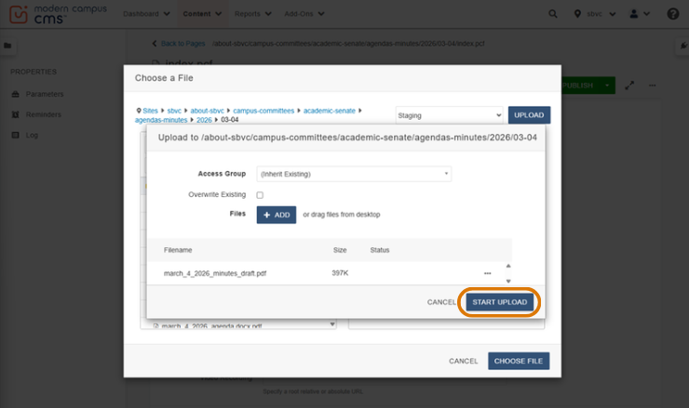

Click START UPLOAD to proceed.

9. Uploading Documents After a Meeting Is Created

If you need to go back and add, replace, or update documents for a meeting that already exists (for example, adding the final approved minutes after a meeting has taken place), follow these steps.

ℹ PREREQUISITE | The meeting must already exist in the system. If it does not exist yet, create it first by following Section 4.

1 | From any page in the CMS, navigate back to the Academic Senate page list.  You can use the breadcrumb navigation at the top of any CMS page to navigate to the Academic Senate level.

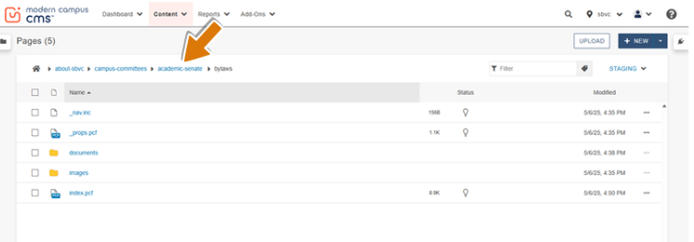
The Academic Senate page list.

2 | Click the 'agendas-minutes' folder.

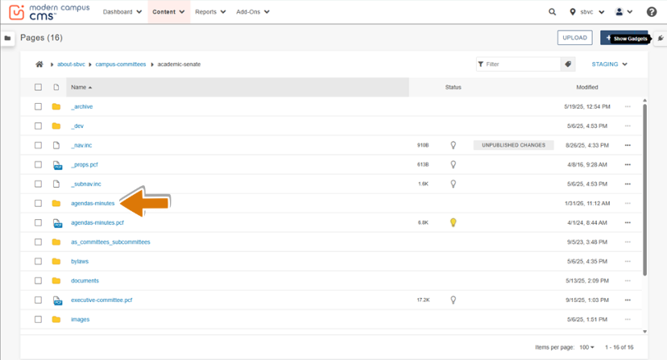
Click the 'agendas-minutes' folder (highlighted with orange arrow) to open the meeting year directory.
3 | Click the year folder that corresponds to your meeting.  Meeting records are organized by year. Click on the correct year.

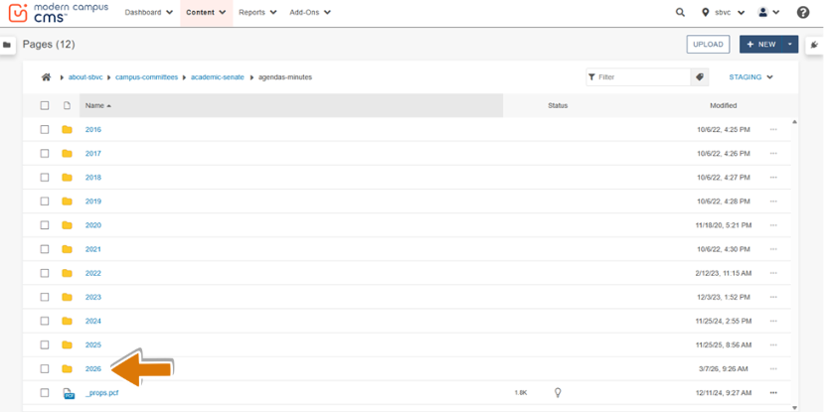
The year folders inside 'agendas-minutes.' Click the correct year (orange arrow), for example, '2026' for a 2026 meeting.

4 | Click the meeting date folder.  Inside the year folder, you will see folders named by meeting date (e.g., 03-04 for March 4). Click the correct date.

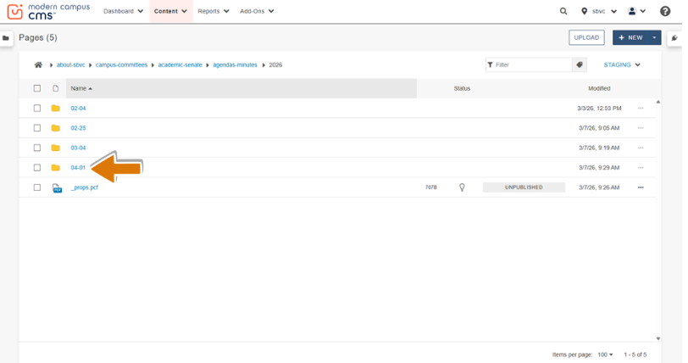
The meeting date folders for the selected year. Click the folder matching the meeting date you want to update.

5 | Inside the date folder, click on 'index.pcf.'  The index.pcf file is the main page file for that meeting. Click it to open it.

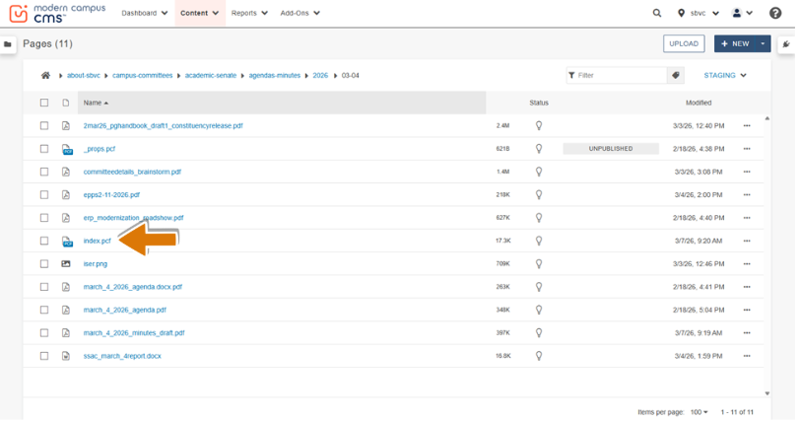
The contents of a meeting date folder. Click 'index.pcf' (highlighted in orange) to open the meeting page.

6 | Click 'MULTIEDIT' in the top toolbar.  This opens the MultiEdit Content form for that meeting, the same form used when creating the meeting, where you can add or replace documents.

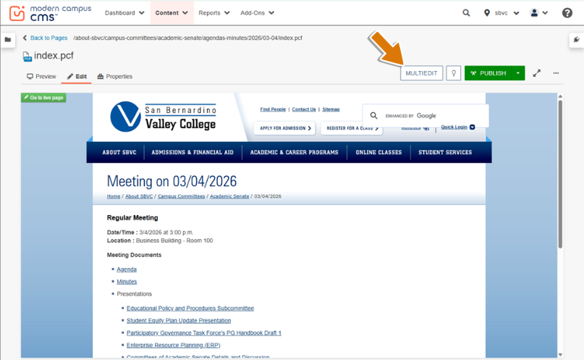
The meeting page preview in the CMS. Click 'MULTIEDIT' (orange arrow) to return to the meeting editing form.

7 | Upload new documents using the steps in Section 5.  You are now on the same MultiEdit Content form. Follow Section 5 to upload files and Section 6 to publish the updated page.

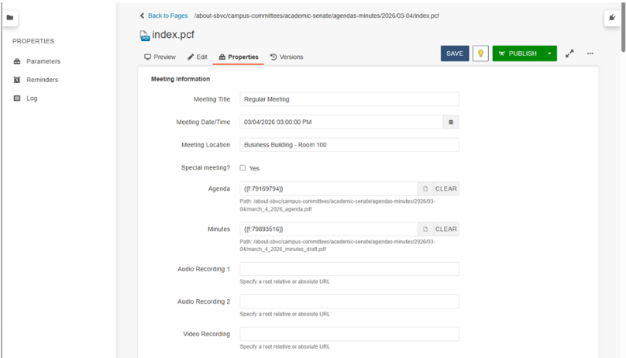

You are back on the MultiEdit Content editing form. Upload your new or updated documents following the process in Section 5, then publish following Section 6.

The updated published meeting page as it appears to the public, showing all linked documents.

10. Quick Reference: File Naming Rules

Use this page as a quick reference. Incorrect file names are the most common reason uploads fail.

✓ VALID EXAMPLES | ✗ INVALID EXAMPLES
senate_agenda_fall_2024.pdf | Senate Agenda Fall 2024.pdf
committee_minutes_2024_03_15.pdf | Committee Minutes 3/15/2024.pdf
presentation_spring_2024.pptx | PRESENTATION-Spring2024.pptx
budget_report_final.xlsx | Budget Report (Final)!.xlsx
regular_meeting_agenda_2026_04_01.pdf | Regular Meeting Agenda 04-01-2026.pdf

Character / Rule | Allowed? | Example
Lowercase letters a–z | ✓ Yes | senate, agenda
Numbers 0–9 | ✓ Yes | 2024, 15
Underscore _ | ✓ Yes | file_name
Period . | ✓ Yes | file.name
Uppercase A–Z | ✗ NO | Senate, AGENDA
Spaces | ✗ NO | my file.pdf
Hyphens / dashes - | ✗ NO | file-name.pdf
Special chars ! @ # $ % | ✗ NO | report!.pdf

📞 QUESTIONS OR ISSUES? | If you encounter a problem not covered in this guide, contact the Academic Senate President or reach out to IT for technical support. Do not share your login credentials with anyone.

— End of Training Guide —

