STUDENT EQUITY PLAN
2025-2028
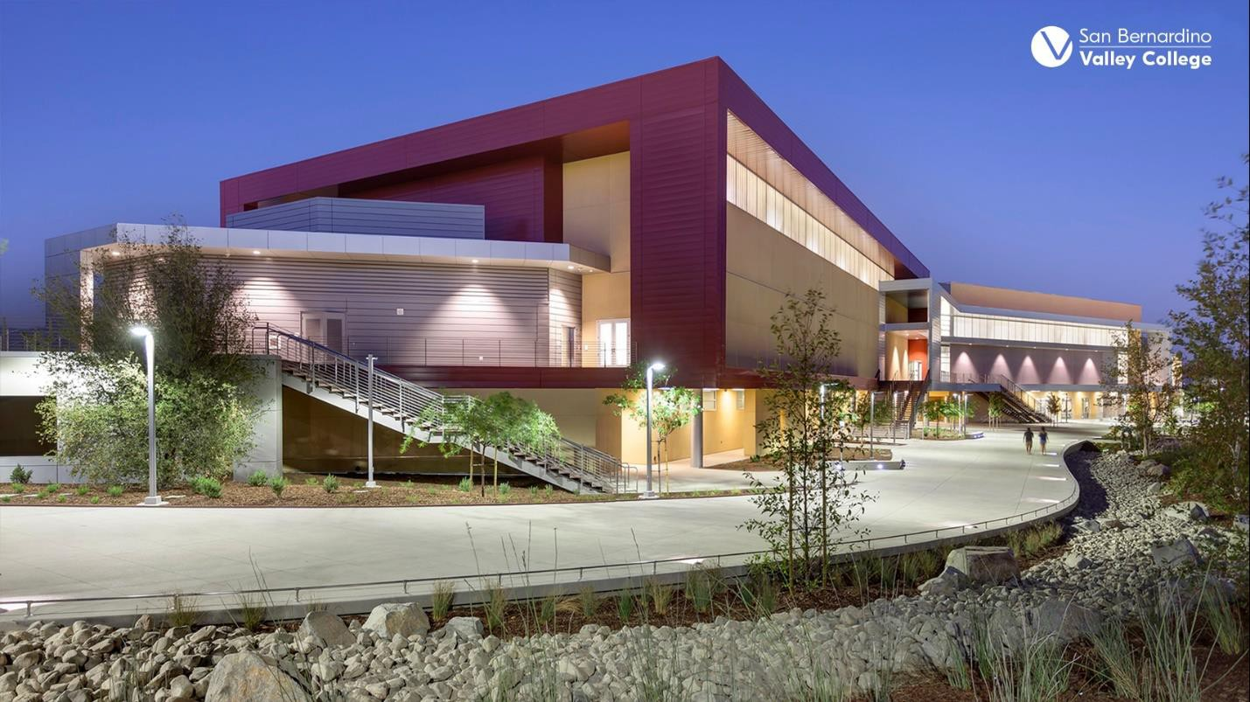

TABLE OF CONTENTS

Section 1: Assurances and Reflection
- Campus Involvement & Leveraging Student Voice
- Race-Consciousness Planning

Section 2: Contacts
Section 3: Student Equity Reflection
Section 4: Executive Summary
Section 5: Student Population Experiencing Disproportionate Impact
Section 6: Metric 1 – Successful Enrollment
Section 7: Metric 2 – Completed Both Transfer Level Math and English
Section 8: Metric 3 – Term to Term Persistence
Section 9: Metric 4 – Vision Goal Completion
Section 10: Metric 5 – Transfer to a 4-year University
Section 11: Intensive Focus on Population(s) Experiencing Disproportionate Impact
Section 12: Student Education Plans
Section 13: Vision 2030 Equity Alignment and Coordination
Section 14: Preview and Submit

Section 1: ASSURANCES AND REFLECTION

Assurances
Please attest to the following assurances and answer its associated question.

- I have read the legislation Education Code 78220 and Education Code 78222 am familiar with the goals, terms, and conditions of the Student Equity Plan, as well as the requirements of Student Equity & Achievement Legislation.
- I have read the legislation Education Code 78221 and acknowledge that Student Equity and Achievement funds are allocated towards the successful implementation of new or existing strategies to achieve the equity goals established for identified student groups in this equity plan.
- I have read and given special consideration to Education Code 78220 section (b), which states, “Student equity plans shall be developed with the active involvement of all groups on campus as required by law, including, but not limited to, the academic senate, academic faculty and staff, student services, and students, and with the involvement of appropriate people from the community.”

Campus Involvement & Leveraging Student Voice
Please provide a description of how your college ensures active involvement of all groups on campus, including, but not limited to, those identified in subdivision (b) above, in developing the student equity plan. Please also include specific strategies your college will deploy to leverage student voice to advance your institutional equity goals.
SBVC recognizes that authentic equity work begins with listening to students and the community. The college will continue to expand opportunities for students to influence institutional equity goals through:
- Student Voice Forums and Listening Sessions: Will host forums and sessions each semester to capture feedback from disproportionately impacted (DI) student populations regarding campus climate, access to resources, and academic experiences.
- Student Focus Groups: In partnership with ASG and student organizations (such as Umoja-Tumaini, Puente, Dreamers Resource Center, Tatayan, and LGBTQA+) will conduct student focus groups to better understand the needs and strengths of specific communities.
- Student Participation in Governance: ASG and student representatives serve as voting members on committees and other governance bodies to ensure the student perspective informs policy and resource allocation.
- Campus Climate and Equity Surveys: Will continue to deploy surveys annually to assess progress toward closing equity gaps and to identify emerging challenges, with findings shared transparently across the college.
- Transparency & Engagement: To maintain engagement throughout the life of the plan, SBVC will employ continuous feedback that includes data review sessions, professional development workshops, and progress updates shared through College Council, Academic Senate, Classified Senate, the President’s Executive Cabinet, and the Wolverine Weekly, a campus-wide newsletter that originates from the President’s Office. Transparency in outcomes and decision-making reinforces trust and motivates continued participation from all constituent groups.
- By embedding student voice and cross-constituent collaboration in every stage of the Student Equity Plan from development to implementation, SBVC transforms equity work into a collective responsibility and a shared commitment to student success.

- I have read the legislation Education Code 78220 and understand per Education Code section (c), the Student Equity Plan “shall be adopted by the governing board of the community college district and submitted to the Chancellor of the California Community Colleges…”
- I acknowledge the importance of needing to be race-conscious in the development of this Student Equity Plan.

Race-Consciousness
Please describe how your college plans to be race-conscious in the development of this Student Equity Plan. The following link is an optional resource: Empowering Lessons from SEPI for Designing and Implementing Race-Conscious 2025-28 Student Equity Plans provides information on race-consciousness strategies and student equity planning.
San Bernardino Valley College (SBVC) is committed to developing a race-conscious Student Equity Plan that acknowledges and addresses the historical and systemic barriers that have impacted racially minoritized students. The college recognizes that equity cannot be achieved through race-neutral strategies; instead, SBVC centers race and intersectionality in its analysis, planning, and implementation to break institutional barriers and foster belonging for all students.
SBVC’s race-conscious equity planning is also supported through alignment with the College’s Institutional Mission, Vision, and Values, which emphasize diversity, inclusion, and social justice. Progress toward racial equity goals is communicated transparently through campus forums, reports, and presentations, allowing the entire community to engage in shared reflection and continuous improvement.

By acknowledging race as a central factor in educational outcomes and embedding race-conscious strategies throughout the Student Equity Plan, San Bernardino Valley College reaffirms its commitment to creating a learning environment where all students, particularly those historically marginalized, can thrive and succeed.

SBVC will continue to employ a race-conscious approach by disaggregating quantitative and qualitative data to uncover equity gaps that may be obscured by aggregate reporting. The college examines outcomes through a lens that considers race and ethnicity alongside gender, income, disability, and other intersecting identities. This analysis is not limited to access and completion metrics but extends to students’ sense of belonging, experiences of bias, and access to support services.
In addition to data, SBVC will actively incorporate lived experiences through student focus groups and feedback gathered from racially minoritized student organizations. These perspectives shape both the understanding of inequities and the design of responsive, culturally affirming strategies.

- I have read Education Code 78220 section a(6) and understand it requires the college’s student equity plan to include a schedule and process of evaluation.

Local Review Process & Schedule

Please describe the process you will implement to ensure ongoing local review and evaluation of how your student equity plan is advancing your institutional common equity goals and supporting continuous improvement. Please also provide your schedule (i.e., annually by June 30th of each year, at the end of each semester, etc.) of when evaluations and reporting to the campus community will take place.

San Bernardino Valley College (SBVC) will continue to establish a structured and transparent process to ensure continuous review, evaluation, and improvement of the Student Equity Plan. The College’s approach will emphasize collaboration, data-informed decision-making, and alignment with institutional and statewide equity goals, ensuring that all efforts are intentional, measurable, and sustainable.

SBVC will continue to implement an equity-centered evaluation cycle that includes data analysis, reflection, and planning throughout each academic year. The Student Success Advisory Committee (SSAC), which integrates Student Equity, Guided Pathways, and Student Support Service, serves as one of the primary bodies responsible for overseeing implementation and review of the Student Equity Plan.
The evaluation process includes:

- Data Review and Disaggregation: The Office of Research, Planning, and Institutional Effectiveness (RPIE) provides disaggregated data by race/ethnicity, gender, and other disproportionately impacted (DI) categories to identify trends, progress, and persistent equity gaps.
- Departmental Reflection and Reporting: Departments and programs supported by Student Equity and Achievement (SEA) will submit reports describing how activities align with equity goals, address barriers, and support DI populations.
- Qualitative Feedback: SBVC will gather input through student listening sessions, surveys, and focus groups, ensuring that data is complemented by lived experiences and student voices.
- Committee Review and Integration: The SSAC will analyze the findings to assess progress toward equity outcomes, recommend improvements, and ensure alignment with institutional priorities and budget planning.
- Communication and Transparency: Progress reports and updates will be shared with College Council, Academic Senate, Classified Senate, and Associated Student Government (ASG) to maintain college-wide awareness and engagement.

Evaluation Schedule

Timeframe | Activity | Responsible Party | Outcome/Deliverable
End of each semester (December & May) | Departmental/divisional reflections and SSAC review of SEA funded activities | Departments, divisions, & SSAC | Semester summary and progress report.
Annually by June 30th | Comprehensive equity evaluation using institutional data, program reflections, and student feedback | RPIE/SSAC/SEA | Annual Equity Progress will be shared with the campus community.
August (start of academic year | Presentation of prior year outcomes, updated goals, and planned interventions | Student Services & Instructional Divisions, SSAC, SEA | Shared presentation at Convocation, governance committees, and campus newsletter
Ongoing | Continuous student and stakeholder feedback (listening sessions, focus groups, surveys). Divisional meetings, cross collaboration with committees | SSAC, ASG, Divisions, Departments, Equity Partners | Real-time improvement of activities and initiatives.

Alignment with Vision 2030 and Chancellor’s Office Requirements

SBVC’s evaluation process aligns with the California Community Colleges Vision 2030 framework, specifically under Goal 1: Equity in Success, which emphasizes closing racial equity gaps and increasing completion rates with equity. Data collected through this ongoing review process supports the college’s contribution to statewide metrics on student achievement, transfer, and workforce outcomes.

Additionally, SBVC ensures compliance with California Community Colleges Chancellor’s Office (CCCCO) requirements for Student Equity and Achievement (SEA) Program reporting. The college submits annual updates and outcome data as part of the statewide accountability framework, using these reports to inform local continuous improvement and strengthen the connection between college-level and systemwide equity efforts.

Through consistent evaluation, reflection, and transparent communication, SBVC maintains a living Student Equity Plan that evolves with the needs of its students and community. Findings from the annual evaluation cycle inform institutional planning processes, program review, resource allocation, and professional development priorities.
This approach ensures that equity remains central to the college’s mission and that all stakeholders, students, classified professionals, faculty, administrators, and community partners will share the responsibility for advancing SBVC’s common equity goals and promoting student success for all.

Section 2: CONTACTS

NAME | RESPONSIBILITY | EMAIL ADDRESS | PHONE NUMBER
Maria Del Carmen Rodriguez | Project Lead | marodrig@sbccd.cc.ca.us | 909-384-8592
Marco Cota | Alternate Project Lead | mcota@sbccd.cc.ca.us | 909-384-8630
Gilbert Contreras | Approver: Chancellor/President | gcontreras@sbccd.cc.ca.us | 909-384-8296
Steven Sutorus | Approver: Chief Business Officer | ssutorus@sbccd.cc.ca.us | 909-382-4031
Leticia Hector | Approver: Chief Instructional Officer | lhector@sbccd.cc.ca.us | 909-387-1685
Yvonne Gutierrez-Sandoval | Approver: Chief Student Services Officer | ygutierrezs@sbccd.cc.ca.us | 909-384-8992
Patricia Quach | Approver: Guided Pathways Coordinator/Lead | pquach@sbccd.cc.ca.us | 909-384-8996
Andrea Hecht | Approver Academic Senate President | ahecht@sbccd.cc.ca.us | 909-384-8974

Section 3: STUDENT EQUITY REFLECTION

Through analysis of the 2022–2025 Student Equity Plan, SBVC has identified multiple systemic and structural factors contributing to persistent equity gaps among disproportionately impacted (DI) student populations across the five key metrics: Enrollment, Transfer English and math completion, term to term persistence, completion and transfer to a 4-year university. Key root causes include, but not limited to:
- Structural Barriers to Access and Engagement: DI students often encounter challenges such as limited financial resources, lack of awareness of support programs, and insufficient advising, which delay enrollment, course completion, and transfer readiness.
- Institutional and Cultural Factors: Students from racially minoritized groups, first-generation learners, and students with disabilities reported feelings of isolation, no sense of belonging, and limited culturally relevant support within classrooms and student services. Implicit bias in advising, instruction, and assessment practices contributed to uneven outcomes.
- Gaps in Data Informed and Targeted Interventions: Prior to the 2022–2025 plan, interventions were sometimes implemented broadly without disaggregating outcomes by race, ethnicity, or other DI identifiers, limiting the effectiveness of strategies to close specific equity gaps.

SBVC has taken intentional steps to embed equity as a guiding principle in both practice and culture. Notable approaches include:
- Equity Minded Decision Making: The college has strengthened the integration of equity considerations into all institutional planning processes, including program review, budget allocation, and curriculum design. Data disaggregation by DI populations ensures that strategies are tailored to the unique needs of each student group.
- Cross-Functional Committees and Shared Governance: The Student Success Advisory Committee, combining Student Equity, Guided Pathways, and Student Support Services, fosters collaboration between faculty, classified staff, administrators, and students to ensure that equity initiatives are informed by diverse perspectives and aligned with institutional priorities.
- Professional Learning and Equity Focused Training: SBVC provides ongoing professional development around anti-racism, implicit bias, culturally sustaining pedagogy, and equity-minded teaching practices. These efforts have cultivated a campus-wide awareness of structural inequities and strengthened a shared commitment to student success.
- Targeted Student Support Programs: Programs such as Umoja-Tumaini, Puente, and the Dreamers Resource Center have provided culturally relevant mentoring, counseling, and academic support that directly address barriers to persistence and completion for DI students. Early data shows these initiatives are improving retention and course completion rates.
- Equity Infused Guided Pathways Implementation: SBVC’s integration of equity strategies into Guided Pathways—through comprehensive onboarding, proactive advising, and streamlined course sequences has reduced confusion and course bottlenecks, particularly for first-generation and racially minoritized students.
- Data-Driven Continuous Improvement Processes: By routinely reviewing disaggregated outcomes data and soliciting student feedback, SBVC has been able to adjust interventions mid-cycle, scale successful practices, and ensure accountability.
- A stronger student-centered culture has emerged, emphasizing belonging, engagement, and co-creation of solutions with students.
- Staff and faculty increasingly embrace equity-minded language and practices, moving away from deficit-focused narratives toward strength-based approaches.
- Shared governance and transparent data sharing have reinforced a culture of collective responsibility, where all campus constituents are accountable for advancing equity goals.

Through these institutional actions, cultural changes, and processes, SBVC has made measurable progress in reducing equity gaps and improving outcomes for disproportionately impacted students, laying a strong foundation for the 2025–2028 Student Equity Plan.

Based on the analysis of the 2022–2025 Student Equity Plan, SBVC has identified several strategies, cultural practices, and institutional processes that are working effectively and will be continued and expanded in the 2025–2028 plan. These discoveries provide continuity between plans and guide the development, implementation, and assessment of equity initiatives:
- Programs such as Umoja-Tumaini, Puente, Tatayan, and the Dreamers Resource Center have demonstrated measurable success in improving retention, course completion, and overall engagement for disproportionately impacted (DI) students. SBVC has learned that providing mentoring, culturally affirming programming, and proactive academic guidance directly addresses barriers faced by racially minoritized students and first-generation learners. These programs will remain central to the 2025–2028 plan, with expanded outreach and integration across additional student populations and instructional areas.

- The integration of equity strategies into Guided Pathways, including streamlined course sequences, comprehensive onboarding, and proactive advising, has reduced confusion, minimized course bottlenecks, and increased student persistence. SBVC has discovered that aligning equity practices with academic pathways and institutional structures ensures that interventions reach students in a timely and meaningful way. This approach will continue in the next plan cycle, with targeted enhancements for DI populations based on disaggregated outcome data.

- SBVC’s practice of regularly reviewing disaggregated student outcome data, combining quantitative metrics with qualitative student feedback, and making evidence-based adjustments has been critical in closing equity gaps. Additionally, the use of cross-constituent committees, such as the Student Success Advisory Committee, fosters shared responsibility and accountability for equity outcomes. SBVC has learned that a culture of transparency, reflection, and collaborative problem-solving drives effective and sustainable change. These processes will continue as a cornerstone of the 2025–2028 plan, ensuring that interventions remain responsive, measurable, and equity-focused.
Guiding Principles for 2025–2028
- Student Voice at the Center: Continue to actively solicit and incorporate input from DI student populations to ensure strategies reflect lived experiences.
- Targeted Equity Strategies: Expand culturally relevant programs and pathway-specific interventions that will demonstrate measurable impact.
- Data Driven Adaptation: Continue to maintain a structured, semesterly, and annual evaluation cycle to inform continuous improvement and campus-wide accountability.
By leveraging these discoveries and maintaining continuity from the previous plan, SBVC is positioned to strengthen its equity-focused culture, sustain successful interventions, and advance measurable outcomes for all disproportionately impacted student populations in the 2025–2028 Student Equity Plan.

SECTION 4: EXECUTIVE SUMMARY
San Bernardino Valley College (SBVC) serves approximately 18,375 students each academic year. The campus is an urban section of San Bernardino County within the boundaries of the city of San Bernardino. SBVC is diverse in every respect including the faculty, staff, and students enrolled in the college. The diverse makeup of the campus contributes to our strong commitment to student equity. The intent of the Student Equity Plan is to increase student equity and success amongst students who are historically underperforming and underserved.

San Bernardino Valley College (SBVC) has reflected on past practices to close equity gaps and is moving forward with intentional strategies aligned to the State Chancellor’s Office Vision 2030 goals. Building on lessons learned, SBVC is committed to ensuring equitable transfer, completion, and retention outcomes for all students, particularly those from historically underrepresented groups.

Black Serving Institution Designation
SBVC has applied for the Black Serving Institution (BSI) designation to strengthen foundational learning and expand resources for developmental education. This designation supports equity by providing scaffolding for students entering with diverse academic backgrounds, ensuring readiness for transfer and career pathways.

Creating a Sense of Belonging
A strong sense of belonging is central to student success. SBVC is expanding peer mentorship, culturally responsive student organizations, and inclusive campus events to foster connection and community. These initiatives empower students to feel valued, supported, and motivated to persist toward their academic and career goals.

Enhancing Culturally Responsive Learning Communities
SBVC is enhancing culturally responsive learning communities that integrate equity into curriculum, pedagogy, and student support. Faculty development emphasizes inclusive teaching, while learning communities provide academic support and cultural affirmation. These efforts strengthen engagement, retention, and equitable outcomes in transfer, degree completion, and workforce readiness.

Through reflection, intentional planning, and alignment with Vision 2030, SBVC is advancing equity-driven strategies that close gaps, foster belonging, and enhance culturally responsive practices. These commitments ensure that all students can thrive academically and achieve successful transfer and career outcomes.

Integrated Curriculum, Instruction, and Student Support SBVC recognizes that a successful educational journey requires alignment between curriculum, instructional practices, and student support services. Curriculum will be designed to reflect transfer, and workforce demands while embedding equity and culturally responsive content. Faculty will employ inclusive instructional strategies that foster engagement and academic rigor. Student support services, including counseling, tutoring, financial aid, and basic needs resources, will be intentionally integrated into the classroom experience and extended beyond it. By combining these elements, SBVC ensures students receive holistic guidance that strengthens learning, retention, and completion both inside and outside the classroom.

Equity-Focused Professional Development
SBVC is deeply committed to advancing equity through intentional professional development opportunities that empower both staff and students. Faculty, administrators, and student leaders have actively participated in nationally recognized conferences and structured training programs designed to strengthen equity practices and cultural responsiveness. In addition, faculty and staff engaged in structured trainings offered through the USC Race and Equity Center and attended conferences such as NCORE, HACU, A2MEND, and APAHE. These experiences provide SBVC with valuable strategies to close equity gaps, foster inclusive learning environments, and advance the Vision 2030 goals.

San Bernardino Valley College (SBVC) has established dedicated task forces for both its Hispanic Serving Institution (HSI) and Black Serving Institution (BSI) designations to advance equity and student success. These task forces are charged with developing and expanding culturally responsive programming, fostering institutional growth, and promoting professional development opportunities for faculty and staff. Through workshops, trainings, and intentional initiatives, SBVC ensures that students receive comprehensive support tailored to their diverse needs. This collaborative approach strengthens the college’s capacity to deliver the highest quality educational experience while honoring its commitment to access, equity, and excellence.

Student Services Leadership in Vision Alignment
In the past, our college operated with over a hundred goals spread across various departments and plans. While each goal had merit, the sheer volume made it difficult to prioritize, align resources, and demonstrate progress. As a result, we recognized that to truly serve our students and community, we need a more focused and strategic approach that would unify our efforts, maximize our resources, and ensure accountability.
The “Valley Up! Initiative 2025-2030” strives to advance the mission of Valley College through intentional strategic planning that leverages existing planning documents and sets the vision as Valley College enters its second century.
The Valley Up! Initiative 2025-2030 refines our strategic approach and sets a clear direction for the college by focusing on one guiding principle, Advancing Community. Our guiding principle is supported by four college priorities:
1. Career and Transfer
2. Health & Safety
3. Boldly Student-Centered
4. Opportunities for All

Student Equity Budgeting 2025-2028
The California Community Colleges Chancellor’s Office (CCCCO) and Legislature Senate Bill (SB) (1456 & SB 860) have provided funding to increase student success and equity in community colleges. SBVC has used the funding in a variety of ways including the funding of positions, professional development, programming, and services to meet the requirements of the legislature, increase student success, and close equity gaps.

Student Equity and Achievement (SEA) Allocation

Expenditure Type | Amount
1000 – Management, Instruction Salary | $2,768,389.00
2000 – Non Instructional Salaries | $1,333,181.00
3000 – Employee Benefits | $1,233,869.00
4000 – Supplies and Materials | $30,835.00
5000 – Other Operating Expenses & Services (conferences for students & staff) | $200,281.00
6000 – equipment – technology | $20,003.00
7000 – other student aid (parking permits, textbooks) | $37,178.00
Total allocation | $5,623,736.00

Evidence of Progress Towards Equity Goals
Based on the student metrics SBVC has closed the equity gaps in two of the three metrics. We closed the Successful Enrollment and Transfer Level Math and English completion. We are still observing an disproportionate impact in the other three metrics.

Section 5: Student Populations Experiencing Disproportionate Impact

Successful Enrollment – DI – White students
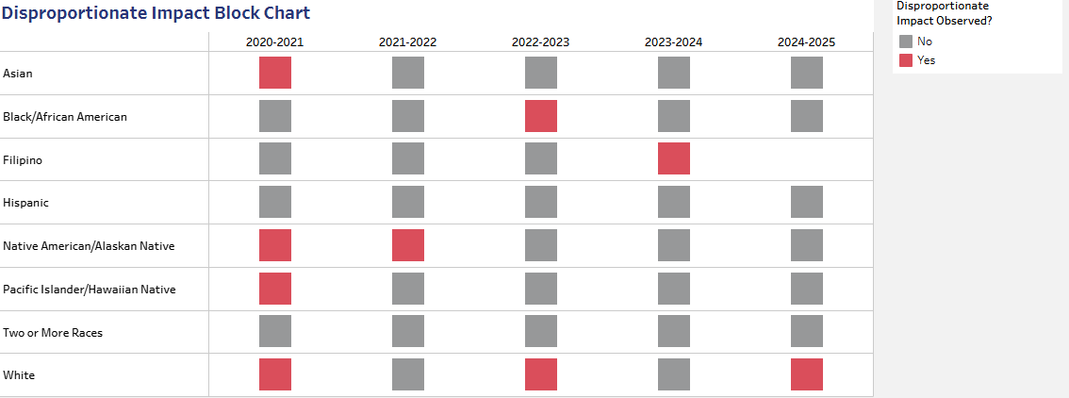
Transfer Level Math & English Completion – DI White students
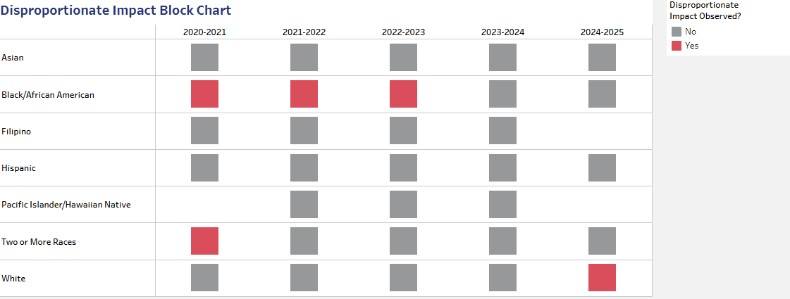

Primary Term to Secondary Term DI – Black/African American and White Students
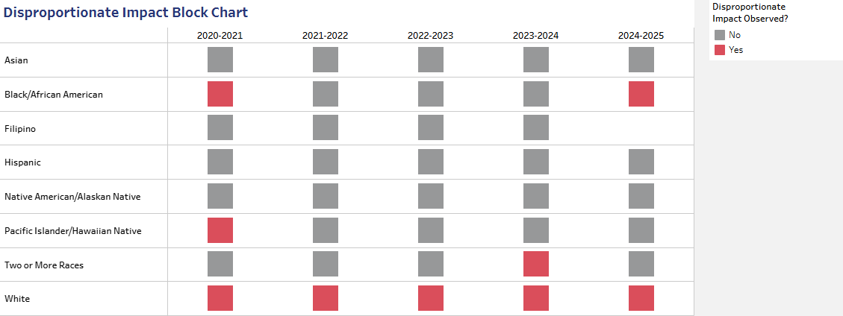
Vision Goal Completion – DI Black/African American Students
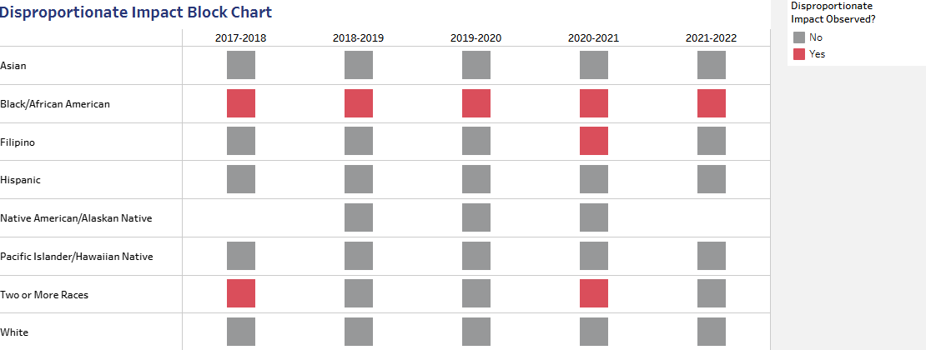
Transfer to a 4-year University – DI Hispanic/Latine Students
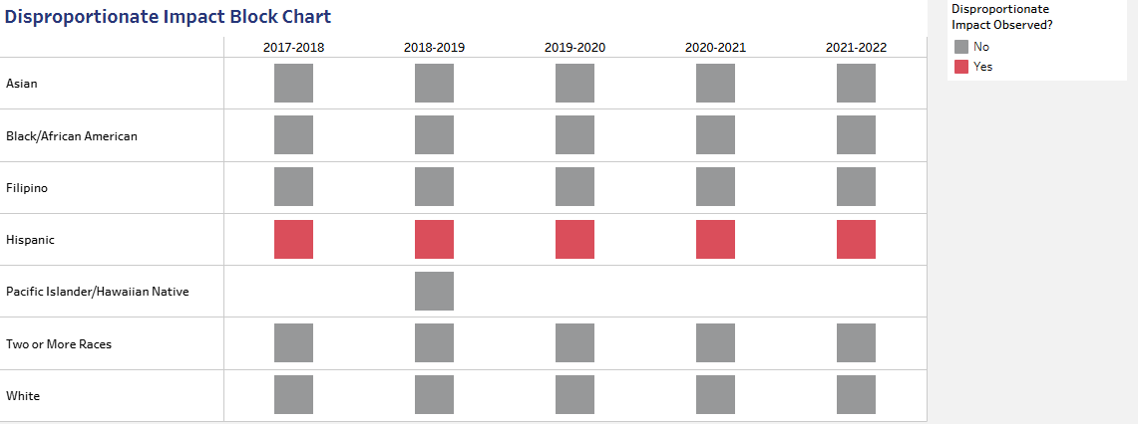
Section 6: Metric 1: Successful Enrollment
The percentage of first-time applicants who enroll by the end of that academic year (summer to spring)
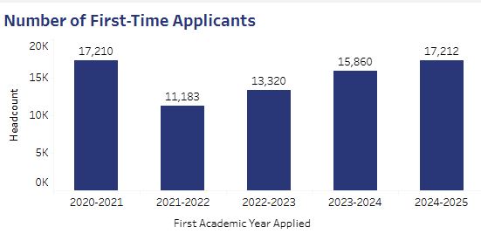

The table above shows that the Enrollment gap was closed for our Black/African American students.
Key Strategies for Successful Enrollment:
- “Reimagine” the use/function of “Assessment Center” The Assessment Center will be reimagined as an Enrollment Lab, serving as a hub where students transition seamlessly from prospective applicants to fully enrolled students. The Enrollment Lab will integrate services that address every stage of the enrollment journey. Students will receive guided support through application completion, document verification, and matriculation steps. Dedicated staff will assist with FAFSA submissions and financial aid counseling to ensure affordability is not a barrier. The lab will also provide hands-on registration support, helping students select appropriate courses aligned with their academic goals and term schedules. Collaboration across admissions, advising, and financial aid offices will create a one-stop environment that reduces confusion and increases enrollment. The goal is to transform the student experience into a streamlined, supportive pathway where every visitor leaves the lab “Successfully Enrolled.”
- Continuation and reinforcement of “Successful Enrollment Labs”; The continuation and reinforcement of Successful Enrollment Labs ensures that students receive consistent, hands-on support throughout the enrollment journey. These labs function as dedicated spaces where staff guide students through completing applications, resolving documentation issues, and navigating financial aid or FAFSA requirements. By addressing difficulties in real time, the labs reduce barriers and prevent delays that often hinder student progress. Reinforcement includes expanding lab hours, integrating technology for tracking progress, and fostering collaboration across admissions, advising, and financial aid offices. The labs will emphasize proactive outreach, inviting students who may be at risk of stopping out to return and complete their enrollment. Workshops and peer mentoring will be incorporated to build confidence and community, while multilingual support ensures accessibility for diverse populations.
- Targeted Recruitment and Outreach efforts, specifically tied into directing students into the use of “Successful Enrollment Labs, will be strategically aligned to direct students into Successful Enrollment Labs, ensuring personalized support at every stage. Efforts will extend beyond traditional marketing, using direct communication with high schools, community organizations, and digital platforms to reach diverse populations. The labs will be emphasized as a central resource for guidance on applications, financial aid, and registration. Staff and ambassadors will highlight the labs during events, orientations, and tours as the “gateway” to enrollment. Campaigns using social media, email, and text messaging will reinforce participation, creating a seamless bridge from interest to enrollment and boosting conversion rates.

- Additional strategy: Strengthen Dual Enrollment and Intentional partnerships with local K-12 partners; to create a more seamless pipeline into higher education. By enhancing our collaboration with district leaders, counselors, and teachers, institutions can ensure that students are aware of opportunities to earn college credit while enrolled in high school. Host annual “College Readiness and Dual Enrollment Summits” where high school students, parents, and educators engage with college faculty and staff. These events will provide hands-on workshops about enrollment labs, financial aid, and course selection, while also celebrating student success stories. This approach not only strengthens academic preparation but also builds trust and visibility, ensuring that more students transition confidently from high school into successful college enrollment.

Section 7: Metric 2: Transfer Level English and Mathematics
The percentage of students who successfully complete transfer-level English and Mathematics in their first academic year.
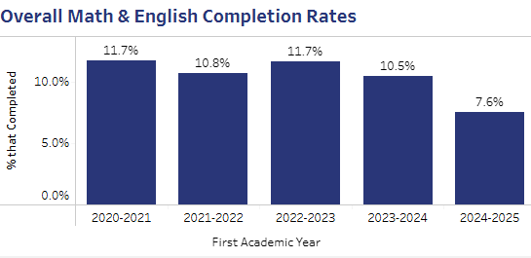

The table above shows that the Enrollment gap was closed for our Black/African American students.
Key Strategies to Transfer Level English and Mathematics:

- Development/maintenance of Major-specific/recommended math courses; will remain a priority to ensure students are placed in pathways that best support their academic and career goals. Continuous assessment and evaluation of student success in these courses will guide improvements, with particular attention to equity and completion outcomes. Progress will be reevaluated considering the Math 102 revamp and the implementation of AB 1705/705, ensuring compliance with state mandates while maintaining academic rigor. Faculty collaboration, curriculum adjustments, and data-driven decision making will strengthen course relevance, improve retention, and enhance overall student achievement in mathematics. Continue to assess and evaluate the effectiveness and success of students in respective math courses. The mathematics department alongside Institutional Research will conduct focus groups with enrolled students each semester to gather feedback on course design, instructional support, and overall learning experience.
- Co-Requisite English course: will be continuously evaluated to measure their effectiveness and impact on student success. These courses, designed to provide additional academic support while students complete transfer-level English, are critical in meeting the requirements of AB 1705/705. Evaluation will include tracking student completion rates, persistence, and performance outcomes, while also identifying equity gaps among diverse populations. Faculty collaboration and curriculum review will ensure that instructional strategies remain responsive to student needs. English department alongside Institutional Research will conduct focus groups with enrolled students each semester to gather feedback on course design, instructional support, and overall learning experience.

- Strengthening “Intrusive Counseling practices”, will involve using data and technology to provide more hands-on support in education planning and registration. Counselors will play an active role in guiding students through registration labs, conducting classroom visits, and collaborating closely with instructional faculty to ensure alignment between academic goals and course selection. Revisiting and refining the counselor liaison model, will help evaluate its effectiveness in fostering stronger student-counselor connections. Will continue to track student persistence and registration completion rates each term, comparing outcomes for those engaged in intrusive counseling versus those who were not.

- Additional key strategy: expansion of cohort models, options, and offerings to provide students with structured learning communities that foster engagement, persistence, and completion. Cohorts allow students to progress together through linked courses, build peer support networks, and access targeted advising and counseling services. Expanding options will include developing cohorts for specific majors, transfer pathways, and special populations such as first-generation or underrepresented students. Faculty collaboration and intentional programming will strengthen the sense of belonging and academic readiness. The departments will work collaboratively with Office of Institutional Research to monitor retention and completion rates of cohort participants compared to non-cohort students each academic year.

Section 8: Metric 3: Term to Term Persistence
The percentage of students who persist from their first primary term (fall or spring) to their second primary term.
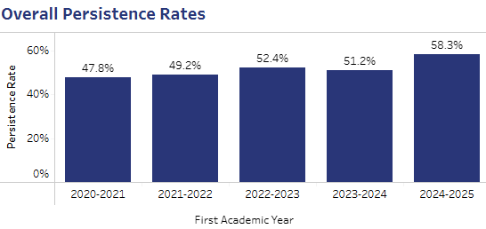

In 2024-2025, 54.0% of the 524 first-time Black/African American students persisted from their first primary term (either Fall or Spring) to the next immediate primary term, resulting in an observable disproportionate impact.
Key Strategies for Term-to-Term Persistence:
- Specialized Programs Information Sessions and Connecting Students to Support Programs and Services: will be expanded to intentionally connect students with campus resources, support programs, and services early and often. Since 80% of students are not affiliated with specialized programs, these sessions will maximize “in-reach” potential by proactively engaging students who may otherwise miss critical opportunities. Counselors, faculty, and program staff will collaborate to deliver presentations, workshops, and resource fairs that highlight academic support, financial aid, and student success initiatives. To measure success, departments and divisions will work collaboratively with Institutional Research to track on how many students joined or utilized support programs after attending sessions.

- Continue to Offer and Reinforce intentional Registration Season Efforts: will ensure students receive timely, proactive support to complete the enrollment process. Activities such as the Registration Block Parties will create welcoming, community-focused events where students can finalize schedules, meet counselors, and access resources in a supportive environment. Technology tools such as Starfish will be leveraged to track student progress, send reminders, and flag those needing additional outreach. Counselors will employ intrusive practices, guiding students step-by-step through registration and connecting them to enrollment labs for hands-on assistance. These combined strategies foster engagement, reduce barriers, and increase successful registration rates across diverse student populations.

- Intentional Efforts to Increase FAFSA and Financial Aid Application Process Completion: will focus on maximizing the use of “Enrollment Centers/Labs” as active spaces for financial aid support. These labs will provide hands-on assistance with FAFSA applications, verification, and award processing, ensuring students overcome common barriers to completion. Staff will collaborate with counseling and admissions to integrate financial aid guidance into the overall enrollment process, directly increasing the percentage of students receiving Pell Grants and other aid. FAFSA completion rates and Pell Grant awards each term will be assessed for outcomes before and after lab implementation.

- Additional Key Strategy: Elevate Equity through Culturally Responsive Academic Empowerment Initiatives, ensuring that all students feel supported and represented in their educational journey. These efforts will include the creation of culturally responsive learning communities that foster belonging and engagement, peer mentorship programs that connect students with role models who share similar backgrounds, and faculty development focused on inclusive pedagogy. By equipping instructors with tools to integrate diverse perspectives into teaching, SBVC can strengthen student success. Institutional research will work collaboratively to track retention and course completion rates of students participating in learning communities compared to non-participants.

Section 9: Metric 4: Vision Goal Completion
The percentage of students who graduate within three academic years of starting SBVC.
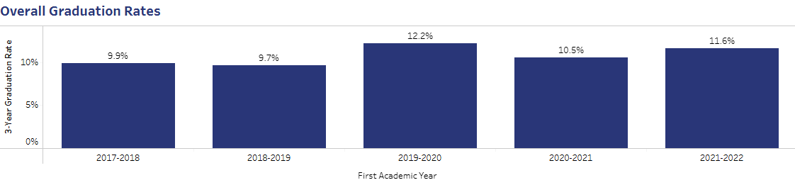

In 2021-2022, 6.5% of the 536 first-time Black/African American students graduated within three academic years of starting at SBVC, resulting in an observable disproportionate impact.

- Enhance data collection to identify the root causes: data-driven, systematic case management will be developed to integrate early alert tools, proactive counseling, and individualized education planning. This system will allow faculty and staff to monitor academic progress, intervene when challenges raise and provide support that addresses barriers to completion. By combining technology with intentional counseling practices, SBVC can ensure students receive timely guidance toward certificates, degrees, and transfer goals. Completion rates and persistence of students will be tracked through case management.
- Guided Pathways and Academic Mapping: continue to develop clear degree maps for all majors with embedded milestones to guide progress.
These maps will outline recommended courses, sequencing, and critical checkpoints, helping students avoid excess units and stay on track toward timely completion. Faculty, counselors, and advisors will collaborate to regularly review and update maps to reflect transfer requirements, workforce needs, and state mandates. By integrating academic planning tools and proactive counseling, SBVC can provide students with a transparent roadmap that improves retention, increases completion, and strengthens overall student success outcomes.

- Advancing Equity & Culturally Responsive Practices – will require intentional efforts to expand learning communities, peer mentorship opportunities, and faculty development in inclusive pedagogy. Learning communities will provide structured environments where students can build connections, foster belonging, and receive targeted academic support. Peer mentorship will connect students with role models who share similar backgrounds, offering guidance and encouragement throughout their educational journey. Faculty training will emphasize culturally responsive teaching strategies that integrate diverse perspectives into curriculum and classroom practice. This will reduce equity gaps, strengthen retention, and empower students to achieve academic and personal success.

- Additional Key strategy: Provide Comprehensive support to students; by expanding access to mental health services, financial aid guidance, and basic needs resources. Success coaches and peer mentors will guide students throughout their educational journey, ensuring personalized assistance and stronger connections to campus resources. Collaborate with Institutional Research to track the utilization of mental health, financial aid, and basic needs services, alongside retention outcomes of students engaged with success coaches and peer mentors.

Section 10: Metric 5: Transfer to a 4-year University
The percentage of students who transfer to a 4-year university within four academic years of starting at SBVC.
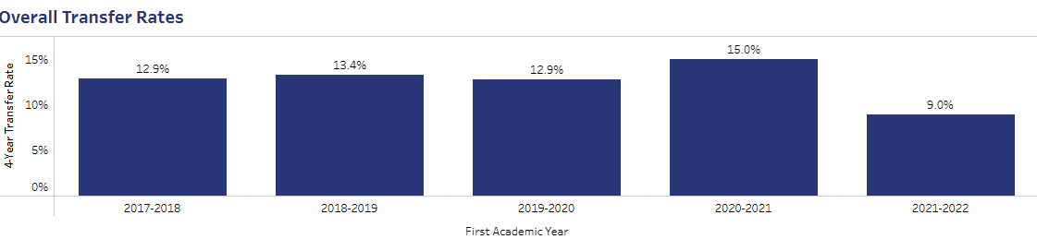

In 2021-2022, 8.0% of the 1,604 first-time Hispanic students transferred to a 4-year university within four academic years of starting at SBVC, resulting in an observable disproportionate impact.
- Eliminate Disproportionate Impact in Transfer Outcomes, SBVC will implement intentional strategies to eliminate disproportionate impact in transfer to four-year universities, to ensure that opportunities are equitable for all students. Collaboration with Transfer and Career Services Coordinator, faculty, and staff will identify and address barriers that prevent historically underrepresented groups from achieving successful transfer outcomes. Continuous assessment of transfer data, disaggregated by student demographics, will guide improvements.
- Close Equity Gaps in Transfer Outcomes- SBVC will implement intentional strategies to eliminate equity gaps in student transfer to four-year universities, ensuring that all students, regardless of race, ethnicity, income, or background, have equitable opportunities to achieve successful transfer outcomes. Strengthening guided pathways, expanding culturally responsive learning communities, enhancing intrusive counseling, and increasing financial aid access, are some of the key strategies. Faculty and staff will collaborate on how to remove systemic barriers and provide targeted support to historically underrepresented groups. Continuous monitoring of transfer data will guide improvements and ensure proportional representation in transfer rates across all student populations by 2030.

- Transfer-Focused Early Alert and Counseling SBVC will integrate transfer-focused early alert systems and counseling interventions to identify students at risk of delays in their transfer journey. Through proactive monitoring, faculty and staff will connect these students with academic advising, financial aid, and transfer resources to ensure timely support. This strategy strengthens pathways to four-year universities, reduces barriers, and promotes equitable transfer success across all student groups. By combining technology with personalized guidance, SBVC will improve retention and completion outcomes. Transfer and Career Services Coordinator will collaborate with Institutional Research to track annual transfer rates of students flagged by early alert compared to those not flagged.

- Additional Key Strategy: Cross Collaboration to Enhance Transfer Culture: SBVC will strengthen cross-collaboration among faculty, staff, student services, and community partners to build a robust transfer culture that supports Hispanic students and closes equity gaps. This strategy will include coordinated efforts between academic departments, counseling, and the Transfer Career Services Department to provide culturally responsive guidance, workshops, and mentorship. Partnerships with four-year universities will expand opportunities and streamline transfer pathways. By fostering a campus-wide commitment to equity, SBVC will ensure Hispanic students receive the resources and encouragement needed to achieve successful transfer outcomes. Transfer Career Services Coordinator will work collaboratively with Institutional Research to annually track Hispanic student transfer rates and compare progress against baseline data to monitor equity gap closure.

Section 11: Intensive Focus on Population(s) Experiencing Disproportionate Impact

Equity Focus: Black/African American Students – Term-to-Term Persistence

Black/African American students at SBVC continue to experience disproportionate impact in term-to-term persistence and Vision Goal completion. To address these gaps, SBVC will implement intentional strategies that provide targeted support, strengthen engagement, and ensure equitable outcomes.

Action Plan 1: Intrusive Counseling and Early Alert Systems
- Implement proactive counseling interventions to identify students at risk of not persisting.
- Use early alert technology to flag attendance, academic performance, and financial aid challenges.
- Connect students immediately to advising, tutoring, and financial resources.
Measurement of Success: Track persistence rates of Black/African American students flagged by early alert compared to those not flagged, aiming for year-over-year improvement and parity with overall student persistence rates by 2030.

Action Plan 2: Culturally Responsive Learning Communities and Mentorship
- Expand culturally responsive learning communities that affirm identity and provide academic support.
- Pair students with faculty/staff mentors and peer mentors to strengthen belonging and accountability.
- Offer workshops focused on transfer readiness, financial literacy, and career planning.

Measurement of Success: Monitor participation rates in learning communities and mentorship programs and compare persistence and completion outcomes of participants versus non-participants. Target: close the persistence gap by 2030.

Support Commitment
SBVC will support Black/African American students by embedding equity into curriculum, instruction, and student services. This includes culturally responsive pedagogy, expanded financial aid outreach, and intentional community-building efforts. By aligning these supports with Vision 2030, SBVC ensures that persistence and completion outcomes reflect the true potential of all students.

Equity Focus: Hispanic/Latine Students – Transfer to Four-Year Universities

Hispanic/Latine students at SBVC experience disproportionate impact in lower transfer rates to four-year universities. To close these gaps, SBVC will implement intentional, equity-driven strategies that strengthen academic pathways, provide culturally responsive support, and ensure successful transfer outcomes.
Action Plan 1: Strengthen Guided Pathways and Transfer Readiness
- Expand guided pathways with clear milestones for transfer preparation.
- Provide intrusive counseling focused on transfer planning, financial aid literacy, and academic advising.
- Partner with four-year universities to streamline articulation agreements and transfer workshops.
Measurement of Success: Track annual transfer rates of Hispanic/Latine students, comparing progress against baseline data. Target: year-over-year increase in transfer rates, with parity achieved by 2030.

Action Plan 2: Expand Culturally Responsive Learning Communities and Mentorship
- Enhance learning communities that affirm cultural identity and provide academic support.
- Pair students with faculty/staff mentors and peer mentors to strengthen belonging and accountability.
- Offer workshops on career readiness, leadership, and navigating university systems.
Measurement of Success: Monitor participation rates in learning communities and mentorship programs. Compare persistence and transfer outcomes of participants versus non-participants. Target: close persistence and completion gaps by 2030.
Support Commitment
SBVC will support Hispanic/Latine students by embedding equity into curriculum, instruction, and student services. This includes culturally responsive pedagogy, expanded financial aid outreach, and intentional community-building efforts. By aligning these supports with Vision 2030, SBVC ensures that Hispanic/Latine students achieve equitable transfer outcomes and thrive both academically and personally.

Section 12: Student Education Plans
Comprehensive Student Education Plans
Academic Year cohort (include summer and winter if applicable | Total number of Enrolled Students in Cohort | # of students who received a comprehensive Ed plan by end of 1st Primary Term | % of students (out of the total number of students enrolled in cohort) who received a comprehensive ed plan by end of first primary term | # of students who received a comprehensive ed plan by end of first academic year | % of students (out of the total number of students enrolled in cohort) who received a comprehensive by end of first academic year
Fall 2022 Cohort (comprehensive ed plan by 6/30/2023)
Spring 2023 cohort (comprehensive ed plan)
Fall 2023 cohort (comprehensive ed plan by 6/30/2024)
Spring 2024 cohort (comprehensive ed plan by 12/30/2024)

Section 13: SBVC Vision 2030 Alignment:
  - Guided Pathways and Equity Centered Strategies
San Bernardino Valley College is committed to centering the student experience through the Guided Pathways framework, ensuring that equity-driven practices are embedded in all aspects of student support, academic programs, and institutional decision-making. Some key strategies, but not limited to:
- Integrated Student Support Structures
- Enhance and support the Welcome Center that integrates admissions, financial aid, and orientation, ensuring students, particularly disproportionately impacted populations, receive holistic and coordinated support.
- Align case management, early alert systems, and student success coaching, which will guide students through course sequencing, program requirements, and transfer opportunities.
- Equity Centered Academic Pathways
- Continue to implement degree and certificate maps that clearly outline major transfer-level course sequences for Black/African American students.
- Expand learning communities and culturally responsive programs to integrate academic support, mentoring, and counseling.
- Utilize disaggregated data to identify equity gaps in course completion, program progression, and transfer, informing targeted interventions within pathways, especially for Black/African American students.
- Cross-functional collaboration and faculty engagement
- Foster collaboration between instructional faculty, student services, and classified professionals to ensure that course offerings, support services, and academic interventions are aligned with student pathways and Vision 2030 goals.
- Provide professional development for faculty and staff focused on equity-minded teaching, culturally responsive pedagogy, and anti-racist practices to strengthen student engagement and persistence.
- Continuous Monitoring and Improvement
- Embed ongoing assessment and evaluation using student outcome data to refine pathways, support strategies, and interventions for disproportionately impacted students.
- Aligning SEA program initiatives with Guided Pathways progress metrics, ensuring that equity center goals, such as enrollment, persistence, completion, and transfer, are met for all student populations.
Through these structural changes, intentional initiatives, and actions, SBVC ensures that the Guided Pathways framework is not only a roadmap for academic success but also a mechanism to close equity gaps and fulfill the Vision 2030 commitment to student-centered, equitable educational outcomes.
  - Student Financial Aid Administration
SBVC is committed to maximizing financial aid access and supporting the success of disproportionately impacted students, particularly Black/African American students. Key strategies include, but are not limited to:
- FAFSA completion and outreach
- Conduct targeted outreach campaigns in collaboration with high schools, community organizations, and internal departments.
- Offer bilingual workshops, virtual sessions, and one-on-one assistance to guide students and families through the application process.
- Holistic Financial Aid Guidance
- Provide early notifications and reminders for students regarding Pell Grants, Cal Grants, scholarships, and emergency aid.
- Offer workshops on financial literacy, budgeting, and planning to help students maintain enrollment and progress toward completion.
- Data-Informed Evaluation
- Use disaggregated data to track FAFSA completion, receipt, and impact on enrollment and persistence.
- Regularly assess financial aid outreach and support strategies to identify gaps and refine interventions for DI student populations.
SBVC will ensure that financial barriers are minimized and that all students can access the resources necessary to enroll, persist, and succeed academically.
3. Student Accessibility Services (SAS)
  - Student Accessibility Services (SAS) is committed to ensuring equitable access and supporting disproportionately impacted students in achieving academic success. Key strategies, but not limited to:
- Proactive Outreach and Early Engagement
- SAS staff will identify and reach out to students with disabilities early in the enrollment process to provide guidance on accommodations, academic planning, and campus resources.
- Collaborate with counseling, outreach, and equity programs to ensure students are aware of SAS services.
- Professional Development and Campus Collaboration
- Provide workshops to faculty and staff on inclusive teaching practices, accessibility, and equity-minded pedagogy.
- Collaborate with student services and instructional divisions to embed SAS support into pathways, ensuring all students have equitable opportunities to succeed.
Through these coordinated efforts, SAS supports the removal of systemic and structural barriers, promoting equitable enrollment, persistence, and completion for Black/African American students.
- Extended Opportunity Programs & Services (EOPS), Cooperative Agencies Resources for Education (CARE) and CalWORKs
EOPS/CARE & CalWORKs programs are committed to removing barriers and promoting equitable success for disproportionately impacted students, particularly Black/African American students. Key strategies include, but are not limited to:
SBVC’s EOPS/CARE & CalWORKs Programs are committed to removing barriers and promoting equitable success for disproportionately impacted students, particularly Black/African American students. Key strategies include, but are not limited to:
- Proactive Outreach and Early Enrollment Support
a) Conduct targeted outreach to identify eligible students early, especially those from underrepresented communities, to maximize program participation.
b) Assist students with application completion, financial aid coordination, and enrollment support, ensuring timely connection to essential resources.
- Integration with Equity Initiatives
a) Collaborate with Guided Pathways, Umoja-Tumaini, Puente, Tatayan, and First Year Experience programs to provide culturally relevant academic and mentoring support.
b) Use data-driven tracking to monitor student progress, identify at-risk students, and intervene early to prevent stop-outs.
c) Track and report outcomes related to enrollment, persistence, degree/certificate completion, and transfer, with particular attention to Black/African American and Hispanic/Latine students.
EOPS/CARE and CalWORKs will continue to ensure that Black/African American and Hispanic/Latine students receive targeted academic, financial, and personal support to overcome systematic barriers, persist towards completion, and achieve their academic and career goals.

- NextUp & Guardian Scholars
NextUp and Guardian Scholars are programs designed and dedicated to providing targeted support to disproportionately impacted students who are also current or former foster youth enrolled at or planning to enroll at SBVC. Like other student support programs, the focus is to promote equitable acces, persistence, and completion. Key strategies are but not limited to:
  - Proactive Outreach and Early Connection
- Identify and engage foster youth early, including those from underrepresented communities, to connect them with essential NextUp services and resources tailored to their unique needs.
- Collaborate with service-area K-12 districts, community partners such as San Bernardino County Superintendent of Schools (SBCSS), the County’s Children and Family Services (CFS), and Giveback Academy as well as the various on-campus departments to ensure timely access to enrollment, financial aid, and academic support services.
  - Foster Youth Advisory Council (FYAC) Initiative: In partnership with SBCSS, the NextUp and Guardian Scholars Program are working with Eisenhower High School in the Rialto Unified School District to roll out the FYAC Initiative during the 2025-2026 academic year. This initiative aims to enhance peer mentorship, student leadership, and engagement opportunities for foster youth students.
Key components of this initiative include:
  - Leadership training provided by the GiveBack Academy.
  - Providing stipends of $800 per semester to four selected NextUp Student Peer Mentors, who will lead FYAC meetings and mentor new and current foster youth students.
  - Allocating funds to purchase incentives (e.g., vendor gift cards) to encourage mentee participation in FYAC meetings and mentoring sessions.
  - Supporting program and marketing materials to promote the initiative and enhance student leadership skills.
NextUp and Guardian Scholars support current and former foster youth, especially DI student populations at SBVC, by providing early outreach, connecting students to essential services, and collaborating with K-12 districts and community partners to ensure access to enrollment, financial aid, and academic resources. The programs are also launching the Foster Youth Advisory Council (FYAC) with SBCSS and Eisenhower High School to strengthen peer mentorship and leadership through training, mentor stipends, participation incentives, and targeted outreach.

- Veterans Resource Center
The Veterans Resource Center is committed to removing barriers and promoting equitable success for disproportionately impacted students, particularly Black/African American students. Key strategies include, but are not limited to:
- Proactive Outreach and Early Enrollment Support
- Conduct targeted outreach to identify eligible students early, including those from underrepresented communities, to maximize program participation.
- Assist students with application completion, financial aid coordination, and enrollment support, ensuring early connection to resources.

- Integration with Equity Initiatives
- Collaborate with Guided Pathways, Umoja Tumaini, Puente, and First Year Experience programs to provide culturally relevant academic and mentoring support.
- Use data-driven tracking to monitor student progress, identify at-risk students, and intervene early to prevent stop-outs.
- Track and report outcomes for enrollment, persistence, degree/certificate completion, and transfer for Black/African American and Hispanic/Latine students, in particular.
The Veteran’s Resource Center will ensure that Black/African American and Hispanic/Latine students receive targeted academic, financial, and personal support to overcome systemic barriers, persist in their education, and achieve their academic and career goals.
- Justice Involved/Justice Impacted Students
San Bernardino Valley College is committed to providing equitable access, support, and pathways to success for justice-involved and justice-impacted students. Key strategies include, but are not limited to:
- Proactive Outreach and Early Enrollment Support
- Conduct targeted outreach to identify eligible students early, including those from underrepresented communities, to maximize program participation. These may include local correctional facilities, probation offices, juvenile facilities, and community organizations.
- Assist students with SBVC admission application completion, financial aid assistance, and enrollment support, to ensure academic counseling, transition to college, and referrals to support programs.

- Integration with Equity Initiatives
- Collaborate with Guided Pathways, Umoja Tumaini, Puente, Tatayan, and First Year Experience programs to provide culturally relevant academic and mentoring support.
- Use data-driven tracking to monitor student progress, identify at-risk students, and intervene early to prevent stop-outs.
- Track and report outcomes for enrollment, persistence, degree/certificate completion, and transfer for Black/African American and Hispanic/Latine students, in particular.
Through these strategies, SBVC removes structural barriers, fosters retention and academic success, and ensures justice-involved and justice-impacted students have equitable opportunities to persist, complete, and transfer.

- Low Income Adults
To expand access and improve outcomes for low-income adult learners, San Bernardino Valley College will implement intentional, equity-driven strategies that address structural barriers and foster a culture of support, flexibility, and belonging. Key strategies include:
1) Flexible Academic Pathways and Scheduling
a) Increase access to short-term certificates, hybrid, and online course offerings to accommodate working adults and caregivers.
b) Expand evening, weekend, and accelerated course options to promote degree and certificate completion.
2) Strengthened Financial and Basic Needs Support
a) Expand outreach and support for financial aid, including FAFSA/CADAA workshops and personalized assistance to increase participation among adult learners.
b) Enhance partnerships with Basic Needs programs (food pantry, emergency grants, transportation assistance, technology loan programs) to reduce non-academic barriers to persistence.
3) Holistic Student Support and Case Management
a) Develop a proactive case management model to connect adult learners with counseling, career services, tutoring, and community resources.
b) Strengthen the coordination between Student Services and Workforce Development to provide wraparound academic and career support.
4) Targeted Outreach and Re-engagement
a) implement outreach campaigns to re-engage students with “some college, no degree,” leveraging data to identify and invite them back to complete their education.
b) Partner with local employers, workforce agencies, and community organizations to increase awareness of educational opportunities for working adults.
5. Professional Development and Institutional Alignment
a) Provide equity-focused professional development for faculty and staff on serving adult learners, trauma-informed practices, and inclusive classroom strategies.
b) Review institutional policies and processes, such as enrollment, placement, and academic probation, to identify and remove barriers that disproportionately affect low-income adults.
6) Continuous Evaluation and Improvement
a) Use disaggregated data to monitor enrollment, retention, and completion outcomes for low-income adult learners.
b) Collect student feedback to guide program improvements and ensure initiatives remain responsive to adult learners’ evolving needs.

- Credit for Prior Learning (CPL)
San Bernardino Valley College is committed to expanding equitable access, support, and pathways to success to Credit for Prior Learning (CPL). Key strategies include, but are not limited to:
- Proactive Awareness and Outreach for Early Enrollment Support
  - Conduct targeted outreach to identify eligible students early, including those from underrepresented communities, to maximize program participation.
  - Assist students with application completion, financial aid coordination, and enrollment support, ensuring early connection to resources.

- Integration with Equity Initiatives
  - Collaborate with Guided Pathways, Umoja Tumaini, Puente, Tatayan, and First Year Experience programs to provide culturally relevant academic and mentoring support.
  - Use data-driven tracking to monitor student progress, identify at-risk students, and intervene early to prevent stop-outs.
  - Track and report outcomes for enrollment, persistence, degree/certificate completion, and transfer for Black/African American and Hispanic/Latine students.
Through these strategies, SBVC ensures that CPL is accessible, transparent, and leveraged as a tool to reduce barriers, promote timely completion, and advance equity for all students.

- Dual Enrollment
San Bernardino Valley College is committed to expanding equitable access, support, and pathways to high school students. Key strategies include, but are not limited to:
- Proactive Outreach and Recruitment
- Conduct targeted outreach to identify eligible students early, including those from underrepresented communities, to maximize program participation.
- Assist students with application completion, financial aid coordination, and enrollment support, ensuring early connection to resources.

- Integration with Equity Initiatives
- Collaborate with Guided Pathways, Umoja Tumaini, Puente, Tatayan, and First Year Experience programs to provide culturally relevant academic and mentoring support.
- Use data-driven tracking to monitor student progress, identify at-risk students, and intervene early to prevent stop-outs.
- Track and report outcomes for enrollment, persistence, degree/certificate completion, and transfer for Black/African American and Hispanic/Latine students, in particular.
- Align dual enrollment courses with SBVC’s guided pathways to ensure transfer-level readiness and seamless transition to college programs.
Through these strategies, SBVC ensures that dual enrollment serves as a bridge to higher education, accelerates academic progress, and reduces equity gaps for Black/African American students.

- Strong Workforce/Perkins
San Bernardino Valley College is committed to providing and expanding equitable access, support, and technical education (CTE) opportunities. Improving workforce outcomes and closing equity gaps for disproportionately impacted students in particular Black/African American students. Key strategies include, but are not limited to:
- Targeted Outreach and Recruitment
- Conduct targeted outreach to identify eligible students early, including those from underrepresented communities, to maximize program participation. These may include local high schools, workforce development boards, and community organizations.
- Assist students with application completion, financial aid coordination, and enrollment support, ensuring early connection to resources.

- Integration with Equity Initiatives
- Provide personalized career counseling, academic advising, and mentorship to guide students through CTE program completion and transfer.
- Use data-driven tracking to monitor student progress, identify at-risk students, and intervene early to prevent stop-outs.
- Track and report outcomes for enrollment, persistence, degree/certificate completion, and transfer for Black/African American and Hispanic/Latine students, in particular.
- Refine program offerings, student support services, and employer partnerships based on equity-focused outcomes to maximize success and socio-economic mobility.
Through these strategies, SBVC ensures that workforce and technical education pathways are accessible, equitable, and aligned with Vision 2030 goals, providing Black African/American students with opportunities to achieve high-wage careers and economic mobility.

