2024-2025 Year-End Committee Report
Guided Pathways
In effort to fulfill Article XV in the Senate’s bylaws, the following annual report is being submitted to the Academic Senate on behalf of the Faculty Co-Leads for the Guided Pathways Standing Committee (Lucas Cuny and Keenan Giles)
Guided Pathways is a whole-college redesign model designed to help all students explore, choose, plan, and complete programs aligned with their career and education goals efficiently and affordably. It is an equity-focused framework that allows us to forge clear paths for students and remove systemic obstacles to their success. The Student Equity and Achievement (SEA) Program requires colleges to implement the Guided Pathways framework.

Student Equity and Achievement (SEA) Metrics
In 2018, the Student Equity and Achievement (SEA) Program was established by the California Community Colleges Chancellor's Office. It merged funding for three initiatives: the Student Success and Support Program; the Basic Skills Initiative; and Student Equity. Integrating these efforts into a single program advances our goal of demolishing once and for all the achievement gaps for students from traditionally underrepresented populations.
Under the SEA Program, colleges are required to implement the Guided Pathways framework offering a clear path to a stated goal, to provide all students with an education plan based on that goal, and to toss aside outdated and inaccurate placement policies that are keeping far too many from completing their goals in a timely manner. SEA focuses on five specific metrics, or success indicators, to measure student success:
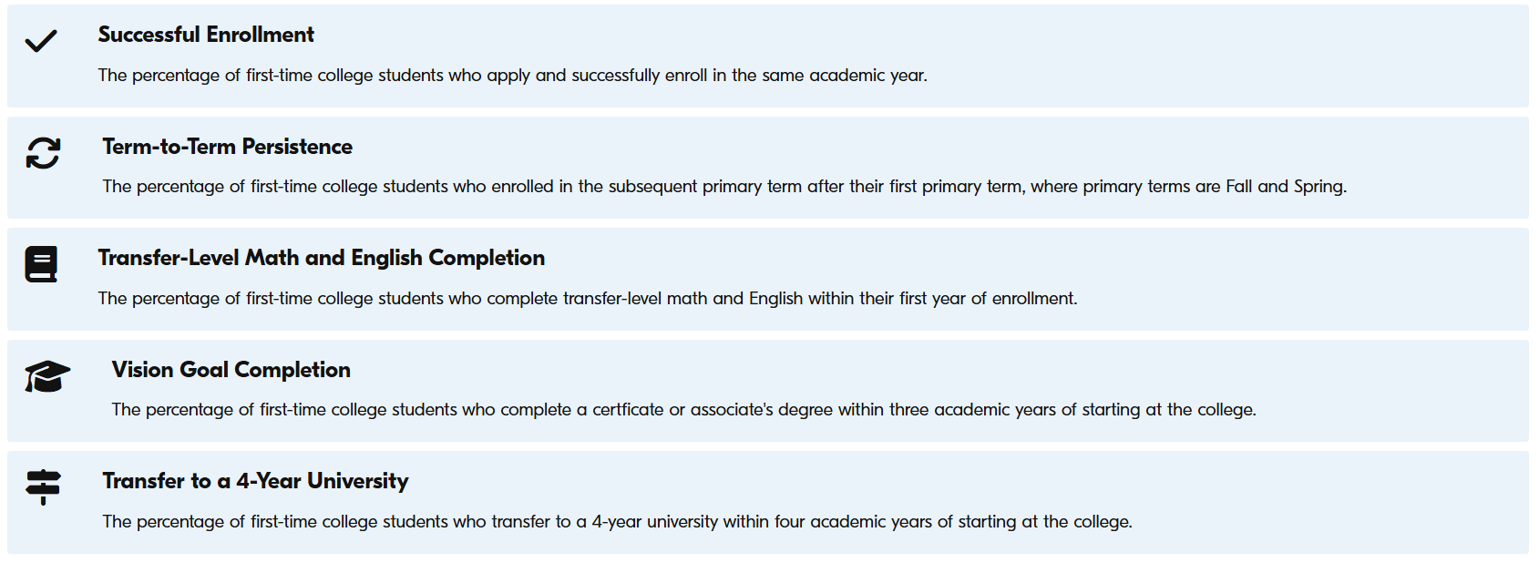
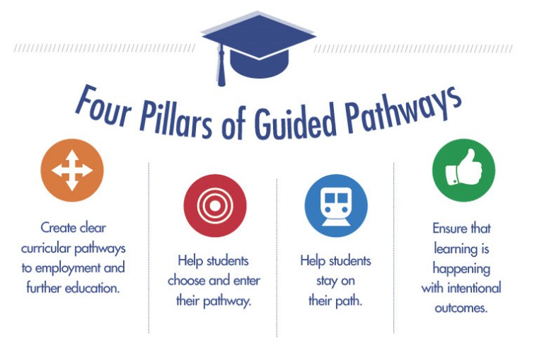
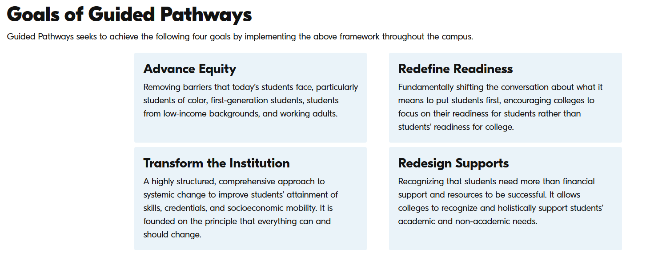
Guided Pathways Committee is currently working from the “Guided Pathways Work Plan” for the 2022-2026 Reporting Period. Expectation is to receive further guidance from the CCCCO as it relates to direction in 2026, as we approach “Vision 2030” Initiative.

Highlights from the 2024-2025 Academic Year
- Continued work on total SBVC Website Overhaul (Metric 1; Pillar 1 &2)
- Refined “Registration Season” efforts (Metrics 1-5; Pillars 1-4)
- Collaborative efforts with the Science Division and Umoja-Tumaini in creating their upcoming cohort (Metrics 1-5; Pillars 1-4)
- Continued collaborative work with SBVC Specialized Programs to increase student awareness, engagement, and participation (Metrics 1-5; Pillars 1-4)
- Continued participation on Regional Student Equity Planning Institute (SEPI), as “Student Equity Committee” prepares for the development of the 2025-2028 Student Equity Plan (Metrics 1-5; Pillars 1-4)
- Foundational work with “Dual Enrollment” to create model(s) for various student demographics/affinity groups and local K-12 district partners (Metrics 1-5; Pillars 1-4)
- Created draft of “Master Calendar of Events”

Direction for 2025-2026 Academic Year
- Anticipating “merger” and establishment of “Student Success Advisory Committee”, as recommended by Participatory Governance Task Force
- Contribute to 2025-2026 Student Equity Plan; November 2025 submission
- Continued development of Dual Enrollment models
- Continued development of Cohort Programs and “wraparound services” models
- Continued development of “Counselor Liaison” structure and utilization of case management model
- Formalize collaborative relationships/efforts w/ District Job Development efforts
- Reestablish and solidify “Communications Team” to ensure institutional communication and collaboration accordingly.
- Finalizing and implement “Master Calendar of Events”
- Continuing work other Campus Committees (Distance Learning, ZTC, Enrollment Management, etc)

