Campus Technology Strategic Plan
2016-2019

Table of Contents

San Bernardino Valley College 3
Vision 3
Mission 3
Challenges and Opportunities 4
Goals for Success (2013–2016) 4
The SBVC Campus Technology Strategic Plan 5
Purpose 5
Process 5
Technology Committee Members 2012-2013 5
Technology Vision 6
Technology Mission 6
Technology Guiding Values 6
Goals and Supporting Strategies 7
Alignment of Technology Goals and Strategies with San Bernardino Community College District’s Planning Imperatives 9
San Bernardino Valley College’s Educational Master Plan (EMP) Objectives for 2013-2016 16

San Bernardino Valley College

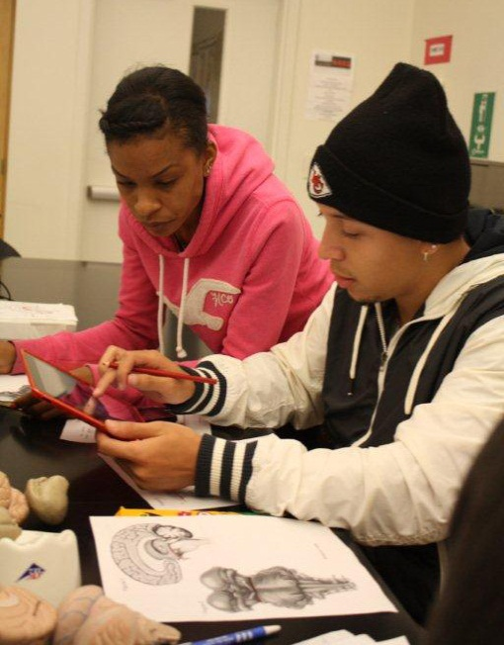
San Bernardino Valley College (SBVC) is a comprehensive community college offering a full range of degrees, transfer programs to four-year institutions, and certificates in a wide range of careers. Fully accredited through 2014, SBVC is a regional leader in career and technical education with programs in computer and information technology, graphic arts, computer science, nursing, automotive, machine trades, welding, electrical, and dozens more. Weekend, online, evening, short-term, and distance-learning classes are available along with classes in Big Bear.

For more information, visit www.valleycollege.edu, follow campus news on Facebook and Twitter, or call (909) 384-4400. The college is located at 701 S. Mt. Vernon Avenue, San Bernardino, CA 92410.

Vision

San Bernardino Valley College will become the college of choice for students in the Inland Empire and will be regarded as the "alma mater" of successful, lifelong learners. We will build our reputation on the quality of our programs and services and on the safety, comfort, and beauty of our campus. We will hold both our students and ourselves to high standards of achievement and will expect all members of the college community to function as informed, responsible, and active members of society.

Mission

San Bernardino Valley College provides quality education and services that support a diverse community of learners.

Challenges and Opportunities
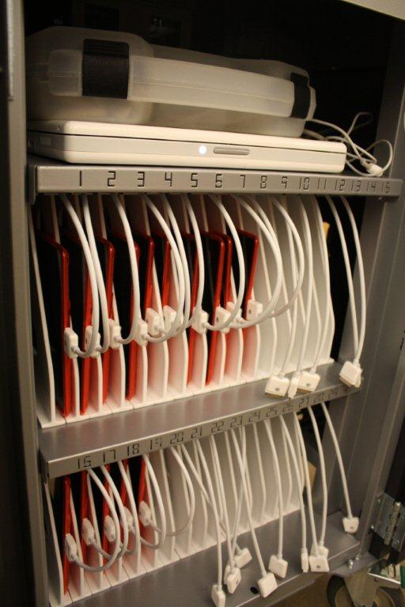
SBVC is facing challenges in funding, competition, changing demographics, escalating constituent expectations, underprepared students, and a growing demand for access to online educational services. As with all higher education institutions, SBVC is affected by an extraordinary level of change, especially in the area of technology. The ever-increasing rate of change requires that SBVC continuously monitor the horizon for emerging trends for future success while maintaining the delivery of quality education services to their current constituents.

Transforming these challenges into opportunities is the fundamental goal of the SBVC IT Strategic Planning effort.

Goals for Success (2016–2019)

This Campus Technology Strategic Plan describes SBVC’s direction for technology through the adoption of goals that are designed to move the institution toward its future vision for technology. The remaining sections in this plan explain the process used to develop these goals, for example, introduction of the supporting strategies for each goal, demonstration of alignment with the Campus Strategic Master Plan, District’s Planning Imperatives, and an implementation plan for each goal and supporting strategy.

- Provide exemplary technology resources and support while maintaining fiscal and environmental responsibility.
- Support the Online Program Committee’s Plans and Goals.
- Encourage partnerships businesses, other organizations, and the surrounding community.
- Collaborate with the District on projects that are beneficial to all.
- Work cooperatively through the Office of Professional Development to provide appropriate technology training.
- Identify and meet accessibility standards set by Section 508.

The SBVC Campus Technology Strategic Plan

Purpose

The SBVC Technology Strategic Plan provides a comprehensive roadmap for utilizing technology to improve the overall performance of the institution. The three-year plan presents focused goals and supporting strategies which will move the institution closer to realizing its vision.

Process

This plan is built on a foundation of IT strategic planning that began at SBVC in 2001. Each plan has enabled SBVC to navigate the changing environment and successfully position itself for the future. This plan has been modified regularly since its inception, and this particular version has been revised and updated by the Technology Committee during the 2012-2013 academic year and finalized in the Fall of 2013. It will remain in place until June 2017, when it will be evaluated once again.

SBVC’s Technology Committee is responsible for developing and maintaining the IT Strategic Plan. It is charged to explore and encourage innovation in the use of technology, including the support and training of faculty and staff in the use of technology for academic and management applications.

Technology Committee Members 2012-2013

Hrdlicka, Rick (Co-Chair) Director, Campus Technology Services
Bastedo, Dave (Co-Chair) Professor, Biology
Batalo, Mandi Assistant Professor, Art
Blecka, Lori Associate Professor, Mathematics
Bojorquez, Ana Assistive Technology Specialist, Disabled Students Program and Services
Dillard, Kristin Assistant Professor, Mathematics
Flaa, Jonathan Media Specialist, Campus Technology Services
Jackson, Jack Professor, Philosophy/Religious Studies
Jackson, Mona M. Professor, Computer Information Technology
Jefferson, Kimberly Assistant Professor, Reading and Study Skills
Manzo, Berenice Counselor, HSI STEM Pass Go
McGinnis, Odette Interim Dean, Mathematics, Business and Information Technology
Powell, Mike Assistant Professor, Physical Education
Race, Steven Senior Media Specialist, Campus Technology Services
Roseli, Gabriel Technology Support Specialist II, Campus Technology Services
Sims, Jeremy Director, District Technology Services
Trejo, Sam Interim Coordinator, Financial Aid
Sogomonian, Nori Acting Coordinator, Professional Development
Stark, Scott Interim Vice President, Administrative Services
Wall, Patti Associate Professor, Library and Learning Support Services

Technology Vision

Students, faculty, and staff will have universal access to the tools and resources of current and emerging technologies, and the expertise to use them effectively for the process of learning

Technology Mission

The Technology Committee is the bridge that crosses the digital divide for students, faculty, and staff by providing and implementing a plan for universal access to technology.

Technology Guiding Values
We value:
- Effective training and professional development
- Development of technologically literate students, staff and faculty
- Effective use of technology that will positively influence the community
- Partnerships with our community
- A climate of continuous improvement
- Exploration of emerging technologies
- That the District and Campus Technology Services provide exemplary support to the campus community.
- Fulfilling the technological needs of the campus community

Goals and Supporting Strategies

In 2013 the Technology Committee revised the goals and the supporting strategies to reflect accomplishments and changing needs.

- Provide exemplary technology resources and support while maintaining fiscal and environmental responsibility.

Supporting Strategy:
1.1. Maintain the processes for determining the technology needs of students, faculty, staff, and administrators and incorporate the data into technology planning.
1.2. Maintain and adhere to minimum standards for classroom technology.
1.3. Provide faculty with the latest information on the trends in emerging technologies.
1.4. Develop and update current web-based services on an ongoing basis.
1.5. Provide an open yet secure network that allows reliable accessibility while providing confidentiality of information.
1.6 Provide adequate number of expert support staff to meet the day-to-day and long-term technology needs of students, faculty and staff on campus.

- Support the Online Program Committee’s Plans and Goals. http://www.valleycollege.edu/about-sbvc/campus-committees/additional-committees/online-program/opcplan

Supporting Strategy:
2.1 Curriculum and instruction
2.2 Faculty support
2.3 Student support
2.4 Evaluation and assessment

- Encourage partnerships with businesses, other organizations, and the surrounding community.

Supporting Strategy:
  - Develop technology-related partnerships with businesses, organizations, and agencies.
  - Promote activities and events that connect businesses with SBVC students.
  - Develop partnership opportunities with feeder schools, colleges, and universities.
  - Review local and national trends in technology to drive program development.
  - Work with vendors to provide student discounts for educational technology.

- Collaborate with the District on projects that are beneficial to all.

Supporting Strategy:
  - Identify, implement, and support electronic communication tools that serve all of our users.
  - Develop initiatives that promote district wide benefits.
  - Ensure communication among students, faculty, staff, administrators, and consultants with regard to technology.
  - Maintain communication mechanisms that connect campus technology with district computing.

- Work cooperatively through the Office of Professional Development to provide appropriate technology training.

Supporting Strategy:
  - Provide appropriate technology training opportunities for all SBVC personnel through the use of diverse delivery methods that provide access to all.
  - Encourage the development of curriculum that prepares our students for success with web-based and web-enhanced courses.
  - Provide individualized technology training for faculty and staff.
  - Provide access to conferences through alternative methods.

- Identify and meet accessibility standards set by Section 508.

Supporting Strategy:
  - Provide accessible systems to the campus community.
  - Maintain standards for accessibility for all institutional websites to ensure compliance.
  - Provide accessibility training to faculty and staff.
  - Provide training in the use of accessibility software where needed.

Technology Plan Objectives
Goal 1. Provide exemplary technology resources and support while maintaining fiscal and environmental responsibility.
1.1 Explore the feasibility of implementing a technology fee for students that can support SBVC technology initiatives.
- Research Ed code and Title V to see if it is permissible
- See what other Community colleges are doing
- Take to campus community for feedback and buy in
- Implement if feasible and desired.

1.2 Explore the feasibility and implement a Virtual Internet Lab that will enable students to take laboratory classes in an online environment and train faculty and staff in its use; promote the use of the hardware and software for all DE classes with associated labs
- Develop a list of interested programs
- Meet with programs to set priorities, expectations, and possible solutions
- Explore vendor solutions
- Identify funding and implement solution if feasible

1.3 Purchase software or service for the development of mobile application that students, faculty and staff can use to interact with campus and district resources
- Choose best product for the campus
- Identify ongoing funding resource
- Implement Mobile presence

1.3 Incorporate the History of SBVC into the campus web page.
- Identify responsible party(s)
- Collect pertinent info
- Implement solution

1.4 Expand the number of technology support staff to meet expectations of students, faculty, and staff.
- Evaluate the needs of students, faculty and staff
- Determine needed expansion
- Hire staff to meet the need

Goal 2. Support the Online Program Committee’s Plans and Goals.
2.1 Coordinate planning processes to ensure that accreditation standards regarding DE are met.
- Collect and monitor all relevant ACCJC docs
- Construct framework for collecting evidence regarding accreditation and DE
- Participate in Accreditation Committee creation of ACCJC self-evaluation
- Review Online Learning Plan every semester and adjust as necessary

2.2 Create a data set to be used to evaluate effectiveness of online and/or hybrid classes.
- Deploy Online Student Satisfaction Survey every spring
- Publicize results of Online Satisfaction survey on SBVC website
- Gather data from state Chancellor's office on success and retention
- Publicize data on success and retention on SBVC website
- Compare DE and non-DE SLO results
- Publicize data on SLOs on SBVC website
- Discuss data set in the Online Program Committee to recommend improvements in DE offerings

2.3 Ensure that faculty assigned to teach online are adequately prepared to teach online, including familiarity with the current CMS and awareness of applicable pedagogical strategies for online teaching and learning.
- Survey faculty on how they learned to teach online and what professional development opportunities they desire
- Explore strategies for verifying faculty qualification for online teaching
- Share results with Deans and Faculty Chairs
- Develop a policy around the results

Goal 3. Encourage partnerships and promote awareness with businesses, other organizations, and the surrounding community.
3.1 Invite prominent business leaders to campus to discuss technology trends associated with their industries. Include questions students tweet to the speaker.
- Work with ASG and CTE Programs
- Schedule at least one campus-wide presentation per semester
- Leverage CTE advisory groups and schedule presentations on the days they are here for advisory meetings

3.2 Expand and enhance local businesses and community organizations awareness of SBVC technology resources by collaborating with one local Chamber of Commerce and other outside entities for a tour of campus computer lab facilities and an explanation of the courses taught in those labs.
- Identify those departments that teach using computer labs (business, CIT, art, music, others?)
- Identify which local Chamber of Commerce to invite for a tour of campus computer labs.
- Arrange for presenters in each lab
- Arrange for light refreshments

Goal 4. Collaborate with the District on projects that are beneficial to all.
4.1 SBVC will collaborate with District and campus entities to provide, increase, and/or maintain electronic access to campus resources, for example, counseling and tutoring appointments.
- Educate employees on the process for requesting technology services

4.2 SBVC will collaborate with District and campus entities to maintain and support multiple forms and methods of communication (webpage, emergency telephones, early alert, campus information, committee minutes, budget and planning, etc.).
- Develop a list of current communication methods.
- Identify any needed or missing communication tools
- Deploy missing communication tools
- Train employees and/or students on the use of communications systems

4.3 Work with KVCR and the Office of Public Relations to stream video of sports activities and cultural events online; create a portal for community users to access stored media of such events (perhaps through the library’s web page) or with a link on the SBVC web page
- Have campus and district discussions to see if this is something we want to invest resources into.
- Identify responsible parties for implementation and maintenance
- Deploy system and maintain information

Goal 5. Work cooperatively through the Office of Professional Development to provide appropriate technology training.
5.1 Stay Current with Tech Trends.
- Brainstorm and identify technology trends that impact education.
- Gather current emerging uses of these technologies by educators.
- Share uses with faculty and staff (Email, blog, newsletter, etc.) and have faculty and staff share their successes.
5.2 Increase the use of Social Networking Tools.
- Collect uses of social media in educational settings.
- Share uses with faculty and staff twice monthly (Email, blog, newsletter, etc.) and have faculty and staff share their successes.
- Organize and develop PD seminars and online resources that train faculty in educational uses.
5.3 Encourage Faculty and Staff to learn new technology software and hardware.
- Collect uses of new technologies in educational and staff settings.
- Share uses with faculty and staff twice monthly (Email, blog, newsletter, etc.) and have faculty and staff share their successes.
- Organize and develop PD seminars and online resources that train faculty in educational uses and staff in streamlining office procedures.

Goal 6. Identify and meet accessibility standards set by Section 508.Create a training plan for those who develop and maintain websites and who author web content.
6.1 Provide training to educate the campus about web accessibility requirements.
- Have ongoing training with support of Professional Development to assure web content incorporate accessibility in the design and authoring process.
- Based on training and experience form a group to create Best Practices document to delineate accessible web development guidelines for web developers and content editors.
- Communicate to faculty that there is a process in place for providing alternative ways of delivering information when web pages are inaccessible through Disabled Student Programs & Services (DSP&S), High Tech Center (Audio, large print, Braille and tactile graphics).
6.2 Create policies that instructional materials, including online course materials, must be accessible.
- Present through Professional Development workshops of current guidelines and tools to help make academic materials accessible.
- Create an accessibility website as a centralized resource for appropriate information relating to accessibility and standards compliance.
6.3 Create process to incorporate accessibility requirements in the purchase of digital or multimedia instructional materials (captions on videos, for example).
- Identify purchasing agents in SBVC campus for training purposes.
- Benchmark with other institutions regarding procurement policies and procedures and provide training for purchasing agents with support of Professional Development.
- Create an electronic and information technology (E&IT) procedure for purchasing products and services used by the campus to conform to Section 508 accessibility standards.
6.4 Facilitate technological access to information having all computer labs and library implement assistive technologies systems to foster student, faculty, and staff academic success.
- Assure assistive technologies software and hardware is part of deployment within their labs.
6.5 Provide ongoing training in the use of assistive technology software.
- Have ongoing training of assistive technologies to help create a technological barrier free campus.
- Trainings will be available in DSP&S High Tech Center upon request.

Alignment of Technology Goals and Strategies with San Bernardino Community College District’s Planning Imperatives
This table demonstrates the alignment of the six SBVC technology strategies with the San Bernardino Community College District’s (SBCCD) planning imperatives.
SBCCD Planning Imperatives | 1. Implement policies, programs, and innovative practices that make learning the highest priority. | 2. Create an educational environment open to and supportive of diverse backgrounds and learning styles. | 3. Sustain joint efforts with other educational segments in the region to advance student learning and success. | 4. Foster relationships with business and community partners and forge new partnerships to meet marketplace demands. | 5. Design, implement, evaluate, and maintain technological currency in education and training.
2013-2016
SBVC Technology Goals
- Provide exemplary technology resources and support while maintaining fiscal and environmental responsibility.
- Support the Online Program Committee’s Plan.
- Encourage partnerships and promote awareness with businesses, other organizations, and the surrounding community.
- Collaborate with the District on projects that are beneficial to all.
- Work cooperatively through the Office of Professional Development to provide appropriate technology training.
- Identify and meet accessibility standards set by Section 508.

