E-mail Encryption Instructions:
- To send an encrypted e-mail message simply type the word “encrypt” without the quotes into the subject of the message.
- Follow up the encrypted message with a second non-encrypted message to the same recipient as the encrypted message letting them know they will be receiving an encrypted message from you. This will prevent them from deleting the encrypted message as spam.
- The recipient will receive an e-mail that looks similar to this:
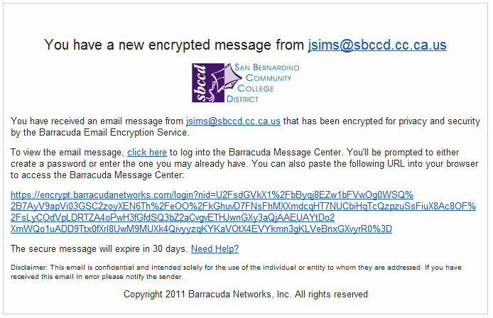
- The recipient will need to click on the link to retrieve the message. This will take them to a secure barracudanetworks.com website requiring a login to retrieve the message:
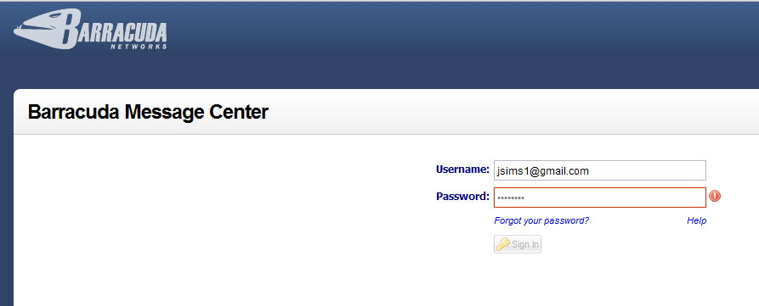
Fist time users will be asked to setup a username and password.
- Once logged in the message will be displayed:
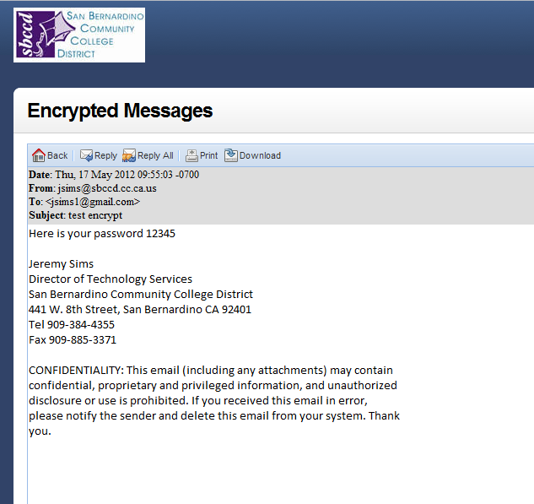
If they choose to reply from this screen the message will be encrypted.

