Logging into SBCCD Helpdesk
- In your web browser, go to www.valleycollege.edu
- Scroll to the bottom of the main page and click on the Tech Support link to open the Helpdesk login page.
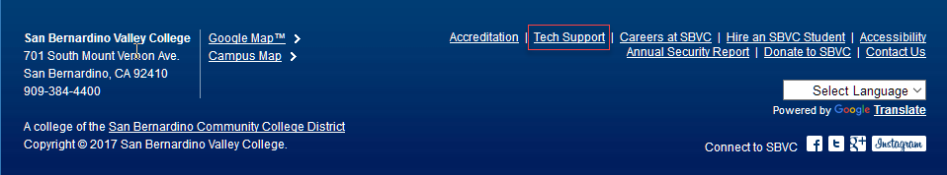
- On the Helpdesk login page enter the following information:
  - Your Login Name – this will be your @sbccd.cc.ca.us email address (NOTE: the entire email address needs to be entered as the Login Name).
  - Your Password – this is the password you created when you received the email for setting up your helpdesk account.
  - Set the Go To dropdown to Help Desk.
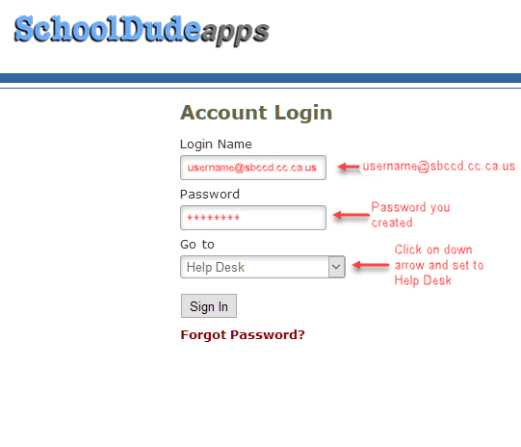

  - If you forgot your password or deleted the registration email, click Forgot Password? on the login page. Enter your @sbccd.cc.ca.us email address in the window that opens and click Submit to be emailed instructions on resetting your password.
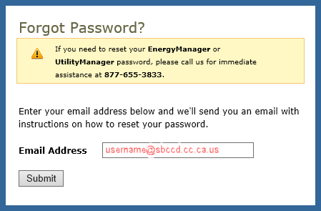
- After you have entered the required information, click Sign In.

