Campus Technology Strategic Plan
2017-2020

Table of Contents

San Bernardino Valley College 3
Vision 3
Mission 3
Challenges and Opportunities 4
Goals for Success (2017–2020) 4
The SBVC Campus Technology Strategic Plan 5
Purpose 5
Process 5
Technology Committee Members 2015-2016 5
Technology Vision 6
Technology Mission 6
Technology Guiding Values 6
Goals and Supporting Strategies 7

San Bernardino Valley College

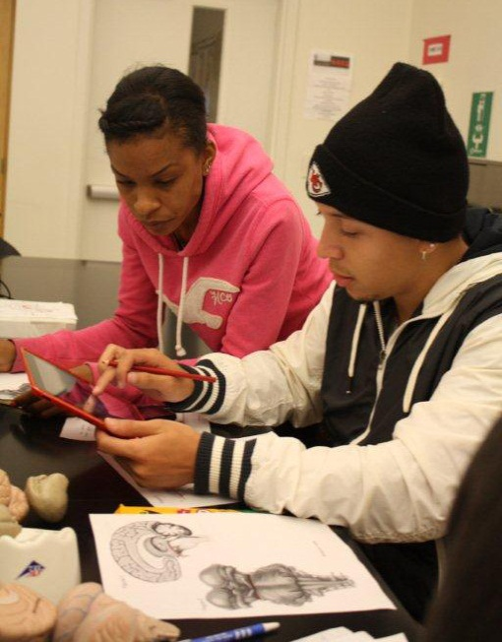
San Bernardino Valley College (SBVC) is a comprehensive community college offering a full range of degrees, transfer programs to four-year institutions, and certificates in a wide range of careers. SBVC is an accredited regional leader in career and technical education with programs in computer and information technology, graphic arts, computer science, nursing, automotive, machine trades, welding, electrical, and dozens more. Weekend, online, evening, short-term, and distance-learning classes are available along with classes in Big Bear.

For more information, visit www.valleycollege.edu, follow campus news on Facebook and Twitter, or call (909) 384-4400. The college is located at 701 S. Mt. Vernon Avenue, San Bernardino, CA 92410.

Vision

San Bernardino Valley College will become the college of choice for students in the Inland Empire and will be regarded as the alma mater of successful, lifelong learners. We will build our reputation on the quality of our programs and services and on the safety, comfort, and beauty of our campus. We will hold both our students and ourselves to high standards of achievement and will expect all members of the college community to function as informed, responsible, and active members of society.

Mission

San Bernardino Valley College maintains a culture of continuous improvement and a commitment to provide high-quality education, innovative instruction, and services to a diverse community of learners. Its mission is to prepare students for transfer to four-year universities, to enter the workforce by earning applied degrees and certificates, to foster economic growth and global competitiveness through workforce development, and to improve the quality of life in the Inland Empire and beyond.

Challenges and Opportunities
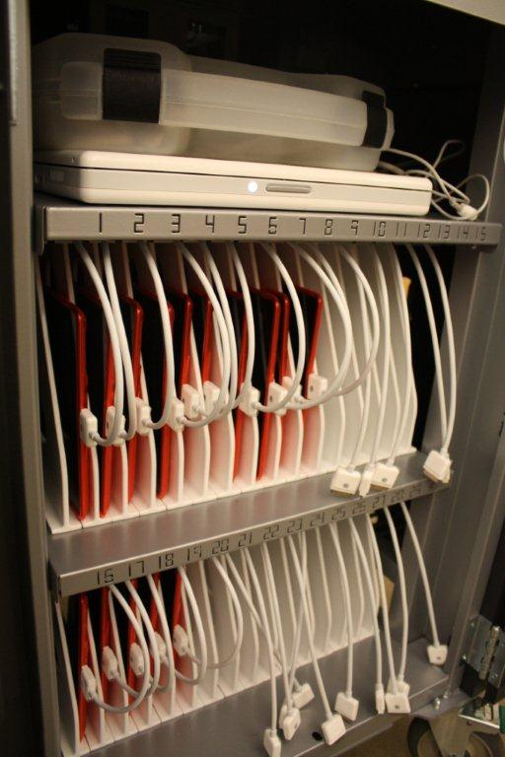
SBVC is facing challenges in funding, competition, changing demographics, escalating constituent expectations, underprepared students, and a growing demand for access to online educational services. As with all higher education institutions, SBVC is affected by an extraordinary level of change, especially in the area of technology. The ever-increasing rate of change requires that SBVC continuously monitor the horizon for emerging trends for future success while maintaining the delivery of quality education services to their current constituents.

Transforming these challenges into opportunities is the fundamental goal of the SBVC IT Strategic Planning effort.

Goals for Success (2017–2020)

This Campus Technology Strategic Plan describes SBVC’s direction for technology through the adoption of goals that are designed to move the institution toward its future vision for technology. The remaining sections in this plan explain the process used to develop these goals, for example, introduction of the supporting strategies for each goal, demonstration of alignment with the Campus Strategic Master Plan, District’s Planning Imperatives, and an implementation plan for each goal and supporting strategy.

- Provide exemplary technology resources and support while maintaining fiscal and environmental responsibility.
- Support the Online Program Committee’s Plans and Goals.
- Encourage partnerships businesses, other organizations, and the surrounding community.
- Collaborate with the District on projects that are beneficial to all.
- Work cooperatively through the Office of Professional Development to provide appropriate technology training.
- Identify and meet accessibility standards set by Section 508.

The SBVC Campus Technology Strategic Plan

Purpose

The SBVC Technology Strategic Plan provides a comprehensive roadmap for utilizing technology to improve the overall performance of the institution. The three-year plan presents focused goals and supporting strategies which will move the institution closer to realizing its vision.

Process

This plan is built on a foundation of IT strategic planning that began at SBVC in 2001. Each plan has enabled SBVC to navigate the changing environment and successfully position itself for the future. This plan has been modified regularly since its inception, and this particular version has been revised and updated by the Technology Committee during the 2015 - 2016 academic year and finalized in the Spring of 2016. It will remain in place until June 2019, when it will be evaluated once again.

SBVC’s Technology Committee is responsible for developing and maintaining the IT Strategic Plan. It is charged to explore and encourage innovation in the use of technology, including the support and training of faculty and staff in the use of technology for academic and management applications.

Technology Committee Members 2015-2016

Hrdlicka, Rick (Co-Chair) Director, Campus Technology Services
Bastedo, Dave (Co-Chair) Professor, Biology
Batalo, Mandi Associate Professor, Art
Blecka, Lori Associate Professor, Mathematics
Bojorquez, Ana Assistive Technology Specialist, Disabled Students Program and Services
Chang, Andy Director, Administrative Applications
Feist, John Technology Support Specialist II, Campus Technology Servces
Flaa, Jonathan Technology Support Specialist I, Campus Technology Services
Hamdy, Rania Coordinator, Professional Development
Hastings, Ron Director, Library and Learning Support Services
Hua, Henry Dean, Mathematics, Business & Computer Technology Division
Jackson, Jack Professor, Philosophy/Religious Studies
Jakpor, Riase Instructor, Political Sciences
Johnson, Wallace Dean, Social Sciences, Human Development & Physical Education
Nguyen, Joseph Coordinator, Student Success
Notarangelo, Joseph Associate Professor, English
Sims, Jeremy Director, District Technology Services
Wall, Patti Associate Professor, Library and Learning Support Services

Technology Vision

Students, faculty, and staff will have universal access to the tools and resources of current and emerging technologies, and the expertise to use them effectively for the process of learning

Technology Mission

The Technology Committee is the bridge that crosses the digital divide for students, faculty, and staff by providing and implementing a plan for universal access to technology.

Technology Guiding Values
We value:
- Effective training and professional development
- Development of technologically literate students, staff and faculty
- Effective use of technology that will positively influence the community
- Partnerships with our community
- A climate of continuous improvement
- Exploration of emerging technologies
- That the District and Campus Technology Services provide exemplary support to the campus community.
- Fulfilling the technological needs of the campus community

Goals and Supporting Strategies

In 2016 the Technology Committee revised the goals and the supporting strategies to reflect accomplishments and changing needs.

- Provide exemplary technology resources and support while maintaining fiscal and environmental responsibility.

Supporting Strategy:
1.1. Maintain the processes for determining the technology needs of students, faculty, staff, and administrators and incorporate the data into technology planning.
1.2. Maintain and adhere to minimum standards for classroom technology.
1.3. Provide faculty with the latest information on the trends in emerging technologies.
1.4. Develop and update current web-based services on an ongoing basis.
1.5. Provide an open yet secure network that allows reliable accessibility while providing confidentiality of information.
1.6 Provide adequate number of expert support staff to meet the day-to-day and long-term technology needs of students, faculty and staff on campus.

- Support the Online Program Committee’s Plans and Goals. http://www.valleycollege.edu/about-sbvc/campus-committees/additional-committees/online-program/opcplan

Supporting Strategy:
2.1 Curriculum and instruction
2.2 Faculty support
2.3 Student support
2.4 Evaluation and assessment

- Encourage partnerships with businesses, other organizations, and the surrounding community.

Supporting Strategy:
  - Develop technology-related partnerships with businesses, organizations, and agencies.
  - Promote activities and events that connect businesses with SBVC students.
  - Develop partnership opportunities with feeder schools, colleges, and universities.
  - Work with vendors to provide student discounts for educational technology.

- Collaborate with the District on projects that are beneficial to all.

Supporting Strategy:
  - Collaborate with District Technology to identify, implement, and support electronic communication methods that serve all of our users. (For Example LMS, EMAIL, SARS, BBConnect, Website CMS)
  - Promote initiatives that lead to district-wide best practices.
  - Educate the campus community regarding available technology resources.

- Work cooperatively through the Office of Professional Development to provide appropriate technology training.

Supporting Strategy:
  - Provide appropriate technology training opportunities for all SBVC personnel through the use of diverse delivery methods that provide access to all.
  - Encourage the development of curriculum that prepares our students for success with web-based and web-enhanced courses.
  - Provide individualized technology training for faculty and staff.
  - Provide access to conferences through alternative methods.

- Identify and meet accessibility standards set by Section 508.

Supporting Strategy:
  - Maintain accessible systems to the campus community.
  - Maintain standards for accessibility for all institutional websites to ensure compliance.
  - Provide accessibility training to faculty and staff.
  - Provide training in the use of accessibility software where needed.

Intentionally left blank.

